Sportable Program Analysis

- TR Process
- Assessment
- When talking with my mentor Kyle, he informed me that there is not a specific assessment that is used by the agency. He told me that if I had the red book to look in there and look for assessments that focus on fine/gross motor skills mostly because those would be the types of assessments that would be used. The assessment that I found within the red book that I believed would be used by the agency was the CERT-Physical Disabilities. The recommended group for this assessment according to the red book are those with loss of function (Burlingame & Blaschko, p. 337, 2010). Another assessment that can be used within this agency would be the STILAP. When talking with my mentor about these two assessments, he wanted to make it clear that only certain sections of these two assessments would be used within this setting.
- According to my mentor, the athletes go through a registration process online where they enter their information such as their basic information, disability, and pay the fee for the month (K. Hitzelberg, Personal Interview, June 16, 2020).
- Other documents or resources that assist in the assessment process are the participates medical records. These play an important role in the assessment process because they hold important information about the participants disability, if they have any allergies, and if there are any more known conditions that could impact their participation.
- Some important things that should be noted as additional aspects of the assessment process would be taking into consideration the athletes’ secondary conditions. When talking with my mentor, he gave the example of someone who has autonomic dysreflexia as a result of their spinal cord injury wouldn’t go out with the cycling program right away. This is an important part of the assessment process because safety is a big concern with the athletes and knowing their secondary conditions is very important when it comes to their participation in programs.
- Plan
- Since there isn’t a specific assessment used at the agency like mentioned above, the planning process doesn’t really involve one. If the two assessments that could be used at the agency were involved, the specific sections of those two assessments would be used when the clients first come in. The second part of the planning process is bringing the client in to get them fitted for the chairs. This part of the planning process is the most important because it helps determine if they need to go out and get additional equipment like straps that will secure their upper body or gloves for their hands.
- The documents used for the planning process would mostly be those forms submitted by the athletes with their information on it. It gives the agency basic information about the client as well as important medical information that they bring with them to the different practice facilities.
- According to my mentor, they don’t have any. The agency does work closely with Sheltering Arms, VCU Rehab and a few other medical providers that recommend athletes to them. There is a lot of collaborating with the athletes’ therapist from these agencies that they do work closely because they know what would work best for the athletes when it comes to what sport might work best or what type of sports chair and equipment would work best. My mentor said that the athletes’ therapist is basically involved from the assessment process through the planning process when it comes to those athletes’.
- The specific sports that the athletes participate in are solely chosen by them. They are able to decide which sports they might be interested in and which ones they might want to try out with the agency. It is recommended that they come see a practice so that they can see what it is all about and if it is something that interest them as well.
- 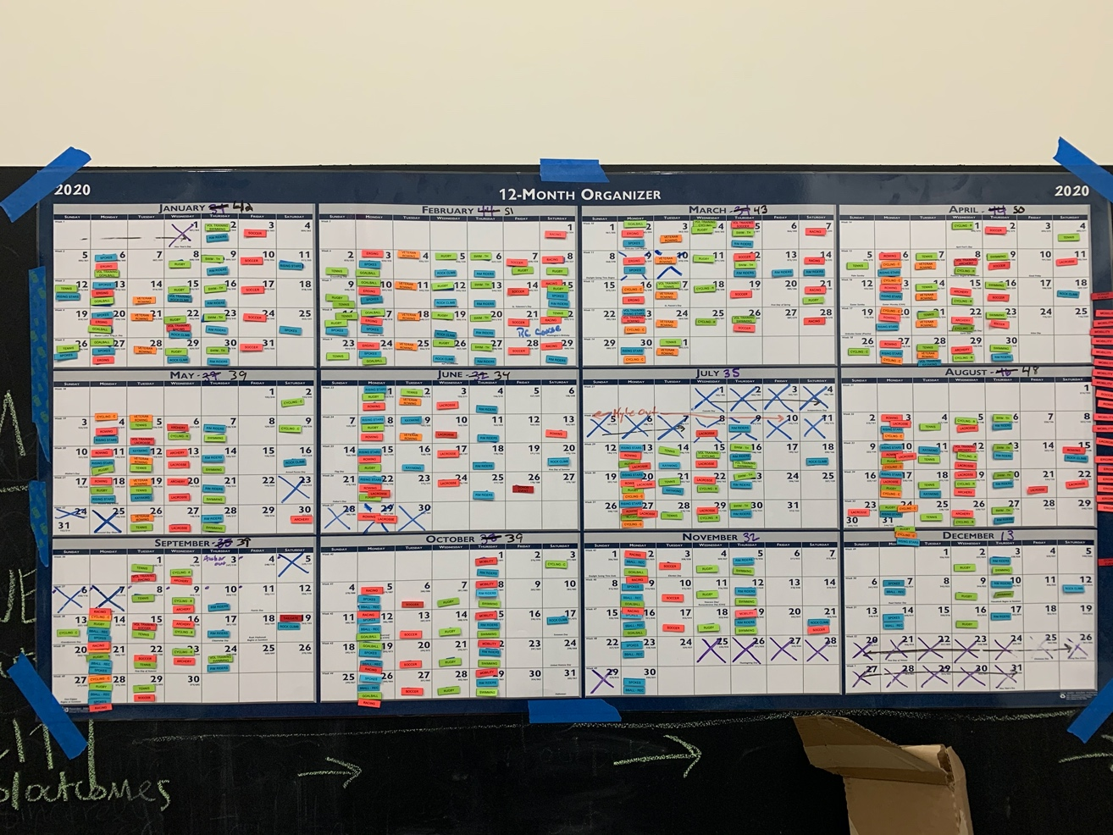 Above is a 12-Month program schedule laid out and color coded that is used for all of the programs offered by the agency (K. Hitzelberg, Personal Interview, June 18, 2020).
- Implementation
- The procedure of the implementation process of these programs would be a typical practice. Example of Cycling Practice: The program managers would show up before everyone to get everything set up. The coaches and volunteers show up for practice to make sure there is nothing else left to do. The athletes then show up, check-in, and get set up with the equipment if they did not bring their own. Their goals are taken for the practice and the athletes are able to start. Once the athletes are done, they need to make sure they turn in their equipment if needed and sign-out with the program manager.
- The documentation style depends on the program being done. Some of the sports have more documentation needing to be done then others. Some of the documents have a self-survey that athletes can use to document their skills and the coaches can do the same according to what my mentor said. My mentor also said that some of the programs that they have they monitor the goal outcomes. The goal outcomes of these sports are documented on specific goals based on those athletes. In all the programs, participation is documented on the athletes.
- Evaluation
- In some of the programs, especially cycling, there are apps that track the progress that are being made by the athletes. It helps to see how far they have come since beginning the program as well as they are able to see the distance that they went during that particular session. Also, according to my mentor before every practice they have a clipboard that they use to take down all the athletes’ goals for the practice and they will check with them after the practice if they were met. This is where the apps can come in handy as well if it comes to the athlete wanting to reach a certain distance or speed.
- When I was talking to my mentor, he said that they receive feedback from the athletes through a survey that is given at the end of a program. This survey helps them to improve on anything that needs to be improved on before the program is offered again.
- According to my mentor, there are annual reviews that help in evaluating his skills in addition to each of the programs being evaluated at the end. He mentioned that part of the evaluation is how well the program was run/practices were implemented. The athletes complete that part about how practices and programs were implemented. The coaches also evaluate them to let them know how everything went. The information that they received helps them improve on future programs.
- Program Outline
- There are 13 programs offered at Sportable. However, only 5 of them are over seen by a CTRS who happens to be my mentor. The programs that are run by my mentor are wheelchair rugby, cycling, swimming, tennis, and goalball.
- Wheelchair Rugby- “A unique sport created by athletes with a disability, it combines elements of rugby, basketball and handball” (Rugby Basics, 2018). This sport is specific to certain population groups according to my mentor. The reason it is specific to certain population groups is the fact it needs to follow regulations set out by United States Quad Rugby Association (USQRA).
Cycling- Adaptive cycling is basically when a cycle is modified specifically for an individual with a disability. This sport is available to all ages and skill levels. There is youth cycling, adult cycling, recreational cycling, and competitive cycling. This sport is open for anyone with a physical disability or visual impairment.
Swimming- Provides basic instruction and skill development for strokes in recreational and competitive swimming (Swimming, 2020). Offered in both a therapeutic pool setting and cold-water pool setting for athletes. According to my mentor they do not offer therapeutic swimming because of the terminology but they do operate in a 92-degree pool for the athletes that need it. Athletes with physical disabilities or visual impairments can participate ages 5 and up.
Tennis- “Participants will learn court mobility, stroke technique, the rules and scoring of the game, all while building strength, cardiovascular ability, and self-esteem in a fun group instruction environment” (Tennis, 2020). This sport is available in a recreational or competitive program for adults with physical disabilities or visual impairments. My mentor also mentioned that they hope to create a youth only program one day.
GoalBall- “Goalball is a Paralympic sport played exclusively by athletes with visual impairments. Players wear opaque eyeshades at all times ensuring fair competition and compete in teams of three” (Goalball, 2020). This sport like mentioned in the description is specifically for athletes that have a visual impairment.
- TR Process Delivery Flow Chart
- 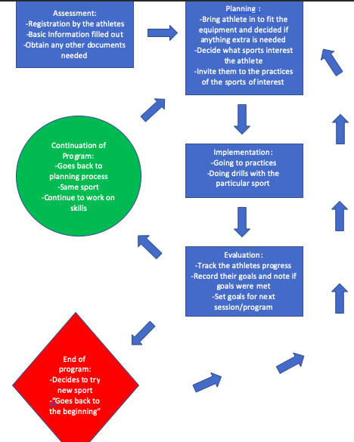
- SWOT Analysis
- Some of the strengths that I think the RT department has would be that they are doing such a good job with everything right now especially since the department is only my mentor at the moment. I believe that there is a lot of hard work going into getting programs back up and running with everything going on lately and that is showing dedication.
- One of the big weaknesses currently at the agency would be that there is only one CTRS at the moment. There are a lot of limitations that come along with that especially when it comes to programing and even collaborating with me as an intern. I personally think it would have been great to have two CTRS’s to talk to during this internship at the agency to get more opinions and insights as well as including more programs above.
- Like my mentor Kyle has said many times before “The opportunities are endless” (K. Hitzelberg, Personal Interview, June 16, 2020). There are plenty of programs that could be brought into the agency if there is interest shown by others as well as there are the resources to provide the new programs.
- The biggest threat that can be seen at this moment to the agency as well as to the programs would be COVID19. This pandemic has caused a lot of programs for the agency because programs have had to be canceled and the facility has had to close for the safety of others.

References:

Burlingame, J., HTR, ABDA & Blaschko, T. M, MA. (2010). Assessment Tools for Recreational Therapy and Related Fields (Fourth ed.). Ravensdale, Washington: Idyll Arbor.
Goalball. (2020, June 15). Retrieved June 21, 2020, from https://www.sportable.org/adult-sports/goalball/
Rugby Basics. (2018). Retrieved June 21, 2020, from https://www.usqra.org/rugby-basics
Swimming. (2020, June 15). Retrieved June 21, 2020, from https://www.sportable.org/adult-sports/swimming/
Tennis. (2020, June 18). Retrieved June 21, 2020, from https://www.sportable.org/adult-sports/tennis/

