RECR 392- Program Analysis Criteria
- TR Process
  - Assessment
    - Name the assessment(s) used at your agency. If your agency does not use an assessment, identify an assessment that maybe appropriate for the agency. Include whether the assessment is standardized or an “in-house” tool.
    - Describe the on-boarding process- registration, admission, etc.
    - Identify other documents or resources that assist in the assessment process (past records, families, other providers).
    - Other- list any other aspect of the assessment process or details you deem important to include here.
  - Plan
    - Describe the planning process at your agency. Be sure to identify the role of the assessment in planning.
    - Identify any documents used in the planning process.
    - Describe other departments, sources, allied professionals that are involved in the planning process.
    - Describe how activities/interventions/programs are selected. Give examples.
    - Provide a monthly and weekly schedule of programming/activities at the agency/setting.
  - Implementation
    - Describe the implementation procedure. Give an example.
    - Identify how implementations are documented. Explain what information is required in this documentation.
  - Evaluation
    - Describe how the client’s progress is evaluated. Be sure to mention all documents used to evaluate client progress.
    - Describe how the program’s progress is evaluated. Be sure to mention all documents used to evaluate programming and how programming improvement is made.
    - Describe how the therapist’s skills are evaluated. Be sure to mention all documents associated with this process. Describe how the therapist uses feedback to improve their skills.
- Program Outline
  - Programming- create an outline of all RT programming offered at your assigned agency/setting
  - Interventions/activities (no more than 10)- list all the activities/interventions, with a brief description and the expected outcomes. Include the duration and frequency of the activity within the program. Identify whether each intervention/activity is evidence-based.
- TR Process Delivery Flow Chart
  - Flow Chart- a flow chart is a visual model depicting a process. There are several types of flow models. You will make a detailed flow model. The Institute for Healthcare Improvement (2013) has an excellent tutorial on how to make a flowchart (http://www.ihi.org/education/IHIOpenSchool/resources/Pages/AudioandVideo/Whiteboard11.aspx). You will make what they refer to as a detailed flowchart. You will use circles, boxes and diamonds as they instruct to identify parts of the process. It will begin with the client’s entry point to the agency, will follow the client through the APIE and/or service delivery process, and end with their exit. Here is an example flowchart that all of you should be familiar with from Healthy Innovations (please note, this is of the documentation only, yours must include the service delivery process).
- SWOT Analysis- conduct a SWOT analysis of your agency. It should be based upon all the information gathered thus far to include the agency summary, market scan, population summary and program analysis. The SWOT analysis should be used to help identify a course project for you to pursue for the remainder of the internship.
  - Strengths- what are the strengths of the RT program?
  - Weaknesses- what are the weak areas of the RT program?
  - Opportunities- what are potential opportunities to expand, obtain resources, or broaden the market?
  - Threats- are there areas that threaten the existence of the program? This may include non-compliance with regulatory bodies, lack of funding, or loss of resources.
  - 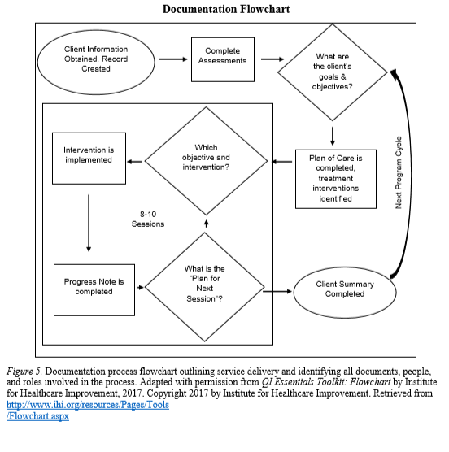

References:
Lloyd, R. (2013, October 7). Whiteboard: Flowchart [Video]. Institute for Healthcare Improvement. Retrieved from https://www.youtube.com/watch?time_continue=258&v=tq7dQVaTbcc&feature=emb_logo
Whitely, K. & Lynch, S. (2018). Documentation flowchart Figure from Healthy innovations documentation process handbook In RECR 260 Children with Disabilities: Spring 2019. Retrieved from https://canvas.longwood.edu/courses/1291071/files/search?preview=54787353&search_term=handbook

