Mariah Strock
Dr. Elif Guler
English 400-16
11 October 2018
Using Stick Figures to Tell a Story: Rhetorical Analysis of the “MADD Zero” Campaign
The artifact that I will be focusing on for this project is a public service announcement (PSA) video entitled “MADD Zero.” The PSA video was released in 2017 by Mothers Against Drunk Driving (MADD), a nonprofit organization founded in 1980 that seeks to stop drunk driving, support people affected by drunk driving, prevent underage drinking, and advocate for stricter impaired driving policies (“About Us,” 2018). MADD has multiple campaigns, PSAs, press releases, and other artifacts related to eliminating drunk driving. I chose “MADD Zero” for analyses because drunk driving takes so many lives each year. I had a friend who died after a car accident while driving under the influence of alcohol and drugs and have seen the pain that his family continues to experience years later. “MADD Zero” shows how drunk driving fatalities negatively affect the family and friends of victims for the rest of their lives.
“MADD Zero” conveys a message of responsibility and reminds the audience of their role in eliminating drunk driving. A MADD spokesperson narrates the video, targeting all of society as the audience. “MADD Zero’s” purpose is to describe MADD’s goals, progress made towards those goals, the work still remaining, and a call to action. “Everyone has a responsibility to help eliminate drunk driving” is the artifact’s tagline (“Public Service Announcements,” 2018). The artifact promotes MADD’s goal of zero deaths, zero injuries, and zero families impacted by impaired driving and can be found on the MADD.org website (“MADD Zero,” 2017). The artifact is frequently shown during Parent Teacher Association (PTA) meetings and drivers’ education classes because of its appeal to teenagers and families. The artifact serves as a reminder that lives can be changed forever because of drunk driving. In this paper, I will analyze “MADD Zero” as a visual artifact to explore its rhetorical value for compelling the audience to recognize and accept their responsibility to prevent drunk driving fatalities.
MADD developed this artifact to raise awareness of the negative impact of drunk driving on victims and offenders and to get all people to take some level of responsibility for preventing drunk driving. The 3-minute video uses stick figures of family members doing typical family activities such as a father tucking in his child at bedtime, a mother walking her child to school, and kids coming home from school, to illustrate how lives would be changed if a family member was killed by a drunk driver. Family members fade out of the picture to suggest that they have been taken away from doing the things that they love to do with their family. The artifact also uses numbers to present statistics related to the effects of drunk driving as well as for presenting MADD campaigns in a logical order. MADD wants to promote social change to save lives by reducing drunk driving. The artifact uses deliberative rhetoric, or the use of policy to guide deliberate choices, to persuade the audience to take action to prevent future occurrences of drunk driving which could harm others (Van Belle et al. 13). The artifact tries to promote something which is beneficial, to reduce something that is harmful.
METHOD
Rhetorical context must be considered when examining this artifact. While rhetorical context such as the topic, the audience, and the author’s purpose and motivation for developing the artifact should be considered during analyses, this context cannot determine everything about the artifact (Schilb 34). To make better sense of the implications of this artifact for social change, the Aristotelian perspective of ethos will be considered. Persuaders may use ethos to get the audience to view them as credible (Heinrichs 40). MADD has a reputation for being a credible resource for information and action against drunk driving. Through its use of artifacts, such as this PSA and lobbying, MADD has been successful in creating social change in the past. “MADD Zero” presents information about MADD’s past successes and the social change they have influenced. The artifact provides information about MADD’s four campaigns, including advocacy for increased law enforcement efforts, ignition interlocks in cars for all offenders, advanced vehicle technology, and public support, and how MADD has made advances in each of these areas (“MADD Zero,” 2017). The artifact compares past to present to show MADD as an effective agent for change and to influence the audience to want to be a part of the change.
The Aristotelian perspective of pathos will also be applied to make better sense of the implications of this artifact for social change. Persuaders may use pathos to persuade the audience by making them feel certain emotions (Heinrichs 40). Pathos is the primary rhetorical appeal that MADD uses. MADD tries to get offenders to see how their actions can negatively impact the lives of others, including victims and their families. “MADD Zero” appeals to the audience’s emotions by trying to get them to visualize what life would be like if they or one of their family members was taken from their lives.
The Aristotelian perspective of logos will also be considered to make better sense of the implications of this artifact for social change. Persuaders may use logos to persuade the audience by presenting arguments that the audience will perceive as logical (Heinrichs 40). “MADD Zero” presents information and the call to action in a logical way. The artifact first describes the goal of the “MADD Zero” campaign, followed by the progress that MADD has made in decreasing drunk driving. The artifact then presents current statistics related to drunk driving to illustrate that more work is needed to achieve MADD’s overall goal of zero drunk driving fatalities. Finally, the artifact presents the call to action in terms of each of its four campaigns. The narrator numbers the campaigns before providing more detailed descriptions for each one to present the logical order of the work that has been done and that is still needed (see fig. 1).
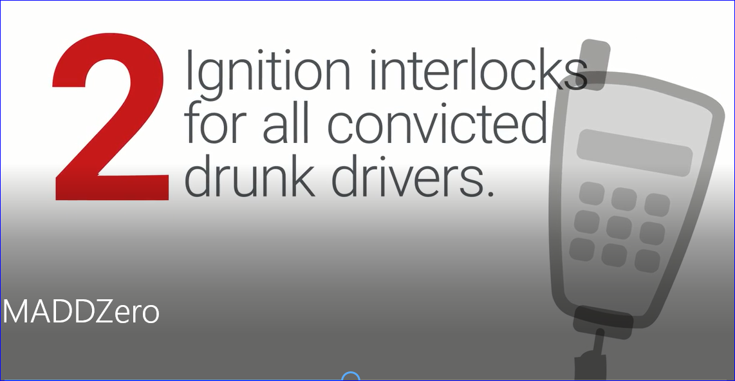
Figure 1. Numbers used to present logical order of MADD campaigns (“MADD Zero,” 2017).
Other methods that will be incorporated during the rhetorical analyses include virtue, disinterest, empathy, repeated first words, and imagery. The artifact uses virtue to persuade the audience that MADD shares the same values, such as family and vitality, as the audience does. The artifact also uses disinterest to persuade the audience that MADD is not biased and is more concerned about the audience’s interests than their own (Heinrichs 57). “MADD Zero” uses empathy to persuade the audience that MADD empathizes with and cares deeply about victims and their families (Heinrichs 85). Repeated first words are used as a figure of speech to draw attention to the message and to gain the audience’s interest (Heinrichs 220). For example, the word “zero” is used at the beginning of several sentences in a row to describe MADD’s goal for the number of people who should be impacted by drunk driving. The artifact uses imagery such as families hugging or spending time together for emotional appeal, persuading the audience to consider MADD’s call to action as something desirable.
ANALYSIS
Rhetorical Analysis of Imagery
“MADD Zero” uses imagery to raise awareness for the social change that is needed and to persuade the audience to follow the call to action. For example, the artifact uses red colored stick figures of family members doing typical family activities such as a mother walking her child to school. The family members, important statistics, and the call to action are illustrated in bold, red font for emphasis. After each image, one of the family members is gradually faded out of the picture to suggest the family activities that would no longer occur if a family member was killed by a drunk driver (see fig. 2).
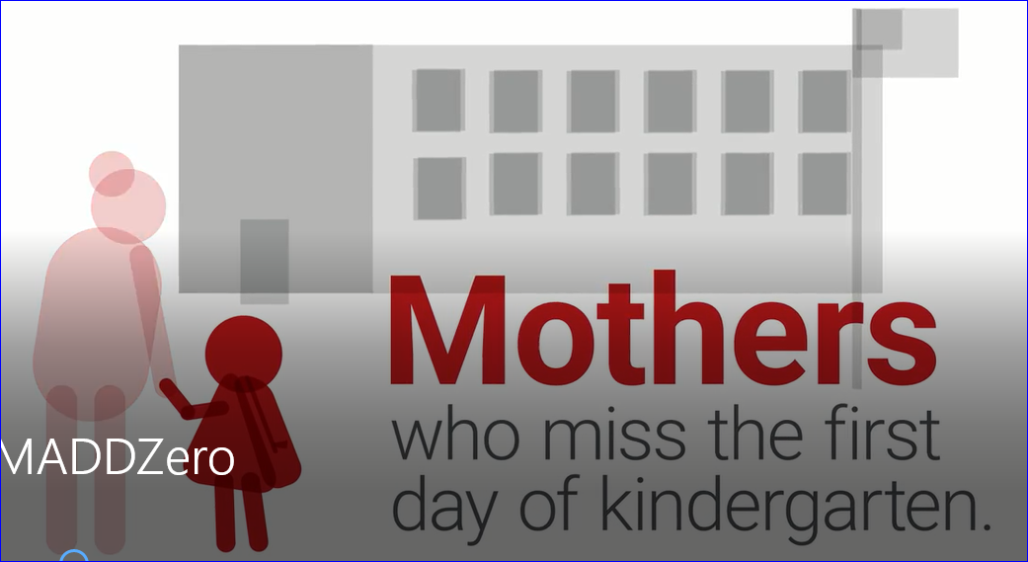
Fig. 2. Fading images illustrate family missing important activities (“MADD Zero,” 2017).
To highlight the overall campaign goal, zero statements in large, underlined text in red font are used throughout the artifact (see fig. 3). Red is the only color used in the artifact. All frames of the video have a black and white background, which helps to convey to the audience the main messages of “MADD Zero.”
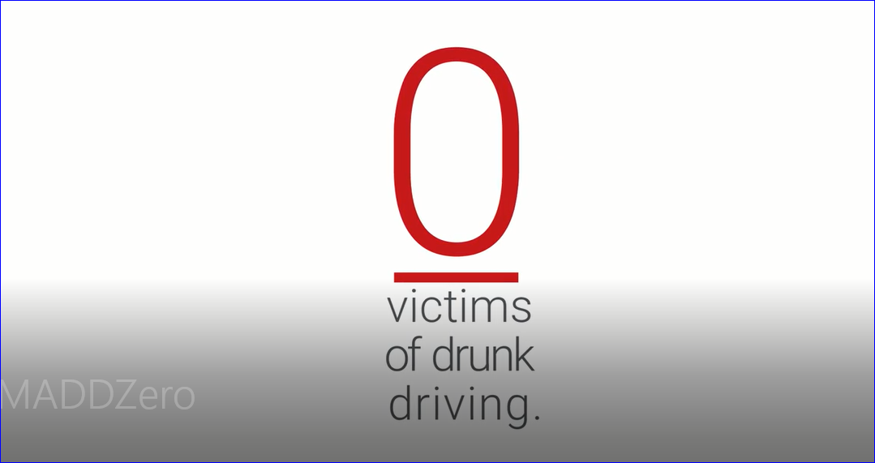
Fig. 3. Use of font and background color to emphasize images (“MADD Zero,” 2017).
Imagery is also used to reinforce the call to action to the audience. An image of a math problem is used to persuade the audience that they are the solution to the problem (see fig. 4).
Fig. 4. Imagery used to show audience their part in the solution (“MADD Zero,” 2017).
Rhetorical Analysis of Emotional Appeal
“MADD Zero” uses emotional appeal to raise awareness for the social change that is needed and to persuade the audience to follow the call to action. The video helps the audience “put themselves in the shoes” of a victim. The audience can empathize with the family members who have lost a loved one because of drunk driving. The artifact evokes an experience for the audience by providing a vivid description of how losing someone to drunk driving will impact the entire family. I felt sad as loved ones faded out of the picture, implying that they had been killed by a drunk driver (see fig. 2). “MADD Zero” persuades the audience to feel what victims are feeling.
The narrator emphasizes what MADD stands for by using repeated first words to appeal to the audience’s emotions. For example, the narrator says, “we believe in a hug on the 1st day of school,” “we believe in another bedtime story,” and “we believe in no more victims” (“MADD Zero,” 2017). The emotional appeals of the video made my heart melt. “MADD Zero” appeals to the emotions that family members feel as they spend special moments with the ones they love. Based on MADD’s beliefs expressed in the artifact, the audience agrees that they believe in the same things. The artifact draws on audience emotions so they will “believe in zero” too.

Rhetorical Analysis of Responsibility
“MADD Zero” also uses responsibility to raise awareness for the social change that is needed and to persuade the audience to follow the call to action. The artifact tries to convince the audience that their individual help is needed for MADD to be able to reach its goals. For example, the artifact appeals to the audience’s pathos by saying, “getting to zero starts with you” (“MADD Zero,” 2017). The artifact’s image on MADD’s media center highlights in red text the audience’s responsibility for being part of the social change (see fig. 5).
Fig. 5. Color and highlighting used to suggest responsibility (“MADD Zero,” 2017).
The artifact reminds the audience that they are responsible for contributing time, financial support, and/or energy to achieve the solution (see fig. 4). The video made me feel a sense of guilt if I did not accept responsibility for becoming part of the change. After all, the narrator says that achieving the goal of zero deaths due to drunk driving “starts with you” (“MADD Zero,” 2017). The artifact is effective in persuading the audience that they are responsible for the solution to the problem because social change cannot happen without them. In fact, “MADD Zero” shows the audience what their responsibilities are in the solution, such as using a seatbelt, not drinking and driving, and taking the keys from others who have been drinking.
CONCLUSION
“MADD Zero” effectively identifies what the audience is thinking so they know that family is what the audience considers most advantageous. The artifact effectively convinces the audience that MADD values the audience’s family as much as the audience itself does. The artifact shows the audience that MADD can meet the audience’s needs by protecting their families and society against the harmful consequences of drunk driving better than any other organization. The artifact presents MADD’s past successes to show the organization’s credibility and persuades the audience to believe that MADD is the best organization for this important job. “MADD Zero” appeals to audience emotions and leads the audience to empathize with the innocent victims of drunk driving. The artifact persuades the audience to take responsibility for the social change needed for eliminating deaths from drunk driving. The audience is left feeling responsible for keeping families intact. MADD helps to save lives, and I believe that this artifact is effective in compelling the audience to join them in their effort. The audience feels like by helping MADD, they are a part of a social change necessary for the common good.
It is useful to analyze “MADD Zero” through the rhetorical concepts of imagery, emotional appeal, and responsibility. The analyses provide support for why the artifact has been successful in social change so far. Analyses also show mechanisms that can be used to effectively persuade audiences to agree with MADD’s views on the topic. Future campaigns are more likely to be successful if similar rhetorical approaches are taken when developing artifacts for this audience. However, I believe that the rhetorical approaches used in this artifact are more likely to appeal to parents, a population that may not be at the highest risk for drunk driving. To add appeal for teenagers, imagery could be added to “MADD Zero” to illustrate teenagers being taken from their friends and from participation in extracurricular activities. Fortunately, MADD does have other artifacts that may have greater appeal to other types of audiences, such as teenagers. Overall, I believe that the “MADD Zero” artifact is highly effective in influencing social change.
Works Cited
Heinrichs, Jay (2017). Thank You for Arguing: What Aristotle, Lincoln, and Homer Simpson Can
Teach Us About the Art of Persuasion. New York: Three Rivers Press.

Mothers Against Drunk Driving. “About Us.” Talklikemadd.org. MADD Media Center, 16 Oct
2018, https://www.madd.org/about-us/

Mothers Against Drunk Driving. “Public Service Announcements.” Talklikemadd.org. MADD
Media Center, 16 Oct 2018, https://www.madd.org/about-us/#psa

Mothers Against Drunk Driving. “MADD Zero.” Talklikemadd.org. MADD Media Center,
2017, MADDZero.mp4

Schilb, John (2007). Rhetorical Refusals: Defying Audiences’ Expectations. Carbondale:
Southern Illinois University Press.

Van Belle, Hilde, Rutten, Chris, Gillaerts, Paul, Van De Mieroop, Dorien, and Van Gorp,
Baldwin (2014). Let’s Talk Politics: New Essays on Deliberative Rhetoric. Philadelphia: John Benjamins Publishing Company.

