Insertion of PpbrA promoter in place of pBad promoter controlling RFP gene expression in Escherichia coli for detection of lead in gunshot residue

Introduction
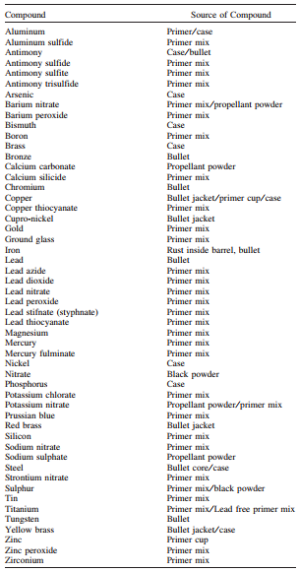
Gunshot residue is made of many organic and inorganic compounds. Common organic compounds include trinitrotoluene (TNT), which is found in the propellant powder and primer mix, and dinitrotoluene (DNT), which is found in the propellant powder (Dalby et. al 2010). Common inorganic compounds include antimony, which is found in the case and bullet, barium, which is found in the primer mix and occasionally the propellant powder, and lead, which is found in the primer mix (Table 1).
There are many techniques currently used to analyze organic and inorganic components of gunshot residue after the samples have been collected. Currently proposed methods of gunshot residue analysis of organic compounds include gas chromatography, high performance liquid chromatography, and capillary electrophoresis. Currently proposed methods of gunshot residue analysis of inorganic compounds are neutron activation analysis, atomic absorption spectrometry, inductively coupled plasma, and most popularly, scanning electron microscopy (SEM). The greatest flaw in SEM analysis is the time-consuming and repeated task of manually searching through many samples. There is also a great risk of human error in this task (Dalby et. al 2010).
Table 1. Inorganic Compounds Typically Present in Gunshot Residue (Dalby et. al 2010).
When the analysis of organic and inorganic compounds is studied together, the results yield to be more accurate (Dalby et. al 2010). The desire for one mechanism to work as an analyzer of organic and inorganic compounds in gunshot residue is possible using synthetic biology.
Synthetic biology is a growing field in science that incorporates genetic engineering with mathematics to create biological systems. The overall goal of this process is to modify or enhance the behavior of an organism and to engineer it to perform the new task (Andrianantoandro 2006).
With the utilization of these tools, Escherichia coli will act as a model organism to detect one of these inorganic compounds present in gunshot residue: lead. The arabinose-sensitive promoter (pBad) in E. coli will be removed and replaced with the lead-sensitive promoter (PpbrA), controlling gene expression of red fluorescent protein (RFP). Once this system is in the presence of lead, it will glow red.
A bacterium commonly found in lead-contaminated soils, Ralsionia metallidurans strain CH34, naturally contains the PpbrA promoter and utilizes this for metal resistance (Borremans et. al 2001). The PpbrA promoter has been proven able to thrive in E. coli (Hobman et. al 2012).
After the assembly of E. coli cells containing PpbrA promoter controlling RFP expression, other components may be annexed to this system to detect other compounds present in gunshot residue.
This device will allow police officers to test suspects of a crime on the scene of an incident to rule out innocent bystanders. The hands of all the people on the scene will be swabbed with a sterile cotton swab and dipped into a collection tube of E. coli. In the presence of lead, and potentially other compounds, the cells will glow red. The collection tube will be placed into a device hooked up to a smart phone to provide accuracy.
Materials and Methods
DNA Isolation
A one mL culture of Escherichia coli that contains J10060 plasmid from the Synthetic Biology BioBrick kit was provided to extract plasmid DNA from. The J10060 plasmid includes the gene for red fluorescent protein (RFP) under control of pBad promoter region.
To isolate the DNA from E. coli, IBIScience’s High Speed Plasmid Mini kit was used. One and a half mL of E. coli cells was transferred into a microcentrifuge tube then microcentrifuged for one minute. The supernatant was discarded so 200 µL of PD1 buffer could be added by pipetting up and down. Two hundred µL of PD2 buffer was added to the tube and mixed by inverting the tube 10 times. The mixture was set at room temperature for two minutes. Three hundred µL of PD3 buffer was then added and mixed by inverting the tube 10 times, followed by microcentrifuging for three minutes. The supernatant was then added to a two-mL collection tube with a PD column in it, followed by microcentrifuging it for 30 seconds, then discarding the flow through. Four hundred µL of W1 buffer was added into the PD column and the flow through was discarded after microcentrifuging for 30 seconds. Six hundred µL of wash buffer (ethanol added) was added into the PD column and the flow through was discarded after microcentrifuging for 30 seconds. The column was again microcentrifuged for three minutes to dry out the matrix. This dried PD column was placed into a new microcentrifuge tube. Fifty µL of elution buffer was added to the center of the column matrix. The column sat at room temperature for two minutes so that the matrix could absorb the elution buffer. Finally, the tube was microcentrifuged for two minutes to elute the DNA.
Restriction Enzyme Digestion, Ligation, and Transformation
Restriction enzymes, EcroRI and NheI that were pre-mixed with buffer, were obtained to cut the DNA sequences. Two reactions were set up for the plasmid DNA and the annealed PpbrA promoter DNA. For the plasmid DNA reaction, 10 µL of plasmid DNA was added to two µL of water and eight µL of restriction enzymes (EcoRI and NheI). For the PpbrA promoter DNA reaction, 10 µL of the DNA with PpbrA DNA was added to two µL of water and eight µL of restriction enzymes (EcoRI and NheI). Both samples were mixed by pipetting gently up and down. The samples were then incubated for 30 minutes at 37 degrees Celsius. Finally, heat inactivate the enzymes at 80 degrees Celsius for five minutes.
A mixture of two µL of 10X T4 DNA ligase buffer, three µL of plasmid DNA (3 kb), 10 µL of PpbrA DNA (0.7 kb), four µL of nuclease-free water, and one µL of T4 DNA ligase was set up in a microcentrifuge tube on ice and mixed by pipetting up and down and briefly microfuged. The mixture was incubated at room temperature for 10 minutes to glue together the cohesive ends. Finally, it was heat inactivated at 65 degrees Celsius for 10 m of minutes.
Twenty µL of NEB 5-alpha competent E. coli cells on ice until the ice crystals disappear. Five µL of plasmid DNA was added to the mixture and mixed by gently flicking the tube four to five times. The mixture was placed on ice for two minutes. The mixture was heat shocked at 42 degrees Celsius for 30 seconds, followed by placing on ice for two minutes. Three hundred eighty µL of room temperature SOC was added to the mixture and immediately spread onto a Luria Broth agar plate containing ampicillin and incubated overnight at 37 degrees Celsius. After 24 hours of growth, they were sealed with parafilm and stored in the refrigerator.
PCR and Gel Electrophoresis
Four mixtures of 0.5 µL of 10 µM forward primer, 0.5 µL of 10 µM reverse primer, 12.5 µL of OneTaq 2X master mix from New England Biolabs, and 11 µL of nuclease-free water was mixed together by gently pipetting up and down and set up in four different PCR tubes. The forward and reverse primers to test for PpbrA promoter insertion into the plasmid are 5’- GCCGCTTGAATTCGTCATATAT-3’ and 5’- GCCGCTTGAATTCGTCTAGACT- 3’ respectively. Four colonies from the LB/ampicillin agar plate were identified. For each colony, a pipette tip was scraped into the colony and inserted into the PCR tube and shaken to mix. The PCR tube was then transferred into a PCR machine to begin thermocycling.
The thermocycling conditions for PCR starts with an initial denaturation, which lasts for 30 seconds at 94 degrees Celsius. Next, the tubes were held for 30 seconds at 94 degrees, followed by 45 seconds at 55 degrees Celsius, and finally 60 seconds at 68 degrees Celsius; these three conditions were repeated for 30 cycles. Then, the tubes were held at 68 degrees for five minutes. Finally, the tubes were held at four degrees Celsius.
A one percent agarose gel was cast by first mixing 0.4 grams of agarose and 40 mL of 1X TAE (90 mM Tris-Acetate, one mM EDTA, pH 8.3) buffer in a 125 mL Erlenmeyer flask. The mixture was microwaved for half of a minute to two minutes until all the agarose dissolved and swirled about every 30 seconds, and cooled to about 60 degrees Celsius. Four µL of ethedium bromide was added to the agarose mixture. The mixture was then poured into the gel tray followed by the immediate insertion of the comb into the top of the gel. The gel was cooled to let it solidify.
Five µL of loading buffer was added into each of the four colony samples’ PCR tubes and mixed by pipetting up and down. The electrophoresis chamber was filled and the gel was covered completely with about 275 mL of 1X TAE buffer. Ten µL of each sample was loaded into the separate wells in the gel chamber. The electrical leads were then connected to the power supply and the gel was ran at 120 volts for about 30 minutes, until the dye, made of Xylene Cyanol FF, Bromophenol blue, and Orange G, is slightly over half way down the gel. The results were observed under a UV camera.
Plasmid Isolation and Function Check
A five-mL liquid E. coli culture was obtained from the colony cultures grown on the LB/ampicillin agar plate. The Miniprep prodedure previously explained in initial plasmid DNA isolation was utilized from IBIScience’s High Speed Plasmid Mini kit. The quantity and quality of the isolated plasmid was tested on a nanodrop by placing two µL of the plasmid on the head of the tester.
One of the four colonies selected for gel elecrophoresis was identified to further observe. This one E. coli colony was streaked onto two new LB/ampicillin agar plates: one with 100 µM of lead and one without lead to confirm that the PpbrA promoter was properly inserted into E. coli cells and controlling the expression of RFP. The plates were incubated at 37 degrees Celsius for 24 hours.
DNA Sequencing and Analysis
To properly identify that the PprA promoter acts upstream of the RFP gene in the J10060 plasmid, the DNA was sent to Eurofins Genomics. Two sequencing tubes were obtained to mix the plasmid with one sequencing primer per tube (one for forward and one for reverse). Five µL of the plasmid was placed in each tube, along with three µL of deionized water, and four µL of the sequencing primer (forward: 5’- GTAAAACGACGGCCAGTG-3’, reverse: 5’- GGAAACAGCTATGACCATG-3’).
SnapGene Viewer was utilized to analyze the DNA sequence. The sequence was scanned and edited, with an “N” placed wherever deemed appropriate. The expected plasmid sequence was compared to the plasmid sequence.
Results
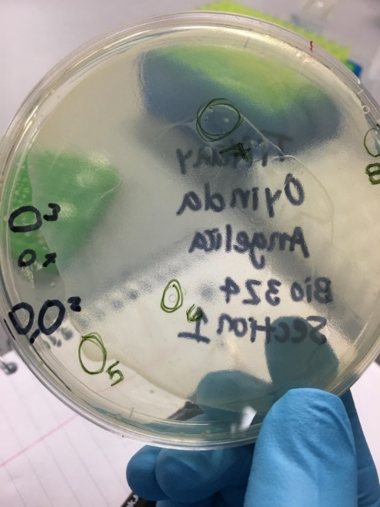
After PpbrA promoter was ligated into the plasmid and placed back into E. coli cells, E. coli was cultured on an LB/ampicillin plate to allow for growth. After 24 hours of growth, E. coli displayed a large white sheet of cultures. Numbers 5, 6, 7, and 8 were the sections of cultures that were isolated for this experiment (Figure 1).
Each of these identified cultures, labeled 5, 6, 7, and 8, were run through gel electrophoresis to confirm that E. coli successfully transformed the PpbrA into its genome. All samples display one small band at approximately 400 base pairs as well as a thick band around 50 base pairs. The thick band at 50 base pairs displays extra proteins that ran to the end of the gel (Figure 2). Section 5 of the LB plate of cultured E. coli was selected to be sequenced.
Figure 1. Growth of Escherichia coli after 24 hours. This E. coli was cultured after reinserting the DNA plasmid.
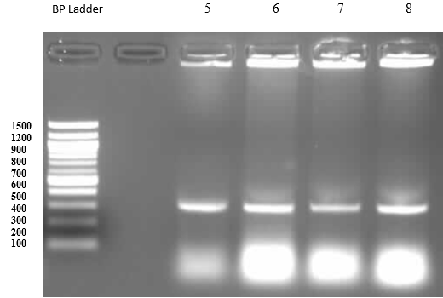
Figure 2. PCR products of each colony after plasmid isolation with promoter PpbrA. Lane 1 is the molecular weight base pair ladder. Lane 2 is empty. Lane 3 is the colony numbered 5 on the LB plate. Lane 4 is the colony numbered 6 on the LB plate. Lane 5 is the colony numbered 7 on the LB plate. Lane 6 is the colony numbered 8 on the LB plate.
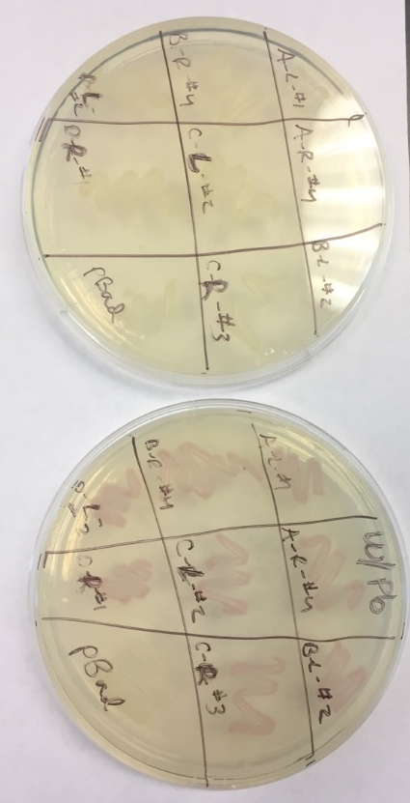
After the plasmid DNA was isolated from the E. coli containing PpbrA promoter, it was checked for quality and quantity on the nanodrop. The concentration of the sample was 25.2 ng/µL with a 1.19 purity.
Once the PpbrA promoter was controlling RFP in E. coli cells and cultured onto LB/ampicillin plates with and without lead, the plates without lead were colored white, and with lead were colored red (Figure 3).
Figure 3. E. coli cultures on LB/ampicillin plates without lead (on the left) and with lead (on the right). The plates labeled D-R #1 was the colony in the 3rd row of the gel electrophoresis.
Discussion
The plasmid DNA of E. coli was successfully manipulated to express red fluorescent protein in the presence of lead when replacing its pBad promoter with PpbrA. This implication can be used to detect one of the major components in gunshot residue. This modification of the plasmid DNA of E. coli will be able to improve the functionality and speediness of detecting suspects at the scene of a crime.
After the plasmid was digested to remove the pBad promoter, ligated to insert the PpbrA promoter, and transformed for the new promoter to stick into the plasmid, the samples were ran through the gel to observe the amount of base pairs. All samples displayed thin bands at approximately 400 base pairs. This confirms that the promoter was properly reinserted into the DNA. Culture sample labeled number five, in lane 3 of the gel, was selected to further analyze because the other lanes displayed very small bands above 400 base pairs. These are unwanted fragments presented in the samples and could potentially affect the sequence of the DNA.
The purity of the plasmid from the cells with the PpbrA was at a lower range than desired. The ideal range is from 1.5 to 2.5, and the plasmid extracted here was 1.19.
When the E. coli cells containing the PpbrA promoter were cultured on the LB/ampicillin plates, the plate without lead presented white cultures of cells, as expected. The E. coli cultures on the LB/ampicillin plate with lead, presented red cultures, as expected. The other sections on the plates are from other studies conducted under the same conditions from other researchers. The other colonies present to not affect the results that are observed in the D-R #1 section. There is a section on each LB/ampicillin plate of E. coli cultures with the pBad promoter to act as the control.
When this system can work with other promoter regions engineered to detect TNT, antimony, and barium, E. coli cells will be able to effectively detect the major components of gunshot residue. With this newly developed mechanism, police officers will have access to a quick method of identifying possible suspects of a crime involving firearms.
Police officers should be especially aware that this device could potentially create a false-negative or false-positive. This means that upon administration of the test, a suspect with gun-shot residue on his/her hands has a negative reading for its presence and a suspect without gun-shot residue on his/her hands has a positive reading for its presence. Of course, the first of these scenarios is far more dangerous, as police officers should also still use their best judgements.
It should also be noted that this system alone is not sufficient to detect the presence of gunshot residue. There are many compounds that must be presented together to be certainly classified as gunshot residue. The presence of this inorganic component may not be specific to only gunshot residue as well. If a suspect has, for whatever reason, the presence of lead on the hand, the innocent person will be suspected until further investigation takes place (Dalby et. al 2010).
There is also a risk that that inorganic compounds are not high in concentration or not present at all in the sample. In this instance, analysis of organic compounds present in gunshot residue should be analyzed alongside inorganic compounds (Dalby et. al 2010).
Works Cited
Andrianantoandro E, et al. Synthetic biology: new engineering rules for an emerging discipline. Molecular Systems Biology. 2006; 2(1).
Borresmans B, et al. Cloning and Functional Analysis of the pbr Lead Resistance Determinant of Ralstonia metallidurans CH34. Journal of Bacteriology. 2001; 183(19): 5651-5658.
Dalby O, et al. Analysis of Gunshot Residue and Associated Materials-A Review. 2010; 55(4): 924-943.
Hobman J, et al. Cysteine coordination of Pb(II) is involved in the PbrR-dependent activation of the lead-resistance promoter, PpbrA, from Cupriavidus metallidurans CH34. Microbiology. 2012; 12(109).

