The Egg-cellent Truth: Does egg consumption cause heart disease?
Heart disease prevails to be the number one cause of death in the United States.¹ Growing up, I saw many news casts about the latest fad of how many eggs we could eat in one day, to how many allowed in a week, since they worsened the effects of heart disease from the high cholesterol content. My grandfather was obsessed over this egg-eating issue since he had heart disease. He monitored his diet very closely – and the news had much influence on his decisions. Thus, the news also had an influence in doctor’s diet recommendations.
The question of how eggs impacted heart disease started in the 1900’s. In 1965, an equation was made that explained how much cholesterol would go into the blood stream after eating cholesterol, like that found in eggs. This cholesterol found on the back of any food, on nutrition labels, is called dietary cholesterol, since it is the cholesterol that we consume from our diet and foods. The study from 1965 thus determined that the more dietary cholesterol that we eat, the higher the amount of cholesterol will be in the blood stream. This study was conducted by comparing people eating a diet high in dietary cholesterol to people eating a diet low in dietary cholesterol. The people on the diet with high dietary cholesterol had a higher amount of cholesterol in their blood.² Thus, it was concluded – eating high amounts of dietary cholesterol increases or worsens the effects of heart disease! Scientists explained this phenomenon by assuming that the dietary cholesterol was entering the blood after eating it from foods and getting stuck in veins and arteries, causing a backup of flow, and ending in a heart attack, as explained by the picture below.³
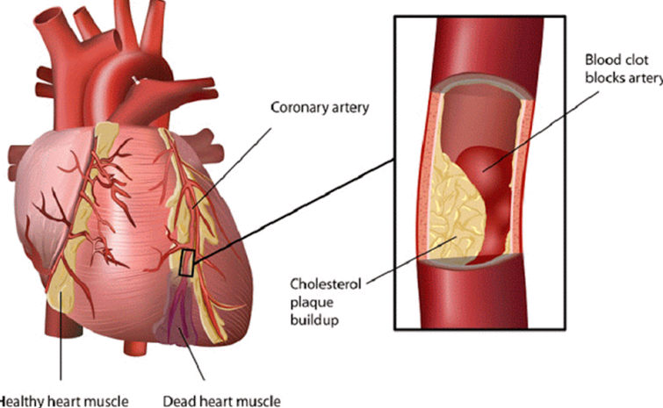
A few years later, in 1968, the American Heart Association agreed with the results found from the study in 1965. The AHA drew their own conclusions that eating more dietary cholesterol did cause heart disease, from a study that found that people eating diets low in dietary cholesterol had a lower body weight and blood pressure. It all made sense! They released recommendations for how much dietary cholesterol people could safely eat, without increasing the risk for heart disease. The daily limit was 300 mg – this amount is only slightly more than one egg!⁴
Although these studies were very convincing – these researchers did not completely understand how dietary cholesterol enters the body. After eating cholesterol, it is broken down into smaller pieces so it can enter the blood. Some pieces go to fat cells to store it or the liver to be repackaged. These smaller pieces that were broken down after eating dietary cholesterol are either repackaged into LDL/VLDL or HDL.⁵ The mechanism is shown below, in the figure. [If you or someone you know has heart disease, you may be familiar with these terms. LDL/VLDL is thought to be the bad cholesterol, and HDL is the good]. After LDL is made, it goes into the blood stream and other muscles or tissues that need the energy from LDL, grab it. Any extra LDL that is left in the blood stream is picked up by HDL and taken back to the liver. Therefore, LDL is thought to be bad if HDL doesn’t pick it all up from the bloodstream, it could clog the veins and arteries to cause a heart attack.
However, high LDL levels are not bad because the surrounding muscles and tissues are asking for the cholesterol to be delivered to it for energy. Determining the risk a person has for being diagnosed with heart disease is best indicated by the LDL to HDL ratio. It is okay for the LDL and HDL levels to rise together. More LDL in the blood stream is okay when there is more HDL to clean up any excess.⁶ The previous researchers, from the studies done in 1965 and 1968, were unaware of how this system actually works. Dietary cholesterol does not have a significant impact on the LDL and HDL levels in the blood. In fact, only 20% of dietary cholesterol enters the bloodstream.⁷ More recent research solidified this statistic; when increasing the levels of LDL and HDL equally, it is not enough to affect the risk for heart disease.⁸
The same research group also concluded that saturated fats are the culprit that increases the risk for heart disease. As seen in the figure to the right, the more saturated fat that was eaten in the diet, the higher amount of cholesterol was found in the blood.⁸ The research that was conducted in 1965 and 1968 also did not account for the high saturated fat content that was in the foods also high in dietary cholesterol. In conclusion, it was the saturated fat making scientists and people all around the world assume that dietary cholesterol was causing heart disease.
Finally, make sure to eat eggs! They are very rich in vitamins and nutrients. They are one of the foods that contain vitamins D and K. Eggs also have a disease fighting component, called carotenoids.⁹

References
- Heron M. Deaths: leading causes for 2015. National vital statistics reports. 2017. 66(5):1-78.
- Keys et al. Serum cholesterol response to changes in diet: The effect of cholesterol in the diet. Metabolism. 1965. 14(7):759-765.
- Hegsted et al. Quantitative effects of dietary fat on serum cholesterol in man. American Journal of Clinical Nutrition. 1965. 17:281-295.
- Some observations on the national diet-heart study. Circulation. 1968. 37(3).
- Jackson B. Digestive III. Lecture slides. 2018. Available from: https://canvas.longwood.edu/courses/1287170/files/54330873/download?wrap=1
- Cui et al. Non-high density lipoprotein cholesterol level as a predictor of cardiovascular disease mortality. Archives of Internal Medicine. 2001. 161:1413-1419.
- Corliss J. How it’s made: Cholesterol production in your body. Harvard Health Publishing. 2017.
- Ernst et al. Consistency between US dietary fat intake and serum total cholesterol concentrations: the National Health and Nutrition Examination Surveys. The American Journal of Clinical Nutrition. 1997. 66(4):965-972.
- Applegate E. Nutritional and functional roles of eggs in the diet. Journal of the American College of Nutrition. 2000. 19:495S-498S.

