Introduction
Bacteria are essential for the overall function of many ecosystems. These microorganisms occupy a dense area of the biomass in aquatic environments and are crucial for the success of many communities (Zinger et al., 2011). They are responsible for vital processes such as reuptake and distribution of nutrients, decomposing many organic substances, and removing harmful pathogens from an ecosystem (Panizzon et al., 2015).
The most diverse microbial ecosystems on Earth have been discovered to be wetlands (Ding et al., 2015). Specifically, when comparing the bacterial diversity between sediment in freshwater, marine, and intertidal wetland ecosystems, freshwater ecosystems prevail in their presence of different classifications of bacteria (Wang et al., 2012). For confidence that there will be a viable number of bacteria present to test in the community, analysis will be conducted in a freshwater community. The richness of different microbes around sediment that lines a body of water, the benthic zone, is significantly higher than that of the surrounding water, the pelagic zone, determined by a study conducted on marine ecosystems around the world (Zinger et al., 2011).
Sequencing of 16s rRNA has been utilized by many microbiologists to determine many different classifications of bacteria, ultimately discovering many microbes that were not known to exist (Rappe and Giovannoni, 2003). Utilizing this technological ability, this experiment will determine if there is a difference in the microbial diversity of the benthic realm versus the pelagic realm of a freshwater ecosystem, located in Buffalo Creek, Farmville, VA. It is hypothesized that the results will conclude to be similar to the findings from Zinger et al.; there will be a significant difference in the number of bacteria present in the sediment located at the bottom of the creek from the surrounding water, with the most microbial diversity in the sediment.

Methods
Environmental Sample Collection
Water and sediment samples were collected from one site at Buffalo Creek, accessed from behind the Environmental Education Center at Longwood University on 8 February 2016. The site of interest of the creek that was selected was approximately two feet in diameter and the samples were collected one foot from the shore. Two sterile tubes were used to gather the samples. First, the water sample was collected by placing the tube vertically into the water and letting the water rush into the tube. The second tube was kept closed until placed in the bottom of the creek and quickly opened and used to scoop the sediment sample into the tube. Both tops were quickly placed onto the tubes to prevent any contamination.
Bacterial Characterization
Environmental samples were then cultured onto three nutrient rich agar plates for each sample by using serial dilutions. The first plate for each sample contained 100 microliters of the original samples. The next plate for each sample contained a dilution of 10% acquired by adding 10 microliters of the original samples with 90 microliters of media. Lastly, 10 microliters of the 1:10 dilution was added with 90 microliters of media to make a dilution 1:100. These dilutions were then plated onto nutrient rich AGAR plates and cultured at room temperature for 48 hours. One plate from each of the three plates colonized was selected to represent the population based on ability to identify individual colonies. Bacterial plates were observed and data was collected on number, size, color, shape, texture, elevation, and margins of the colonies.
Isolating DNA
One colony of bacteria from each sample was selected to isolate DNA from. DNA was extracted from the colonies using UltraClean Microbial DNA Isolation Kit. Each sample of bacteria was first placed in the MicroBead Solution, Solution MD1 was added and placed in a heated water bath of 65 degrees Celsius for 10 minutes, followed by extracting the solution at the top of the column, adding MD2 and placing it at 4 degrees Celsius for 5 minutes. The solution was then placed into 2 microliter collection tube with a spin filter. MD3 was added followed by MD4 and the flow through was discarded after each addition. Finally, MD5 was added and the spin filter was discarded. In between each addition, the collection tubes were spun in a centrifuge.
Amplification of 16s rRNA using PCR
Two PCR tubes were obtained. A total of 44 microliter mixture was used from OneTaq 2X Master Mix with Standard Buffer from New England Biolabs. Each tube contained one microliter of forward primer (5’-GAGTTTGATYMTGGCTC-3’), one microliter of reverse primer (5’-NRGYTACCTTGTTACGACTT-3’), 25 microliters of OneTaq 2X Master Mix, and 17 microliters of nuclease-free water. Six microliters of the previously isolated DNA from each sample was added to 44 microliters of the mixture provided in two separate PCR tubes. The two tubes were then placed into a PCR machine to undergo thermocycling. The thermocycling conditions for PCR included a 30 second interval at 94 degrees Celsius for initial denaturation, followed by 30 cycles of 30 seconds at 94 degrees, 45 seconds at 55 degrees, ended by 60 seconds at 68 degrees. After the 30 cycles, the final extension step took place for five minutes at 68 degrees Celsius, finalized by a holding time at four degrees Celsius.
Digestion with Msp I and Gel Electrophoresis
One-hundred microliters of each sample PCR product were placed into its own microcentrifuge tube. Fifty microliters of DF Buffer were added to each tube and vortexed. A DF column was placed in a new collection tube along with each sample in each new tube, and centrifuged at full speed for 30 seconds. The flow-through was then discarded. Six-hundred microliters of wash buffer were added to each tube, and it was left to sit for one minute, then centrifuged at full speed for 30 seconds. The flow-through was again discarded and centrifuged again for three minutes. The dried products from each sample were ten added to a new microcentrifuge tube along with 15 microliters of elution buffer and was let stand for two minutes, finalized by two minutes of centrifuge at full speed.
Five microliters of the dried PCR product from each sample was added to ten microliters of MspI enzyme by pipetting up and down. Samples were then incubated for 45 minutes at 37 degrees Celsius.
Agarose gel was then casted by mixing 0.6 grams of agarose and 40 milliliters of 1X TAE buffer in a 125 milliliter Erlenmeyer flask and microwaved for two minutes, stirring every 30 seconds. Four microliters of ethidium bromide were added to the mixture and poured into the gel tray followed by the insertion of the comb immediately. The gel set at room temperature for 40 minutes to solidify and the comb was removed.
Five microliters of 5X loading buffer was added to each sample by pipetting up and down. Ten microliters of each PCR sample and MspI digested sample were loaded into a separate well in the gel chamber. The lid was placed on the electrophoresis chamber along with the electrical leads connected. The gel was run at 120 volts for 30 minutes. After this, the gel and tray were removed from the gel box and visualized under a UV camera.
Five microliters of each dried PCR product from each sample was added to four microliters of the sequencing primer, 5’-GAGTTTGATCCTGGCTCAG-3, along with three microliters of deionized water. Each sample was sent to Eurofins Genomics to be sequenced.
Sequence analysis
Chromatograms from each sample sequenced was observed in Snap Gene. Each sequence was scanned for “N” and was edited if seemed appropriate. The beginning and end of the sequences were trimmed to remove the long strings of “N”. The modified sequences were analyzed using NCBI BLAST. Bacteria that have similar or identical 16s rRNA sequences to the samples that were isolated were shown based in order of similarity. For the top five alignments of each sample, the sequence was compared to the matches in the database to identify if the original sequence’s mismatched bases are “N” or true mismatches. The bacteria with the lowest number of mismatches was identified to be the strain that was isolated from the sample.
The sequences were also placed into NEB Cutter Tool to observe where MspI should have cut the DNA sequence and the number and size of the DNA fragments. These results were compared to the number of bands observed in the agarose gel.
Results
After the both colony samples were grown for 48 hours at room temperature, the number of colonies present on the nutrient rich agar plates of the sediment and water samples were analyzed. The sediment sample showed rapid growth, much faster than that of the water sample, with also a significantly higher number of colonies growing in the sediment sample than the water sample. The number of colonies that were present in the water sample after 24 hours was 20 and increased to 21 after 48 hours. The number of colonies that were present in the sediment sample after 24 hours was 3000 and increased to 6800 after 48 hours. Because the number of colonies present in the sediment sample compared to the water sample is significantly higher, the microbial diversity in the sediment sample is much higher in the sediment sample than the water sample (Figure 1).

Figure 1. Number of colonies of bacteria present on nutrient rich agar plates from water and sediment samples over time. Number of colonies were counted after 24 and 48 hours of growth at room temperature.

Figure 2. The color of colonies of bacteria Figure 3. The form of colonies of bacteria
present on nutrient rich agar plates from present on nutrient rich agar plates from
water and sediment samples. The outer ring water and sediment samples. The outer ring
represents the percentage of the color of sediment represents the percentage of the form of sediment
bacterial colonies and the inner ring represents the bacterial colonies and the inner ring represents
water colonies. the water colonies.

To further elaborate on the diversity between the two samples, color and form of the colonies was observed. The most abundant color displayed from sediment and water bacterial colonies was white, with 84% observed from the sediment colonies and 48% from the water colonies. The color that was displayed the least often from sediment and water bacterial colonies was orange, with 4% observed in the sediment colonies and 24% in the water colonies. The bacterial colony that was isolated from the sediment sample was orange and the bacterial colony that was isolated from the water sample was white. (Figure 2).
The most abundant form displayed from sediment and water bacterial colonies was circular, with 84% observed from the sediment colonies and 75% from the water colonies. The water colonies contained a total of three different forms, while the sediment colonies contained four different forms. (Figure 3).

MspI Sediment
PCR Sediment
MspI Water
PCR Water

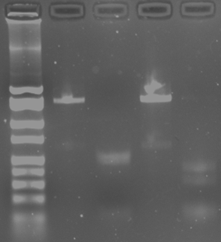
2000
1550

1000
750

500
400
300
200

100
50
Figure 4. PCR product and MSPI digested product of collected water sample and collected sediment sample through gel electrophoresis. Lane 1 is the molecular weight base pair ladder. Lane 2 is the PCR water sample product. Lane 3 is the MspI digested water sample product. Lane 4 is the PCR sediment sample product. Lane 5 is the MspI digested sediment sample product.

After one bacteria colony from the agar plates was selected, 16s rRNA was isolated and the PCR products and MspI digested products from both samples were run through a gel electrophoresis to observe the number of base pairs. The purpose of lane 1 is to provide context to the size of the DNA fragments that were run through the gel electrophoresis. The water and sediment sample PCR products were run through the gel to ensure that 16s rRNA was amplified at the correct size, approximately 1800 base pairs. The MspI digested water and sediment samples were run through the gel to observe the diversity of the two strains of bacteria. Lane three displays the water sample, that was cut by MspI, has a fragment of DNA that is approximately 500 base pairs and a fragment of approximately 100 base pairs. Lane five displays that the sediment sample, that was cut by MspI, has a fragment of DNA that is approximately 400 base pairs, 300, and 100 (Figure 4). From these results, the two strains of bacteria are obviously of different species.
The bacteria that was selected from each sample was sequenced and determined to be Pseudomonas brenneri Strain CFML 97-391 in the water sample and Aeromonas encheleia Strain A 1881 in the sediment sample.
When comparing the 16s rRNA sequence of the brenneri species in the NCBI GenBank database to the sequence of the tested water bacterial colony, a 99% identity was yielded. There are three gaps present when comparing the two strains. Only four base pairs differ from the isolated 16s rRNA and the strain sequence in the database (Figure 5).
When comparing the 16s rRNA sequence of the encheleia species in the NCBI GenBank database to the sequence of the tested sediment bacterial colony, a 99% identity was yielded. There is one gap present when comparing the two strains. Only two base pairs differ from the isolated 16s rRNA and the strain sequence in the database (Figure 6).

Bacterial Alignments | % Identity | # Of Gaps | # Of Differing Base Pairs
Pseudomonas Brenneri Strain CFML97-391 | 99 | 3 | 4
Pseudomonas Migulae Strain NBRC103157 | 99 | 1 | 7
Pseudomonas Proteolytica Strain CMS64 | 99 | 3 | 7
Pseudomonas Migulae Strain CIP105470 | 99 | 1 | 7
Pseudomonas Panacis Strain CG0106 | 99 | 3 | 11
Figure 5. The first five matches of nucleotide sequences in 16s rRNA of water samples. 16s rRNA was isolated from one water bacterial colony and compared to other known sequences of bacteria, using GenBank.

Bacterial Alignments | % Identity | # Of Gaps | # Of Base Pairs
Aeromonas Encheleia Strain CECT4342 | 99 | 1 | 2
Aeromonas Encheleia Strain A 1881 | 99 | 1 | 2
Aeromonas Molluscorom LMG22214 | 99 | 1 | 5
Aeromonas Molluscorom Strain 848 | 99 | 1 | 5
Aeromonas Salamonicicla Strain ATCC 33658 | 99 | 1 | 6
Figure 6. The first five matches of nucleotide sequences in 16s rRNA of sediment samples. 16s rRNA was isolated from one sediment bacterial colony and compared to other known sequences of bacteria, using GenBank.
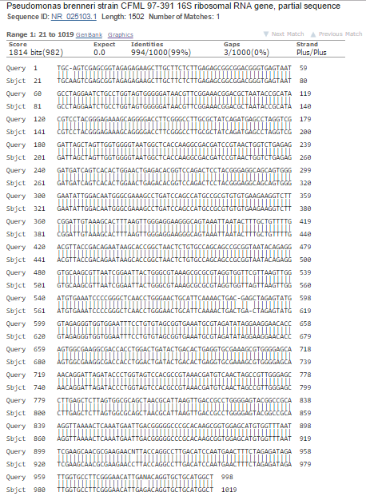
Figure 7. Comparison of nucleotides sequenced from the water sample to Pseudomonas brenneri strain CFML 97-391. This species of Pseudomonas only differed from the sequenced water bacterial colony by four base pairs.

The bacterial colony isolated from the water sample was determined to be Pseudomonas brenneri strain CFML 97-391 due to almost all base pairs matching, except for four. At nucleotide 919 and 982 in the sequenced sample, an N was placed in the spot of a nucleotide to represent the possibility of any nucleotide being there. When looking at the visual DNA file in SnapGene, it is very likely that a C could replace the N at base 919, and a G could replace the N at base 982 (Figure 7).
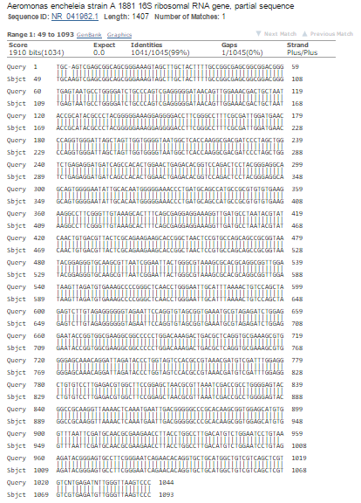
Figure 8. Comparison of nucleotides sequenced from the sediment sample to Aeromonas encheleia strain A 1881. This species of Aeromonas only differed from the sequenced sediment bacterial colony by two base pairs.

The bacterial colony isolated from the sediment sample was determined to be Aeromonas encheleia strain A 1881 due to almost all base pairs matching, except for two. At nucleotide 1023 and 1030 in the sequenced sample, an N was placed in the spot of a nucleotide to represent the possibility of any nucleotide being there. When looking at the visual DNA file in SnapGene, it is very likely that a G could replace the N at base 1023, and a G could replace the N at base 1030 (Figure 8).

Discussion
The hypothesis of this experiment was found to be true, with the most microbial diversity in the sedimentary region versus the water of this freshwater community. When comparing the bacterial colonies present in the benthic to the photic zone of this freshwater ecosystem in Buffalo Creek, the benthic realm presents to be the most microbial diverse. The bacteria colonized on a nutrient rich agar plate from the sediment sample displayed rapid growth in high numbers with various colors and forms of the colonies. During the first 24 hours of growth of bacteria from the sediment sample, the number of colonies present was 3000; that exceedingly doubled in the next 24 hours to 6800. On the other hand, the colonies from the water sample seemed to quickly reach its carrying capacity by 24 hours, at 20 colonies counted; this number only increased by one (Figure 1). While both samples portrayed similar colors of the colonies growing (Figure 2), the sediment sample’s colonies had many different types of forms, such as filamentous and spindle that was not observed in the water colonies (Figure 3). 16s rRNA that was amplified from one colony of each sample was digested by MspI and ran through the gel electrophoresis. Per figure 4, the base pair bands are in different weights after being digested; meaning that MspI cut the sequences of the two strains of bacteria in different locations, indicating that the sequences are different. These factors support that the microbial diversity in the subsurface of Buffalo Creek is higher than that of the water in the creek.
Similar results were observed from a study conducted in the East China Sea of the comparison of the microbial diversity of water and sediment. The bacterial colonies from sediment and water displayed two distinctly different groups, even though they were both collected from the same location. The diversity present in the sediment sample posed to be much higher than that in the water sample. The habitat type, water or sediment, is the direct cause of the differences displayed in the communities (Feng et al., 2009).
These results come to no surprise due to the number of prokaryotes in terrestrial subsurface (up to 250*10^28) compared to aquatic habitats (12*10^28), as shown in Figure 9 (Whitman et al., 1998).
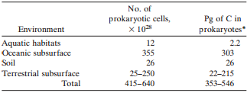
Figure 9. Number and biomass of prokaryotes in the world. This data was collected from "Prokaryotes: The unseen majority."
There is the possibility that the abundance of the number of colonies growing on the nutrient rich agar plate from the sediment sample was due to some of the water entering the sample. To prevent this mistake in future studies, the sediment sample should be collected by wedging part of the opening of the collection tube into the sediment, then opening it.
Determination of the strains of bacteria present in each sample was conducted by analysis of the sequences of the 16s rRNA to other known sequences of bacteria in GenBank. The bacteria were identified by observing the percent similarity to the closest match in the database and number of base pairs that did not match with the sampled sequence. In both strains of bacteria, there was less than five bases that did not match the known 16s rRNA sequence in the GenBank database (Figure 7 & Figure 8).
The bacteria from the water sample was determined to be Pseudomonas brenneri Strain CFML 97-391. This bacterium was also identified from natural mineral waters in France. Pseudomonas brenneri is a gram-negative and has a single flagellum (Baida et al., 2001). The bacteria from the sediment sample was determined to be Aeromonas encheleia Strain A 1881. This species was also identified from the Czech Republic, in unpolluted surface waters as well as underground waters. Aeromonas encheleia is a gram-negative, anaerobic bacterium that primarily resides in aquatic environments. It can also thrive in cold-blooded and warm-blooded animals (Novakova et al., 2008).
To further this research, many other samples must be collected and bacterial communities must be identified to observe the total microbial diversity of Prince Edward County, Va.
It is important to study the microbial diversity because it affects the community composition, stability and functionality at a local level. Determining the importance of the microbial diversity in Prince Edward County is essential to the start of the analysis of the global microbial diversity. This is crucial for understanding community function and structure, seeking new drugs for probiotics, or determine the presence of chemicals (Curtis 2004).

Literature Cited
Baida N, Yazourh A, Singer E, Izard D. Pseudomonas brenneri sp. nov., a new species isolated from natural mineral waters. Research in microbiology. 2001; 5: 493-502.
Curtis T and Sloan W. Prokaryotic diversity and its limits: microbial community structure in nature and implications for microbial ecology. Current opinion in microbiology. 2004; 7: 221-226.
Ding X, Peng XJ, Jin BS, Xiao M, Chen JK, Li B, Fang CM, Nie M. Spatial distribution of the bacterial communities driven by multiple environmental factors in a beach wetland of the largest freshwater lake in China. Frontiers in Microbiology. 2015; 6: 129.
Feng B, Li X, Wang J, Hu Z, Meng H, Xiang L, Quan Z. Bacterial diversity of water and sediment in the Changjiang estuary and coastal area of the East China Sea. Federation of European Microbiological Societies. 2009: 70: 236-248.
Novakova D, Svec P, Sedlacek I. Characterization of Aeromonas encheleia strains isolated from aquatic environments in the Czech Republic. The Society for Applied Microbiology. 2008; 48: 289-294.
Panizzon J, Pilz Junior H, Knaak N, Ramos R, Ziegler D, Fiuza L. Microbial diversity: relevance and relationship between environmental conservation and human health. Brazilian Archives of Biology and Technology. 2015; 58(1): 137-145.
Rappe M, Giovannoni S. The uncultured microbial majority. Annual Review of Microbiology. 2003; 57: 369-394.
Wang Y, Sheng HF, He Y, Wu JY, Jiang YX, Tam NFY, Zhou HW. Comparison of the levels of bacterial diversity in freshwater, intertidal wetland, and marine sediments by using millions of illumina tags. Applied Environmental Microbiology. 2012; 78(23).
Whitman W, Coleman D, Wiebe W. Prokaryotes: The unseen majority. Proceedings of the National Academy of Sciences. 1998; 95: 6578-6583.
Zinger L, Amaral-Zettler L, Fuhrman J, Horner-Devine M, Huse S, Welch D, Martiny J, Sogin M, Boetius A, Ramette A. Global patterns of bacterial beta-diversity in seafloor and seawater ecosystems. Plos One. 2011. 6(9).

