**Evaluation of Speech-Language Pathologist Private Practice Websites:**

**A Proposal for an Updated Website for Farmville Speech and Hearing**

Prepared for:

Farmville Speech and Hearing

Prepared by:

Farmville Consulting Firm

November 28, 2018

Farmville



Speech and Hearing Services

Letter of Aut

# Letter of Authorization

**Farmville Speech and Hearing**

Human Resources Department

470 Oak Tree Road

Farmville VA, 23909

August 20, 2018

Miss. Lexi Stenback

Principle Consulter

Farmville Consulting Firm

356 Willow Drive

Farmville, VA 23909

Dear Miss Lexi Stenback:

Subject: Evaluation of Private Practice Speech and Hearing Clinics

In the last year alone, there has been a 20 percent increase in the number of children in need of speech, language, and hearing services; however, the number of clients attending private practice clinics has dropped by one-third in the past five years. In response, Farmville Speech and Hearing is expanding their staff and services to help meet the needs of our community.

As we discussed on September 15, 2018, we would like to commission your firm to evaluate and recommend the three best private practice speech and hearing clinic websites’ available on the internet. These websites would serve as a model for a new, updated version for Farmville Speech and Hearing Services’ website. We would like you to develop evaluation criteria that will provide our clinic with the best website for our clients and potential clients.

We would like to begin designing this new website by November 20, 2018. To meet this deadline, we must receive your report by October 31, 2018.

We look forward to receiving your report. If you require any further information, please feel free to contact Betty Brown at 445-340-6679, ext. 113.

Yours sincerely,

Carly Stone

Carly Stone

Owner of Farmville Speech and Hearing Services

# Letter of Transmittal

**Farmville Consulting Firm**

400 Main Street

Farmville, VA 23901

November 26, 2018

Carly Stone

Owner of Farmville Speech and Hearing Services

470 Oak Tree Road

Farmville, VA 23909

Dear Mrs. Stone:

Subject: Private practice speech clinic proposal completion

I have attached the report evaluating private practice speech clinics’ websites.

We have recommended three websites that exhibit information on provided services, overall visual layout, and organization:

* Danville Speech and Hearing
* Speech Smarts
* Bayside Speech Therapy, Inc.

We are hopeful that these three websites possess three components that your clinic would like to incorporate into the Farmville Speech and Hearing Services’ website.

We have enjoyed analyzing research and information from this report. We would like to thank you for the opportunity to help Farmville Speech and Hearing in updating the current website. We would like to thank the speech-language pathologists, staff and clients from all participating speech clinics for partaking in our survey. If you have any questions, comments, or concerns please do not hesitate to contact us at 302-937-2778.

Yours sincerely,

Mrs. Lexi Stenback

Mrs. Lexi Stenback

Principle Consulter

Enclosure: Report on private practice speech clinics

Table of Contents

Letter of Authorization ii

Letter of Transmittal iii

List of Figures v

List of Tables v

Executive Summary vi

Introduction 1

Analysis of Danvillespeechandhearing.org 3

Overall Visual Appeal 3

Organization 3

Information on Provided Services 4

Analysis of Cslstherapy.com 5

Overall Visual Appeal 5

Overall Organization 6

Information on Services Provided 6

Analysis of Baysidespeech.com 8

Overall Visual Appeal 8

Overall organization 8

Information on services provided 9

Conclusions 11

Recommendations 12

Appendix A: Client Options on Website Improvement Options 13

Appendix B: Client Options on Website Improvement Options Results 14

Appendix C: Overall Effectiveness of the Website 15

Appendix D: Overall Effectiveness of the Website Results 16

Appendix E: Ranking of what they liked about each website 17

Appendix F: Ranking of what they liked about each website results 18

Weekly Progress Meeting Minutes 19

Appendix G: Abby’s minutes 19

Appendix H: Lexi’s minutes 20

Appendix I: Tanna’s minutes 21

Appendix J: Team work log 22

# List of Figures

Figure 1: The opinions of FSH clients on which website categories need improvement. 1

Figure 2: This chart shows the five most common disorders treated at Danville Speech and Hearing. 4

Figure 3:This chart shows the five most common of common disorders treated at Danville Speech and Hearing. 5

Figure 4: This is a screenshot of the Bayside Speech Therapy home page. 8

Figure 5: This is a screenshot of the Bayside Speech Therapy Services page. 10

Figure 6: Client Options on Website Improvement Options Results 11

# List of Tables

Table 1: Client Options on Website Improvement Options Results 14

Table 2: Overall Effectiveness of the Website Results 16

# Executive Summary

In the past year, there has been a 20 percent increase in the number of individuals who need speech services. These services can include treatment of many disorders such as fluency, speech, language, cognition, and voice disorders.

Websites of private practice speech clinics often serve as first impressions to potential clients. Farmville Speech and Hearing Services asked Farmville Consulting Firm to recommend three websites that provide similar services as their private practice clinic and provide information about the company as a whole. These websites will serve as models for a redesign of Farmville Speech and Hearing Services’ website.

Farmville Consulting Firm task was to find websites that effectively provide information about the services that are provided through their private practice. As a part of this analysis, organization, and visual appeal of the websites were evaluated.

Each website was analyzed and rated using the following criteria:

* **Information of provided services**: List of all services provided by the clinic, disorders they treat, accessibility to the information
* **Organization:** layout, simple language, cohesion, tabs, user-friendliness, contact information easy to locate;
* **Visual Appeal:** appealing images, length of the text, color-scheme.

The results of our analysis, which were supported by a survey completed by all clients at the clinic they receive services from, led us to recommend the following website as models for Farmville Speech and Hearing’s website redesign.

* Bayside Speech Therapy,
* Children Speech and Language Services
* Danville Speech and Hearing

The goal of this report is to inform Farmville Speech and Hearing of the best model to use when redesigning their website. Our firm is confident that our analysis and recommendation will provide Farmville Speech and Hearing a successful website, which in return will provide more referrals and happier clientele.

# Introduction

Private practice speech and hearing clinic websites’ are crucial for both current and potential clients, as well as speech-language pathologists (SLPs) looking for employment in this field. Websites showcase the essential resources that private practices offer to individuals with speech, language, and hearing impairments; therefore, they must be aesthetically pleasing and easy to navigate, while depicting services and their involvement in the community.

Farmville Speech and Hearing, located in Farmville, Virginia, was founded in 2010 by Taylor Reveley. His mission was to create a state-of-the-art speech and hearing clinic that services anyone with a speech, language or hearing impairments or disorders. Since then, Farmville Speech and Hearing has increased its number of ASHA certified SLPs to cater to a larger population of people in need of services.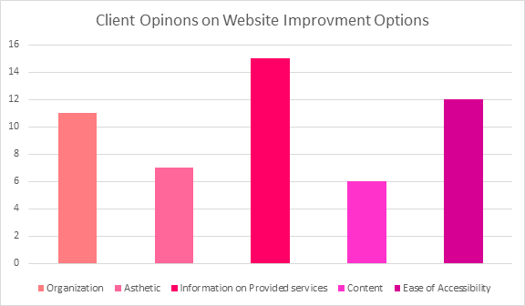

Figure : The opinions of FSH clients on which website categories need improvement.

In 2014, Farmville Speech and Hearing had the largest number of clients it had ever seen, since its opening in 2010. Since last updating their website, the number of clients attending therapy sessions has decreased

by 3 percent starting in 2015.

When Farmville Speech and Hearing clients were surveyed on which aspects of fsh.com they thought needed improvement, the top three areas of complaint were chosen as criteria for our evaluation examples. Those three areas were, in ascending order: organization, visual appeal, and information on provided services (see Figure 1).

Farmville Consulting Company was commissioned due to a history of resurrecting withering websites. Farmville Consulting Co. was founded by former Apple employees who have doctorate degrees in computer science with concentrations in software design and system maintenance. Not only do Farmville Consulting technicians understand current website design trends, but all employees are trained and certified in website design, computer programing, and troubleshooting various technical issues.

This report will elaborate on issues relevant to fsh.com and recommend several strategies and changes that will bring more attention to their website, thus generating new service opportunities for their business.

As the focus of our analysis, we chose websites from other private practice sites that cater to childhood speech, language, and hearing disorders. We chose to analyze Danville Speech and Hearing Center, Bayside Speech Therapy, Inc. and Children’s Speech and Language Services for the following criteria:

· Visual Appeal

· Overall Organization

· Information on services provided

A second survey was administered to clients asking them to rank what they liked best about danvillespeechandheairng.org, baysidespeech.com, and cslstherapy.com. The results of the second survey confirmed that each of these websites were given high marks in the areas fsh.com were given low marks.

# Analysis of Danvillespeechandhearing.org

<http://www.danvillespeechandhearing.org>

## Overall Visual Appeal

The overall layout and design of Danville Speech and Hearing Center’s website is professional yet simple. It has a blue and white color scheme that matches the company’s colors. They utilize white space well on each page by adding multiple pictures when the amount of text is lacking. The style of the website aligns with contemporary design standards.   
  
The right side of each page is devoted to photos of the employees providing treatment and participating in different activities in their communities. It is not intrusive and without the photo album, the website’s overall visual appeal would be dull. Some of the images are misleading because not all of the individuals pictured still work at the sight; so, a few pictures need to be updated to show the organization’s most current activity.   
  
The homepage is simple and informative. It is very easy to find general information pertaining to the organization. There is a good balance of text and visuals. The visuals are located on the right side of the page and are vertically organized while the text starts on the left side of the page and is formatted into short, concise paragraphs.

## Organization

Danville Speech and Hearing Center’s website is easy to navigate. The tab bar stays at the top of the screen on each page and their content is clearly defined except for the “support” page. The company’s logo is located at the top of every page and links each page to the home page when it is clicked. The tab bar remains at the top of each page which makes switching from page to page very convenient. All links are functional and are located on the right side of each page or under the information they support.  
  
Where Danville Speech and Hearing Center’s website fails is the specification of content on the support page. By only viewing the tabs at the top of the webpage it is unclear if this page is for clients or the organization. Upon clicking the tab, a page full of text appears. There are no titles or subtitles, only single sentences separated by a space before leading to short paragraphs. The “About” page is the complete opposite. Each section’s heading has a larger font size and is a different color than the body text. Also, by clicking on each subtitle one can find out more information on each topic. The support page contains no titles or bullets. It also does not utilize bold or italic features.   
  
Danville Speech and Hearing Center’s website lacks in areas similar to Farmville Speech and Hearing does. The site’s pages are organized well but not all content is clearly labeled. Viewers may find themselves rereading content to determine the purpose of the page. Viewers may also have issues locating the content they are researching due to the lack of defined headings. For example, the viewer may want to see what other resources are available to them so they go to the support page only to find a page that states things they can do to help support Danville Speech and Hearing.

## Information on Provided Services

Danville Speech and Hearing Center is one of the top private practice speech, language, and hearing service providers in the Danville area. To stay competitive, Danville Speech and Hearing Center provides information on their speech-language pathologists and the disorders they treat. This permits prospective clients to gather more information on each SLP’s specialization, allowing the clients to decide if this is the correct organization for them. Danville Speech and Hearing Center treats childhood speech and language disorders across the gamut which allows them to take on a more diverse clientele than other speech service locations. Figure 2 shows the most commonly treated disorders at Danville Speech and Hearing Center.   
  
Danville Speech and Hearing Center not only lists and defines the different types of services they provide, but they also post pictures of therapy sessions. These pictures show the SLPs working with various

Figure : This chart shows the five most common disorders treated at Danville Speech and Hearing.

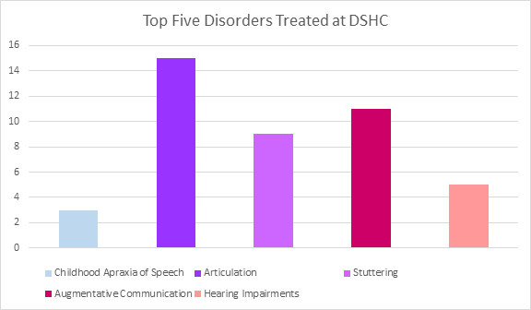

clients using various techniques for differing disorders. This

provides a visual component that

helps to further their credibility. This not only promotes the therapists’ passion to help those with communication disorders but depicts a welcoming therapy environment.  
  
Once the types of disorders page is clicked from the homepage, a list of disorders appears on the screen. By scrolling to the end of the list one can find a link that provides information on signs and symptoms of speech and language disorders. Upon clicking this link the viewer is taken to a different website but to get back to Danville’s site all the viewer has to do is hit the back arrow. This is very helpful because it allows potential clients to research their signs and symptoms which will help them determine if they are in need of an evaluation.

# Analysis of Cslstherapy.com

<https://cslstherapy.com>

## Overall Visual Appeal

The overall layout and design of CSLS website is appealing, but not overbearing. Throughout the entire website they follow a subtle blue and yellow color scheme. It is appealing to both genders and children, as that is who the clinic primarily serves.

On the home page there are pictures of clients and the therapist. This gives the appeal of the welcoming and fun environment the clinic maintains. Most sections of the website include welcoming pictures that go along with the text. The text size and font are all traditional which makes it easier to read.

There is more text than visuals. The text is not overbearing because the site utilizes white space well. This makes viewing the site easy on the eyes. Throughout most sections of the webpage, the visuals were positioned above the text. As seen in Figure 3, the CSLS website is in need of more visuals. They could include more photos or incorporate a photo album. This does not have to be overbearing, but this is one thing that many clients say they are lacking.

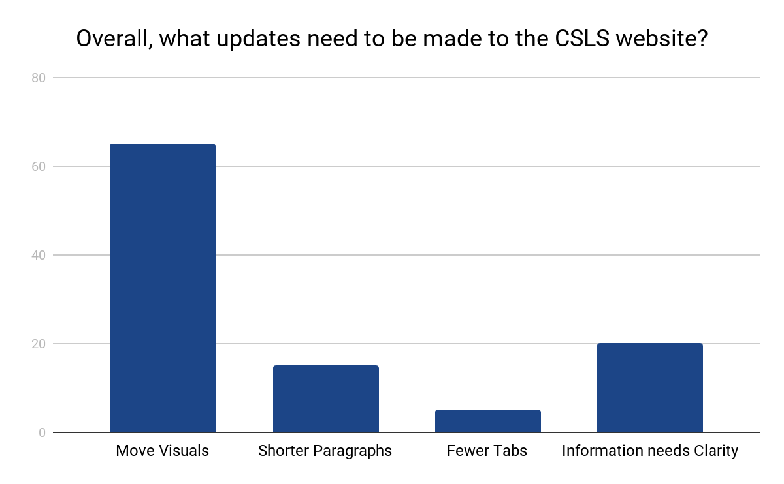

Figure :This chart shows the five most common of common disorders treated at Danville Speech and Hearing.

## Overall Organization

CSLS website is very user-friendly. The website is organized into seven different tabs. Each tab provides subsections which makes it easier to find the information you are looking for. Their logo and company name are presented at the top corner of each section and links back to the home page. The tab bar also remains at the top at each section of the website. These features allow easy navigation and consistency.

Their layout is very clean and simple. In regard to the organization, the company uses simple language while maintaining a professional mannerism. They don’t just use language that is intended for speech-language pathologists to understand, but rather for all adults, especially parents. There is cohesion among the paragraphs throughout the website. It ties together previously stated information and brings in new information without confusion or difficulty understanding. The clinic states its most important facts in short paragraphs, so it does not get lost inside the other information. No matter where you are on the website, the company’s contact information is always located on the bottom of every page.

## Information on Services Provided

It is evident at first glance of the website that this private practice only serves children. Every therapy CSLS provides is explicitly written on the home page prior to navigation.

CSLS provides treatment for language and feeding therapy. Their website allows you to click on each of the therapies provided to learn more information pertaining to disorders that commonly fall under therapy, evaluation, and treatment. For example, when clicking on feeding therapy, they list out all nine disorders they treat in regards to feeding therapy. They discuss how they evaluate and diagnosis feeding and swallowing difficulties. In addition, they discuss common techniques used during treatment sessions. They conclude with their overall goal for feeding therapy, which is “Allows children to experience less stressful mealtimes with their family. We work towards establishing feeding patterns that promote optimal nutrition and growth while supporting the child’s development in physical, social, ethical and cognitive areas.” The homepage also features their specialty treatment called “Prompt” that helps provided better speech production and communication. This is a special treatment technique, that makes CSLS unique. In addition, they also talk about the group therapies and summer camps they provide. CSLS even provide sample session video clips. The website also presents “success stories,” these are stories that provide information on former clients who successfully completed treatment.

They utilize their website to provide information for potential and current clients. In being a speech-language pathologist, part of their role is educating families. One of their tabs is the “blog” section. This discusses a number of different speech therapy topics that are easy for families to understand. Each blog is written by a speech therapist at the clinic. They not only provide useful information for families; CSLS also includes activities for children to work on specific speech skills.

# Analysis of Baysidespeech.com

<https://www.baysidespeech.com/>

## Overall Visual Appeal

The overall visual appeal of Bayside Speech Therapy website is eye catching; however, the polka dots can be a source of distraction and can cause the website to look busy and over cluttered. The polka dots are gender neutral in color and appealing to the clientele, which is exclusively children. The font style, size, and color differ on different pages of the website. The amount of text greatly out numbers the number of pictures on the website.

The whole website uses this same design and displays the company’s logo on the top, left side. Also, the home page rotates through pictures of clinicians providing services to the children they serve. The different pictures provide a welcoming and exciting environment for the children and parents alike. 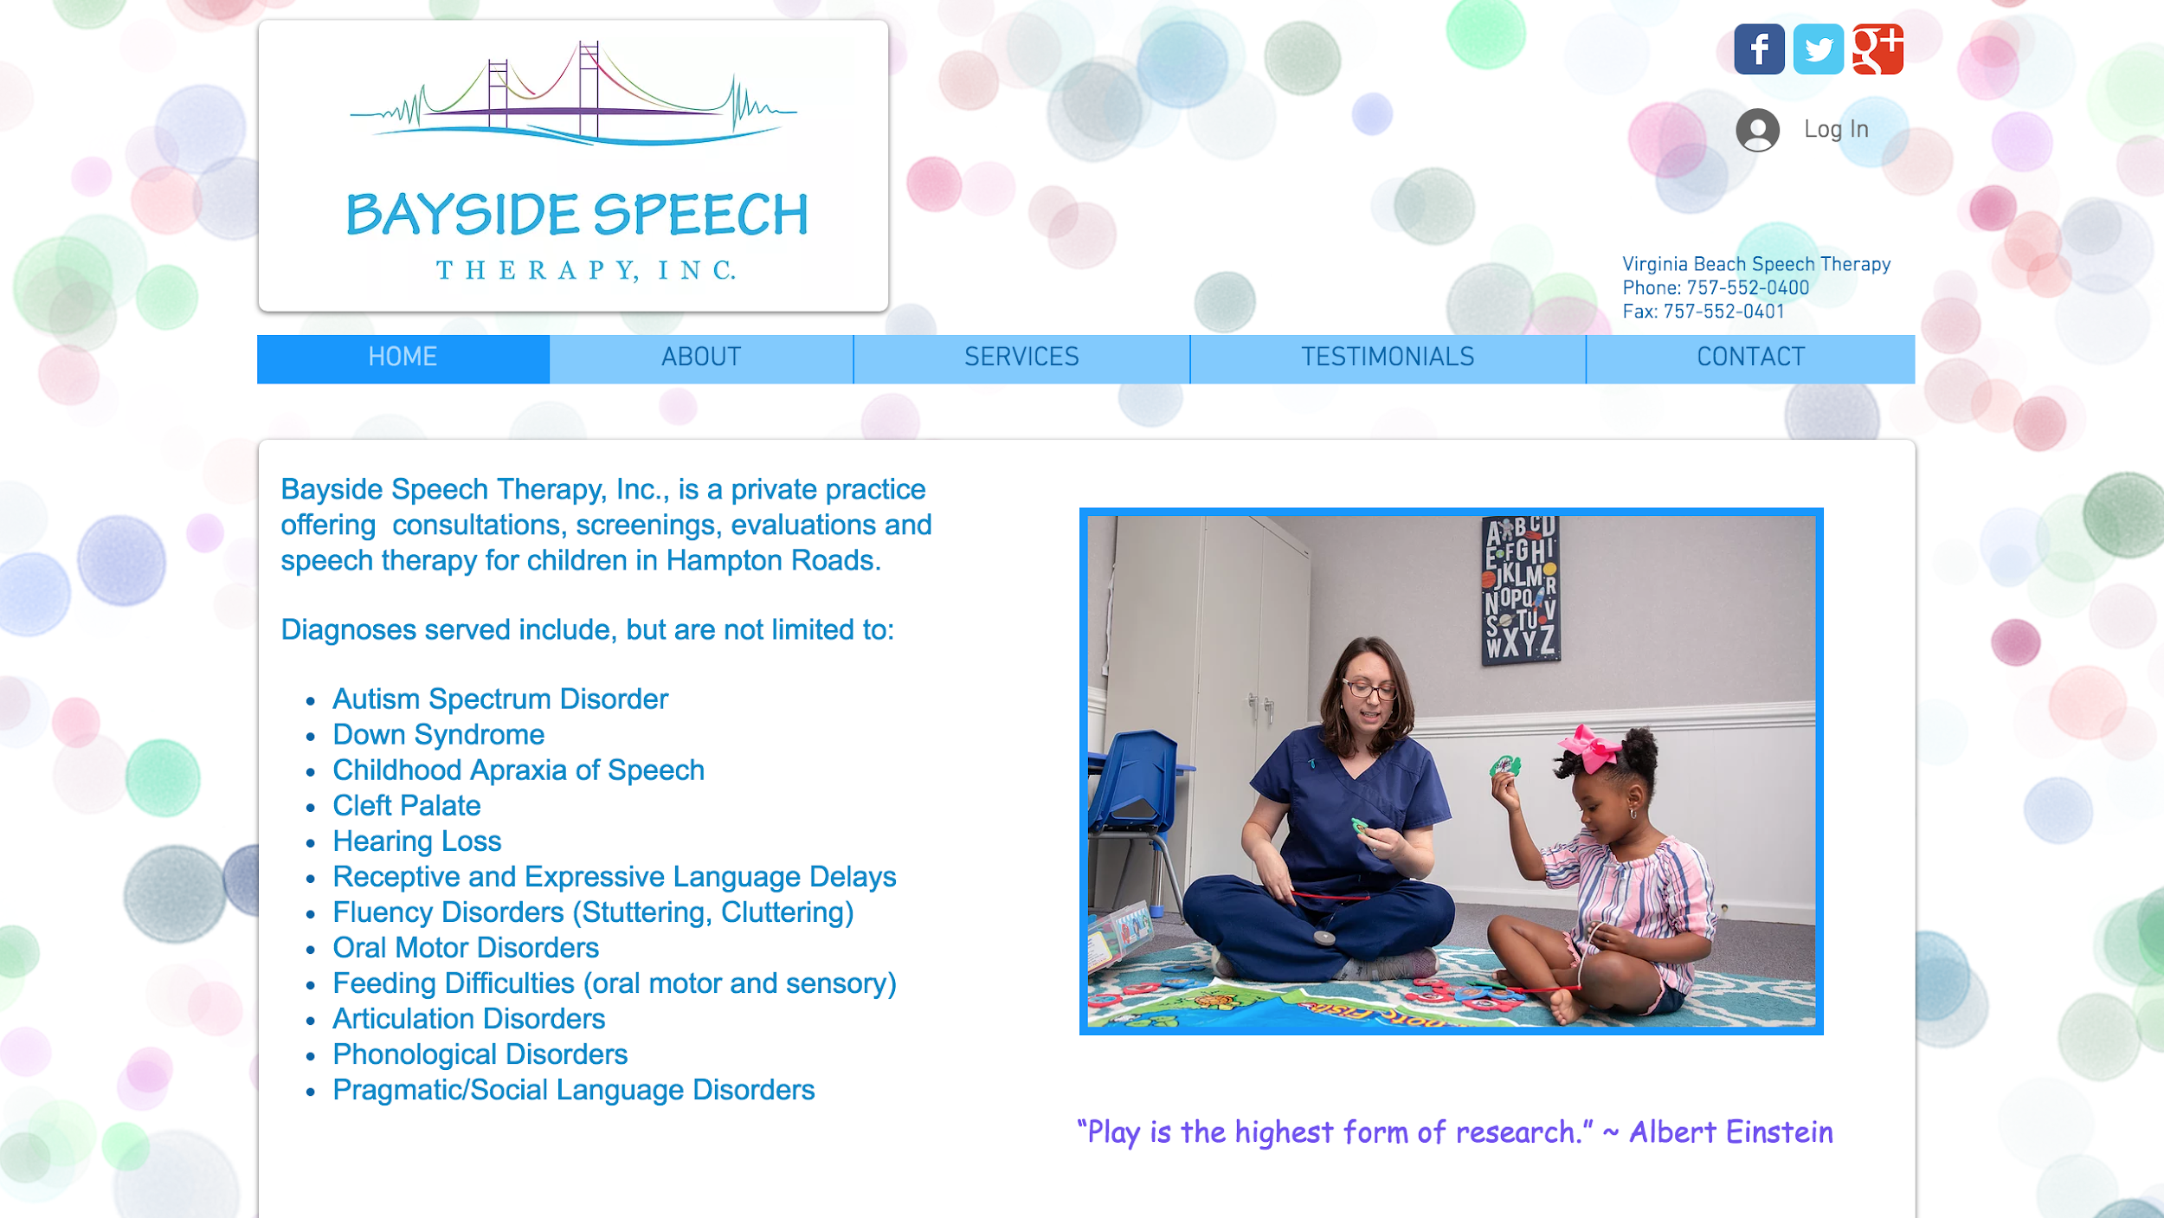

Figure : This is a screenshot of the Bayside Speech Therapy home page.

Overall, the Bayside Speech Therapy website is simple, easy to follow and understand. The homepage provides a wealth of information for parents of potential clients. This information can be a deciding factor for whether parents choose this private practice.

## Overall organization

Bayside Speech Therapy provides five sections: home, about, services, testimonials, and contact. By clicking on each of the tabs, parents are provided with more information pertaining to each of the different sections. To return to the homepage, potential clients can click on the “home” tab or on the Bayside Speech Therapy logo, located in the top, left corner of each page. While navigating the website the toolbar remains at the top immediately below the logo, throughout the entire website regardless of the tab the person is looking at.

Information provided under each tab uses simple, layman's terms when explaining the services provided. The use of the layman’s terms helps with organization because it prevents potential clients from having refer to another website to find information on an unknown term or service. The contact information is easy to locate and allows parents to ask direct questions to certified speech language pathologists. The website utilizes white space and does not over crowd each of the different pages.

## Information on services provided

The Bayside Speech Therapy provides services exclusively to children, so the diagnoses and services discussed pertain only to children. The home page provides a list of the diagnoses that are serviced at this particular private practice. It is also noted that the list of diagnoses is not limited to the ones listed on the website. This can be an encouraging to parents, but this can also deter parents from selecting this practice because the clinicians may not be as experienced in the services not listed.

If parents, of potential clients, click on the “service” tab it will provide them with more information on the services provided by the SLPs. The list of services is included, but the website fails to go into in depth detail about the extent of each of the services. This private practice has decided to offer free consultations and to discuss pricing options. Bayside Speech Therapy also briefly discusses the three-step intake process for new clients.

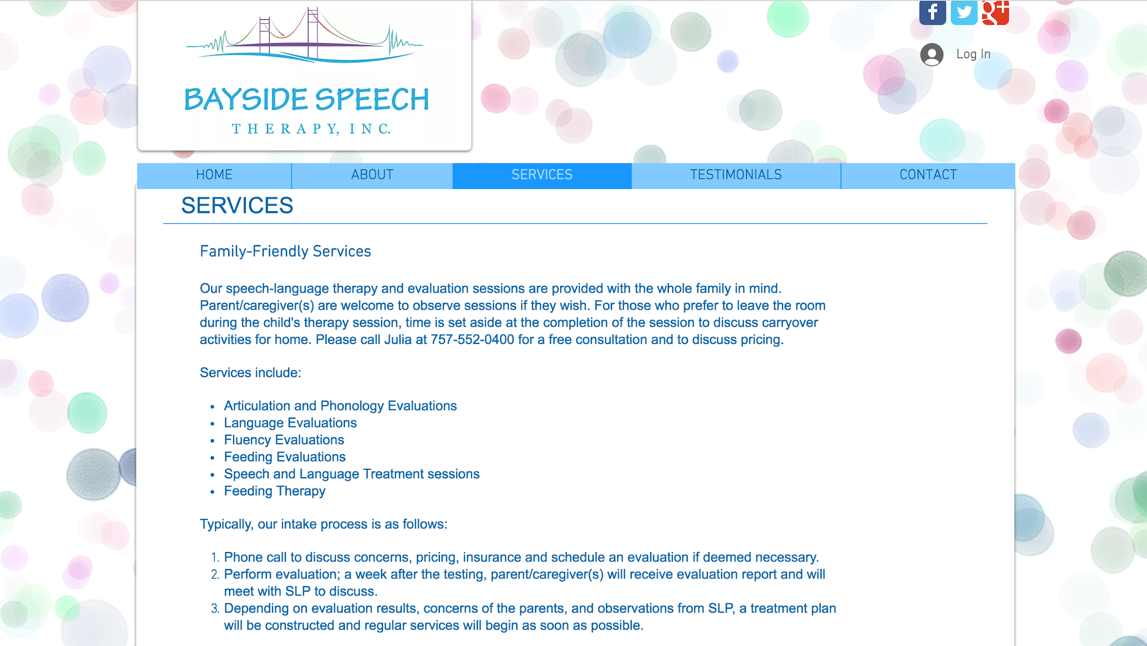The Bayside Speech Therapy website also provides client testimonials. Because the private practice provides services exclusively to children, the testimonial are from the child’s parent(s). The use of these testimonials can encourage parents to refer to Bayside Speech Therapy for future services for their child. They show parents that this private practice is a creditable, well established practice.

Figure : This is a screenshot of the Bayside Speech Therapy Services page.

# Conclusions

Farmville Speech and Hearing uses their website to sell their private practice to potential clients and to provide a place for current customers to have questions answered. Since the last update of the Farmville Speech and Hearings website, there has been a steady decline in the number of people utilizing private practice clinics for speech and language services. This private practice speech and language center believes they can improve their clientele and to improve the reputation of private practice speech and language clinics.

Speech and hearing private practice clinics whose websites are poorly designed fail to appeal to new clientele and even can even cause current client to revert to services from other practices. A website redesign that focuses on overall visual appeal, overall organization, and information on provided services stands to be the most appealing to clients and in encouraging new clients to consider a particular private practice. A website design, based on the previously stated criteria, is shown to have an increase in web traffic.

Using several surveys, Farmville Consulting concluded that the three best private practice websites that exhibited the best overall visual appeal, overall organization, and information on provided services are the following:

danvillespeechandhearing.org, cslstherapy.com, baysidespeech.com.

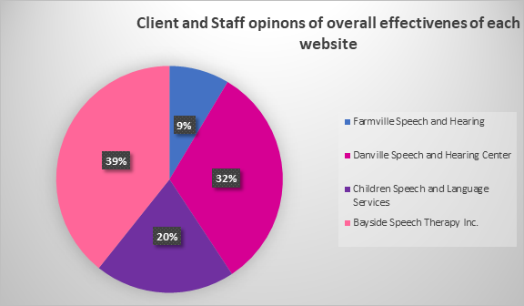

Figure : Client Options on Website Improvement Options Results

All websites considered, Bayside Speech Therapy was favored by the clients and staff, from all four private practices, for overall effectiveness in conveying information. Whereas Danville Speech and Hearing and Children Speech and Language Services was favored more for visual appeal and information on provided services.

In closing, all three websites Farmville Consulting Company analyzed presented with various pros and cons. We believe in Farmville Speech and Hearings website redesign it is important to utilize different aspect of each website, as well as incorporate new ideas, unique to your company.

# Recommendations

We recommend that Farmville Speech and Hearing implement all the following in the redesign of their website. All ideas were derived from the three websites. The recommendations are as follows:

* On the homepage of the website, all services provided by the clinic should be present without having to scroll or click, like the Children’s Speech Language Service Clinic does. More information may be included in the link
* The color-scheme should be eye-catching, but not too overwhelming. The color scheme should be inviting to children and both genders.
* Try to avoid the use of long block text. When necessary try to utilize bullet points, lists, and images to break text up.

# Appendix A: Client Options on Website Improvement Options

**This survey was authorized by the Farmville Consulting Firm for the distribution to 105 clients and staff of Farmville Speech and Hearing. It was used to determine which elements of website design users found to be the most important.**

1. I believe ease of accessibility is one of the most important elements of website design.

Disagree Neutral Agree

1. I believe information on provided services is one of the most important elements of website design.

Disagree Neutral Agree

1. I believe content is one of the most important elements of website design.

Disagree Neutral Agree

1. I believe organization is one of the most important elements of website design.

Disagree Neutral Agree

1. I believe aesthetics is one of the most important elements of website design.

Disagree Neutral Agree

# Appendix B: Client Options on Website Improvement Options Results

|  |  |  |  |
| --- | --- | --- | --- |
|  | **Disagree** | **Neutral** | **Agree** |
| **Ease of accessibility** | 30 | 13 | 62 |
| **Information on provided services** | 22 | 8 | 75 |
| **Content** | 48 | 20 | 37 |
| **Organization** | 15 | 34 | 56 |
| **Aesthetics** | 33 | 32 | 40 |

Table 1: Client Options on Website Improvement Options Results

# Appendix C: Overall Effectiveness of the Website

**This survey was authorized by Farmville Consulting Firm. It authorizes the distribution of this survey to 100 of the clients and staff of Farmville Speech and Hearing, Danville Speech and Hearing Center, Children Speech and Language Services, and Bayside Speech Therapy, Inc.. They were encouraged to fill out the survey and return it back within one week. They were asked to rank each website, on a scale of 1-10, based on the effectiveness of the website, as a whole.**

1. Farmville Speech and Hearing - FSH.com

1 2 3 4 5 6 7 8 9 10

1. Danville Speech and Hearing Center - danvillespeechandhearing.org

1 2 3 4 5 6 7 8 9 10

1. Children Speech and Language Services - cslstherapy.com

1 2 3 4 5 6 7 8 9 10

1. Bayside Speech Therapy Inc. - .baysidespeech.com

1 2 3 4 5 6 7 8 9 10

# Appendix D: Overall Effectiveness of the Website Results

|  |  |
| --- | --- |
| **Institute** | **Visitors who approved of the website** |
| Farmville Speech and Hearing | 12 |
| Danville Speech and Hearing Center | 27 |
| Children Speech and Language Services | 16 |
| Bayside Speech Therapy Inc. | 45 |

Table : Overall Effectiveness of the Website Results

# Appendix E: Ranking of what they liked about each website

**This survey was given to 300 client families at each of the three clinics. This survey was intended to find out how the clients’ families reacted to their respected clinic website.**

1. What clinic do your child receive services from?
2. What services does your child receive?
3. What improvements would you make to the website? More visuals, shorter paragraphs, fewer tables, and clarity of information.

1. Out of these 3 websites, which one are you most likely to choose from the above criteria?

# Appendix F: Ranking of what they liked about each website results

1. What clinic do your child receive services from?

33% - Danville Speech and Hearing

33% - Children’ Speech and Language Services

33% - Bayside Speech Therapy

1. What services does your child receive?

23% - Articulation

13% - Fluency

30% - Language disorders

12% - Assistive technology and augmentative communication

10% - Hearing

15% - Feeding and swallowing

1. What improvements would you make to the website? More visuals, shorter paragraphs, fewer tables, and clarity of information.

50% - Visuals

10% - Shorter paragraphs

5% - Fewer tables

35% - Information clarity

1. Out of these 3 websites, which one are you most likely to choose from the above criteria?

54% - Bayside Speech Therapy

23% - Danville Speech and Hearing

23% - Children’s Speech and Language Services

# Weekly Progress Meeting Minutes

## Appendix G: Abby’s minutes

**Weekly Progress Meeting**

**Greenwood Library**

**Wednesday, November 3, 2018, 12:00 PM**

**Agenda**

1. **Call to order** - 12:10 PM
   1. **Present** - Abby Collier, Lexi Stenback, Tanna Turner
   2. **Recording Secretary** - Abby Collier
2. **Approval of Agenda** - Abby moved, seconded by Lexi. Passed unanimously
3. **Previous Minutes** - None
4. **Designer’s Report:** Designer has created the logo and has begun inserted graphics into the report, such as website screenshots.
5. **Programmer’s Report:** Programmers have chosen the three websites. Programmers have also discussed at length what specifically we want to cover in our survey. Criteria was discussed at length and what falls under each criterion.
6. **Other Items** - Table of Contents, Letter of Authorization, and Letter of Transmittal have been started
7. **Next Meeting** - Monday, November 19, 2018, 12:00PM
8. **New Business** - None
9. **Adjournment** - Abby moved to have the meeting be adjourned. Passed unanimously. Meeting ended at 1:30 PM

## Appendix H: Lexi’s minutes

**Farmville Consulting Firm**

**Weekly Progress Meeting**

**Greenwood Library**

**Monday November 19, 2018, 12:00 PM**

**Agenda**

1. **Call to order** - 12:05 PM
   1. **Present** - Abby Collier, Lexi Stenback, Tanna Turner
   2. **Recording Secretary** - Lexi Stenback
2. **Approval of Agenda** - Lexi moved, seconded by Tanna. Passed unanimously
3. **Previous Minutes** - The minutes of the meeting held on November 3rd were agreed upon and approved by all members.
4. **Designer’s Report:** Brought the logo to the table for all members to discuss and edits will be ready for the next meeting. Three surveys were also created by all members. Abby has recorded those surveys and plans on distributing them to all clientele.
5. **Programmer’s Report:** All programmers have discussed the three websites based on the criteria we are rating the websites on. Analysis have been wrote on each of the three websites.
6. **Other Items** - Introduction has been wrote
7. **Next Meeting** - Sunday, November 25, 2018, 6:00PM
8. **New Business** - None
9. **Adjournment** - Lexi moved to have the meeting be adjourned. Passed unanimously. Meeting ended at 1:45 PM

## Appendix I: Tanna’s minutes

**Farmville Consulting Firm**

**Weekly Progress Meeting**

**Greenwood Library**

**Wednesday, November 29, 2018, 11:10 PM**

**Agenda**

1. **Call to order** - 11:10 PM
   1. **Present** - Abby Collier, Lexi Stenback, Tanna Turner
   2. **Recording Secretary** - Tanna Turner
2. **Approval of Agenda** - Tanna moved, seconded by Abby. Passed unanimously
3. **Previous Minutes** - The minutes held on November 3rd and November 19th were agreed upon and approved by all members.
4. **Designer’s Report:** Designer has created the logo and has inserted all graphics into the report.
5. **Programmer’s Report:** Programmers have completed website analysis of all of websites. Programmers have administered and collected all surveys and graphed all data.  at length what specifically we want to cover in our survey.
6. **Other Items** -  Table of Contents, List of figures, Letter of Authorization, and Letter of Transmittal, recommendations, and conclusion have all been formatted correctly and completed.
7. **Next Meeting** - Final meeting before submission
8. **New Business** - none
9. **Adjournment** - Lexi moved to have the meeting be adjourned. Passed unanimously. Meeting ended at 12:30 PM

# Appendix J: Team work log

|  |  |  |  |
| --- | --- | --- | --- |
| **Team members**  **(name)** | **Tasks** | **Total # of hours** | **Signature of all team members** |
| Abby Collier | * Created Google Docs. * Drafted Letter of Transmittal * Drafted the analysis of Bayside Speech and Hearing * Drafted conclusion * Created surveys and results * Scribe for meeting one minutes * Final proofreading * Formatting | 5 | Abby Collier  Lexi Stenback  Tanna Turner |
| Lexi Stenback | * Created logo * Drafted the Executive Summary * Drafted the analysis of Children Speech and Language Services. * Drafted Table of Contents * Drafted Recommendations under the discretion of all team members. * Scribe for meeting two minutes * Final proofreading | 5 | Abby Collier  Lexi Stenback  Tanna Turner |
| Tanna Turner | * Drafted Letter of Authorization * Drafted Introduction * Drafted the analysis of Danville Speech and Hearing * Created graphs based off survey results * Scribe for meeting three minutes * Final proofreading | 5 | Abby Collier  Lexi Stenback  Tanna Turner |