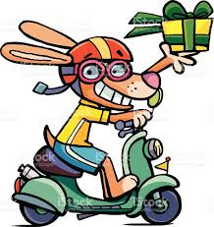

February 4, 2018- FOR IMMEDIATE RELEASE

Robot Dogs are here! Are they Friend or Fido?

HAMBURG, GER- A tech startup, named DalHan, just rolled out with their new product yesterday morning dubbed the Parcel Pup.

“We here at DalHan thought it was time to truly bring the future into today and what better way to do that than have your own personal robot?” says company CEO Nel Reece during the product’s announcement. Dedicating himself for the past 15 years, Mr. Reece aims to bring the world a product that had never been available to purchase on the consumer market.

The Parcel Pup acts as a courier device designed to ferry items from point A to point B via smartphone through bluetooth. This product is the first mass implementation of robots into the consumer market.

The Parcel Pup demoed at the expo yesterday was shown to be able to open doors, handle delicate items like eggs, and transport open containers of liquid. Nel Reece claimed that the battery life would last up to 24 hours and Parcel Pup is able to hold up to 250lbs before buckling under the stress. Parcel Pup is made of an aluminum alloy that is dense enough to bear heavy loads but also light enough to be quick on its feet to maintain balance.

Angela Merkel, the German Prime Minister, was at the convention after playing with Parcel Pup said: “I really love Parcel Pup! It was even super helpful once I left my key card by the front desk and it fetched it!”

Parcel Pups go on sale world wide on National Puppy day March 23rd. The first 1,000 customers receive 20% off their purchase order. They retail for $1,400, payment plans are available.
-30-
For further information, please contact Joshua Phelps
At 420-666-6969, email joshuaphelps@email.com

