Lindsey Sparrock
PSYC 452
Dr. Franssen
05/08/17
Analysis of the Effects of Antidepressant on Pregnant Females and Neonates

What is Depression?
Depression is a pervasive and wide-ranging disorder that has potentially life-threatening consequences. As such, it is imperative that proper research regarding the illness, as well as treatment methodologies, are studied. Some populations, such as pregnant females and neonates, are more vulnerable to the symptoms of depression and potentially the medications used to counteract them.
A “chronic, recurring, and potentially life-threatening illness”, depression is “currently the third most disabling disease, and by the year 2020, it will be the second leading cause of disability across the globe” (Advokat et al., 2014, p. 386). Depression, as well as anxiety which is often comorbid with depression, are extremely prevalent in females. According to one study, approximately 25 percent, or more, of women will experience depression in their lifetime. In correspondence, many of these women will also experience depression during pregnancy, an already emotional and arduous period.
Unfortunately, even after the child is born the risk of depression does not end. According to the National Institute of Mental Health, postpartum depression is “a mood disorder that can affect women after childbirth. Mothers with postpartum depression experience feelings of extreme sadness, anxiety, and exhaustion that may make it difficult for them to complete daily care activities for themselves or for others”. Often women who have previous experience with depression or present symptoms of depression during pregnancy are at a greater risk for developing postpartum depression.

What are Antidepressants?
In an attempt to alleviate the negative symptoms associated with depression, antidepressant medications are often prescribed. Antidepressants are, as the name suggests, medications meant to counteract depressive symptoms and, in extension, hopefully, treat the disorder. Generally, with the introduction and promotion of antidepressant medications by physicians and the pharmaceutical industry respectively, there was the a clear goal in mind: “alleviate the signs, symptoms, and distress associated with clinical depression; relieve anxiety either as a single diagnosis or as apart of comorbid anxiety/depression; improve the lives of persons with debilitating depression; [and] repair the neuronal damage associated with depression” (Advokat et al., 2014, p. 385). Unfortunately, the majority of these goals have not yet been met.
In the case of pregnant women suffering from depression, the most frequently prescribed antidepressant medications are selective serotonin reuptake inhibitors (SSRIs). SSRIs, such as Prozac, Zoloft, Lexapro, and Paxil, are drugs, which act my blocking the presynaptic transporter for serotonin reuptake. The remaining serotonin in the synapses assists in regulating mood and relieving depression making it a more productive mean of treating depression.
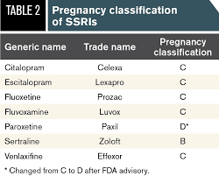
Presently, antidepressant medications have not proven to me very efficient in treating depression. Worse off, antidepressants are linked with several troublesome side effects, such as “sexual dysfunction, weight gain, possible adverse cognitive effects, and even suicidal ideation” (Advokat et al., 2014, p. 385), which limit is clinical use. According to the American Congress of Obstetricians and Gynecologist, “of the 500,000 pregnant women who struggle with a mood or any other kind of psychiatric disorder, about one-third of them will take medication to treat it” (Gonser). Currently, it is believed that approximately 8 percent of pregnant females will be prescribed antidepressants at some point during the course of their pregnancy (Advokat et al., 2014, p. 510). With such as a growing number of pregnant women with depression being prescribed antidepressants a discussion needs to be opened regarding whether or not they will be more productive or harmful to the mother and her child, especially when noting that a potential symptom of depression, as well as antidepressant medications, are suicidal ideations.
As people continue to ask the question of whether or not antidepressant medications even work, let alone if their pros out weigh their cons, there becomes a growing necessity to further analyze the drugs effects on patients as well as others. Pregnant females and their infants are extremely vulnerable to drugs when considering factors such as the placental barrier, which does not actually serve as a barrier at all. During pregnancy, the growing fetus is at the mercy of the placenta when foreign substances, such as drugs or toxins, appear in the mother’s blood (Advokat et al., 2014, p. 46). Drugs, including antidepressants, rapidly cross the placental membrane via passive diffusion. Regardless of the substance, the fetus is exposed to it at largely the same rate as the mother. This create vital concern regarding the ethicality of prescribing antidepressants, or really any other drug, to a pregnant mother when her child will be undeniably exposed to it as well as instigates questions regarding the actual extend to which antidepressants will effect a child’s development and behavior.

How do Antidepressants Effect Neonates & Children?
Currently, research is being conducted to analyze the potential effects of antidepressants on neonates. In one massive study composed of nearly 850,000 births in Finland, short-term complications in newborns whose mothers used commonly prescribed antidepressants, specifically SSRIs, while pregnant where found (Esposito). It was noted that complications infants born from mothers prescribed SSRIs had led to a higher rate of hospitalization in neonatal intensive care units, although the length of time hospitalized went un-described. However, interestingly enough, the same study also found potential benefits of antidepressant use such as a lowered risk of premature births and cesarean sections in women who took these drugs compared to women with untreated psychiatric disorders, although which psychiatric disorders were included was not specified (Esposito). Likewise, research shows that “some newborns exposed to SSRIs in utero may experience mild withdrawal symptoms such as jitteriness, high-pitched crying, feeding difficulties, irritability, and possibly respiratory distress”, however, luckily, these symptoms generally seem to dissipate after a short period without any required treatment (Gonser).
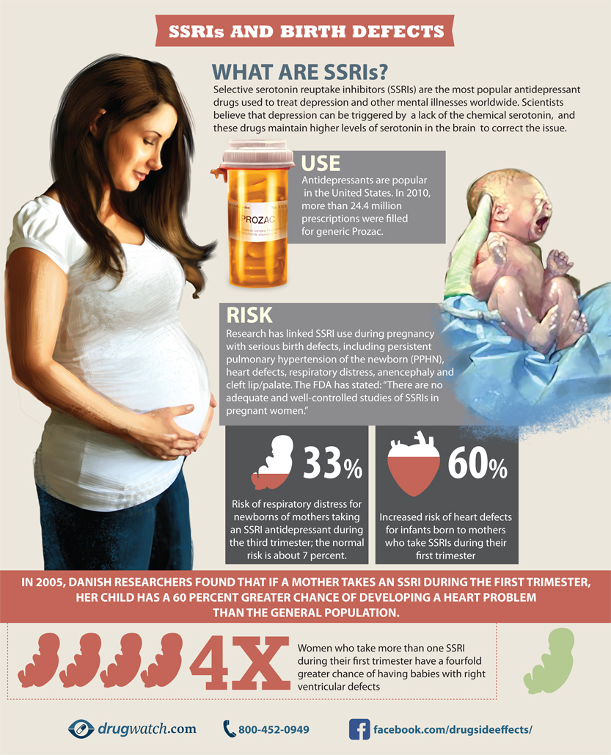

Research findings are quite controversial, as many suggest little to no associated risk, while others suggest more serious and long-lasting effects. Notably, one Canadian study that included “more than 145,000 infants born in the province of Quebec found a link between antidepressant use during pregnancy and an increased risk of autism in offspring” (Esposito). In consideration of the possible negative side effects for neonates whose mothers are prescribed antidepressants the answer might seem to simply be to not prescribe women antidepressants while pregnant. However, this does not fully solve the problem and may lead increased risks for the mother and child alike. A woman who is no longer on antidepressants may experience a worsening of depressive symptoms, which could, in a worse case scenario, lead her to harming herself or her child. Likewise, according one research article regarding antidepressant use during pregnancy, “studies have shown that terminating antidepressant treatment in pregnancy in women with a previous history of depression leads to relapse of symptoms in as much as 60-70% of women” (Payne & Meltzer-Brody). As such, there needs to be either a new form of treatment introduced, potentially psychotherapy, or a mother and physician have to come to an agreement on whether the severity of the current depression warrants the use of antidepressants while pregnant.
While there is evidence showing that antidepressant use may be correlated with neonatal health issues, it cannot be guaranteed that the infant complications are exclusively due to the drug. It is also suggested that the difficulties these infants present may also be influenced by socioeconomic status as many times mothers who are suffering from depression, anxiety, or an array of other mood disorders have difficulty functioning in their daily life and as such may have difficulty providing for their child. Similarly, the question regarding a mother’s use of antidepressant and its affect on her child extends still to other related topics of concern, such as “the safety of antidepressant use during pregnancy and lactation, long-term outcomes for children, consequences of exposure to maternal illness, and whether antidepressants should be tapered prior to delivery” (Payton & Meltzer-Brody). Overall, it is essential that we take a critical look at antidepressant medication use in pregnant mothers when concerning the health of a child.

Reference
Advokat, C. D., Comaty, J. E., & Julien, R. M. (2014). Julien's Primer of Drug Action: A
Comprehensive Guide to the Actions, Uses, and Side Effects of Psychoactive
Drugs(13th ed.). New York, NY: Kevin Feyen.
Esposito, L. (2016, January 13). Antidepressants During Pregnancy: Stay on Them or
Stop? Retrieved May 08, 2017, from http://health.usnews.com/health-
news/patient-advice/articles/2016-01-13/antidepressants-during-pregnancy-stay-
on-them-or-stop
Goner, S. (n.d.). Depression, Antidepressants, and Pregnancy. Retrieved May 08, 2017,
from https://www.seleni.org/advice-support/article/depression-antidepressants-
and-pregnancy
Payne, J. L., & Meltzer-Brody, S. (2009). Antidepressant Use During Pregnancy: Current
Controversies and Treatment Strategies. Clinical Obstetrics and
Gynecology,52(3), 469-482. doi:10.1097/grf.0b013e3181b52e20
Postpartum Depression Facts. (n.d.). Retrieved May 08, 2017, from
https://www.nimh.nih.gov/health/publications/postpartum-depression-
facts/index.shtml

