Effect of Natural Environment vs. Artificial Environment on Stress

Lindsey S. Sparrock

Longwood University

Abstract

It is currently not known whether an artificial environment or a natural environment is more effective in reducing stress in people. The purpose of the present study is to examine the affect of being indoors or outdoors on stress as measured by cortisol, a stress hormone, levels in saliva. In this experiment participants will be instructed to partake in a guided meditation and then shortly afterwards be asked to spell words in a mock spelling bee. It is predicted that the experimental findings will suggest that participants in a natural environment will experience less stress and hence produce less cortisol.

*Keywords:* Nature, Artificial, Outdoors, Indoors, Environment, Cortisol, Stress, Anxiety, Meditation, Spelling

Effect of Artificial Environment vs. Natural on Stress

As society progresses into a technological world many people are becoming increasingly dissociated with nature. The biophilia hypothesis (Grinde, Patil 2009) describes how humans have an inherent connection and relationship with nature, along with the living organisms that are included. It is suggested that visual contact with nature can have significant effect on a person’s health and general well being. Grindr and Patil note in their study that an environment devoid of nature may have detrimental effects overtime on the human mind. Along with the decreased exposure to nature, stress in humans has gone rampant over the past century. Frequently, people encounter an array of stressful events during their daily lives. As time goes by humans have started to respond to what would be considered an insignificant or mild event as a major stressor. Stress can be measured in a variety of ways although one of the simplest methods is through a saliva sample. Cortisol is a steroidal hormone produced by the adrenal glands located above the kidneys. An increase in stress can have a plethora of negative health effects such as decreased immune systems, digestive issues, and hypertension.

Due to this it is becoming increasingly important for natural elements to be utilized in people’s daily lives as to lower the risk of stress and stress-related disorders. There is growing evidence to suggest that exposure to natural environments can be associated with mental health benefits. Proximity to green-space has been associated with lower levels of stress and reduced symptomology for depression and anxiety (Pearson, Craig 2014). According to one study (Aspinall, Macros, Coyne, Roe 2013), the use of mobile electroencephalograph (EEG) can be utilized as a method to record and analyze the emotional experience of a group of walkers in three types of urban environment including a green space setting. The results of one study regarding nature-based therapy reveal potential beneficial effects of using garden activities and natural environments in a stress management intervention (Sahlin, Ahlborg, Matuszczyk, Grahn 2014). Another therapy option explored by DeAngelis (2013) describes the plethora of benefits from psychologists using outdoor, natural environments as a backdrop and therapeutic tool in their work. Many workplaces are making adjustments to add in natural elements such as plants or natural sounds to improve work capacity and decrease office stress in employees.

Countless researchers have conducted studies that show some of the many beneficial aspects of a natural environment on stress. According to one article in the International Journal of Environmental Research and Public Health (Alvarsson, Wiens, Nilsson 2010), visual impressions of natural compared with urban environments facilitate recovery after psychological stress. Further research results suggest that nature sounds facilitate recovery from sympathetic activation after a psychological stressor. This study showed how stress recovery could be increased when people were exposed to natural sound. One study (Gladwell, Brown, Wood, Sandrercock, Barton 2013) noted that natural, outdoor environments positively influence someone’s physiological and psychological well being during physical activity.

In the current study, therefore, researchers will compare participant’s stress levels in two different environments: natural and artificial. The research will be conducted as an experimental design meant to establish if there is a relation between different types of environments and stress levels as measured by cortisol amounts present in the participant’s saliva. Researchers hypothesize that the artificial environment, which includes a classroom setting, will produce higher levels of cortisol in participants than the natural environment, which includes a wooded outdoor area, in response to a mock spelling bee stressor.

**Method**

**Participants**

The participants (6 women, age range: 19-39), who agreed to voluntarily participate in the empirical research study, were conveniently sampled from an undergraduate behavioral neuroscience course at a four-year, mid-sized liberal arts university located in central Virginia. The participants differed greatly in age and class standing (1 professor, 2 seniors, 1 junior, and 2 sophomores). Prior to the actual experiment, participants were made aware that they would performing tasks in an outdoors setting, which participants were either given prior knowledge regarding the location of, as well as a classroom, which they had previous experience in. None of the tasks performed put the participants in physical, mental, or emotional harms way. All participants reviewed and signed consent forms, as well as received ethical treatment. Participants were made aware that they could withdraw from the study at any time without repercussion.

**Materials and Procedure**

For the present study experimenters utilize a guided pre-recorded meditation video (WiseMindBody 2014), a one hundred-word list for the mock spelling bee (see Appendix A), and test tubes used to collect participant’s saliva. Participants were directed to an outdoor area where experimenters gave them a survey (see Appendix B) to complete, pens were distributed for those who did not have a writing utensil. Participants were asked to silence all of their digital devices that could cause a distraction such as cellphones and place them out of sight. Throughout the experiment, other experimenters by means of digital cameras and cellphones were recording participants. After collecting all of the surveys from the participants, an experimenter guided the participants in a pre-recorded meditation played on a laptop via speakers that would last a total of 10-minutes. Participants were instructed to get into a comfortable sitting position while closing their eyes and follow the male meditator’s instructions. Once the participants completed the meditation session they were allowed a few minutes to reflect and converse with the other participants.

Participants were then instructed to line up horizontally and an experimenter asked them in order to spell words from a pre-constructed list (see Appendix A). There was no time limit on how long a participant could take in the attempt to spell a word. Although, the actual ability to accurately spell out a word was not recorded, unbeknownst to the participants. Words utilized in the mock spelling bee task widely ranged in difficulty. After 10-minutes, the mock spelling bee task was completed and participants were allowed to reflect for 5-minutes. The participants were then instructed to given a saliva sample by means of small test tubes that were provided by the experimenter.

At the same time, 9 am to 9:50 am, two days later, the same group of participants was instructed to complete the same requirements as in the outdoor environment, except that participants were now in an artificial environment. The artificial environment was a university classroom that all of the participants were comfortable with through previous experience. After the last 5-minute period in the experiment the experimenters again collected saliva samples. The saliva samples were properly stored and later analyzed using a Salimetrics Saliva ELISA kit in a university laboratory. Along with the saliva samples, surveys were also stored and utilized to analyze potential differences between participants in both the natural and artificial environment as well as between participants who noted a preference of one of the environments.

**Results**

To test the hypothesis that after equal meditation time cortisol will be higher in the artificial classroom environment than in the natural outdoors environment, in response to a mock spelling bee stressor. Experimenters analyzed if the corresponding day of the week, Wednesday or Friday, has a significant interaction on the participant’s preference to being in a natural environment or an artificial environment by utilizing a Contingency Table Chi Square. Results revealed that whether the participants preferred to be in a natural environment or an artificial environment was not significantly related to the day of the week. A Correlated T-test was utilized to analyze the data regarding the relationship between stress, measured by the amount of cortisol present in saliva samples, in a natural, wooded outdoors, and an artificial environment, classroom. After analyzing the collected data experimenters concluded that there was no significant difference between participant’s environment preferences regardless of whether asked on Wednesday, when the participants were outdoors, or Friday, when the participants were indoors (see Figure 1). Similarly, there was no significant difference between the participant’s cortisol levels regardless of setting, outdoors or indoors (see Figure 2).

**Discussion**

In the present study researchers were testing the effect of different environments, artificial and natural, on a person’s stress. A within-subjects design consisting of six females, who varied greatly in age, was utilized to compare the results to see if one environment would produce higher levels of stress. The dependent variable, participant’s stress, was operationally defined as the level of cortisol, a stress hormone, present in the participant’s saliva. Additional information was gathered via survey (see Appendix B) regarding the participant’s perception of the stress gained during the experiment. Confounding variables that remained in the study may have altered the results. One such confounding variable is the responses given by one of experimenters who proctored the mock spelling bee. During the spelling bee, the proctor did not tell the participants whether they had correctly or incorrectly spelled the designated word. Instead, the proctor simply said thank you in a monotone voice and moved on to the next participant. This could have potentially led the participants to believe that they had spelt the word correctly causing reduced stress. If the proctor had specified whether the participants were correct or incorrect then the participants may have had increased or decreased stress based on the amount of words that they had succeeded in spelling, potentially leading to significant results.

Likewise, participants were presented with a general survey rather than a likert scale that may have produced less than accurate results. The reasoning behind using a general survey rather than a likert scale was due to the fact that researchers were gathering demographic information prior to each environment and were not as concerned about the participants actual perception of stress. Regarding the participants, the sample selected for the experiment was small due to the fact that participants were only able to come from the university’s behavioral neuroscience course and even from those people only those who were not acting as experimenters in the present study were tested. Increasing the amount of participants in the study could potentially have a great affect on the results and possibly provide significant findings.

In future studies it is recommended that different types of natural and artificial environments be tested. Researchers could test the natural environment as in a wooden area, on a beach, or in a dry rocky area. Similarly, the artificial environment utilized could be changed as well to include an environment that the participants did not have prior experience in such as an unfamiliar home or in an auditorium rather than a classroom. During the guided meditation (WiseMindBody 2014) portion of the experiment a male voice was used. Future research could potentially include a female voice instead as past research has suggested that female voices are generally perceived as more pleasant and relaxing.

Implications for future research include addition of natural elements in artificial environments such as placing plants in classrooms and workplaces. A plethora of people are dealing with some type of stressor at a given time, and this constant stress can have extremely detrimental effects on a person both mentally and physically. Due to this, it is imperative that methods be taken to reduce place regardless of the setting. By performing further related studies researchers can potentially form a number of connections between natural environment and artificial environment’s impact on a person’s stress level.

**References**

Alvarsson, J. J., Wiens, S., & Nilsson, M. E. (2010). Stress Recovery during Exposure to Nature

Sound and Environmental Noise. *International Journal of Environmental Research and*

*Public Health*, *7*(3), 1036–1046. <http://doi.org/10.3390/ijerph7031036>

Aspinall, P., Mavros, P., Coyne, R., & Roe, J. (2013). The urban brain: Analysing outdoor

physical activity with mobile EEG. *British Journal of Sports Medicine,* *49*(4), 272-276.

doi:10.1136/bjsports-2012-091877

Deangelis, T. (2013). Therapy gone wild: More psychologists are using the wilderness as a

backdrop and therapeutic tool in their work. *PsycEXTRA Dataset,* *44*(8), 48.

doi:10.1037/e575722013-021

Gladwell, V. F., Brown, D. K., Wood, C., Sandercock, G. R., & Barton, J. L. (2013). The great

outdoors: how a green exercise environment can benefit all. *Extreme Physiology &*

*Medicine*, *2*, 3. http://doi.org/10.1186/2046-7648-2-3

Grinde, B., & Patil, G. G. (2009). Biophilia: Does Visual Contact with Nature Impact on Health

and Well-Being? *International Journal of Environmental Research and Public Health*,

*6*(9), 2332–2343. <http://doi.org/10.3390/ijerph6092332>

Pearson, D. G., & Craig, T. (2014). The great outdoors? Exploring the mental health benefits of

natural environments. *Frontiers in Psychology*, *5*, 1178.

<http://doi.org/10.3389/fpsyg.2014.01178>

Sahlin, E., Ahlborg, G., Vega Matuszczyk, J., & Grahn, P. (2014). Nature-Based Stress

Management Course for Individuals at Risk of Adverse Health Effects from Work-

Related Stress—Effects on Stress Related Symptoms, Workability and Sick Leave.

*International Journal of Environmental Research and Public Health*, *11*(6), 6586–6611.

http://doi.org/10.3390/ijerph110606586

WiseMindBody. (2014). Mindfulness Meditation to help Relieve Anxiety and Stress. Retrieved

April 25, 2016, from https://www.youtube.com/watch?v=Fpiw2hH-dlc

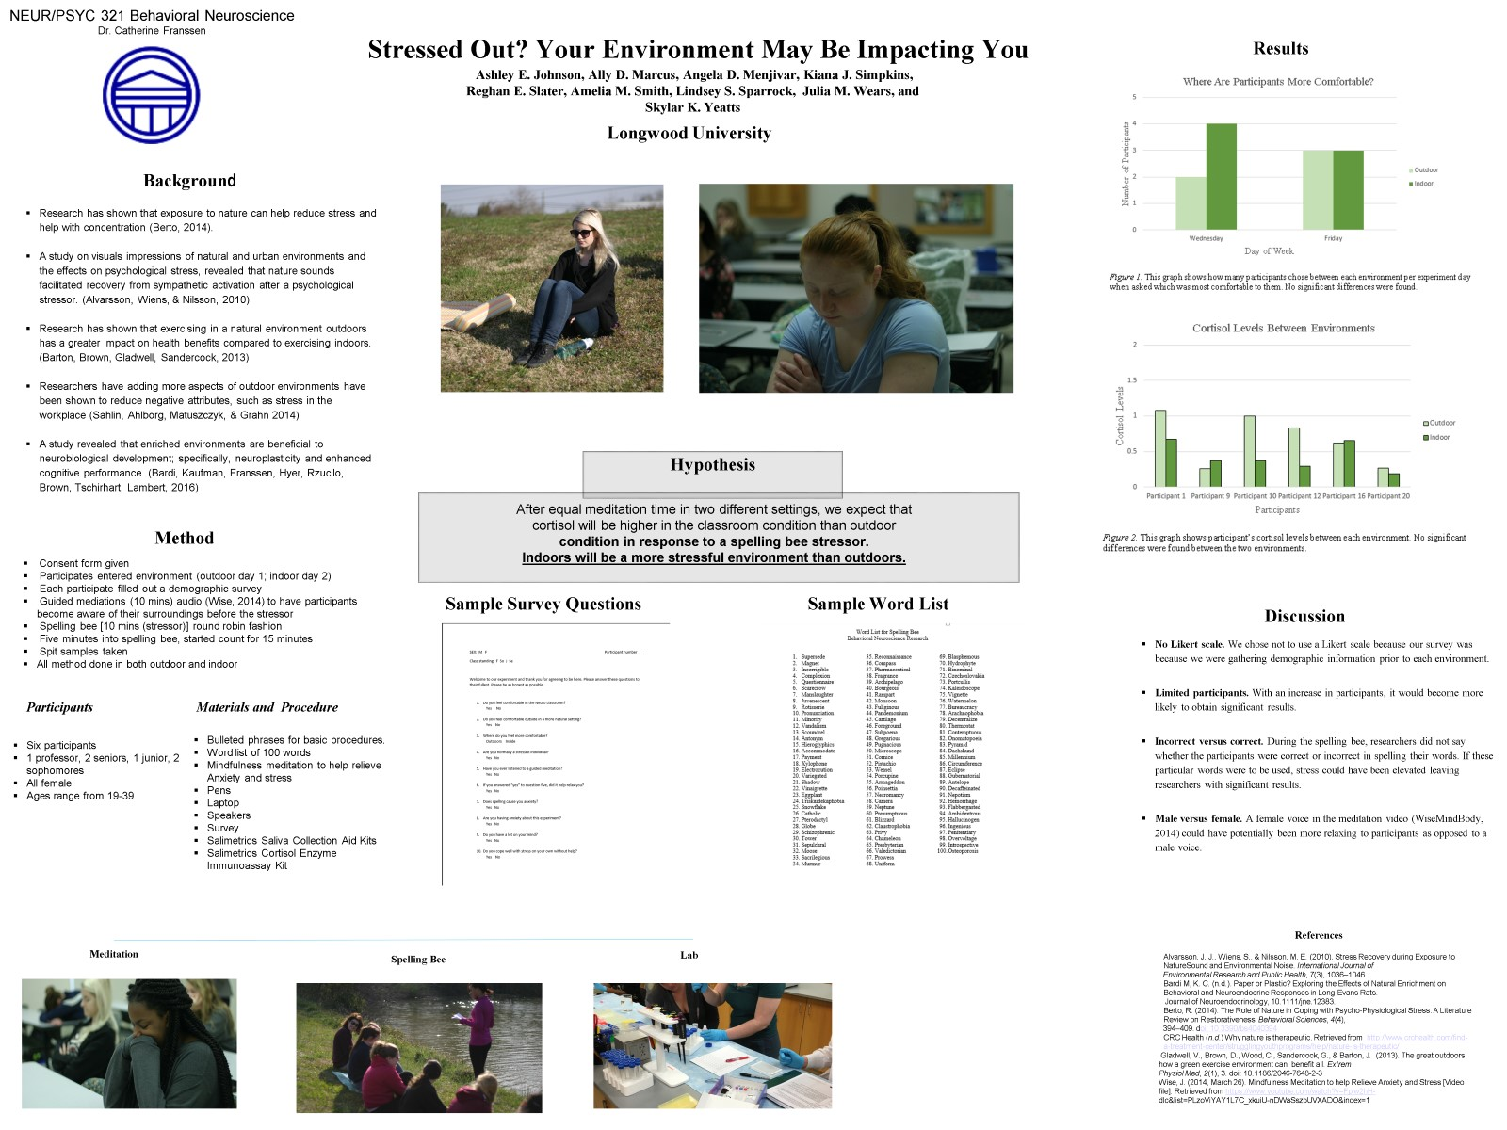



Appendix A

Word List for Spelling Bee

Behavioral Neuroscience Research

1. Supersede
2. Magnet
3. Incorrigible
4. Complexion
5. Questionnaire
6. Scarecrow
7. Manslaughter
8. Juvenescent
9. Rotisserie
10. Pronunciation
11. Minority
12. Vandalism
13. Scoundrel
14. Antonym
15. Hieroglyphics
16. Accommodate
17. Payment
18. Xylophone
19. Electrocution
20. Variegated
21. Shadow
22. Vinaigrette
23. Eggplant
24. Triskaidekaphobia
25. Snowflake
26. Catholic
27. Pterodactyl
28. Globe
29. Schizophrenic
30. Tower
31. Sepulchral
32. Moose
33. Sacrilegious
34. Murmur
35. Reconnaissance
36. Compass
37. Pharmaceutical
38. Fragrance
39. Archipelago
40. Bourgeois
41. Rampart
42. Monsoon
43. Fuliginous
44. Pandemonium
45. Cartilage
46. Foreground
47. Subpoena
48. Gregarious
49. Pugnacious
50. Microscope
51. Cornice
52. Pistachio
53. Weasel
54. Porcupine
55. Armageddon
56. Poinsettia
57. Necromancy
58. Camera
59. Neptune
60. Presumptuous
61. Blizzard
62. Claustrophobia
63. Privy
64. Chameleon
65. Presbyterian
66. Valedictorian
67. Prowess
68. Uniform
69. Blasphemous
70. Hydrophyte
71. Binominal
72. Czechoslovakia
73. Portcullis
74. Kaleidoscope
75. Vignette
76. Watermelon
77. Bureaucracy
78. Arachnophobia
79. Decentralize
80. Thermostat
81. Contemptuous
82. Onomatopoeia
83. Pyramid
84. Dachshund
85. Millennium
86. Circumference
87. Eclipse
88. Gubernatorial
89. Antelope
90. Decaffeinated
91. Nepotism
92. Hemorrhage
93. Flabbergasted
94. Ambidextrous
95. Hallucinogen
96. Ingenious
97. Penitentiary
98. Overvoltage
99. Introspective

100.Osteoporosis

Appendix B

Participant Survey

Participant Number____

Sex: M F

Class Standing _____

Please fill out this survey to the best of your ability. This survey helps researchers gain a little background and further information about the participants.

1. Which do you prefer – indoor or outdoor? Indoor Outdoor

2. Were you comfortable during this experiment? Yes No

1. Where did you feel more at ease? Wilderness Greenhouse
2. I enjoyed this experiment. (1 = not at all; 5 = very much) 12345
3. I felt anxious with my belongings being absent in my presence. (1 = very much; 5 = not at all) 12345
4. Did you notice the switch in the Likert Scale number definitions? Yes No