Correlations between Weather and Bird Feeding Activity

Victoria Acosta, Kaitlyn Marston, Cole Milliron, and Andrea Soles

Biology 251

Longwood University

Department of Biological and Environmental Sciences

Abstract
In this study the main focus was to examine how abiotic factors, such as weather parameters, affected bird feeding activity. By studying this we can better understand how animals, specifically our study organism of birds, cope with these daily abiotic factors; UV index, temperature, wind speed, precipitation, humidity, cloud cover, and air pressure. Knowledge from previous studies and information learned previously we came to the hypothesis that no weather parameter will have a significant correlation with bird feeding activity. We came to this conclusion by directly observing birds at feeders at the Environmental Education center recording number of individuals and species. In doing so, we found that our null hypotheses were supported with the exception of temperature and number of species at the feeder, which had a significant p-value.
Introduction
Abiotic factors are the nonliving aspects of an ecosystem. These factors commonly include temperature, precipitation, as well as air pressure. Fluctuation of these factors is constant and varies commonly due to time period or seasonal changes. Organisms are always in a changing abiotic environment. Birds are frequent organisms seen in our daily lives. This presence makes them a perfect study organism, with much variation between species. Birds are seen enduring through many forms of weather, one can assume it could be extreme or miniscule. Is there a threshold to the amount of these abiotic factors that birds can live effectively? If so, how does it affect their behaviors?
A study was conducted with white-throated sparrows to see how their feeding was affected by changes in barometric pressure and temperature. In a drop in pressure, birds approached their food cup more quickly and moved more often. There was no effect of increasing barometric pressure and no effects of temperature change. The results indicate that white-throated sparrows can adjust their behavior in response to changing barometric pressure and temperature (Metcalfe 2013). Another study was done with white-crowned sparrows to see how a significant drop in barometric pressure before severe storms affects their feeding behavior. The results showed that a declining barometric pressure significantly increased their food intake (Breuner 1982). A third study was conducted to see how foraging habits of birds is weather dependent in deciduous woodlands. The weather parameters studied were humidity, solar radiation, temperature, and wind speed. The birds examined were the Downy Woodpecker, Black-capped Chickadee, Tufted Titmouse, and White-Breasted Nuthatch. The results indicated that lower temperatures and higher wind speeds produced significant changes in foraging habits of those different species of birds (Grubb 1975).
Many studies have been done on the effects of weather on bird migration, whereas this study is focusing on the activity of feeding. With multiple aspects of weather we can find multiple correlations to the feeding activity of the amount of birds at the feeder as well as the number of species. From this we form a hypothesis that there is no correlation between the abiotic factors common to weather and the bird feeding activity. This study aims to enhance the previous understandings of bird activity as well as the negative effects of weather and its abiotic factors

Materials and Methods
Study Area
The site of observation for this study is located at the Environmental Education Center of Longwood University in Lancer Park. The building is found behind apartment complexes and is close to a wood line. The feeders that were used to collect data from are located on the wooded side of the building (Figure 1). The area around the feeders are maintained and transition into a shrub habitat which backs up to the wood line.
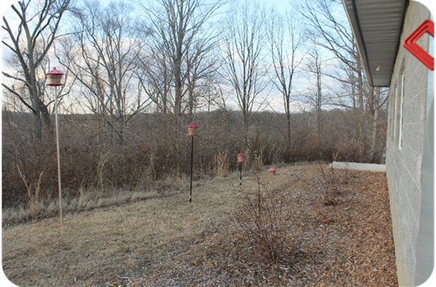
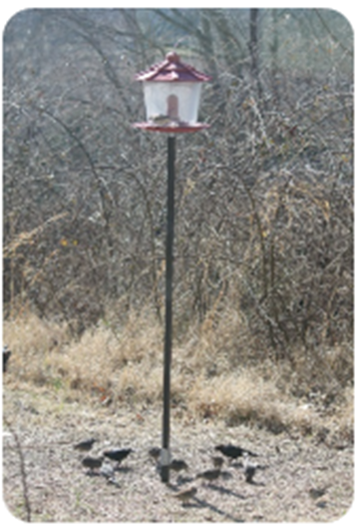
Figure 1. Site of observation at the Environmental Education Center.
Data Collection
During a span of three weeks our group gathered a total of twelve data sets. We recorded data on two specific days throughout the week, Tuesday and Thursday. On these days at 11 o’clock in the morning and 4 o’clock in the evening, at the Environmental Education Center, a group of two students observed and recorded our response variables, number of individuals and number of species. We collected weather data including humidity, cloud cover, UV index, precipitation, wind speed, temperature, and barometric pressure before each session. Specific weather data were acquired from Weather Underground (https://www.wunderground.com). Then we set up phone cameras to live record our observations for fifteen minutes and observed the activity patterns of birds by counting number of species and number of individuals of each species. Identification of each bird was taken by observing the various colors, size, patterns, and shape. If there was a bird we questioned or did not know, we captured an image of the specimen with a camera for further analysis and identification. We used Merlin Bird ID and National Audubon Society Field Guide to North American Birds for species identification.
Data Analysis
After all of the data was collected, it was then transferred into Microsoft Excel to be analyzed. It was categorized by day of observation and time of day. The species were listed and how many of each were observed. Dominance and heterogeneity were found using the Shannon-Weiner index for heterogeneity, H’= ΣPi*lnPi, and Simpson’s index for dominance, D = ΣPi. Then, graphs were constructed to show correlations between the predictor and response variables. The predictor variables included; temperature, wind speed, humidity, cloud cover, UV index, air pressure, and precipitation while the response variables included; number of species, total of individuals, heterogeneity and dominance. For the testing we utilized “R”, a statistical analysis program, which ran simple linear regression tests. This particular test was chosen to compare two or more variables in order to display a correlation, such as a correlation between the number of species and the temperature.

Results
Over a three week span of data collection, we observed a total number of 757 birds who visited the feeders. From that total number of individuals we identified a total of fifteen species. With this information we described each weather parameter into the two categories, number of species and number of individuals.
In the case of air pressure, we found that there was a higher number of species or individuals around the lower and the higher mmhg (Figure 1). Also, that was a slight dip in the middle of each of the polynomial curves in both graphs around 30 mmhg to 30.2 mmhg. In both cases of the temperature there was a decrease in the number of species and the number of individuals in response to the increase of temperature (Figure 2). The highest number of species or individuals was discovered between 0 to 5 degrees Celsius and the lowest was at around 20 degrees Celsius which displayed a negative linear correlation. For humidity and number of species there was a polynomial cure that displayed that there was a higher number of species at the lower and higher percent of humidity (Figure 3E). There was a slight dip around the middle of the overall percent of humidity with the species. While in the humidity and number of individuals it shows an increase in individuals as the humidity increased and displayed a positive linear correlation (Figure 3F). In the case of ultraviolet index and number of species there was a polynomial curve where at the lower and higher index there was lower number of species. Then in the middle of this curve there was an increase in species around 2 to 3 ultraviolet index (Figure 4G). Then when it was ultraviolet index and number of individuals there was a very sight positive linear correlation so the higher the index the more individuals (Figure 4H). In the case of the wind speed in correlation to the number of species or number of individuals there was a negative linear regression (Figure 5). In each of the scatter plots there was a decrease in species or individuals as the wind increased. Finally in the case of cloud coverage there was negative linear regression in both scatter plots when comparing to number of species or number of individuals, and as there was more cloud coverage there were less birds (Figure 6). We then made a table of averages for each of the day’s observations and then displayed them to compare over the three week span for each day (Table 1).
Following our graphs that we created, we performed a simple linear regression test to further examine if the comparison of the weather parameters and the number of species (Table 2) or the number of individuals (Table 3) displayed a significant P-value. Throughout all of the predictor variables we found that the only weather parameter that did not follow our null hypotheses was temperature in correlation to the species. This single correlation was significant and that all others were proved insignificant. Further examination of our original data also examined the significance of the dominance (Table 4) and the heterogeneity (Table 5) in relation to each predictor variable. In each of those tables there was no significant values and no true correlation in comparison to any of the weather parameters.
Discussion
Throughout our study it was discovered that each of our null hypotheses were supported excluding our null hypothesis of temperature in correlation bird activity. Specifically, it was shown that there was a significant correlation between the temperature and number of species. Although, when temperature was correlated to the number of individuals it was displayed as insignificant. The number of species compared to the temperature displayed that there was a p-value of 0.05337 which shows that there was a correlation between temperature and the amount of bird species feeding at the feeders.
Considering previous studies, it was found that variation in temperature can produce significant changes in foraging habits of birds (Grubb 1975). This information can be correlated to our results which display higher bird activity with lower temperatures and a decrease in bird activity at higher temperatures. However in this study, the response variable of barometric pressure, was not significant for species of birds or for the number of individuals. Therefore, it contradicts the study about white throated sparrows where a decrease in barometric pressure caused an increase in bird activity (Metcalfe 2013). That pattern observed in the previous study was not observed in our study.
A possible setback of the study was that there was a lack of variation in the weather parameters over the length of our three weeks of observation. There was a constant lack of precipitation to observe on days that data was collected. Also, barometric pressure barely increased or decreased on the days data was collected. It always fell in the range of 29 to 31 millimeters of mercury. The lack of variation in the weather parameters could have contributed to the circumstance that the majority of the hypotheses were supported. Another possible error would be the amount of time spent on this study. Short term studies of this nature could not possibly yield significant relationships between bird activity and weather patterns due to the lack of variation in three weeks.
Building off the previous statement, a longer study could possibly result in significant data in more than one weather parameter. Instead of doing this study again for three weeks, conducting it for six weeks, nine weeks, or longer throughout varying seasons could result in more significant relationships between variables. Also, altering the observation times from eleven in the morning or four in the evening could result in different data. An earlier morning time could be added to see if there is higher bird activity with the new observation time as well as adding an early afternoon and later evening observation. The changes in these observation times have the potential to alter the significance of any predictor variable.
In conclusion, it was found that changes in weather do not affect bird activity and their foraging habits except in the case of temperature and species. However, further research that studies how weather patterns affect birds could possibly bring new insight on the species of bird activities and their individual foraging habits. Supplemental investigation into weather parameters in correlation to bird activity, research could bring light to possible new bird conservation ideas for future endeavors. Understanding how multiple parameters of weather affect birds could assist researchers on how the patterns of multiple species for their interactions while feeding, feeding times in correlation to migrating, and other various activities.

Literature Cited

Breuner, C, Rachel S.S., Stephen H.P., and Woods H.A. 1982. Environment, behavior and physiology: do birds use barometric pressure to predict storms? The Journal of Experimental Biology 216: 1982-1990.
Grubb, T.C., 1975. Weather-Dependent Foraging Behavior of Some Birds Wintering in a Deciduous Woodland. The Condor, 77: 175-182.
Metcalfe J., Schmidt K., Kerr W., Guglielmo C., and MacDougall-Shackleton S. 2013. White-throated sparrows adjust behavior in response to manipulations in barometric pressure and temperature. Animal Behaviour 86: 1285-1290

