Rate of Photosynthesis Lab Report
Molly Farthing, Samantha Fitz, Andrea Soles, Carrie Zimmerman
Longwood University

Introduction:
Plants are heterotrophs, meaning that they produce their own food instead of getting it from their environment. They use photosynthesis to convert light energy into glucose, which the plant can then use as food. The chemical equation for this reaction is as follows:
6CO₂ + 12H₂O → C₆H₁₂O₆ + 6H₂O + 6O₂
During photosynthesis, photons, or particles of light, are absorbed by the pigments in mesophyll cells. These photons then go through a series of reactions inside the chloroplasts that then produce organic molecules. These organic molecules then move outside of the chloroplasts to be converted into glucose. Glucose is then used as energy to fuel respiration.
Because light energy is needed in this reaction, we decided to test factors that affect the rate of photosynthesis. The control group had one light source, was at room temperature, had clear water in a beaker for light to refract through, and used a sodium bicarbonate solution with a pH of 8. To control the experiment every group used the same type of Elodea plant, test tubes, stoppers, and glass pipes. Over-all it was a fairly controlled experiment. Using the control group as a reference, the different groups manipulated their set-up’s. Group 1 was the control, group 2 lowered the pH of the bicarbonate solution to 6, group 3 used two light sources, and group 4 used blue water in their beaker. Our group, group 5, believed that if we replaced the sodium bicarbonate solution, which was the carbon source for the plant, then the rate of photosynthesis would decrease.
We predicted that lowering the pH of the solution would decrease the rate of photosynthesis, this hypothesis was made hastily in the lab with no further research. With the addition of scholarly research as well as the evidence from our own experiment, we determined that this prediction was wrong. In a similar experiment using Euglena gracilis, it was found that the rate of photosynthesis was most efficient when the pH of the solution that the Euglena was in was at a pH of 6 (Danilov, 2001).
We also predicted that the rate of photosynthesis would increase when exposed to two times the normal light source. Similarly to the prediction of the pH, this was made with no background research. Upon further investigation it was discovered that how intense the light source did not make a difference of the rate of photosynthesis. This can be seen in a study on a marine diatom in which the rate of photosynthesis and growth were measured after fluctuating the light intensity to mirror that of the natural day time. It was found that the intense afternoon light had no effect on the rate of photosynthesis if not a slightly lowering effect (Marra, 1978).
We did not think that the violet water would have an effect on photosynthesis, however as stated above we did predict that removing the carbon source from the experiment would slow the rate of photosynthesis. As we learned in class and from the book, without carbon, plants cannot complete photosynthesis as normal. In normal photosynthesis ATP reduces carbon dioxide to produce glucose, this is called Carbon Fixation or The Calvin Cycle (Cain, 2009). Through this cycle plants can complete C₃ photosynthesis which yields the optimum ATP and glucose products. If a carbon source were to be removed, the plant could not go through the Calvin Cycle and would be forced to uses photorespiration which is highly adaptive in some plants but is not ideal in others. In fact, when using oxygen alone instead of carbon dioxide, the plant loses 20% of its photosynthetic fixed carbon is lost (Cain, 2009).

Method
In this experiment, the rate of photosynthesis of the Elodea plant was measured after four manipulations were done in each level. In the first level was the control level; in this group the procedure was completed as described by the lab instructions. The Elodea was placed into the test tube and filled with the carbon source solution, in this experiment sodium bicarbonate was the carbon source. The test tube was capped with a stopper fitted with bent glass tubing; the volume in the test tube was then marked. The test tube with the Elodea was placed on a test tube rack so that it wouldn’t move and the measurements wouldn’t be tampered with. A beaker with water was placed between the test tube and a light. A 60-watt light bulb was placed into a lamp provided by the lab and was turned on and adjusted so that the light was as close to the beaker as possible and directly on the Elodea. See Figure 1 for a photo representation of the control group experimental setup. After the lamp was turned on it was left on untouched for 20 minutes. The rate of photosynthesis was measured by comparing the initial level of the water to the level of the water after the 20 minutes in millimeters. This number was then multiplied by three to get the rate of photosynthesis per hour.
There were four manipulations to the control group. The first manipulation was to lower the pH of the solution that the Elodea was in. The initial pH of the solution was measured to be an 8, to lower the pH, several drops of hydrochloric acid (HCl) was added were added until the pH was measuring at 6. This manipulation visually looked like the control experiment. The second manipulation measured the effect that a doubled the light source had on the Elodea rate of photosynthesis. Instead of one 60-watt lamp being placed directly on the plant, there were two. See Figure 2 for a visual representation of the double light source manipulation.
The third manipulation measured the effect that violet water had on the rate of photosynthesis. To measure this, 10 drops of violet food coloring were added to 1900 mL in the beaker in between the lamp and the test tube with the Elodea in it. The last manipulation was to remove the carbon source from Elodea. Instead of filling the test tube with the sodium bicarbonate solution, the Elodea was placed into a test tube filled with spring water. This manipulation visually looks the same as the control; see Figure 1 for a visual representation of the set up.
Results:
As can be seen in the graph and the table below, the control condition of photosynthesis had a rate of 18mm/hr. The second group with the lowered pH in the Elodea solution had a rate of photosynthesis of 111 mm/hr implying that the addition of hydrochloric acid to the Elodea greatly increased the rate of photosynthesis. The third group double the light source that the Elodea was exposed to, the rate of photosynthesis was measured at 18 mm/hr implying that doubling the light source had no effect on the rate of photosynthesis. The fourth group added violet food coloring to the water in the beaker between the test tube and the light source, the rate of photosynthesis was measured at 15 mm/hr which is close enough to the control rate that this manipulation is considered not to have had a significant impact on the rate of Elodea photosynthesis. Finally the last group removed the carbon source from the Elodea and replaced it with spring water. The water displacement was measured to be at 9 mm/hr. This means that removing the sodium bicarbonate from the experiment slowed the rate of photosynthesis by half. See Figure 4 for a graphical representation of the experiment.

Raw Data
Group 1 (Control) | 18 mm/hr
Group 2 | 111 mm/hr
Group 3 | 18 mm/hr
Group 4 | 15 mm/hr
Group 5 | 9 mm/hr

Discussion:
In this experiment, the rate of photosynthesis in the control group was 18 millimeters per hour. The test with two light sources had the same rate. The rate of photosynthesis was probably limited by another factor that was not changed within the experiment (Rate of). The hypothesis of this test was that the rate would be increased due to the increased light. In another test, the pH was lowered from 8 to 6 and the rate of photosynthesis was 111 millimeters per hour. It was hypothesized that the lowered pH would slow the rate of photosynthesis. Every reaction has an optimum pH to perform at the most effective rate. The lower pH is likely to be closer to the optimal pH for photosynthesis in this plant. The reaction between the hydrochloric acid and the sodium bicarbonate could have caused a fizz in the solution, speeding up photosynthesis. In one experiment, the carbon source was removed from the solution. In this test, the rate of photosynthesis was the slowest at 9 millimeters per hour. It was hypothesized that removing the carbon source would slow the rate of photosynthesis, which is correct. Finally, a test was done with different colored light. The light was changed from white light to blue/violet light. This rate was the slowed to 15 millimeters per hour. The hypothesis of this test was also that the rate of photosynthesis would be slowed. The wavelength of the light was changed as it passed through the blue filter placed in front of the plant, affecting the amount of light absorbed by the plant and slowing the rate of photosynthesis.
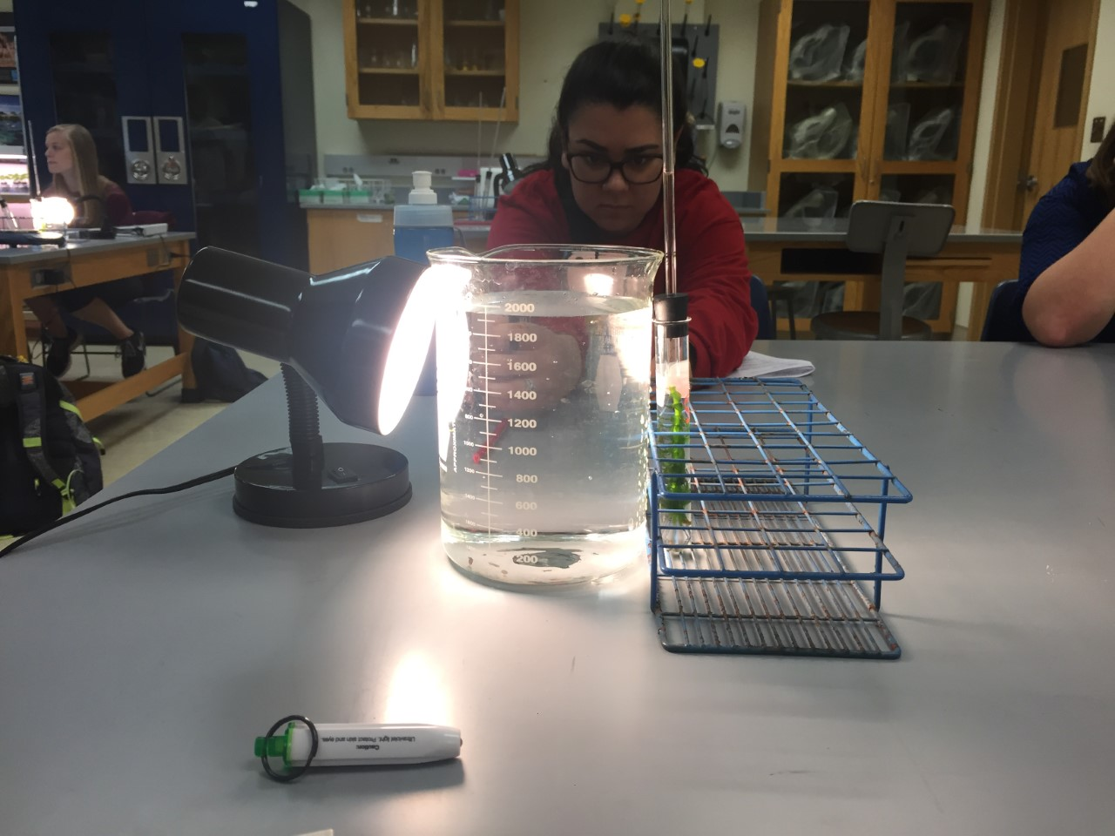
Figure 1. The setup for the control, pH manipulation, and the removal of the carbon source manipulation.

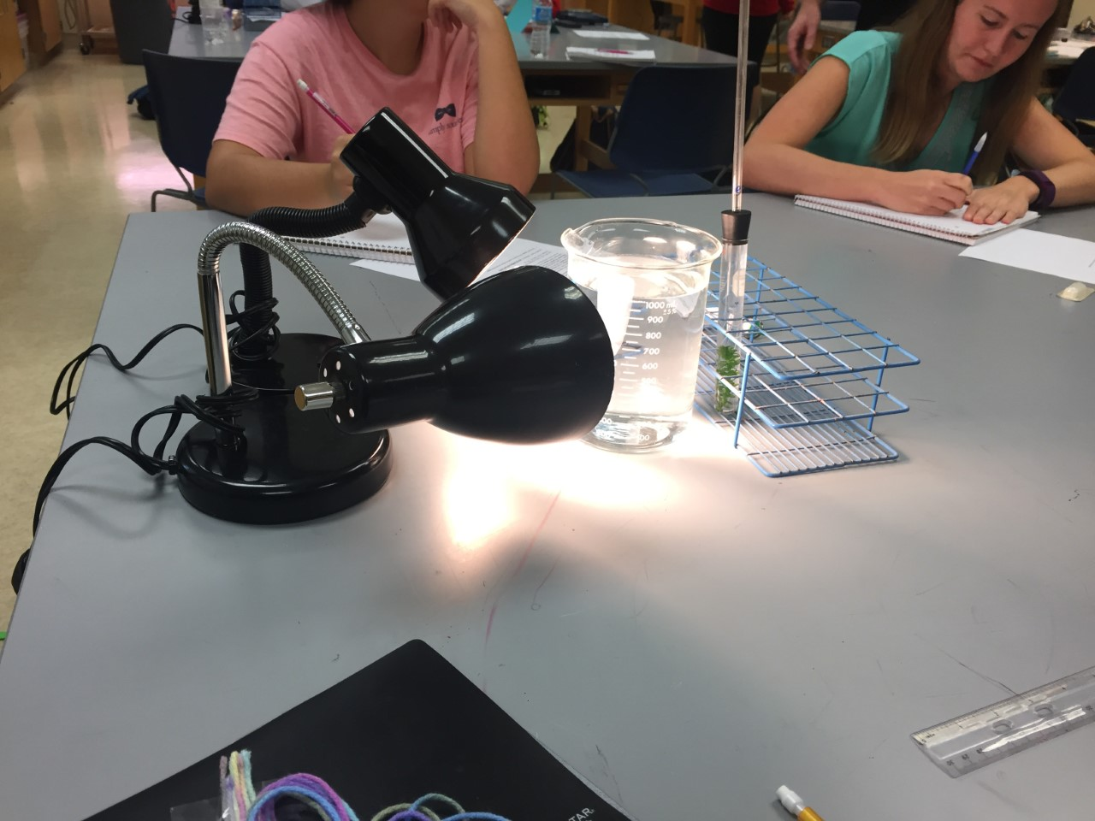
Figure 2. The third group, the addition of a second 60-watt light source setup.

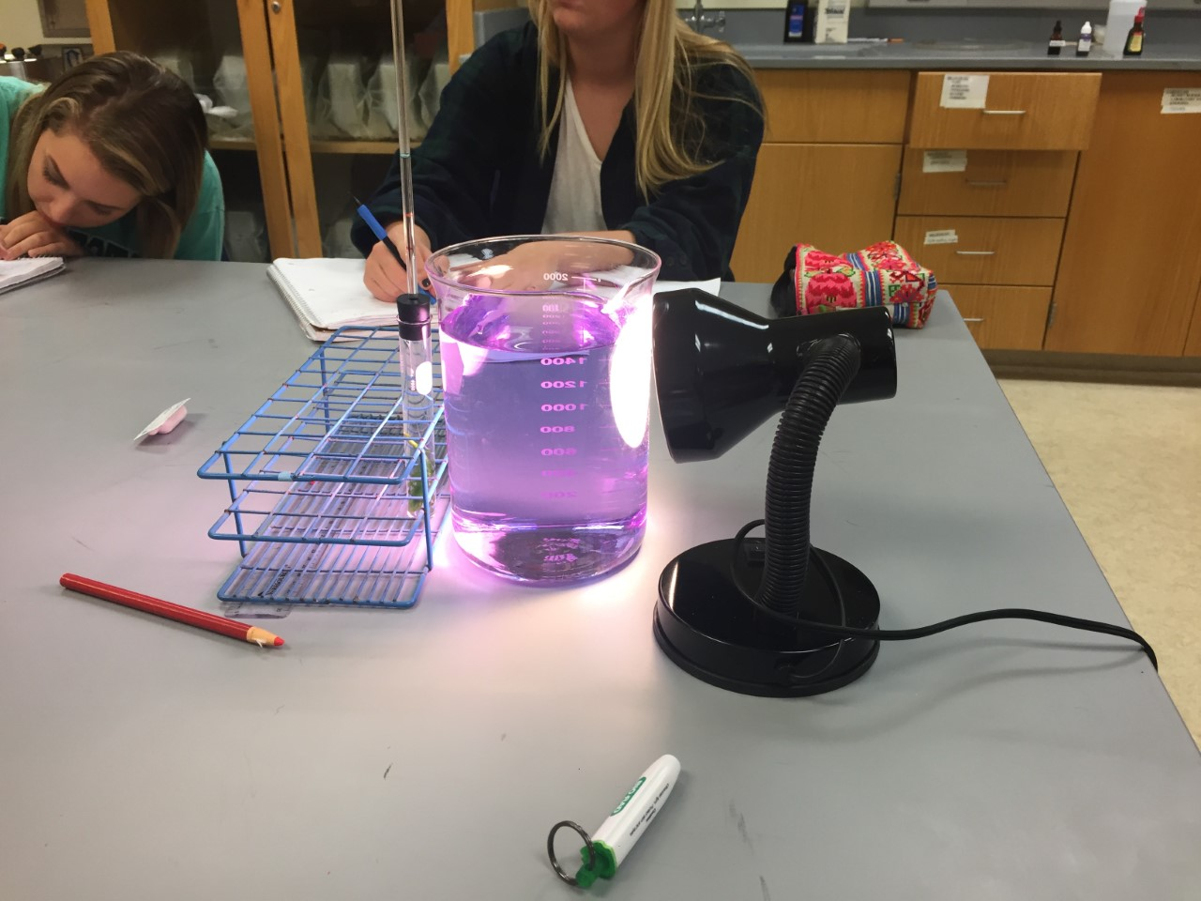
Figure 3. The fourth group manipulated the experiment by adding violet food coloring to the beaker of water separating the light source and the Elodea.

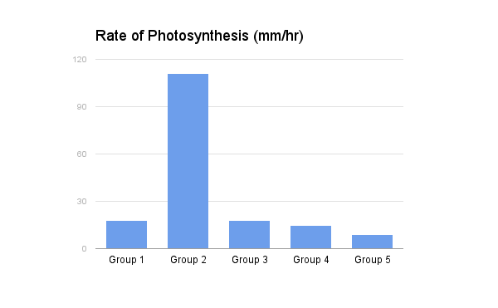
Figure 4. The lowered pH in group two most greatly affected the rate of photosynthesis of the Elodea, the lack of a carbon source in group five, reduced photosynthesis by half. There was no change in the rate of photosynthesis from the control in the third groups double light source or the fourth groups violet water condition.

References
Cain, M.L., C.K. Yoon, A. Singh-Cundy. 2009. Discover Biology, 4th Edition. W. W. Norton &
Company. New York, NY. 517 pp.
Danilov, R.A. & Ekelund, N.G.A. Folia Microbiol (2001) 46: 549. doi:10.1007/BF02818001
Marra, J. Mar. Biol. (1978) 46: 191. doi:10.1007/BF00390680
Rate of photosynthesis: Limiting factors. (n.d.). Retrieved October 12, 2016, from
http://www.rsc.org/learn-chemistry/content/filerepository/CMP/00/001/068/Rate of
photosynthesis limiting factors.pdf

