Comparison of Estrogen Receptor Activation by Parabens versus Brominated Parabens
Andrea Soles and Rex Liggon
Biology of Cancer 450
3/26/18

Abstract
Parabens can be found in the majority of cosmetics and other health products used by people around the world. Recently, parabens have been found to increase the likelihood of developing cancer. Studies have found that parabens can activate the estrogen receptors and as a result, that activates the genes used in cell proliferation. In this study, we changed the structure of various parabens by substituting Bromine at position 3 and 5 on our parabens of choice. We observed and compared the methyl, ethyl, butyl, propyl, and isobutyl parabens between their brominated counterparts on their effects on Cyclin D and E, C-myc, p21, and B-actin as a control. A proliferation assay was performed to measure cell proliferation and found that the brominated parabens displayed a significant decrease in proliferation, almost equaling the proliferation results of the controls. A LDH (Lactate dehydrogenase) assay was performed and showed that the parabens had similar lysis percentages, but there were a few parabens that had a high or very little percent lysis. Lastly, RT-PCR was performed. The results showed that the brominated parabens displayed a decrease expression in cyclin D, E, and C-myc and a positive expression of p21 compared to the normal parabens. Overall, the results showed that brominated parabens are blocking estrogen receptor binding and activation of cell proliferation.

Introduction
The use of parabens is extremely common in the commercial industries world. They gained their popularity for strong anti-microbial properties to preserve the freshness of what every material they are combined with. However, recent data has been linking them to playing a role in developing breast cancer and a few others through absorption through the skin and through ingestion. This is incredibly alarming because of their popular use in cosmetics. A study showed that paraben esters can absorb through the skin within a few applications causing osteogenic stimuli (Darbre and Harvey, 2014), and another study showed that exposure to ultraviolet absorbing parabens can increase metastasis in human breast cancer cells (Almer and Darbre, 2017). It’s even been shown that intact parabens have been found in breast tumorous tissue (Harvey and Darbre, 2004). With news as alarming as this, something must be done to replace the use of parabens in cosmetics.
Parabens can activate the estrogen receptor (ER) turning on many genes needed for proliferation. It was first believed that paraben mimic estrogen in both size and shape along with what genes they regulate. While they do mimic the shape of estrogen, it takes two parabens to activate the ER, and each paraben turns on their very own sets of genes only sharing a few with estrogen (Pugazhendhi et al. 2007). Even in a recent study showed that parabens can successfully decrease the activity of estrogen activating and deactivating ligands 17β-HSD1/17β-HSD2 depending on the size of the ester (Engeli et al. 2017). The genes that do share with estrogen are usually cycle and apoptotic genes. One study showed that when the MCF-10A non-transformed cell line is exposed to parabens, they develop transformed phenotypes in vitro (Khanna and Darbre, 2013), and in Wróbel and Gregoraszczuk’s study methyl-, butyl-, and propyl parabens increased the expression of survival genes and vice versa to apoptotic genes in MCF-7 breast cancer cell line and increased nearly every pro-survival gene in MCF-10A non-malignant cell line (Wróbel and Gregoraszczuk’s, 2014). There are even studies down in vivo. In that study, they use patient xenografts to test parabens effects on proliferation and showed that they do through TIC activity (Lillo et al. 2017). In review, parabens can bind and activate the ER, and the potency is related to size. This only leaves it to the shape of the compound.
In this study, we manipulated the shape of various parabens by substituting Bromine at position 3 and 5 on our parabens. This study is originally part of the Bergquist et al. study and our study were done cooperatively with theirs (2017). In their experiment, they created various Bromo parabens that exhibited weaker osteogenic properties (Bergquist et al. 2017). In this study, we observed and compared the methyl, ethyl, butyl, propyl, and isobutyl between their brominated counterparts on their effects on Cyclin D and E, C-myc, p21, and B-actin as a control. It has been shown that these five parabens are the main versions that are increasing proliferation in human breast cancer cells (Charles and Darbre, 2013). Due to the large bromines obstructing the second paraben from binding to the ER, the brominated parabens should show a decrease expression in cyclin D, E, and C-myc and a positive expression of p21 compared to the normal parabens.

Materials and Methods
Proliferation Assay
A total of 40,000 murine breast cancer cell line E0771 were placed into two 96-well plates. Both plates containing these cells were suspended in triplicates of media, 64 mg/ml of estrogen, methyl, ethyl, butyl, isobutyl, propyl parabens, and the brominated form of each parabens listed. The samples were stained prior to inhibitor treatment with the MTT assay following manufacturer’s instructions. The plates were then incubated for 72 hours at 37 degrees Celsius. 100 ml of Solubilization/ Stop solution was added to each well. Then absorbance was measured and recorded on a color spectrometer.

LDH (Lactate dehydrogenase) Cytotoxicity Assay
Cell viability was measured using an LDH release assay. This was performed using the Pierce LDH Cytotoxicity Assay Kit by Thermo Scientific, following the manufacturer’s instructions. Cultured cells were incubated with chemical compounds (Actinomycin D) to induce cytotoxicity and release LDH. The LDH released was then transferred to new plates and mixed with the Reaction Mixture. The plates were then incubated at room temperature in the dark for 30 minutes. Then the reactions were stopped after the addition of Stop Solution. Absorbance was then measured by a plate-reading spectrophotometer and recorded. Leftover cells not used in the LDH assay were snap frozen at -80 degrees Celsius.

mRNA isolation, cDNA synthesis, and RT-PCR
mRNA was isolated from the snap frozen cells and cDNA was created for use in the RT-PCR procedure. cDNA was created using the ReliaPrep™ RNA Cell Miniprep System Quick Protocol by Promega, following the manufacturer’s instructions. cDNA was then diluted by adding 180 microliters of water. Using the cDNA, RT-PCR was then performed to measure gene expression of c-myc, cyclin D1, p21, and cyclin E with b-actin as a control. The RT-PCR procedure was completed using the GoTaq® 2-Step RT-qPCR System Quick Protocol by Promega. The primer sequences used in the RT-PCR can be found in Table 1 below.

Table 1. Primers used in the PCR Reaction Mixes

Gene | Primers
B-actin | Forward: GTGTGATGGTGGGAATGGGTCAGA  Reverse: TACGACCAGAGGCATACAGGGACA
C-myc | Forward:  AAGGACCCCTCAACCTTGCT  Reverse:  GACAAGAAATCGCCTCTTCGTAT
Cyclin D1 | Forward:  GCCATACATCCCTTCCACAGA  Reverse:  TGGCTCATTCTTTTGCTGAAGT
p21 | Forward:  TGCACTCACATTGTATTTTCCCT  Reverse:  GCCAGTATGGTCACATTGACAGA
Cyclin E | Forward:  ACTGTCATTTGTACTCTGCTCTG  Reverse:  GCAAGTTTCCAACACATATCCCA

Data Analysis
Absorbance of MTT assay data was recorded and made into bar graphs. T-tests were performed in order to find significant differences between the parabens and brominated parabens. Absorbance of LDH data was recorded and made into bar graphs. Ct values were found by RT-PCR and then fold change expression was quantitated for myc, cyclin D1, p21, and cyclin E using the “delta delta Ct” method. The genes of interest were normalized to B-actin and then the normalized values were used to compare between the media, DSMO, estrogen, parabens, and brominated parabens. Four bar graphs of the values were then constructed.

Results
MTT Proliferation Assay and LDH Cytotoxicity Assay Data
The results from the assay showed increased proliferation on the non-brominated parabens compared to the controls. The brominated parabens showed a significant decrease in proliferation nearly equaling the proliferation data for the controls (Figure 1). Significance of the data are shown in Figure 1. The LDH assay show the ability of the cells to resist toxicity through percent lysis. The percent lysis of the cells was shown to have similar outcomes. However, there were certain parabens that showed a higher or very little percent lysis (Figure 2).
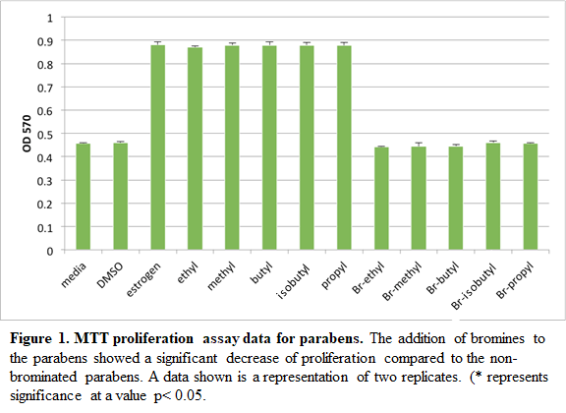

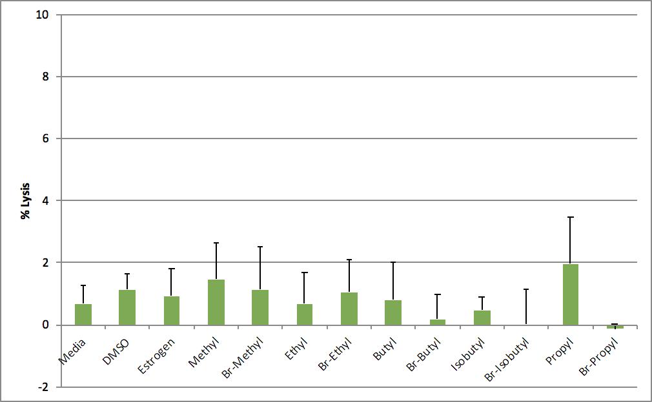
Figure 2. Percent lysis of cells. This shows a side by side comparison of %lysis of cells containing one of each paraben. Most of the parabens show similar levels of %lysis. Both non and brominated butyl- and iso-butyl- parabens showed a decrease along with Br-propyl paraben. Propyl paraben was the only one to show an increase %lysis. All data is representing two replicates.

RT-PCR Data
Gene expression of c-myc, Cyclin D, E, and p21 was recorded through RT-PCR. Expression of c-myc was drastically upregulated by all normal paraben and by Br-Et paraben while all the other brominated parabens retained normal expression or decreased expression (Figure. 3A). Figures 3B and 3C also shared similar data showing a noticeable increase and decrease of gene expression in the same parabens. Expression of p21 contained normal regulation between the brominated parabens and the controls. The other parabens (including Br-Et) showed an extreme deregulation of p21 (Figure. 3D)
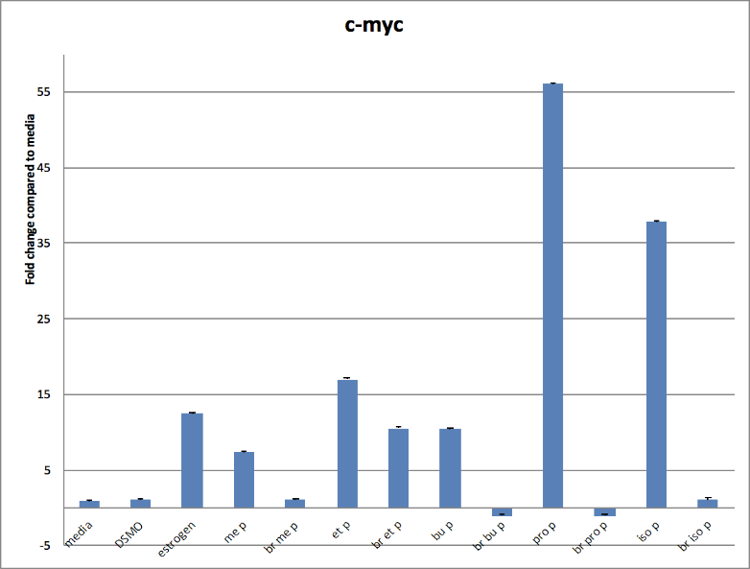
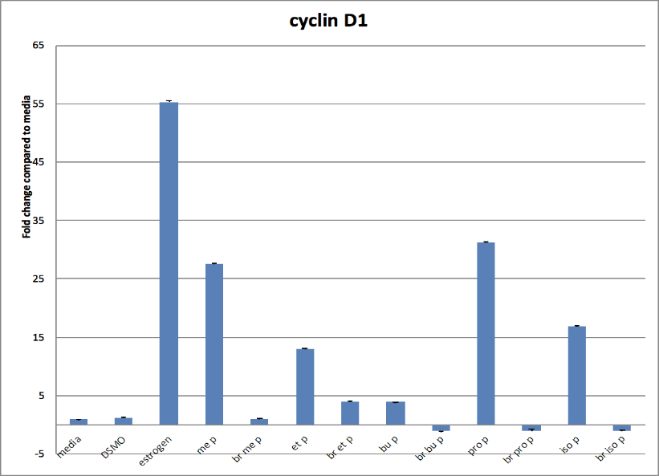
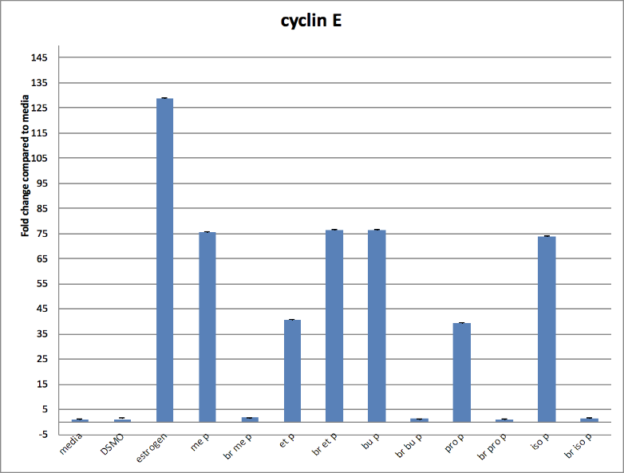
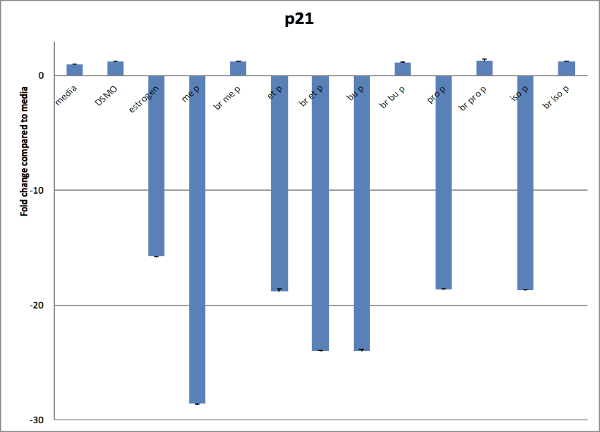
A
B
C
D
Figure 3. RT-PCR Data. These graphs are the representation of the expression of c-myc (A), Cyclin D (B), Cyclin E (C), and p21 (D) effected by the brominated and non-brominated parabens. Each were measured by their 2-fold change expression and representative of two replicates.

Discussion
In this study we found that brominated parabens are blocking estrogen receptor binding and activation of cell proliferation. The one thing that did not go as expected was that the brominated ethyl upregulated the expression of c-myc, cyclin D1, and cyclin E. It also deregulated the expression of p21. Another puzzling detail is that brominated ethyl upregulation of Cyclin E and deregulation of p21 was almost double that of the normal ethyl-paraben. Further examination would be needed to understand this odd result. Besides the brominated ethyl results, our data was shown to coincide with other primary literature relating to the subject. A future direction for this study would be to test our brominated parabens in vivo similar to the patient xenograft study mentioned earlier (Lillo et al. 2017). Overall, this data suggests a possible paraben replacement that could be used in everyday cosmetics and help reduce the number of paraben related cancers.

Works Cited
Alamer M, Darbre P. Effects of exposure to six chemical ultraviolet filters commonly used in personal care products on motility of MCF‐7 and MDA‐MB‐231 human breast cancer cells in vitro. Journal of Applied Toxicology. 2018;38(2):148-159.

Bergquist B, Jefferson K, Kintz H, Barber A, Yeagley A. Disconnecting the Estrogen Receptor Binding Properties and Antimicrobial Properties of Parabens Through 3,5-Substitution. ACS Medicinal Chemistry Letters. 2018;9(1):51-55.

Charles A, Darbre P. Combinations of parabens at concentrations measured in human breast tissue can increase proliferation of MCF-7 human breast cancer cells. Journal of Applied Toxicology. 2013;33(5):390-398.

Darbre P, Harvey P. Parabens can enable hallmarks and characteristics of cancer in human breast epithelial cells: a review of the literature with reference to new exposure data and regulatory status. Journal of Applied Toxicology. 2014;34(9):925-938.

Engeli R, Rohrer S, Vuorinen A, Herdlinger S, Kaserer T, Leugger S, Schuster D, Odermatt A. Interference of Paraben Compounds with Estrogen Metabolism by Inhibition of 17β-Hydroxysteroid Dehydrogenases. International Journal of Molecular Sciences. 2017;18(9):2007.

Harvey P, Darbe P. Endocrine disruptors and human health: could oestrogenic chemicals in body care cosmetics adversely affect breast cancer incidence in women? Journal of Applied Toxicology. 2004; 24(1):167-176.

Khanna S, Darbre P. Parabens enable suspension growth of MCF-10A immortalized, non-transformed human breast epithelial cells. Journal of Applied Toxicology. 2013; 33(5):378-382.

Lillo M, Nichols C, Perry C, Runke S, Krustilina R, Seagroves T, Miranda-Carboni G, Krum S. Methylparaben stimulates tumor initiating cells in ER+ breast cancer models. Journal of Applied Toxicology. 2017;37(4):417-425.

Pugazhendhi D, Sadler A, Darbre P. Comparison of the global gene expression profiles produced by methylparaben, n-butylparaben and 17β-oestradiol in MCF7 human breast cancer cells. Journal of Applied Toxicology. 2007;27(1):67-77.

Wrobel A, Gregoraszczuk E. Differential effect of methyl-, butyl- and propylparaben and 17β-estradiol on selected cell cycle and apoptosis gene and protein expression in MCF-7 breast cancer cells and MCF-10A non-malignant cells. Journal of Applied Toxicology. 2014; 34(9):1041-1050.

