MicrRobo Cop: Synthetic Biology Lab Report
Introduction
Synthetic biology is a complex field where artificial biological systems are engineered to look into biological phenomena and certain processes (Andrianantoandro et al., 2006). It focuses on the whole systems of genes and their products and because of that focus, synthetic biologists can design and create artificial biological systems (Andrianantoandro et al., 2006). An example of synthetic biology is the engineering of microbial consortia. These microbes are good for environmental remediation, wastewater treatment, and food digestion (Brenner et al., 2008). The biologists engineered the behavior of the microbes to make them focus on certain functions, such as drug and fuel production (Brenner et al., 2008). Another example of synthetic biology is an experiment where biologists where interested in how they could engineer a bug to produce a biofuel similar to petroleum (Lee et al., 2008). Several groups tried this experiment and got the bugs to create low amounts of molecules similar to petroleum (Lee et al., 2008). The main goal of synthetic biology is to modify the behavior of organisms and to engineer them to carry out new tasks (Andrianantoandro et al., 2006).
The beneficial use of synthetic biology is that it can help make research and development of ideas faster and more organized (Kelle, 2013). Six areas can see improvements from this and they are biomedicine, biopharmaceuticals, sustainable chemical industry, the environment and the energy it produces, the production of smart material and biomaterials, and counter-bioterrorism resources (Kelle, 2013). However, with synthetic biology being a relatively new thing, there are some negatives associated with it. Sometimes, things do not go as planned. If the function of each part is known, the expected result may not happen when they are put together (Kwok, 2010). That can lead to many trials trying to fix that error and a lot of frustration. It is also a costly and time-consuming process especially if it is a big project (Kwok, 2010). That can be a major turn off to scientists who are interested in a project that requires synthetic biology.
Gunshot residue is a group of particles made during the use of a firearm. The residue is usually made of partially burnt propellant powder, particles from the ammunition primer, smoke, grease, lubricants, and metals (Oliver et al., 2010). When fired, combustion products are released onto the nearest surface which is usually a person’s hand. Gunshot residue can be detected through a scanning electron microscope. This can be done through particle analysis which can identify residue particles through morphological and elemental characteristics (Romolo and Margot, 2001). However, this method and other methods, like x-ray fluorescence, used to detect gunshot residue may not always work correctly or in a timely manner.
The experimental goal of this research is to manipulate E. coli to quickly detect gunshot residue on people who have just fired a gun. To reach this goal we will engineer and express the plasmids from PpbrA-RFP in E. coli. That way gunshot residue will turn a fluorescent red when detected on a person’s hand. The hypothesis of this experiment is that the expression of the lead binding protein (PpbrA-RFP) will allow for the detection of gunshot residue to be seen on peoples’ hands.

Materials and Methods

Plasmid Isolation
The first step was harvesting and that was done by transferring 1.5 mL of the cultured bacteria that contains J10060 plasmid with pBad promoter RFP (red fluorescent protein) to a microcentrifuge tube. It was microcentifuged for 1 minute and the supernatant was discarded. The second step was re-suspension and that was done by adding 200 μl of PD1 Buffer to the tube and the cell pellet was resuspended by vortexing. The third step was lysis and that was done by adding 200 μl of PD2 Buffer. It was mixed (not vortexed) by inverting the tube 10 times. The mixture was left to stand for 2 minutes. The fourth step was neutralization. That was done by adding 300 μl of PD3 Buffer and mixed immediately by inverting the tube 10 times. Then it was microcentriguged for 3 minutes. The fifth step is DNA binding. A PD column was placed into a 2-mL collection tube. The supernatant from step 4 was added into the PD column and microcentrifuged for 30 seconds. The flow through was discarded and the PD column was placed back into the 2-mL collection tube. The sixth step was to wash. 400 μl of W1 Buffer was added to the PD column, microcentrifuged for 30 seconds, and the flow through was discarded. The PD column was placed back into the 2-mL collection tube and 600 μl of wash buffer was added into the column. It was microcentrifuged for 30 seconds and the flow through was discarded. The PD column was placed back into the 2-mL collection tube and microcentrifuged for 3 minutes to dry the column matrix. The final step is DNA elution and that was done by transferring the dried PD column to a new microcentrifuge tube and 50 μl of elution buffer was added. It stood for 2 minutes and then finally microcentrifuged for 2 minutes to elute the DNA.

Restriction Enzyme Digestion and Ligation
For restriction enzyme digestion, the plasmid DNA (plasmid with pBad promoter that controls RFP expression) was isolated and a tube with the annealed Ppbr A promoter DNA was obtained. A tube containing EcoRI and NheI pre-mixed with buffer (restriction enzymes) was also obtained. Two reactions were then set up. The first one was for the plasmid DNA. That contained 10 μl of plasmid DNA, 2 μl of water, and 8 μl of EcoRI/NheI. The second one was for the Ppbr A promoter DNA. That contained 10 μl of Ppbr A DNA, 2 μl of water, and 8 μl of EcoRI/Nhel. Both of the samples were mixed by pipetting gently up and down. The samples were incubated for 30 minutes at 37 degrees Celsius. The samples were then heated at 80 degrees Celsius for 5 minutes to inactivate the enzymes.
For ligation, the plasmid and Ppbr A promoter DNA that were digested with EcoRI and NheI were obtained. A reaction was set up in a microcentrifuge tube on ice. The components were 2 μl of 10X T4 DNA Ligase Buffer, 3 μl Plasmid DNA, 10 μl Ppbr A, 4 μl Nuclease-free water, and 1 μl of T4 DNA Ligase (leave this component for last). The reaction was mixed by pipetting up and down and microcentrifuged briefly. Then it was incubated at room temperature for 10 minutes for the cohesive (sticky) ends. Lastly, the reaction was heated for 10 minutes at 65 degrees Celsius.

Transformation
For transformation, a tube of 20 μl NEB 5-alpha Competent E. coli cells were thawed and then 5 μl of plasmid DNA was added to the cell mixture. The tube was flicked 5 times to mix the cells and DNA. The mixture was placed on ice for two minutes then was heat shocked at 42 degrees Celsius for 30 seconds. Then the mixture was placed back on ice for 2 minutes. 380 μl of room temperature SOC was pipetted into the mixture then was immediately spread onto a Luria Broth agar plate that contained ampicillin. That was then incubated overnight at 37 degrees Celsius. The plate was then checked after 24 hours.

Polymerase Chain Reaction(PCR)
For PCR, a reaction was set up. The reaction included 0.5 μl of 10 μM Forward Primer, 0.5 μl of 10 μM Reverse Primer, 12.5 μl of OneTaq 2X Master, and 11 μl of nuclease-free water. The PCR primer sequences that were used to test for Ppbr A promoter were: Forward- 5’ GCCGCTTGAATTCGTCATATAT-3’ and Reverse- 5’ GCCGCTTGAATTCGTCTAGACT-3’. Four colony samples of transformed E. coli were scraped onto a new and sectioned off agar plate. The four colony samples were then placed into separate tubes. The PCR tubes containing the samples were then placed into the PCR machine for thermocycling. The initial denaturation was 94 degrees Celsius and lasted for 30 seconds. Then there was 30 cycles of the temperature being at 94 degrees Celsius for 30 seconds, 55 degrees Celsius for 45 seconds, and 68 degrees Celsius for 60 seconds. The final extension was at 68 degrees Celsius for 5 minutes and a hold at 4 degrees Celsius.

Gel Electrophoresis
First an agarose gel was casted. That was done by mixing 0.4 grams of agarose and 40 mL of 1X TAE buffer in a 125 mL Erlenmeyer flask. Then the mixture was microwaved until the agarose dissolved and was set out to cool. While wearing gloves, 4 μl of ethidium bromide was added to the mixture. The mixture was then poured into the gel tray and a comb was inserted at the top of the gel tray to create wells. The gel solidified and the comb was removed. Then 5 μl of loading buffer was added into each PCR tube. The electrophoresis chamber was filled and covered with 1X TAE buffer. 10 μl of each sample added into separate wells in the gel. The lid was put on and the electrical leads were put into the power supply. The power was turned on and the gel ran at 120 V for 30 minutes. When that was done, a UV camera was used to take a picture of the gel.
Plasmid Isolation/ Function Check /Nanodrop
Plasmid DNA from one E. coli colony that had the PpbrA promoter controlling the expression of RFP was isolated using the same process completed earlier. A function check was performed to indicate whether or not the plasmid isolated and engineered is performing the correct function by expressing the RFP in the presence of lead. To do a function check, the E. coli was streaked onto two plates: 1-LB/ampicillin agar plate (no lead) and 1-LB/ampicillin/lead agar plate (100 μM). The plates incubated at 37 degrees Celsius for 24 hours and then were checked. Lastly a nanodrop was performed on the DNA sample to check quantity and quality.

DNA Sequencing
DNA sequencing was performed to check to see if what was isolated was the PpbrA promoter RFP gene in the J10060 plasmid. A reaction was made to send to the sequencing company, EurofinsGenomics. The reaction included 5μl of the plasmid, 4μl of the sequencing primer (Forward- 5’-GTAAAACGACGGCCAGTG-3’ and Reverse- 5’-GGAAACAGCTATGACCATG-3’), and 3μl of deionized water.

Results

The methods performed yielded important results indicating that we were successful in engineering the PpbrA promoter RFP gene in the J10060 plasmid. 24 hours after transformation, the agar plate was check. There was a tremendous amount of growth on the plate. There were many tiny, white colonies that had formed on the plate. After PCR, a gel electrophoresis was done.
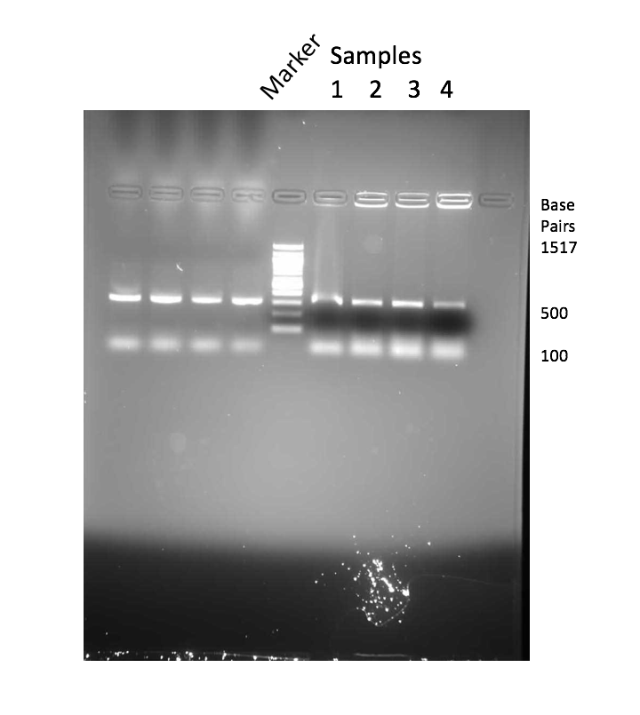
Fig. 1 Agarose gel of plasmid digested with EcoRI and NheI. Colony PCR for insertion of PpbrA promoter products were run a gel electrophoresis. Lanes 6-9 have DNA from four different E. coli colonies. Lane 5 has the molecular weight markers.

In Fig. 1, there are bright bands shown at around 400-500 base pairs. This indicates that there is the presence of the PpbrA lead expressing promoter in the colony samples chosen for the gel electrophoresis.
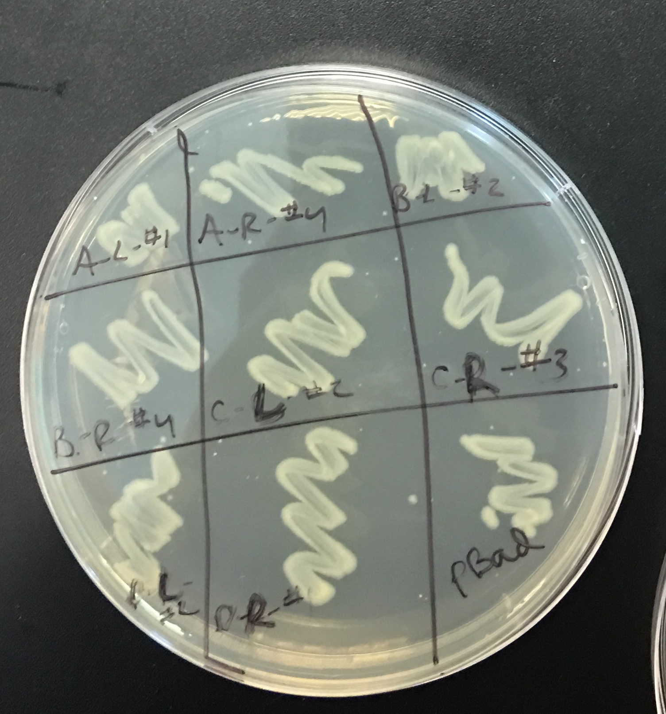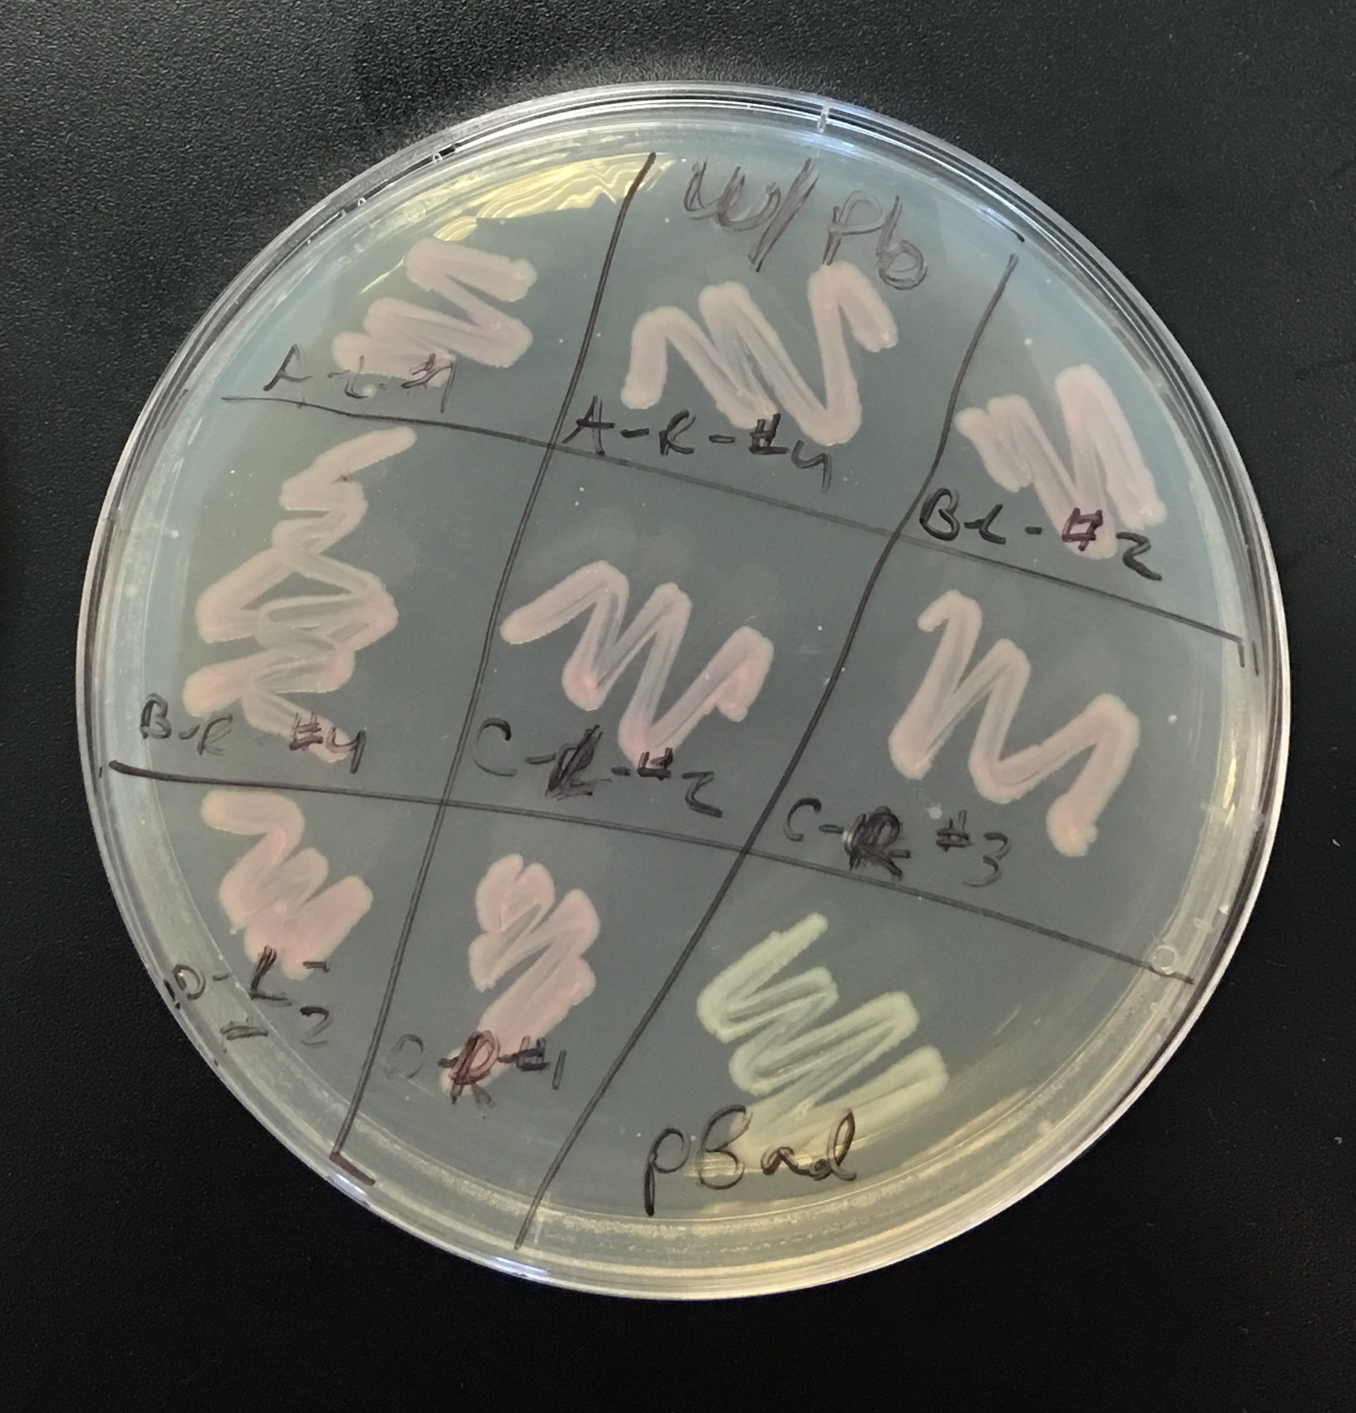
Figure 2 Function Check of the Sample. E. coli samples were streaked onto two plates: 1-LB/ampicillin agar plate (no lead) on the left and 1-LB/ampicillin/lead agar plate (100 μM) on the right.

The function check indicated that our plasmid was engineered correctly. In the presence of lead, it emits a red fluorescent color. This can be seen in Fig. 2. The nanodrop of our isolated plasmid showed that the DNA concentration was weak. It was 6.9 ng/μl. The 260/280 ratio was 3.44 and the 260/230 ratio was 1.33. The DNA sequence of the plasmid sample that was done by EurofinsGenomics was 5’GCCGCTTGAATTCGTCTTGACTCTATAGTAACTAAGGGTGTATAATCGGCAA
CGCGAGCTAGCGCAT-3’.

Discussion
The goal of this lab was to manipulate E. coli to be able to quickly detect gunshot residue on people who have just fired a gun. To reach the goal, the plasmids from PpbrA–RFP in E. coli needed to be engineered and expressed. The hypothesis of this experiment was that the expression of the lead binding protein (PpbrA-RFP) would allow for the detection of gunshot residue to be seen on peoples’ hands. The hypothesis was supported because the transformation of the promoter to indicate lead and emit a fluorescent residue when a gun is fired was successful. The function check gives us visual confirmation that we successful expressed the lead promoter and RFP gene. For future studies, maybe this can be performed in yeast or some other common bacteria. Studying this in different bacteria may yield some different results. This study is important because gunshot residue detection can be a timely process. It is important that there can be a way to detect the residue on the spot in a matter of seconds. Success of this research can help the police tremendously when investigating crimes and identifying culprits in under a minute.

Works Cited
Andrianantoandro E, Basu S, Karig D, Weiss R. 2006. Synthetic biology: new engineering rules for an emerging discipline. EMBOpress. 2(1).

Brenner K, You L, Arnold F. 2008. Engineering microbial consortia: a new frontier in synthetic biology. 26(9):483-489.

Kelle A. 2013. Beyond patchwork precaution in the dual-use governance of synthetic biology. Sci Eng Ethics. 19(3):1121-39.

Kwok R. 2010. Five Hard Truths for Synthetic Biology. Nature. 463.
Lee S, Chou H, Ham T, Lee T, Keasling J. 2008. Metabolic engineering of microorganisms for biofuels production: from bugs to synthetic biology to fuels. 19(6):556-563.
Oliver D, Butler D, Birkett J. 2010. Analysis of Gunshot Residue and Associated Materials- A Review. Journal of Forensic Science. 55(4):924-943.
Pfeifer B, Admiraal S, Gramajo H, Cane D, Khosla C. 2001. Biosynthesis of Complex Polyketides in a Metabolically Engineered Strain of E. coli. Science. 291(5509):1790-1792.
Romolo F, Margot P. 2001. Identification of gunshot residue: a critical review. Forensic Science International. 119(2):195-211.

