How is the Population Density of the Florida Panther Affected by Human Activity?
Andrea Soles and Nikki Copenhaver

Abstract
The Florida Panther, Puma concolor coryi, is an endangered big cat species currently inhabiting the southern tip of the Florida peninsula. This paper explores the effect human activity has had on the population density of the Florida Panther. Data was collected and compiled to analyze the total effect human interference has had on the panther population since early colonization of the United States. Here, we report several factors leading to the population decline and endangerment of the Florida Panther and the selected conservation efforts enacted to repopulate and diversify the gene pool of the animals. According to compiled data, mortality rate of panthers was further increased by disease agents, habitat loss and fragmentation, lack of genetic diversity, over hunting by humans, and the decline in prey availability. Several efforts in conservation have been taken to combat the decline of the panther population including radio tracking collars, selective breeding programs, medical treatment of feline diseases, and panther relocation initiatives. These data support the hypotheses that human activity has led to decrease in panther numbers, and that so far conservation efforts to save the Florida Panther have not been successful in bringing them back to their historical population numbers.

Introduction
The Florida Panther, Puma concolor coryi, is the most endangered mammal in the entire Eastern United States. This large, predatory, mammal, was federally listed as an endangered species in 1967 and has remained on the IUCN Red List for endangered species ever since (The Nature Conservancy, 2018). With a current home range at only a fraction of the size it used to be, there are only an estimated 120-180 individuals remaining in the total population (Coastal Breeze, 2015). Compared to historical populations spanning from the tip of the Florida peninsula, all the way up to Arkansas, Louisiana, and South Carolina (Mountain Lion Foundation, 2018), the Florida Panther has experienced severe population decline and habitat area reduction. Not only is the panther a symbol of the great wilderness that once encompassed the state of Florida, it is also hailed as the beloved state animal as voted by local school children (Coastal Breeze, 2015). According to Tom Trotta, a master naturalist and the president of the Friends of the Florida Panther Refuge, the Florida Panther is also an umbrella species, benefiting many other rare, threatened, and endangered species (Coastal Breeze, 2015). Because the panther requires such large, connected home ranges, it ensures federal protection of large expanses of connected, undeveloped habitat that would otherwise become fragmented and unsuitable for many other endangered organisms to live in. However, even with federally protected lands for panthers to live on, their habitat area is simply too small for the population to be able to grow to its former numbers (The Nature Conservancy, 2018). We must conduct studies like these to determine the success of the panther population as a whole, to know how to properly allocate appropriately sized areas for conservation, to know where to develop housing and construction projects, and to maintain environmentally friendly ecosystem management policies for future generations so that the Florida Panther may be around for many years to come.

Methods

Data was collected and analyzed using previously completed work from other scholars in order to determine if the decreasing population of the Florida Panther is directly correlated with human activity. We used findings from articles published in scientific journals, the work of online panther research organizations, and environmental magazine clippings to aid us in receiving a solid understanding of problems by looking at the issue presented in both layman’s terms and using scientific language. Data on current and historical distribution of the Florida Panther species and subspecies was collected and analyzed. Information on current individual panther locations was also collected using panther telemetry stations. As well as telemetry data, we compiled data on locations of both viremetic and nonviremetic instances of feline leukemia. Finally, human population data from the 2010 United States Census Bureau for the state of Florida was compiled and analyzed. After our work proposal was reviewed and approved, we worked with these datasets that we extracted from other scientific works in order to answer our hypothesis of whether or not the decreasing population of the Florida Panthers is directly correlated with increasing human activity.

Results and Discussion
Disease
From around 2001 to 2005, an outbreak of the feline leukemia (FeLV) took a toll on Florida Panther populations (Figure 1). Feline leukemia is a retrovirus that impairs a cat’s immune system and leads to further complications like cancer. It is a disease that mainly affects household cats and is usually spread by infected cat biting another cat or the exchange of saliva. The symptoms of FeLV are anemia, weight loss, and enlarged lymph nodes (Brown et al., 2008). This disease is historically known to not affect the panthers because they do not possess FeLV antigen. Since 1978, they have always tested negative for exposure or infection to this disease (Brown et al., 2008). In a study completed in 2001, 23 panthers were found to have FeLV antibodies in their system and 5 panthers actually possessed the antigen and eventually died from the disease (Brown et al., 2008). Scientists did more investigating into the outbreak and decided to compare FeLV strains found in the panther and compare them to the strains that have been extracted from domestic cats. They determined that the outbreak originated from a cross species transmission from a single domestic cat. They found that the FeLV-Pco virus in the Florida Panther and the FeLV-945 in domestic cats was similar in structure (Brown et al., 2008). It is unfortunate how one insignificant sick house cat could decrease a population of a species in a matter of years. It shows how destructive and detrimental a disease can be to species, especially an endangered species.
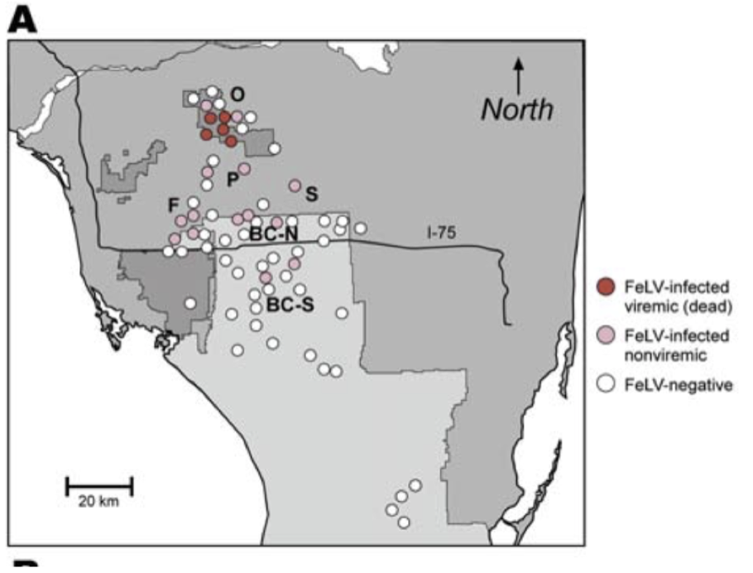Figure 1. Feline Leukemia Statistics from 2008. Panthers were tested to see if there were either positive or negative for the lethal strain of feline leukemia. Data was compiled and put onto a map for areal representation of the spread of feline leukemia.

Habitat loss and fragmentation
The population of the Florida Panther is around 100 individuals and is slowly declining throughout the years (Figure 2). The panthers prefer to inhabit the forest areas compared to the wetlands (Land et al., 2007). Habitat loss and fragmentation are severe threats to panther populations and limit their ability to increase in numbers and expand their territory (Thatcher et al., 2006). The increasing human population in Florida and the new housing developments are encroaching on their territory in the southern peninsula of Florida (Land et al., 2007). The new developments are dividing up the habitat which has created a burden on the panthers and their daily activities. Also, roads and major highways are dividing up the panthers’ habitats (Defenders of Wildlife, 2018). The divisions have caused over many panther deaths by motor vehicle collisions. A record of 25 panthers were killed by cars in 2014 (Defenders of Wildlife, 2018). Scientists believe that these motor collisions and deaths are the main reason why the panthers are having a difficult time expanding their territory across the Caloosahatchee River (Defenders of Wildlife, 2018). Habitat loss and fragmentation of the panthers’ territory has significantly decreased their populations numbers over the years. This species is at a huge risk of becoming completely extinct by housing developments, new shopping centers, roads, and major, traffic-filled highways.
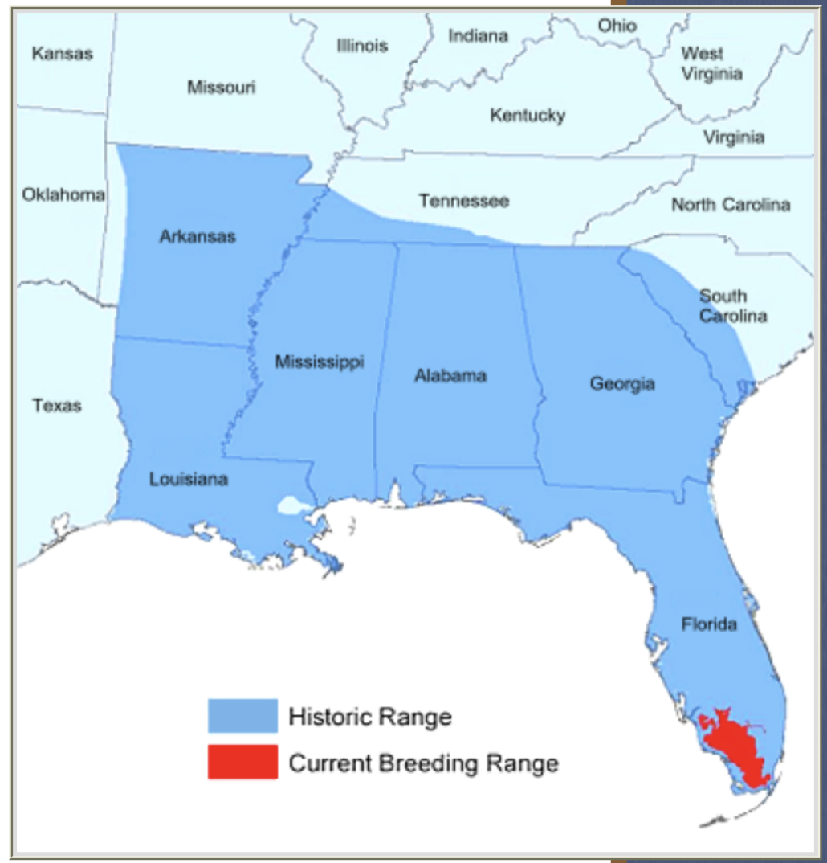Figure 2. Historical and Current Habitat Range of the Florida Panther. The Florida Panther’s habitat was located throughout the Southeastern part of the United States. Over time, through habitat destruction and urbanization, their current habitat range in the Southern part of Florida.

Lack of genetic diversity
Habitat degradation and fragmentation has led to the low levels of genetic diversity. Small populations tend to participate in inbreeding in desperate times to increase populations numbers. Inbreeding among the Florida panthers has led to the presence of mutations in the DNA that ultimately lead to developmental, reproductive, and immune system issues. The mutations also reduce the variation in the DNA. Those genes are then continued to be passed down through inbreeding and the population of panthers have similar characteristics and many mutations affecting their livelihood. Lack of genetic diversity and mutations are a huge threat to the remaining panthers in Florida. It is important to continue with reintroduction methods of other species, for example the Texas Puma reintroduction method, to help bring more diversity to the panthers’ genes and increased population size. While, the puma introduction methods were successful at first, lack of prey availability and habitat degradation ultimately lead to the failure of this reintroduction methods and the loss of more Florida Panthers (Figure 3).
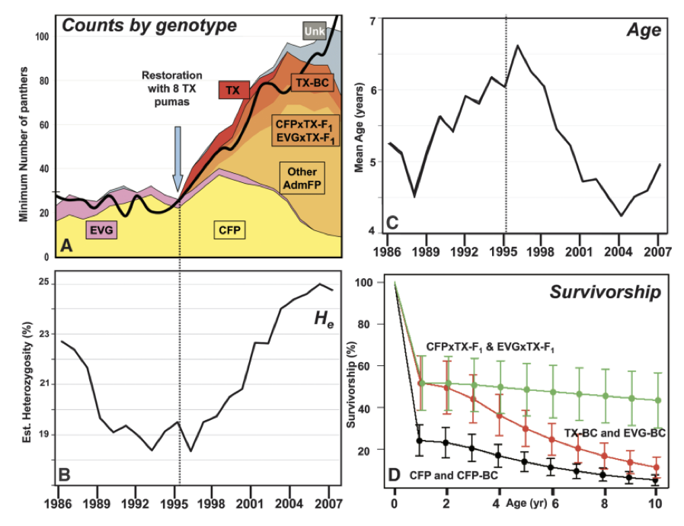 Figure 3. Reintroduction Statistics from 2006 Study. Panel A shows the amount of panthers compared to their genotypes. Panel B displays the increasing amount of mixed genotypes (heterogeneity) among the the panthers. Panel C shows the decreasing mean age of panthers from 1995 to 2007. Panel D shows the decreasing survival of the Florida panthers mixed with Texas Pumas.

Over hunting
Over hunting is excess hunting that causes damage to the population of a species. The threat of over hunting started back in the 1890’s when this species was considered a major threat to humans and their livestock (Robertson & Bass, 1986). Lawmakers in Florida offered an award to the citizens for every panther or other big animal they killed. Around 1950, there was a growing concern about the uncontrolled and unmonitored hunting of panthers (Robertson & Bass, 1986). That lead to lawmakers to classify the panther as a game animal. Then eventually in 1958, the Florida panther was made federally protected from legal hunting and eventually put on the endangered species list in 1967 and has been on the IUCN Red List since that time (Robertson & Bass, 1986). Over hunting really took a toll on the Florida panther populations. While reintroduction methods have been put into places since 1967, increasing human populations, more housing developments, habitat fragmentation, and diseases have made these efforts not as success in restoring population numbers of the panthers.

Decline in prey availability
Florida panthers required a large area of suitable habitat to meet their social, reproductive, and energetic demands (National Wildlife Refuge System, 2018). Their habitat selections are directly correlated to prey availability (National Wildlife Refuge System, 2018). This means that they only select habitats that contain a plentiful number of vulnerable prey to stalk, kill, and consume (National Wildlife Refuge System, 2018). Habitat degradation and fragmentation is the main reason for the decline in the panther’s prey availability (National Wildlife Refuge System, 2018). The fragmentation caused by urbanization is making it harder for the panthers to find and hunt down prey. In desperate times, they encroach on human territory to find a food source and are either killed or harmed for trespassing.

Overall, our hypothesis that the decreasing population of the Florida Panthers is directly correlated with the increasing human activity was proven to be true with the data collected and analyzed. Through habitat loss, fragmentation, and over hunting throughout the 1900’s and 2000’s, humans are the main contributor to the decreasing population of the Florida Panther. Habitat loss and over hunting has led to more problems that affect the population numbers. It has led to inbreeding, lack of genetic diversity, decline in prey availability, and vulnerability to disease. All of these factors have led to a population estimate of 120 to 180 panthers left living. To save the species from extinction, it would be best to have more reintroduction studies done and have more federal reserves built to protect the panthers from further human interference.

Literature Cited
Brown M, Cunningham M, Roca A, Troyer J, Johnson W, O’Brien S. 2008. Genetic Characterization of Feline Leukemia Virus from Florida Panthers. Emerging Infectious Diseases 14(2): 252-259.

Land E, Shindle D, Kawula R, Benson J, Lotz M, Onorato D. 2007. Florida Panther Habitat Selection Analysis of Concurrent GPS and VHF Telemetry Data. Journal of Wildlife Management 72(3): 633-639.

Robertson W, Bass O. 1986. Ecology and Population Dynamics of the Florida Panther in Everglades National Park.

Roelke M, Martenson J, O’Brien S. 1993. The consequences of demographic reduction and genetic depletion in the endangered Florida panther. Current Biology 3(6): 340-350.

Thatcher C, Van Manen F, Clark J. 2006. Identifying Suitable Sites for Florida Panther Reintroduction. Journal of Wildlife Management 70(3): 752-763.

2015. Why We Need to Save the Florida Panther. Coastal Breeze News. Available from https://www.coastalbreezenews.com/articles/why-we-need-to-save-the-florida-panther/ (accessed April 2018).

2018. Florida Panther. U.S Fish & Wildlife Service, National Wildlife Refuge System. Available from https://www.fws.gov/refuge/florida_panther/wah/panther.html (accessed April 2018).

2018. Help Save the Florida Panther. The Nature Conservancy. Available from https://www.nature.org/ourinitiatives/regions/northamerica/unitedstates/florida/explore/save-the-florida-panther.xml (accessed April 2018).

2018. Threats to Florida Panthers. Defenders of Wildlife, Washington D.C. Available from https://defenders.org/florida-panther/threats (accessed April 2018).

