The Microbial Diversity of Two Lotic Systems in Prince Edward Co.
Introduction
Many water systems around the world have different microbial communities (Fazi et al. 2005). Also, the soil near and in the water have different microbial communities. There are many factors that contribute to the differences in those microbial communities in soil both located in and near a body of water. Moisture, temperature, presence of organic material, pH, creatures that inhabit the soil, plant vegetation, and other various factors contribute to the microbial communities in the soil (Sagova-Mareckova et al. 2015). One study done compared the relationship of microbial distribution and diversity between two rivers and two wetlands in China. The hypothesis of the study was that the wetlands would have a higher microbial abundance and more diversity than the rivers (Cao et al. 2017). The hypothesis was proven to be true in the experiment. Another study done studied the microbial diversity and abundance in Lake Chaka and correlated it with the changing environmental conditions. The hypothesis of this study was that there will be significant differences in the microbial community structure between the lake water and the sediments (Jiang et al. 2006). It was found that there was a higher abundance of microbes in the sediments than the lake water.
There are different methods in determining the microbial diversity in a sample. One common way to determine the different microbes in the soil is to extract the DNA from the soil samples and use the 16S rRNA gene-based pyrosequencing method (Ding et al. 2017). This method can give the individual counts of each of the different species of the microbes found in the soil and determine the microbial diversity in a soil sample.
The goal of this experiment is to study the differences between the microbial diversity in Prince Edward County more specifically the soil located in Buffalo Creek and the Appomattox River. Buffalo Creek is located in Prince Edward County and flows into the Appomattox River. The hypothesis for this experiment is that Buffalo Creek will have a significantly higher microbial diversity than the Appomattox River because the wetlands had a higher microbial diversity than the rivers in the study done in China. Even though a creek and wetland are very different, it is likely more microbes will be found in a slow-moving creek than a fast-moving river.

Experimental Procedures
Environmental Sample Collection
Samples were collected around the Environmental Educational Center (EEC). The first sample was collected at Buffalo Creek which is a two minute walk from the EEC. The soil sample was collected in a 50 ml conical tube. The soil sample was collected where the shore and the water of the creek meet. The second sample was collected at the Appomattox River which is about a 5 minute walk along Buffalo Creek. Buffalo Creek runs into the Appomattox River. The second soil was collected around that meet up point. The second sample was collected in a 50 ml conical tube. The sample was collected where the shore and the water of the Appomattox River meet. These samples were then taken back to EEC for plating.
Plating Bacterial Cultures
The bacterial cultures were plated in nutrient agar plates. 0.5 grams of each soil sample was weighed out, added to 50 mL tubes of sterile water, and shook vigorously. The samples were then incubated for five minutes. Those two tubes were used for the two direct count plates. 90 μL of sterile nutrient broth was placed into the two 1:10 and two 1:100 tubes. 10 μL of the soil/water sample from the original tubes was then transferred to the 90 μL of nutrient broth in the two 1:10 tubes. The contents of those tubes were then vortexed. 10 μL of sample from the 1:10 dilution tubes were transferred to the 90 μL of nutrient broth in the two 1:100 tubes. The contents of those tubes were then vortexed. 100 μL of the samples were pipetted to the middle of the appropriate plates (a direct count and a 1:10 and 1:100 count plate for both samples). The samples were spread on the plates using the hockey stick method. The plates were incubated in a room temperature (25°C) incubator for 48 hours.
Genomic DNA Extraction
One colony from each sample was used to perform DNA extraction. One colony from the 1:10 Appomattox River sample and one colony from the 1:100 Buffalo Creek sample. 300 µL of microbead solution was added to each labeled microcentrifuge tube for the two samples. The colonies were put appropriately labeled tubes filled with sterile water and swirled for about 15 seconds. The cells (all 300 µL) were transferred to a labeled microbead tubes. 50 µL of solution MD1 was added to each microbead tube. The microbead tubes were heated to 65°C for 10 min. The microbead tubes were vortexed at maximum speed for 10 minutes. The tubes were centrifuged at 10,000 x g for 30 seconds at room temperature. This step collects the beads and cell debris at the bottom of the tube. The supernatant of each tube was transferred to clean, labeled 2 mL collection tubes. 100 µL of solution MD2 was added to the supernatant and vortexed for 5 seconds. Then the tubes were incubated at 4°C for 5 minutes. The tubes were centrifuged at room temperature for 1 min at 10,000 x g. The entire volume of supernatant was transferred to clean, labeled 2 mL collection tubes. 900 µL of solution MD3 was added to the supernatant and vortexed for 5 seconds. 700 µL was put into the spin filter and centrifuged at 10,000 x g for 30 seconds at room temperature. The flow through was discarded. The remaining supernatant was added to the spin filter and centrifuge at 10,000 x g for 30 seconds at room temperature. The flow through was discarded. The DNA stuck to the white silica membrane in the spin filter. 300 µL of MD4 was added and centrifuged at 10,000 x g for 30 seconds at room temperature. Solution MD4 is a solution that removes residual salt and other contaminants while allowing the DNA to remain bound to the membrane. The flow through was discarded. It was centrifuged again form 1 min at 10,000 x g. The spin filters was placed in a set of two new 2 mL collection tubes. 50 µL of MD5 was added to the center of the white filter membranes and centrifuged at 10,000 x g for 30 sec at room temperature. Before storing the DNA, the DNA samples were measured for quantity and purity using a nanodrop machine. Then, the two tubes of DNA were stored at -20°C.
Polymerase Chain Reaction (PCR)
The polymerase chain reaction is a method used to generate multiple copies of a certain spot of a single molecule of DNA. The 16s rDNA sequence was amplify from the two unknown bacteria from the two samples collected at the EEC. 50µl of PCR component (forward primer, reverse primer, OneTaq 2X Master Mix, nuclease-free water) was added to two reaction tubes. Then 3µl of the genomic DNA previously isolated from the Appomattox River sample was put in one reaction tube and 3µl of the genomic DNA from the Buffalo Creek sample was put in the second reaction tube. Those reaction tubes were then transferred to the PCR machine to undergo thermocycling. In the PCR machine, initial denaturation happened for 30 seconds at 94°C. Then, there was 30 cycles where the temperature was 94°C for 30 seconds, 55°C for 45 seconds, and 68°C for 60 seconds. Lastly, final extension happened at 68°C for 5 minutes. Once the PCR is done, the thermal cycler is set to around 4°-10°C to maintain the integrity of the sequence until the tubes are removed from the machine. The universal primers amplified 16S rDNA that have the following sequences: Forward- 5’GAGTTTGATYMTGGCTC-3’ Reverse- 5’-NRGYTACCTTGTTACGACTT-3’.
PCR Clean up
To prepare the samples, up to 100 µl of reaction product was transferred to 1.5 microcentrifuge tubes. 5 volumes of DF buffer was added to the tubes and mixed by vortex. The next step was to bind the DNA. To do that, a DF column was placed into two 2mL collection tubes. The sample mixtures from step 1 were transferred into the DF columns and centrifuged at full speed for 30 seconds. The flow through was discarded and the DF columns were placed back into the 2mL collection tubes. Then 600 µl of wash buffer was added into the DF columns and centrifuged at full speed for 30 seconds. The flow through was discarded and put back into the 2mL collection tubes. The tubes were centrifuged again at full speed for 3 minutes. The final step was to preform DNA elution. The dried DF columns were transferred to new 1.5mL microcentrifuge tubes. 25 µl of elution buffer was added to the tubes. The two tubes stood for 2 minutes to be absorbed by the matrix. Lastly, the tubes were centrifuged for 2 minutes at full speed to elute the purified DNA.
Restriction Enzyme Digestion
Two tubes were set for the reaction of 5 µl PCR product and 10 µl of MspI. The samples were mixed. Then they were incubated for 45 minutes at 37°C.
Gel Electrophoresis
A 1.5% agarose gel was casted. 5 µl of 5X loading buffer was added to each tube and the contents were mixed. The electrophoresis chamber was filled and covered by 1X TAE buffer. 10 µl of each sample (PCR only and PCR with MspI for both Appomattox River and Buffalo Creek samples) loaded into separate wells in the gel chamber. The lid was placed on chamber and the electrical cords were connected to the power supply. The power was turned on and the gel ran at 120 V for 30 minutes or until the dye got halfway down the gel. When the electrophoresis run was complete, the power was turned off and the lid was removed. The gel was removed from the chamber and put on a tray. Pictures of the gel were taken by a UV camera.
DNA Sequencing
The clean PCR for both samples (5 µl) was mixed with 4 µl of the sequencing primer: 5’-GAGTTTGATCCTGGCTCAG-3’and 3 µl of deionized water in two sequencing tubes. The tubes were then sent to EurofinsGenomics to be sequenced.
DNA Sequence Analysis and Microbial Identification
EurofinsGenomics sent back the completed sequences. They were put onto a shared Box folder. The files were then downloaded on a computer. One of the files included a PDF file of the whole sequence. SnapGene Viewer was used to analyze the sequence. In SnapGene viewer, the whole sequence was scanned and the “N’s” were edited to the appropriate base sequence. The changes were then saved and the BLAST-Targeted Loci search was used to identify the prokaryote. The sequence of the prokaryote from BLAST was compared to the sequence of the unknown prokaryote. This step was repeated for at least 10 matches that BLAST gave. Also, the MspI digestion sites for the sequence was checked using NEB cutter and compared to the sequences observed in the gel. After deciding what prokaryote generated from BLAST matched the sequence, research was done on the newly identified prokaryote.
Results
Sample Collection
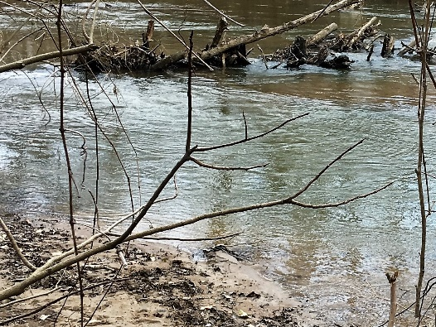
Fig. 1. Collection site. The site is located at the Appomattox River near the EEC.
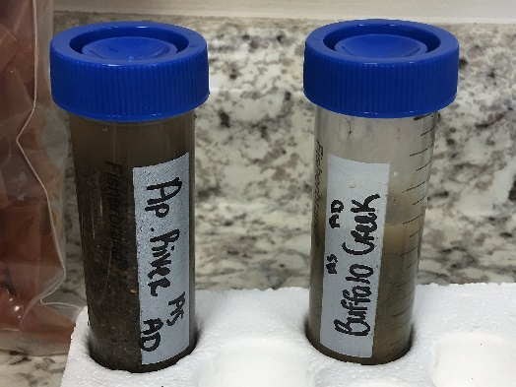
Fig. 2. Soil Samples. These are the soil samples collected from both sites.
Sample collections were done at Buffalo Creek and the Appomattox River. These bodies of water surround the Environmental Education Center (EEC). The first picture shown above is the site where soil from the Appomattox River was collected (Fig. 1). The second picture shown above shows the soil samples collected at the two sites (Fig. 2).

Bacterial Cultures
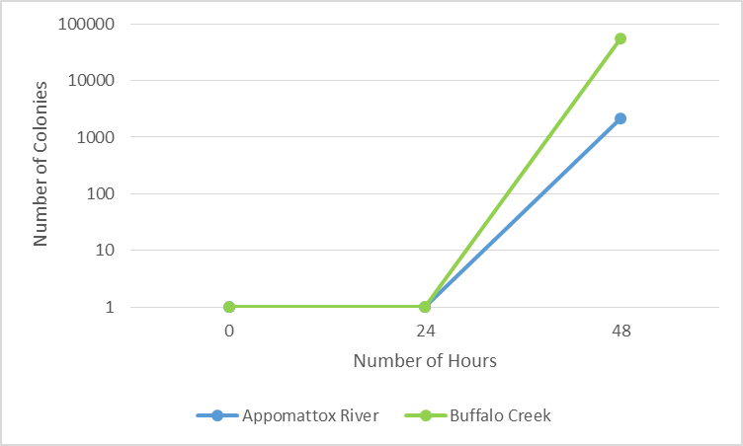
Fig. 3. Line graph of the growth in the number of colonies after 24 and 48 hours in the two samples. According to the graph, the Buffalo Creek sample has a higher amount of colonies than the Appomattox River sample.
Bacterial cultures were done to show the microbial diversity in the Buffalo Creek and Appomattox River samples. The number of colonies in the Appomattox River sample plate after 24 hours was 0. The sample thing occurred in the Buffalo Creek sample plate. It was quite odd not having any colonies form after 24 hours. After 48 hours, there were around 2150 colonies in the Appomattox River sample plate. The 1:10 dilution plate was used for counting. However the Buffalo Creek plate (1:100) had around 55000. There was significant higher amount of colonies in that sample than the Appomattox River sample (Fig. 3).

Fig.4. Pie chart of size comparison of the colonies between the samples. The inside circle is the Appomattox River sample and the outside circle is the Buffalo Creek Sample. The number of large and small colonies is greater than medium sized colonies.
In the Appomattox River sample, the number of small colonies was greater than medium and large colonies. However, in the Buffalo Creek sample, the number of medium sized colonies was greater than small and large colonies. In both samples, there were not very many large colonies compared to the small and medium sized colonies (Fig. 4).

Fig. 5. Pie chart of the percentages of circular and filamentous colonies in both samples. In both samples combined, the majority of colonies are circular.
In both the Appomattox River and Buffalo Creek samples, there were a few filamentous colonies. Filamentous colonies are like thin, threadlike clusters of bacteria. The majority of the colonies that appeared in both of the samples were circular (Fig. 5).

Genomic DNA Extraction and Gel Electrophoresis
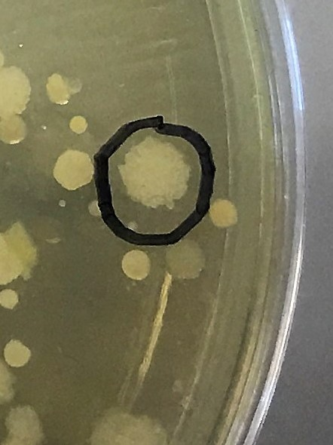
Fig. 6. Bacterial Culture of 1:100 Buffalo Creek sample. The colony that was tested is circled.
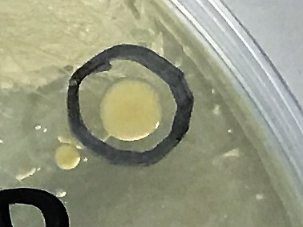
Fig. 7. Bacterial Culture of 1:10 Appomattox River sample. The colony that was tested is circled.
DNA was extracted from one, white colony from Buffalo Creek sample (Fig. 6) and one, yellow colony from Appomattox River (Fig. 7). The amount of DNA and purity of the DNA was discovered after extraction. The Buffalo Creek 1:100 sample had 6.0 ng/µl and a 260/280 of 1.72. The Appomattox River 1:10 sample had 11.8 ng/µl of DNA and a 260/280 ratio of 1.79.
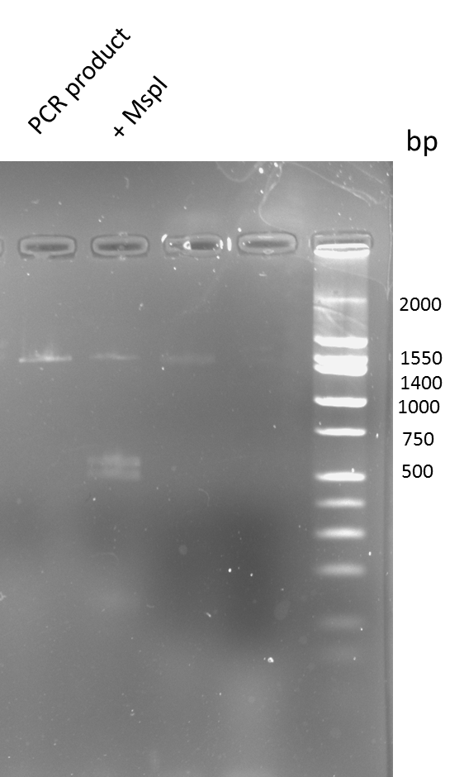
Fig. 8. Results of PCR amplification and MspI digestion. This is the gel panel of the Buffalo Creek and Appomattox River DNA colony samples.
The gel electrophoresis shows that a 2000 bp product was amplified by PCR for the 16s rRNA region. Under digestion with MspI, bands were seen at 1550, 600, 500. The bands shown are for the Appomattox River sample. Bands for the Buffalo Creek sample did not show up.

DNA Sequences and BLAST Identification of Bacteria
Our DNA samples were sent to EurofinsGenomics. This company sequenced all of the DNA that the class sent in. The Buffalo Creek sample sequence was not successful, so the colony was not able to be identified. The Appomattox River sample came back with a successful sequence (https://app.box.com/file/143282805134). The link provided is a PDF of the Appomattox River sequence.

Name | Percent identity | Number of Gaps
Pseudomonas Arsenicoxydans | 98% | 3
Pseudomonas Prosekii | 98% | 2
Pseudomonas Lini | 97% | 3
Pseudomonas Migulae | 97% | 3
Pseudomonas Marginalis | 97% | 5
Table 1. Top scoring alignments of our Appomattox River colony’s 16s rRNA sequence.
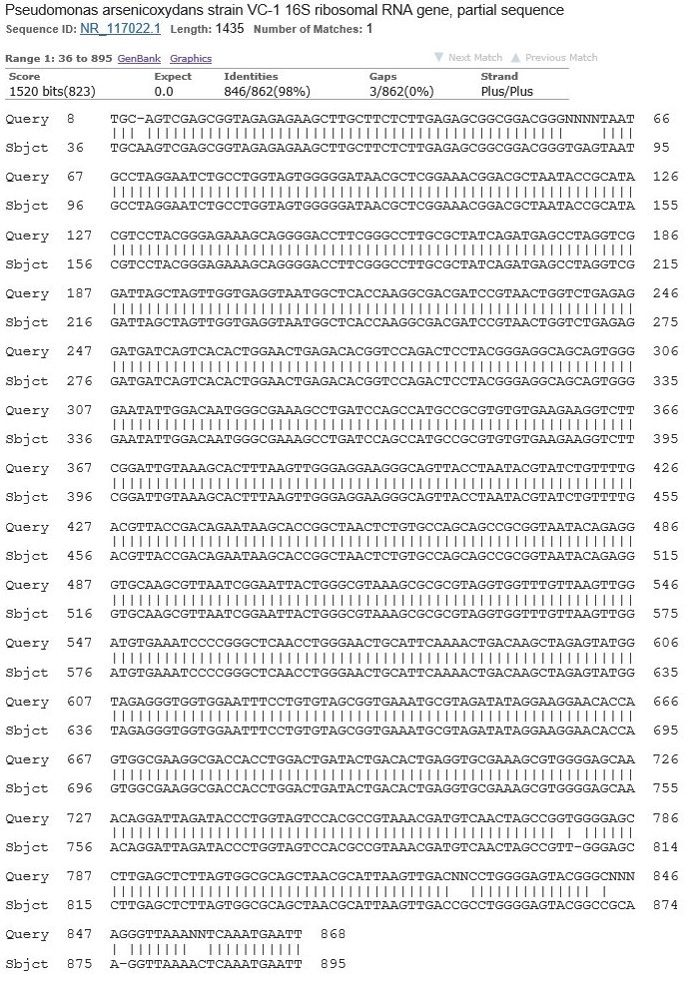
Fig. 9. Alignment of Pseudomonas Arsenicoxydans. This shows the matching DNA sequences between the Appomattox River (top row) sample and Pseudomonas Arsenicoxydans (bottom row).
To identify the bacteria, BLAST was used. Above is a table that shows the top five results of the Appomattox River DNA sequence that was searched in the database (Table 1). After comparing sequences of those five to the Appomattox River sample DNA, it was identified as Pseudomonas Arsenicoxydans (Fig. 9).

Discussion
The purpose of this experiment was to study the differences between the microbial diversity in Prince Edward County more specifically the soil located in Buffalo Creek and the Appomattox River. We were interested in studying this topic because it is known that many water systems around the world contain different microbial communities (Fazi et al. 2005). Various conditions like moisture, temperature, presence of organic material, pH, creatures that inhabit the soil, plant vegetation, and other various factors contribute to the amount of microbial communities in the soil (Sagova-Mareckova et al. 2015). The hypothesis of this experiment was Buffalo Creek will have a significantly higher microbial diversity than the Appomattox River. My hypothesis was somewhat supported in that fact that there was more colonies in the Buffalo Creek plates than the Appomattox River plates. One study done compared the relationship of microbial distribution and diversity between two rivers and two wetlands in China. The hypothesis of the study was that the wetlands would have a higher microbial abundance and more diversity than the rivers (Cao et al. 2017). The hypothesis was proven to be true in the experiment. This previous experiment helps backs up my hypothesis and results. However, there is not anymore evidence available to support my hypothesis. The reason why I could not identify the colony I extracted DNA from in the Buffalo Creek culture was because it was not prokaryotic. It was eukaryotic and that means 16s rRNA cannot be extracted from it. That is why the DNA sequence did not work and was not able to be identified.
The bacteria identified in the Appomattox River sample was Pseudomonas Arsenicoxydans. It was isolated from sediment samples from the Camarones Valley, Atacama Desert which has a high arsenic concentration in both the water and sediments (Campos et al. 2010). Some minerals of metallic sulphides that contain arsenic are dissolved from the Andes Mountains, affecting superficial and ground waters that cross the Atacama Desert (Campos et al. 2010). Also, they are used as drinking water sources.
Finding a bacteria that is common to an area of Northern Chile is quite shocking. It shows how water systems transfer bacteria all around the world to increase the overall microbial diversity in all different types of areas. This study is important because we identified microbes common and not so common to Prince Edward County. In the future, I think it would better to sample more bodies of water in Prince Edward County. That could possible give us more results and increase the number of microbes identified.

Works Cited
Campos V, Valenzuela C, Yarza P, Kampfer P, Vidal R, Zaror C, Mondaca M, Lopez-Lopez A, Rossello-Mora R. Pseudomonas arsenicoxydans sp nov., an arsenite-oxidizing strain isolated from the Atacama desert. Systematic and Applied Microbiology. 2010;33:193-197.
Cao Q, Wang H, Chen X, Wang R, Liu J. Composition and Distribution of Microbial Communities in Natural River Wetlands and Corresponding Constructed Wetlands. Ecological Engineering. 2017;98:40–48.
Ding L-J, Su J-Q, Li H, Zhu Y-G, Cao Z-H. Bacterial Succession along a Long-term Chronosequence of Paddy Soil in the Yangtze River Delta, China. Soil Biology and Biochemistry. 2017;104:59–67.
Fazi S, Amalfitano S, Pernthaler J, Puddu A. Bacterial communities associated with benthic organic matter in headwater stream microhabitats. Environmental Microbiology. 2005;7:1633-1640.
Jiang H, Dong H, Zhang G, Yu B, Chapman LR, Fields MW. Microbial Diversity in Water and Sediment of Lake Chaka, an Athalassohaline Lake in Northwestern China. Applied and Environmental Microbiology. 2006;72:7430–7430.
Sagova-Mareckova M, Cermak L, Omelka M, Kyselkova M, Kopecky J. Bacterial diversity and abundance of a creek valley reflected soil pH and season. Open Life Science. 2015;10:61-70.

