Biomechanics Analysis Project

11/17/17

Jessica Smith

Table of Contents

1. The Problem ……………………………………………….. Page 3
2. The Solution ……………………………………………….. Page 7
3. The Implementation ……………………………………….. Page 9
4. The Conclusion …………………………………………….. Page 14

**The Problem**

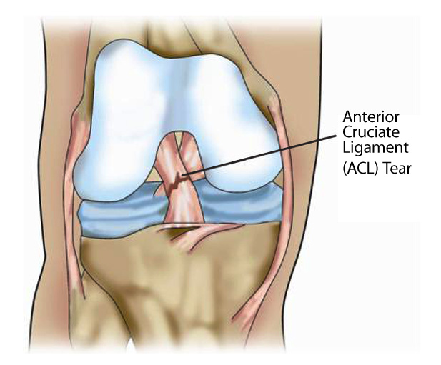 The anterior cruciate ligament is responsible for limiting the movement of the knee anteriorly. The tearing of this ligament is one of the most prevalent sports related knee injuries to occur in athletics, specifically female athletics. Athletes who have an increased risk of an ACL tear are females between the ages of fourteen and eighteen who engage in sports that involve sharp turns, quick accelerations, and any pivoting movements. The sport with the highest risk is soccer, followed by basketball, skiing, football, and tennis. Even though it is not as likely, any sport could possibly lead to an ACL tear, whether it be from impact (football) or twisting the knee a little too far in a swing (Mayo Clinic, 2017). Coach Rick Canter, the head strength and conditioning coach at Longwood University, explained a common cause for ACL tears is that the training athletes participate in is not relevant to competition. He used the example of increasing the weight on a back squat for a basketball player. It is amazing for that athlete to lift more weight; however, if those muscles are not the ones being fired during competition, it does not decrease the risk for ACL injuries. Coach Canter basically explained that neurons that learn to fire together will fuse together. This means that training that is specific to competition will create neural pathways that will continue to strengthen. Only when an athlete trains the muscles used in competition will he or she decrease the risk of an ACL injury (personal communication, Nov. 10, 2017).

<http://www.themichelicenter.com/the-facts-behind-acl-tears/>

Image (above) shows where the ACL is located and what a common tear looks like

The prevalence of ACL injuries can vary depending on the school, age, and division. Not only is this injury common in youth athletics, but also occurs in the pro-sports. Longwood, for example, has a high amount of soccer players that have undergone surgery for torn ACL’s. In an interview with Coach Canter, he mentioned that he knows of four or five athletes this year alone with a torn ACL. This number is likely to increase as we are not even halfway through the school year. The prevalence of ACL injuries at Longwood varies depending on the year, the condition of athletes recruited, and the age of athletes. Freshman athletes are more likely to tear their ACL because they are not used to practicing at the level they now are required to (personal communication, Nov. 10, 2017). This university also has two softball players that have had surgery for the same types of injuries, and one player who tore her MCL.

Image (above) shows the number of athletes with a torn ACL this year (Fall 2017).

Symptoms for ACL tears include a loud popping noise, swelling, inability to continue playing, and loss of range of motion (Mayo Clinic, 2017). Knee injuries, in general, have different rehabilitation programs that depend on the severity of the injury. For an ACL tear, depending on the severity, an athlete can be prescribed rest and physical therapy to strengthen muscles surrounding the knee and to strengthen the hamstring. The reasoning behind strengthening the hamstrings is that many female athletes have an imbalance in their quadriceps versus their hamstrings. This imbalance leads to the hamstring being overstretched which forces more pressure on the knee often leading to knee injuries. If an athlete has a more severe tear, he or she may be prescribed surgery. Rehabilitation after surgery takes longer and may cause the athlete to feel depressed and lead to other mental disorders. Besides mental problems, athletes also have an increased risk of retearing the ACL and losing the ability to return to complete physical activity. According to a study done by Darin Padua, athletes who played soccer and tore their ACL no longer played soccer within a seven year period. Padua also stated that 25% of athletes who tear their ACL do not return to activity at all. His study was on youth soccer athletes and what occurred after their surgery. He claimed that athletes who undergo surgery, are still at a high risk for issues later in life such as arthritis (Padua et al., 2015). The easiest way to combat an ACL tear is to prevent it.

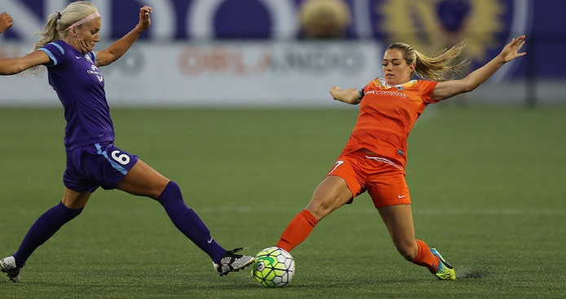A student at Longwood on the men’s soccer team named Akable Wilson Miezan, tore his ACL the first time in August 2016 and then tore it again this past summer. This means he underwent surgery for the same injury twice and the likelihood for his return to full ability is lessened even more. After his first procedure, his doctor recommended an eight month recovery time. However, after his second procedure, his recovery time became eleven months. Akable Miezan, commonly referred to as Willy, tore his ACL the first time by cutting, which is a quick change in direction, and getting his foot stuck in the grass. With his foot unable to move properly, more stress was placed on his knee than his knee could handle. The second time he tore his ACL he jumped to trap a ball and landed on an uneven surface causing his knee to twist. If you look at the causes for injury, you can see that the first one is a much more strenuous cause whereas the second one was just a loss of balance. This proves that athletes who have previously torn their ACLs have a weakened ligament and therefore, are more likely to tear that ligament again. In an interview with Willy, he was asked if the doctor put any limitations on activities for him after recovery. His response was that there were no limitations; however, only two surgical procedures could occur on the same knee so if he was tear his ACL for the third time, his collegiate soccer career would be over. Willy proves to us that ACL injuries are not something to mess around with (personal communication, Nov. 9.2017). Not only are they very detrimental to athletes, but they start a cycle of knee issues that can never be stopped. This is why screening for the increased likelihood of ACL injuries is so important.

<http://www.excellesports.com/news/kealia-ohai-acl-season-injury/>

Kealia Ohai, Houston soccer player, tore her ACL playing soccer and was out for the rest of the season. Image (above) shows the play that caused it.

An external file that holds a picture, illustration, etc.
Object name is nihms627208f1.jpgThe main problem associated with an ACL injury for a continuing athlete is the increased risk of a retear. Willy is just one example of this problem. Paterno, Rauh, Scmitt, Ford and Hewitt did a study to find the likelihood of a re-injury in the same limb or an injury in the collateral limb versus the likelihood of an athlete without any ACL injuries to have an injury. They found that athletes who have already torn their ACL once are six times more likely to re-injure their ACL than an athlete who has never had an ACL injury, They also found that athletes who were female were two times more likely to tear their ACL in the opposite limb than those without a previous injury. However, it was noted that females are at a higher risk for an injury in the opposite limb while men are at a higher risk of re-injuring the same limb (Paterno, 2014). In a study done by David Bell et al, athletes who previously tore their ACL had worse landing mechanics on that leg and scored higher LESS scores because of the previous injury. This, along with Paterno’s study, confirms that athletes who tore their ACL once have a very high risk for tearing it again.

<https://www.ncbi.nlm.nih.gov/pmc/articles/PMC4205204/figure/F1/>

Image (above) was used in Paterno’s study to show the likelihood for each sport. Blue Is the group who already had an injury and red is the control group.

**The Solution**

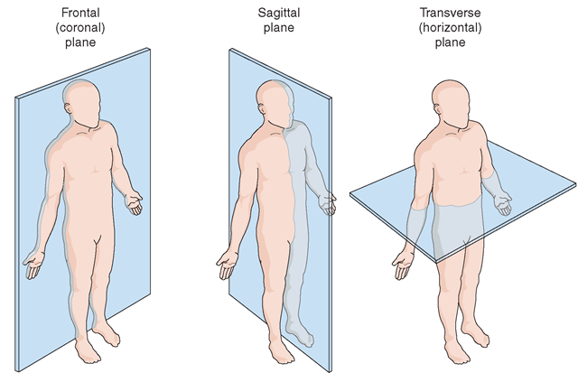 Prevention programs can be hard to design, specifically for people who do not understand how an ACL injury occurs or what increases the likelihood. A system that helps find the increased risk for a specific athlete is the Landing Error Scoring System (LESS). The LESS is a screening tool commonly used to assess probability of lower extremity injuries. This system was developed by Padua and implemented in his JUMP ACL study with military subjects. The Joint Undertaking to Monitor and Prevent ACL injuries, or JUMP ACL, was performed using 2691 subjects. Padua completed this study to test the reliability of LESS screening compared to that of the Gold Standard. After completing his study, he concluded that LESS is a reliable and inexpensive way to test individuals for risk of ACL injuries (Padua, et al 2009).

<http://www.lateraledgeonline.com/blog/2017/3/1/the-necessity-of-exercising-in-the-frontal-plane>

Image (above) shows the different planes of motion. LESS screens have cameras looking at the frontal and sagittal planes.

LESS looks at the landing of an individual. This screen comes with a scoring sheet that explains what exactly to look for in the sagittal plane and frontal plane. The evaluator will look at the torso, feet, knees, and hips in the frontal or sagittal plane and give the athlete a score of zero or one. The scoring sheet tells the evaluator what to look for and what score to give if the information being evaluated is present or not. When using the scoring sheet, an evaluator should grade more harshly because the point is to find the risk for that athlete. Padua said in his study, that athletes who scored above five points were at a higher risk for an ACL injury than those who scored below five. Even though using LESS screening gives the athlete a probability of injury, that does not mean that athletes who scored above five will absolutely have an injury nor does it mean that athletes who scored below five will not have an ACL injury.

The point of identifying the increased risk for an athlete is to create a prevention program that the athlete can follow to hopefully decrease the risk of an ACL injury. This program could include exercises to increase strength in the lower extremities, specifically the hamstrings and the hips. An example of exercises to be included could be RDLs, glute-ham raises, or hip sleds (personal communication, Nov. 10, 2017). Rick Canter also suggested strengthening the lower back and ab area to increase core strength. Besides strengthening the muscles and connective tissues surrounding the knees, doing extra work on cutting techniques before competition is helpful. The point of this is to not allow the athlete to go through full speed activities until their muscles are prepared to take it. This could take a couple weeks, or a month depending on how advanced the skill is and how trained the athlete is. The last component of a prevention program is to work on proper landing techniques. The LESS screen will show what the athlete is doing wrong in their lower extremities, allowing the trainer or coach time to make adjustments on landing. If an athlete learns to land the proper way, they will have a decreased risk of an ACL injury.

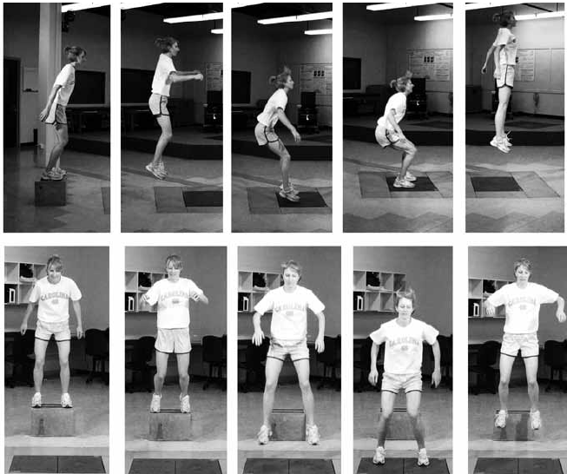 One limitation with using LESS screening is that the general population does not understand the terms on the scoring sheet. This makes this specific screen difficult for people such as trainers to implement. Taking this into consideration, a modified LESS screening was developed. The differences are that in the modified screening there are no cameras, which makes this screen even less expensive but also less effective, and there are only ten terms to be graded instead of seventeen. There is also one more trial involved in modified than that of normal LESS screening because when there are no cameras, it is harder to look back on what was incorrect in their form. The main benefit for a modified LESS screen is the quick turn-around time. While the results from a normal LESS screen are quick, it takes longer because the grader has time to evaluate in detail the form of the three trials involved (Timothy Coffey). Padua, in a reliability study performed in 2011, found that using the modified LESS screen is effective. While the modified screen is more beneficial than no screen at all, the best indicator is the full LESS screen.

**Implementation**

LESS screening is a very inexpensive screening tool. The materials needed are a 30 centimeter plyometric-box, two cameras (one facing the frontal plane, one facing the sagittal), a tape measurer, and a marker for the horizontal distance of the jump. The only expensive part of a LESS screen would be the use of a force plate, which is not necessary for this screen. The procedure has multiple steps but is very simple to set-up. First, use the tape measurer to get the athlete’s height and then divide that measurement in two. Use half of the height to measure out from the 30 centimeter plyometric-box and then mark that distance on the ground. After that, the cameras need to be set up to look at the landing and torso of the athlete after the jump. This means the lateral camera should be in line with the marker on the ground and far enough back to see the whole body and the front camera should be directly in the middle of the box, far enough back to see the whole body. After set-up, make sure all of the equipment is safe and in the right areas before asking the athlete to complete their jumps.

<https://www.researchgate.net/figure/51131028_fig1_Figure-1-Standardized-jump-landing-task-performed-by-subjects-during-the-Landing-Error>

Image (above) shows a client completing a LESS screen. Shows views from sagittal and frontal planes.

When instructing an athlete on how to do this screen, start off with a demonstration. While explaining something is beneficial, most athletes are kinesthetic learners or visual learners meaning a demonstration would prove to be the most helpful. The easiest way to explain is to tell the athlete that they are completing three trials where they are to stand on the plyometric-box, take a horizontal broad jump out to where their heels are past the marker on the ground, and then immediately jump vertically as high as they can. The purpose of getting the athlete to complete a vertical jump is because without the end jump, the athlete will focus on their landing too much and possibly skew the data. While it is important to tell the athlete to land with two feet after the broad jump, no other information on landing techniques should be given because then the athlete will be focused on following the instructions instead of doing what comes naturally to them. After completion of the screen, it is alright to tell the athlete anything major they are doing wrong at that moment but remember a prevention program is on the way. One last thing to take into consideration when teaching an athlete to complete this screen is to allow them a few trial runs. Nobody is capable of doing something right the very first time and the athlete also might feel a little nervous, so it would be good to get the first few jumps out of the way without filming.

Implementing a LESS screen varies depending on sport. The testing for Longwood University should be in order of season and then likelihood of injury. Testing should occur an ample amount of time before season so that a prevention plan can be put to use. Keeping that into consideration, the fall sports include soccer, field hockey, and cross country. Since soccer is the sport with the highest risk for ACL injuries, they should be tested first. After soccer, cross country and field hockey should be tested since they are also fall sports and require quick turns and stops in acceleration. After fall, there are winter sports including basketball who should be tested next because of the quick pivots involved in basketball as well. The spring season follows and those sports include softball/baseball, tennis, golf, and lacrosse. Tennis should be tested first because their sport requires quick back and forth movements followed by baseball and softball. Golf and cross country have a very low risk of injury and LESS screening is not as necessary for 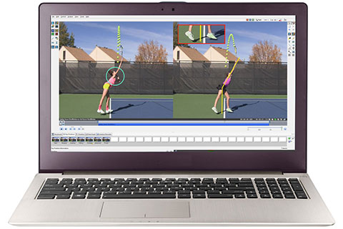those sports. However, in an interview with Coach Canter, he suggested we test all sports, including those at a lower risk.

<http://www.dartfish.com/analyze>

Image (above) shows a dartfish screen where someone is analyzing a tennis screen and showing some things that can be done, i.e. angles.

Scoring a LESS screen is not difficult for people who understand the terms being used and what to look for. In Longwood’s screening process, strength and conditioning coaches will complete the scoring process with the help of Dr. Timothy Coffey. These coaches will practice on Dartfish, a computer software used to measure angles in a video and see issues in slow motion, until they are comfortable with using the scoring sheet and understand the terms. Dartfish, as seen in the image to the above, allows for measurements to be taken and that is what is suggested for use when analyzing the two camera angles after the LESS screen. Although it is not necessary to use Dartfish when scoring a LESS screen, it makes it easier to access. When the actual screen is occurring, the strength and conditioning coach will be present as well as the specific sports athletic trainer for that team. For example, for softball strength and conditioning Coach Tyler Wrenn will perform the screen and the athletic trainer Morgan Langton will be there. It is important for the athletic trainer to watch because it will ensure that he or she learns common problems associated with ACL injuries that they can look for and put into their rehabilitation programs. The strength and conditioning coaches will perform the screen because they work with the athletes in a training way the most. They can watch athletes jump and squat and notice what the knee is doing that could lead to weakening. It is important for them to realize the common risk factors so they can change the way an athlete jumps to lessen risk. Besides these two people, the head coach for each team could also be present for the same reason: he or she needs to learn what to look for in the lower extremities that increase risk of injury. If the coach, athletic trainer, and strength coach are all watching for risk factors and able to correct them, the likelihood of an athlete getting an ACL injury decreases immensely. However, Coach Canter brought up a good point in that if the head coach, or any coach, increases the level of stress for the athlete being tested, the coach should not be included. If the coach increases stress, which is physiologically an increase in cortisol levels and can induce a fight or flight response. With the increase of adrenaline and cortisol, the athlete can no longer perform at their top level. The goal is to limit any stressors affected the athlete and make he or she as comfortable as possible so that he or she can perform naturally. Lastly, the location of the LESS screen matters. If someone wished to perform one with the force plate, they would have to go to Bedford Hall because that is where force plate equipment is set up. However, as noted earlier, a force plate is not necessary. The location should be in a place where athletes feel comfortable training and performing. For Longwood, that location would be Iler Hall because that is where athletes do all of their strength training. The reason we look for a place of comfort is because athletes are more likely to perform in the most natural place if they are in an environment that is calm and normal for them.

Timing is always difficult to discuss because collegiate athletes say they all are missing one thing: time. Completing the LESS screen during an athletes normal lifting time is recommended because of comfort level for the athlete. As for how long the screen will take for each team, it depends on the number of athletes. Each athlete has to complete three trials, not including instruction time and allowance for practice. The evaluator will need to reset the cameras each time to record the three different trials as well. LESS testing has been performed at Longwood before, just not with all of the teams. In an interview with Rick Canter, he suggested a that all athletes should be tested in the Spring. This would be the beginning of off-season for fall sports and pre-season for Spring sports. Doing testing at this time would give us a risk evaluation for each sport except winter sports. Basketball should be tested right when they finish season, so every team can be tested while they are not in season. As for how long each team would take, one player can be tested in one to two minutes. For example, softball has nineteen players. This means it could take anywhere from nineteen minutes to thirty-eight minutes. This can still seem like it takes up a lot of time, but is worth it if we can reduce the number of ACL injuries at Longwood. After an athlete is tested and the reviewer has graded the three trials, the information should then be given to the head coach, athlete, athletic trainer, and strength coach. The reason we give the information to everyone is because the head coach and strength coach need to know not to push the athlete as hard until a prevention program is in place. Once the athlete starts the program, he or she can continue training at high intensity with very little drawbacks.

**The Conclusion**

ACL injuries affect athletes from youth leagues up to pro-sports. Although these injuries do affect younger generations more often than older, we only have the ability to change the way Longwood helps its athletes. ACL injuries are hard to come back from, and the increased risk of another injury is very high. Preventing that first injury is necessary and possible to an extent. We may not be able to remove all ACL injuries present at Longwood, but any decrease in the risk would be beneficial to the athletes, athletic trainers, and coaches.

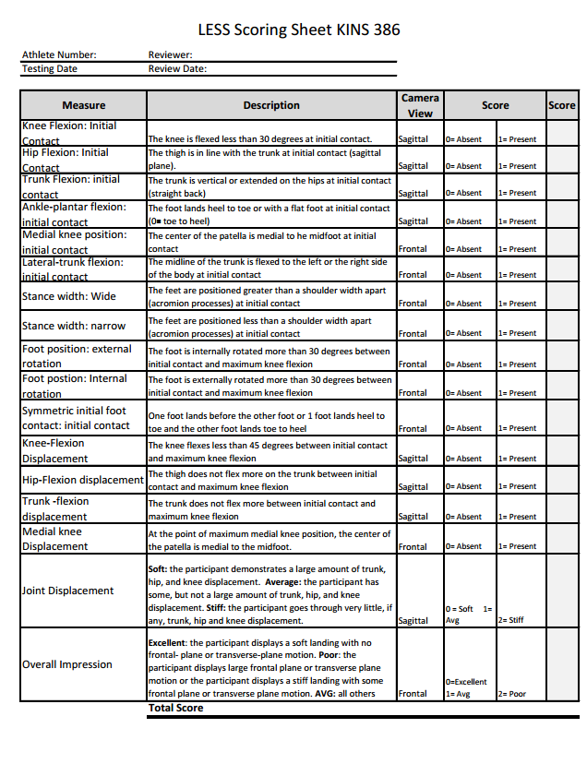

Reference Page

A Miezan, personal communication, November 9, 2017.

Bell, D., Smith, M., Pennuto, A., Stiffler, M., and Olson, M. (2014) Jump-Landing Mechanics

After Anterior Cruciate Ligament Reconstruction: A Landing Error Scoring System

Study. *Journal of Athletic Training*: Vol. 49, No. 4, pp. 435-441.

Mayo Clinic Staff. (2017). ACL Injury- Symptoms and Causes. *The Mayo Clinic.* Retrieved

from: <https://www.mayoclinic.org/diseases-conditions/acl-injury/symptoms-causes/syc-20350738>.

Padua, D., Boling, M., DiStefano, L., Onate, J., Beutler, A., & Marshall, S. (2011). Reliability of

the Landing Error Scoring System- Real Time, a Clinical Assessment Tool of Jump-

Landing Biomechanics. *Journal of Sport Rehabilitation*, vol. 20, issue 2, 145-156.

Padua, D., DiStefano, L., Beutler, A., de la Motte, S., DiStefano, M., & Marshall, S. (2015). The

Landing Error Scoring System as a Screening Tool for an Anterior Cruciate Ligament

Injury- Prevention Program in Elite- Youth Soccer Athletes. *Journal of Athletic Training,* 589-595.

Padua, D., Marshall, S., Boling, M., Thigpen, C., Garret, W., & Beutler, A. (2009). The Landing

Error Scoring System is a Valid and Reliable Clinical Assessment Tool of Jump-

Landing Biomechanics. *The American Journal of Sports Medicine,* vol. x, no. x, 1-7.

Paterno, M., Rauh, M., Ford, K., & Hewett, T. (2014). Incidence of Second ACL Injuries Two

Years After Primary ACL Reconstruction and Return to Sport. *American Journal of*

*Sports Medicine,* (Abstract).

R. Canter, personal communication, November 10, 2017.