Jessica Smith
Dates Tracked: 2/18-2/24 & 2/25-3/2
Week 2/18-2/24
Total Steps: 91,984
High Day: 2/22 21,607
Low Day: 2/23 7,057
Week 2/25-3/2
Total Steps: 107,639
High Day: 3/2 21,273
Low Day: 2/29 9,731
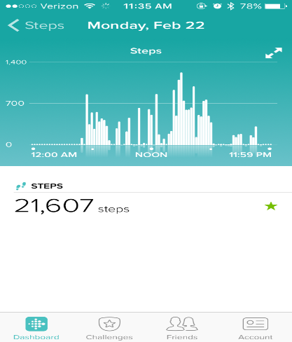
High Day 2/22
This was my high day because on Mondays, I have morning practice and afternoon practice which involves a lot of running and movements.

Low Day 2/23
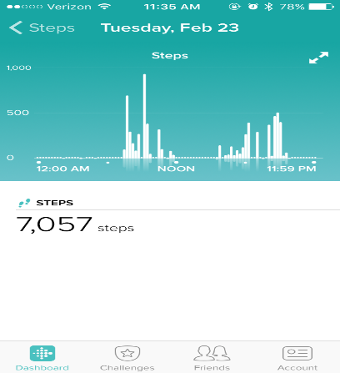
This was my low day because it was a Tuesday and I do not do as much physical activity on Tuesdays because there is no morning running.

Week One Stats
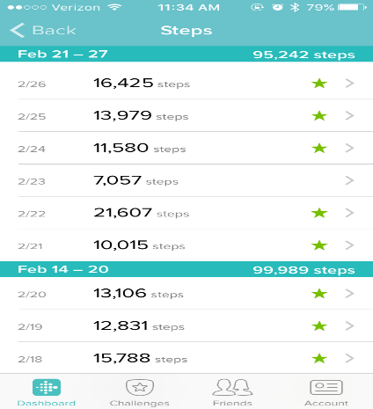

High Day 3/2
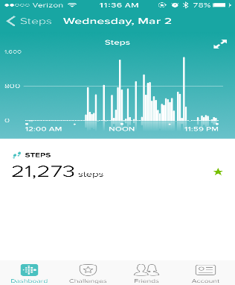
This was my high day because Wednesdays usually involve a lot of walking around campus because of my classes and I walked even more because it was the day before I left for Spring Break softball trip.

Low Day 2/29
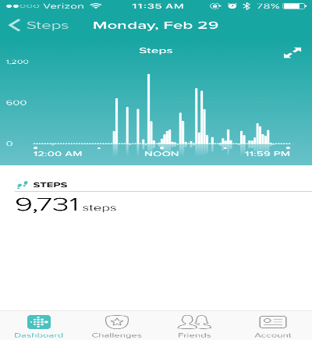
This was my low day because I was off in the morning because of traveling the weekend before.

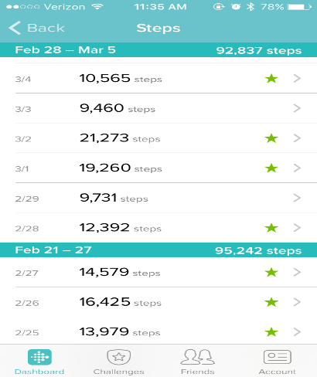
Week Two Stats

Environmental Barriers:
