Name: Sierra Garland

Bi-weekly report dates: 1/31 - 2/6 & 2/7 – 2/13

Steps week 1 totals: 94,465 High day: Thursday 2/4 (20,362 steps) Low day: Sunday 1/31 (7,481 steps)

Steps week 2 totals: 85,698 High day: Thursday 2/11 (19,648 steps) Low day: Sunday 2/7 (5,786 steps)

Week 1 Graphs

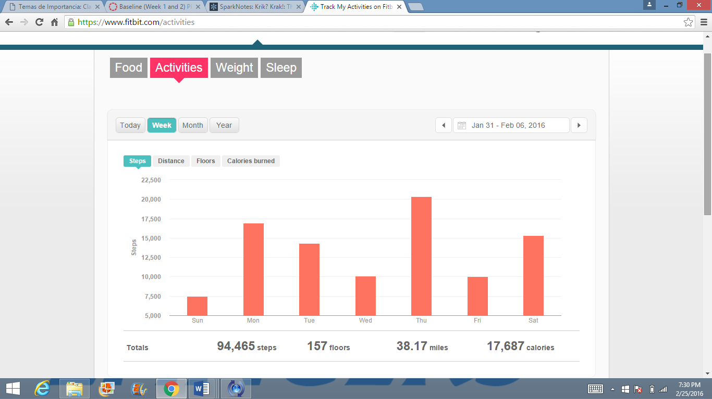Weekly outlook

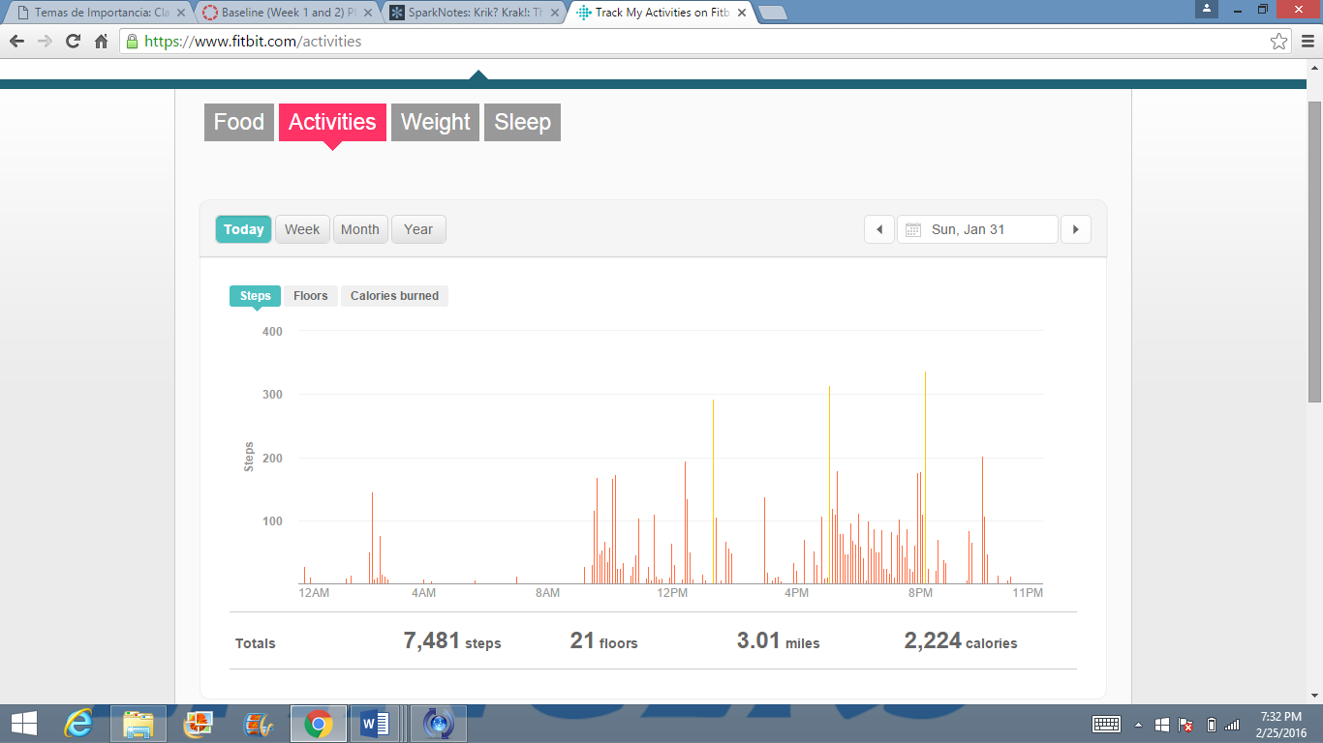Low Day

High Day

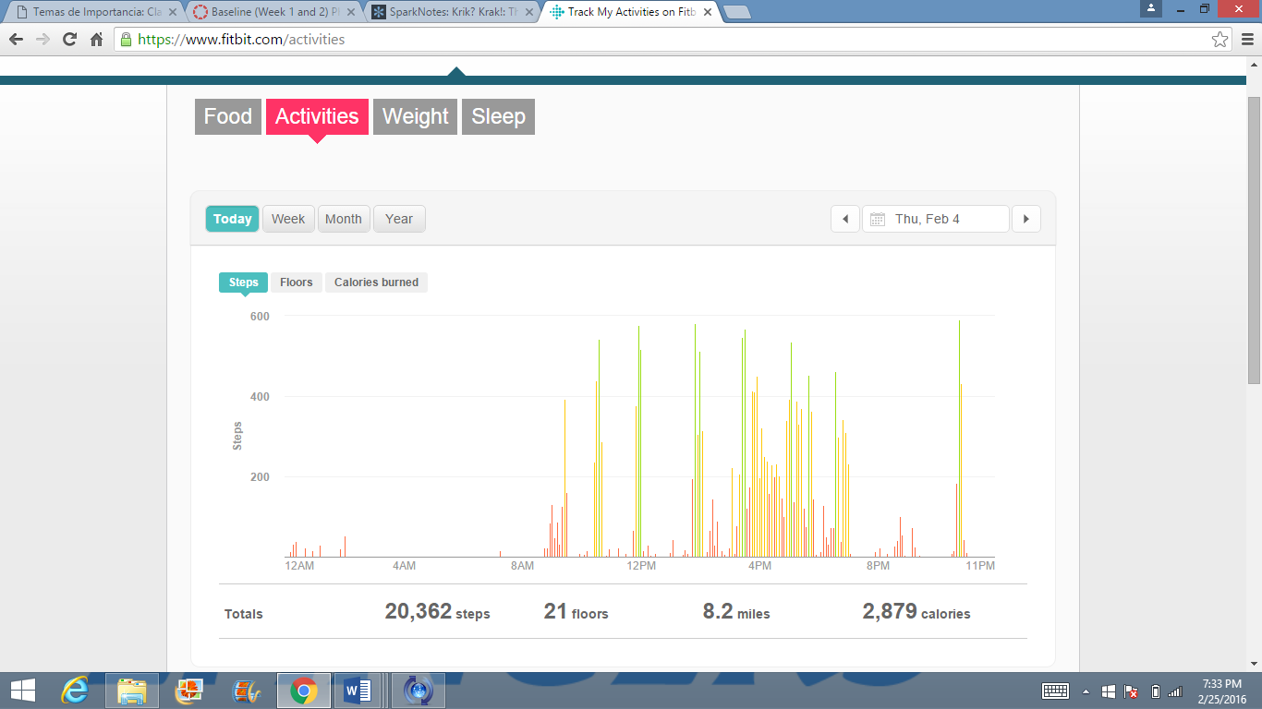

Reflection for Low and High Activity Day (Week 1):

* On Sunday I stayed in bed until around 12, which is why my steps were so low
* The most activity I did was on Sunday afternoon between 4pm and 6pm when I was walking to dinner and to my car
* On Thursday, the activity was concentrated between 3:30 pm and 8pm because I had basketball practice
* On Thursday I was more active earlier in the day rather than on Sunday when I did not being to move around until 12 pm

Week 2 Graphs

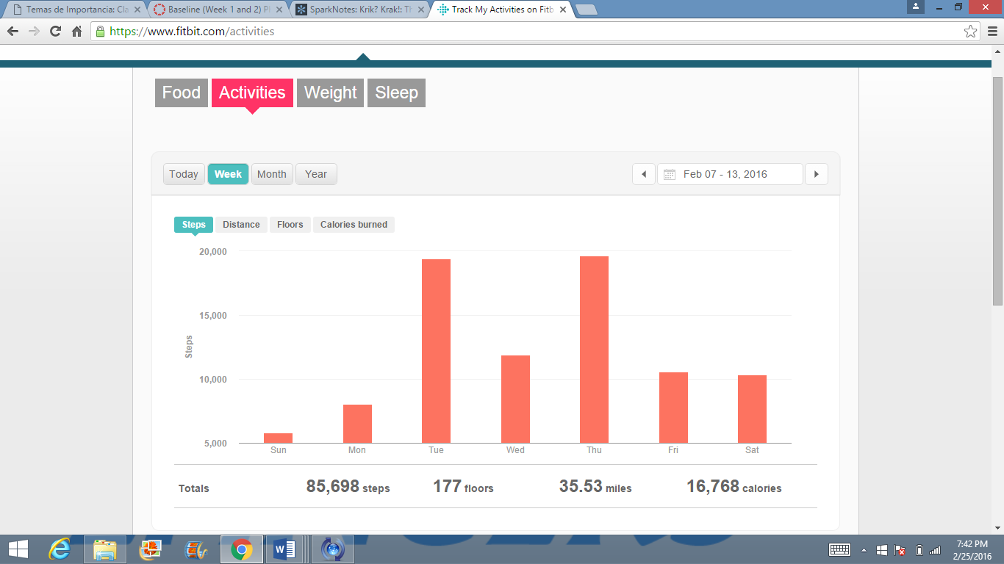Weekly Outlook

Low day

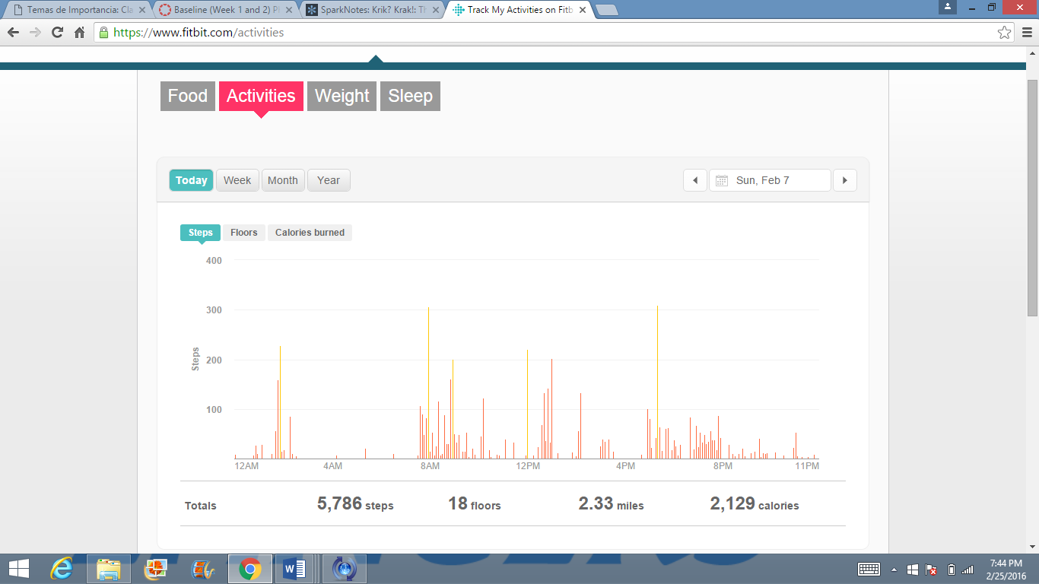

High day

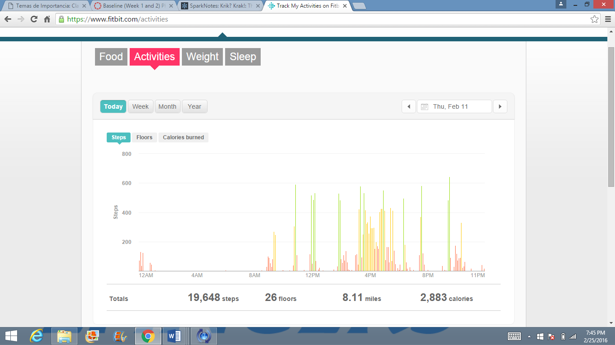

Reflection of Low and High activity day (Week 2):

* The low day I got up early but I did not move around much
* I was doing homework most of the day on Sunday
* Thursdays are always my high day because I have basketball practice
* Also on Thursday, I had an intramural basketball game and I wore my Fitbit during warm ups
* Most of my activity on the high day was after 3 pm