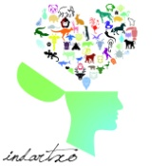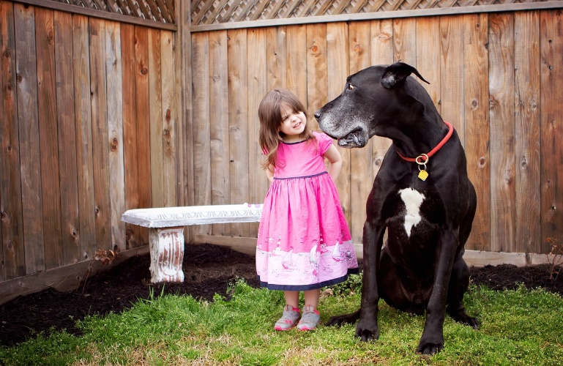

Congue nihil imperdiet doming id quod mazimplacerat facer minim veni am utwisienimadminimeniam, quiseratnostruexe

rcitationullamcorpernostruexercitationullamcorper et iustoodio dig nissim qui blanditpraesentlupta. Tummerdelenit

augueduis dolore tefeugaitnullafacilisi. Con erattissectetueradipiscingelit, sederatdiamnonummynibh magna erat.

*About A.R.C.*

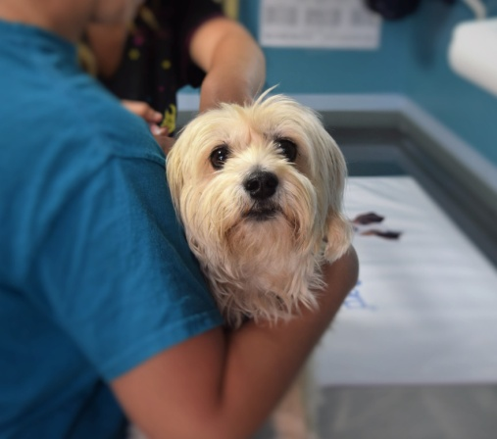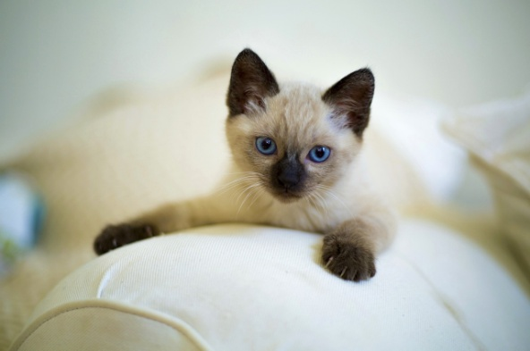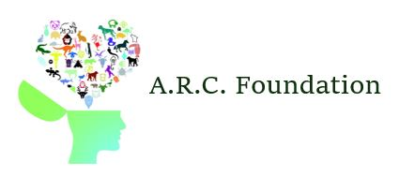

Originally founded as a animal hospital known as Noah’s Arc in 1998, the A.R.C. Foundation has grown to become the world’s leading provider in pet neurology and human-animal communication. Along with our dedication to biological and technological research, the A.R.C. Foundation offers outpatient services that allow individuals to not only speak with their pet(s), but for their pet(s) to speak with them. The A.R.C. Foundation also offers a wide range of neurological examinations and procedures. Please refer to our website [www.arcneurology.com](http://www.arcneurology.com) for more information regarding our practices, procedures and dedication to animals of all shapes and sizes.

- Pamela R. Stapleton CEO

“We are very proud of the strides we have made in Animal-Human communication.

We will continue to provide for a community that has been so supportive.”

Schedule a consultation today at

**555-543-5432** or online at **www.arcneurology.com**

*The acronym A.R.C. stands for Animals Recipricate Communication. We are the leading providers in human-animal interaction. The ARC Foundation is centralized in Pheonix, Arizona but provides animal neurology and interpersonal translations from pet to owner statewide.*

A.R.C. Foundation Neurology Center

6055 Clawson Circle

Phoenix, AZ 85001

*The A.R.C. Foundation*

*Bringing you closer to your pets than ever before!*

Leading Animal Neurologists

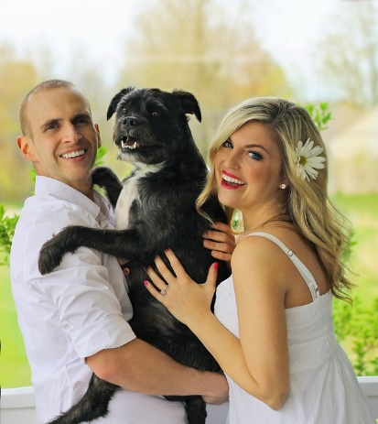

*Stories from our clients*



***Dr. Jaylen P. Anderson***

Lead A.R.C. Neurologist

*For the past 12 years, the A.R.C. foundation has been offering animal communication services for competitive rates. Our clients drive us to succeed daily. The love provided by a pet is truly one of a kind, show them that you care by* ***telling*** *them yourself.*

One day, a little kitten showed up on my doorstep in the rain. Naturally, I brought her in, fed her, and started posting on Facebook, “Lost Cat”. After two weeks of vigorous searching, no one claimed her. LUCKY FOR ME! Kiwi is my best friend. She has been with me through my very worst and has always comforted me through the tough times. After learning about the A.R.C. Foundation, I quickly made an appointment. It was so amazing to be able to speak with her after all our time together. This experience has brought us so much closer.

At first I was skeptical. I knew that animal communication science and technology exisited but never knew it could be so affordable and intimate. Being able to really talk to Max made me feel more secure as a cat mom and helped my boyfriend and I discover an illness before even going to the vet. Max had a great experience and truly knows I love him now. Even though I tell him I love him everyday, it was such a beautiful experience for me to say the words and for him to understand and reciprocate his feelings.

We resured Lipton from an abusive home in Pheonix, AZ in 2012. He is such a sweet boy but shortly after we adoped him, he started to experience a lot of issues with PTSD and anxiety. Thanks to the A.R.C. Foundation, we were able to schedule weekly appointments to talk with Lipton and work through his issues. After only a few short weeks of sessions, Lipton was happier than ever. My husband thinks our ability to both show and tell him he is out of an abusive situation was the trick.

***Providing a gentle touch***

***Shelby Shelton & Maximus***

***Melanie Walton & Kiwi***

Our process is quite simple, we make a small insertion in the animal’s left frontal lobe, and attach a detachable microchip that translates thought into formable speech and translates human language into understandable symbols and phrases. From there, we allow patients to speak with their pets either privately or with a licensed facilitator. Our sessions last exactly one hour, not including the chip implantation. This microchip is made out of all soft, organic materials and is safe for any amimal’s brain. There is no pain involved and the method is approved by the Global Science Administration.

***Mark and Natalie Price & Lipton***

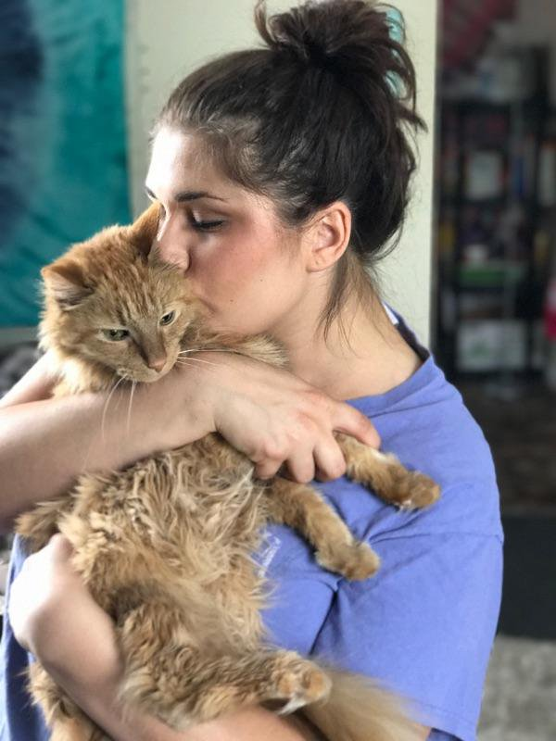

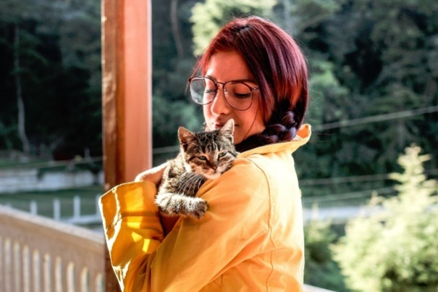

***Follow us on social media for additional stories, process information and more!***



**@ARCFOUNDATION**