Q1. In this scenario, write a formula for the total cost of producing x mats each year. Call it f(x).
$$f\left(x\right)=5x (Expense of Mats)$$
$$f\left(x\right)=5x+200 (Total Annual Expense)$$

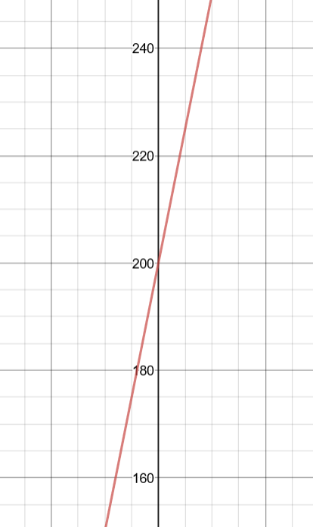

Q2. Now determine the average cost function F(x). What is the average cost of producing 500 doormats per year? 1000 doormats per year?
$$f\left(x\right)=5x+200$$
$$average cost: f\left(x\right)={5x+200}/x$$
$$500 mats:f\left(x\right)= {5\left(500\right)+200}/{500}=\$5.4 per mat$$
$$1000 mats:f\left(x\right)= {5\left(1000\right)+200}/{1000}=\$5.2 per mat$$

Q3. What happens to the average cost as the number of doormats increases? Is there a number below which the average cost won't go? Write the formula for your average cost function in such a way that it's clear what that lower bound is.

As the number of doormats increases, the average cost of the doormats decreases.
$$As x→∞, f(x)→0$$
As the average cost approaches zero, it does not cross zero even though zero mats may be produced. There is still an initial cost included into the total amount ($200) which prevents the function from crossing such asymptote.
$$f\left(x\right)={5x^{2}+200}/x with x>0$$

Q4. Rewrite the total cost function g(x) in this scenario, as well as the new average cost function G(x).
$$g\left(x\right)=-0.0003x^{2}+5x+200$$
$$G\left(x\right)= {-0.0003x^{3}+5x^{2}+200}/x$$

Q5. Graph the two average cost functions F and G on the same set of axes. Find intervals where they look basically the same. At what number of mats does the x2 term appear to kick in? Justify your answer.
Black Function:
F(x)
Purple Function: G(x)
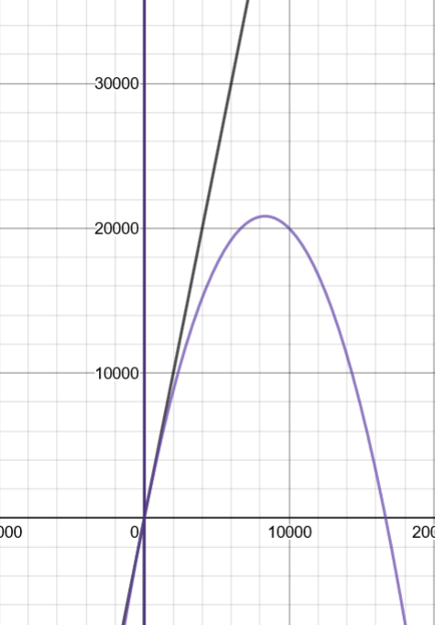

Around the 2000th doormat at is where the function G(x) drops off the more linear curve of the first average function.

Q6. Graph G and the non-fractional terms on the same axes for large values of x to be able to see this behavior. The remaining terms are called a slant asymptote of G.

$$G\left(x\right)=(-0.0003x^{2})+(5x)+({200}/x)$$
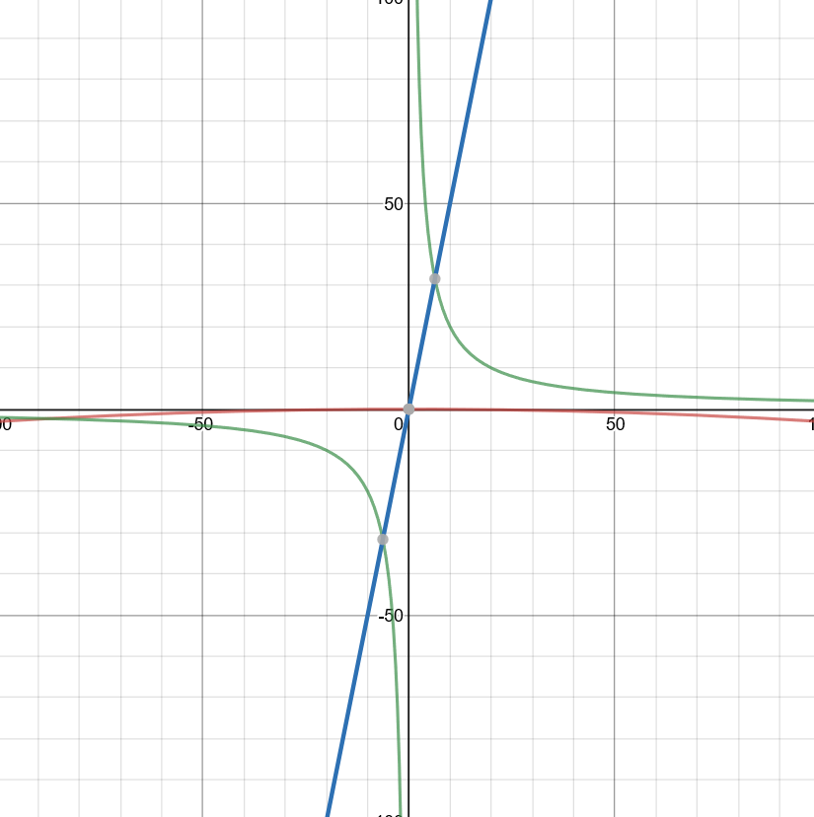
Red Function: $-0.0003x^{2}$
Blue Function:
$$5x$$
Green Function:
$$200/x$$

Q7. Decide whether the term should be added or subtracted. Rewrite the total cost function h(x) to include this term, and then write a formula for the new average cost function H(x).

$$h\left(x\right)=0.0000001x^{3}-0.0003x^{2}+5x+200$$
$$H\left(x\right)={0.0000001x^{4}-0.0003x^{3}+5x+200}/x$$

Q8. Graph H(X) on a reasonable interval. Explain why the interval is reasonable. Does the graph suggest an optimal amount of doormats to produce? Interpret the behavior of H(x) for large values of x in terms of doormats.

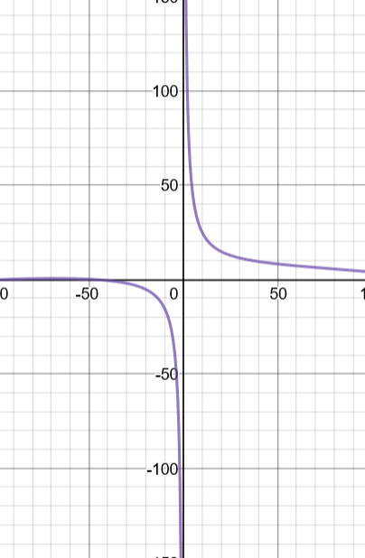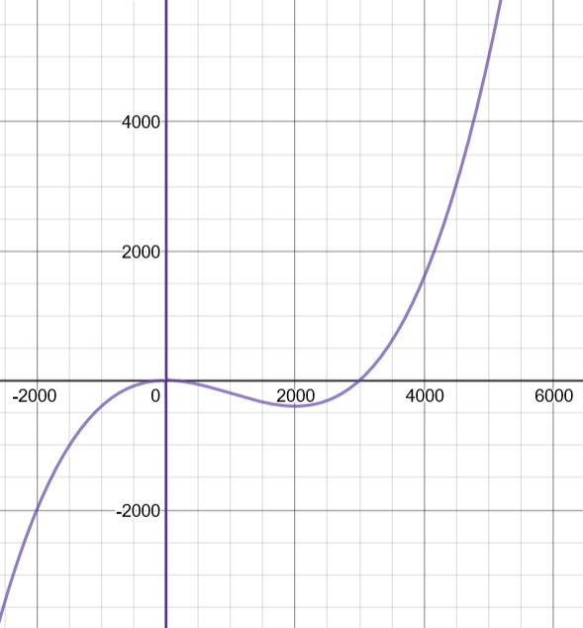

The interpretation of the graph suggests that the best production of doormats would be at a higher rate then what may already be produced which can be determined through the lowering of the total production cost as the number of doormats increases as well as the increase in selling rate by the couple.

Q9. Now, summarize each of the models F, G, and H in context for the doormat makers. For each of the models, describe production goals in terms of average cost for each model.

Model F:
The graph describes a linear function with the total cost rising with the more doormats being made. The function cannot go lower than $200 dollars because the initial production cost is at a fixated $200. With the average cost, the cost for each mat is the function of the total production divided by the number of mats produced which can be then interpreted at a curved function that lowers with the increase of doormats being produced.
Model G:
For the model of the function G(x), the function is interpreted as a parabola that in flipped about the x axis from the subtraction of the coefficient added. This is the interpreted that the production of doormats will lead to a total greater cost with the increase in doormats produced until it takes a curve past a specific point of production.
Model H:
With this modeled function, it describes an average cost value which cannot reach zero, lowers as the production approaches 2000 doormats and shoots upwards as the production goes past 2000 doormats and upwards. This suggests that the average cost per mat increases with the more doormats that are produced annually.

