Academic writing: The Development of Written Communication in an Ever-Changing World
Kinsey Shefelton
ENGL 165
Professor Elise Green
April 20, 2020

Introduction
Within the academic world, there is much differentiation on study and the development of knowledge. Much of this can be related to the differences found with WAC (writing across the curriculum) in which a university is separated by focus of study and brought together through the communication of information across the academic world. Between each field, audience is a strong factor in determining how a paper may be written. Studies are done and discussions are written in relation to each topic and the approach taken to by each author depending on the technique tought in their university or college. Communication differences within the academic world are a strong barrier in furthering the knowledge that can be found.
Within the study conducted here, the approach towards communication between three field of three disciplines is addressed. The three disciplines represented are the natural sciences, social sciences, and humanities. The natural sciences approaches the topics related the function of the natural world including the fields of biology, physics, and chemistry. The social sciences keeps within the realm of scientific experimentation, yet approaches human actions. As for the humanities, the information studied is of the ideas and concepts that come from cultures and eras. Between each of these disciplines, there are many focuses of similarities and differences which can be noted within my study with language, structure, and reference. With these, the ideas of language are approached through how the author may approach the audience, what word formatting, what tone of speech. This may be then set into a specific structure related to how the paper may be written and how the citations within the paper may be conducted, such as: how many references, what structure, etc. From each discipline, the fields of astrophysics, psychology, and literature were taken as focuses. From these topics and articles found, the study was conducted between the similarities and differences that can be found in communication style.

Literary Review

History has proved the world incapable of remaining the same. There is always something that some person may find unfit for their present living situation. Perhaps it may have been the reformation, the industrial revolutions, the French revolutions, the civil war, the world wars, or civil rights, any of which have moved the entirety of the world far further than we may have ever imagined beforehand. Across the history of writing, it is often found that there is a movement or a change in communication. Whether it be as a form of speaking or writing, there are often movements that have developed the methods of communication that the world knows of today. Between instances such as social movements (civil rights or feminism), the great vowel shift, or the change in curriculum writing, there have been and will continue to be many changes across society. One of the more recent movements was that of the curriculum-based writing form (WAC). As determined within The Future of WAC (Walvoord,1996), “A movement depends on a shift in a public perception: something that has always seemed tolerable must now seem intolerable.” Over time, history found its way into writing, currently through the integration of WAC. Writing has since lead away from specialization and skill and towards the enhancement of learning a subject (Anson, 2010). Written word may be the best way to communicate ideas, although each field may have separate ideas, the communication between these fields is what builds upon the academic community.
The movement of Writing Across the Curriculum began with the determination that writing is communication in one of the best forms in this modern world. Conceptualizing knowledge and spreading education amongst a wide world with many societies, has become a focus to of the academic world. How may knowledge best spread? What is the best way to spread knowledge? How is it spread equally to those willing to learn? Much of the development of the WAC system was under the pressure of the academic world to formulate a system of learning that each population may embrace it (Walvoord, 1996). Writing Across the Curriculum is inclusion within the academic world and university life to better explore the knowledge of the university per each student (Stout, 2010) as well as it is believed to be the furthering of knowledge within oneself which pertains to the knowledge within the university as a whole (Bartholomae, 1986). The movement of the WAC system has been defined and explained with many reasonings across the academic world, not to say that any reasoning is more or less right than the other, yet the intention and future purpose of the system is at an undetermined point between academics.
Many of the fields across the academic world are separated through discipline and focus. There are several different fields such as that of the Humanities, Social Sciences, Natural Sciences, and Applied Fields. Each of these disciplines embraces a different field of study whether it be language, chemistry, visual arts, law, or psychology. Within Writing Across the Curriculum, it is of substantial importance to be able to communicate the necessary amounts of information to a general crowd as well as to other academics within the community of the same discipline. This increases the importance of the role of WAC through the intradisciplinary roles: “…more sophisticated theories about students’ enculturation into disciplinary discourse communities and their need to learn the expectation and conventions of disciplinary genres…” (Anson, 2010). Anson discussed the importance of interdisciplinary communication with the difference in subject which must be overcome to build upon the university. Within this description, the university must be understood with communication running in between the separation of discipline. Within Bartholomae’s description of the university (Bartholomae, 1986), it is better understood that the university is invented through the separation of study which builds upon the knowledge in each field and the building of the standing of the university itself with the communication between each of the fields. Thus, intercommunication is necessary to limited links.
History and communication come together to bring past works into account for the furthering of the present studies. Discourse within the academic communities relates itself entirely to the accreditation of past and recent works. Such as in the natural sciences, much of the research done must have citations and references towards past related works and further findings from such works. To be able to forward oneself with the knowledge of a subject, one will have a need to rely on the past knowledge that had once been founded. Within the sciences, this is immensely necessary, unlike within the visual arts where representation can be founded within each of the artists themselves. Although it may seem that discourse within the art community may come directly from the statements written by artists themselves, the relation of present artwork to the progression of societal artwork as a whole displays the need for WAC and the demonstration of communication within the University. This is well represented within “Hello, I’m Carbon” (Stout, 2010) and “Writing in and about the Visual and Performing Arts” (Pemberton, 2019) with the relation of scientific data into an emotional connection as well as artistry into a collective definition. Within each campus, it is brought to light that many students may struggle with communicating throughout the university and into other disciplinary communities such as the studies of studio artwork in relation to ‘sizeable writing components’ (Pemberton, 2019).
Within the natural sciences, it is often found that the data represented in the findings of the students must be translated into a communicable text, in this, difficulty may be found to be able to directly relate the quantitative data into conceptual understanding and further discourse. The journal entry of “Hello, I’m Carbon” (Stout, 2010) relates the thinking processes of undergraduate students to the conceptualization of the data they are given. The students are found to have difficulties in creating an understanding adequate to the needs of the professor’s standards. The professor further comments that the need for a greater understanding of the knowledge demonstrated through Writing Across the Curriculum would aid in the understanding of the concepts.
Each of the entries given demonstrate a knowledge upon Writing Across the Curriculum in how it was founded, how it may be expressed, and how it may be used in the future. Because the WAC system is a highly interdisciplinary structure, each discipline may have a separate connotation of WAC. Within the sciences such as “Hello, I’m Carbon” (Stout, 2010), the system may be best used as a form of conceptualization from the difficulties that lie within the barriers of the data. Within the visual arts, as well, there is a point in communicating the statement made by the artwork such as in Writing in and About the Performing and Visual Arts (Permberton, 2019). Clear communication is a point of strong emphasis within the system of WAC, it demonstrates the ability to confront the dynamic changes that are seen between subjects within the academic world. Each of the sources give an understanding that WAC is to bring together a common ground of understanding on such wide and spacious portions of the modern learning world. Through any similarity, there may always be found a contradiction.
Within the WAC system, there is a dispersion upon the foundation of the university. Perhaps the university is built upon the knowledge of the students, or perhaps the student grows from the previously founded university (Bartholomae, 1986 & Anson, 2010). The best form of understanding is within the student to develop. To invent a university or to understand the direction in which a university takes its steps to educate its students is a long path down the road of the academic world. Knowledge is within the student his or herself to delve into the world of an academic and bring forth the capabilities that come with learning and experience. The modern world calls for a form of language that will best communicate the ideas represented by the modern people whether it be in the humanities or the sciences. Writing Across the Curriculum has directly come forth to be able to confront the issues which the university faces upon a collective knowledge with a body of students. There are and forever will be much more to learn and to give to the university in order to achieve a full understanding. It is often said that one must place themselves ‘into the shoes’ of another being to be able to fully comprehend the situation. This is much of the life of a student; to be able to mimic the given environment and become one’s own figure through the entirety of the knowledge previously gained is a talent within itself. The university is built upon the students and academics within it; each of the students develop themselves through the knowledge of the university and the university through the knowledge of the students. The separation of the fields within a university may best be accomplished through the communication the university applied across the curriculum, preferably through written work.

Methods
From the literature review previously conducted, the definition of WAC was approached and made great connections to the general four disciplines of natural sciences, applied fields, social sciences, and humanities. This literature may then be connected greatly to the fields taken into focus within the research study. It was decided that the best method of approach to this study would be research within three dominate fields of three separate disciplines, being: natural sciences, social sciences, and humanities. I chose the study astrophysics, psychology, and English literature to research. From each field, the main studies were taken from the language, structure, and references of each article.
With this study, the research was approached in a manner like that of a coded letter written for a detective. Each article was read in depth then taken apart and analyzed in relation to language, structure, and reference. Much of the analyzations were related towards the intended direction of each article and the underlying connections or meaning that the authors may have. Information such as sectioning, keywording, themes, point of view, and contextual vocabulary were highlighted sections. With each paper, the article was downloaded, read, sectioned, and noted to best understand the communication structure. In this structure, I was best able to comprehend and take apart each article.

Results and Discussion

Language

“Written language” is a highly developed term which changes greatly in relation to context. Between the disciplines of natural science, social science, and humanities, there is a vast change in communication styles displayed within each field and their disciplines. In this study, the stylizing of language will be analyzed through the chosen fields of astrophysics, psychology, and literature.
Within the natural sciences, it is often found to take after methodization. It is common to find that scientific articles display data-centered information and language in the passive voice to focus on the experimentation rather than the relation to the world or its people and opinion. The use of jargon or scientific wording which can be found within the article Advances in Solar-Stellar Astrophysics with ‘chormospheric emissions’, ‘asymptotic giants’, etc (Haisch,1996) is commonly found within writing the natural sciences. Other wording structures, such as qualifiers are meant to enhance the meaning of the wording that relate the writing to being of speculation and observation. As an example, within the article The Crab Nebula as a Standard Candle (Meyer, 2010), stellar astrophysics with emission spectra, particle energy fluxes, and pitch-angle isotropization are terms that are referenced to quite often. This language is often interpreted and used within the scientific field by specialists to identify their results. Because the jargon is not put into generic terms of speech and referencing as with the common tongue, papers within the natural sciences are generally solely directed to the scientific communities. Although much research within the natural science communities revolves around and within such communities, there are efforts to communicate information into the public world.
Within the social sciences, there is much similarity to the natural sciences, yet the language within the social sciences takes much more consideration of the social constructs that take part in the understanding and interpretation of the information. Within the article, Improving self-monitoring and self-regulation: From cognitive psychology to the classroom (de Bruin, 2012), cognitive psychology is related to the specialization of educational teaching methods and how best outcomes can be made through learning. In relation to the natural sciences, the social sciences have a tendency to use jargon as well as qualifiers to push forward their data and information. The findings within the experimentation of the social sciences may be scientifically found but it is socially debatable as well. As an example, The Psychology of Life Stories (McAdams, 2001) presents itself as an argumentative case towards human behavior linked towards each person’s backstory. This data is presented in a form of methodized scientific studies as well as social concepts and argued constructs. Thus, the soundness of the data relates to the natural sciences in that in is fact-proofed, yet also in a sort-of ‘conceptual middle-ground’ with the humanities.
The humanities focuses its efforts towards the interpretation of the social world into an opinionated and communicated form, such as the arts, language, history, and literature. This form can be taken as more active with reference to the author as well as general opinion around the subject rather than experimented data. Within literature, qualitative data can be taken from representation of human findings and written work throughout history which may lead to great findings and representations within society and the human world. With the text, The Alterity of Modernity of Medieval Literature (Jauss, 1979), the reader may analyze the opinionated formatting surrounding the thesis and setting of medieval texts in relation to their placement in the modern world. As an example within the text, the argument was stated that “…the classical paradigms of the positivistic research of tradition as well as of the idealistic interpretation of the works or styles have exhausted themselves, and the highly touted . modern methods of structural linguistics, semiotics, and phenomenological or sociological literary theory have not yet gelled into the development of paradigms.” (Jauss, 1979). This example demonstrates extensive thought and technical speech which may be often found within papers within the humanitiesAs well as medieval literature, the search for old and well-formulated forms of writing is an opening within the modern literature world. The article In Search of ‘Post-Classical Literature’: A Review Article (Bauer, 2007) emphasizes upon the importance of finding written work from past ages. The formulation of humanities written works revolves highly around introduction of the thesis through definition and background, then support of thesis through findings and formulated opinion. Because the thesis must be highly supported through persuasive concepts, the author may take towards difficult and rigorous language such as ‘hermeneutics’, ‘concretized’, ‘contemporaries’, dichotomy’ etc (Bauer, 2007 & Jauss, 1979). Humanities work much differs from the style and approach of the natural sciences yet relates well to the approach of the social sciences in relation to the societal world.
Similarities and differences come across each of the settings of language depending on subject and discussion, yet each with the focus pertaining to sharing the intellect gained from experience. Language takes the form of communication within society and human connection across the globe, with the understanding and comprehension of language may come the understanding of perspective and placement of people whether it be within nature or within our lives.

Structure

The structure of such writings are comprised of many different forms to best communicate the ideas represented. Through each discipline there is a structure in which the communication to the public as well as other bodies within the discipline is best formed.
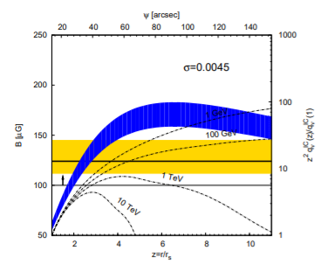
Within the natural sciences, the typical structure happens to be the IMRaD format (introduction, methods, results, and discussion). With the IMRaD format, the scientists devise a plan and experimentation to test the hypotheses presented. The structure of IMRaD is Introduction, Methods, Results and anaylsis, and Discussion. With this structure, a hypothesis is developed in relation to a scientific and testable theory, then an experiment is developed and tested which brings forth the results and discussion upon the results. As represented in The Crab Nebula as a Standard Candle in Very High-Energy Astrophysics (Meyer, 2010), The IMRaD structure is presented to test the hypothesis that the Crab Nebula would provide an accurate standard candle measurement in comparison to other cosmological bodies. Most of the paper is separated by scientific topic within the introduction and discussion such as portions labeled: “II. Spectral Energy Distribution of the Crab Nebula”, “Electrons in the Nebula”, etc to demonstrate enough information on each topic. As well as the separation of topic, the natural science article carries many tables and graphs to support the results tested upon, as demonstrated in the figure. The discipline of the natural sciences revolves much around what can be tested and proven which is well demonstrated in the structure.
A
Figure 1 (Meyer, 2010)
s with the natural sciences, much of the social sciences demonstrate a similar formatting. Both the natural sciences and social sciences revolve around the concepts of testing hypotheses which details itself within the IMRaD structure. What makes the structure between the natural science structure from the social science structure is the use of language which pushes the discussion and introduction further with more qualifiers to support the argument. Because of the language use, the formatting of the social sciences may dip towards the side of the humanities with an essay-like structure yet built in an IMRaD format. Within the article Improving Self-Monitoring and Self-Regulation: From cognitive psychology to the Classroom (de Bruin, 2012) the formatting of the IMRaD structure is used to support the hypothesis and experimentation of educational psychology. Although the use of the IMRaD structure may be common within the field of psychology, it may not be solely used. Within the article, The Psychology of Life Stories (McAdams, 2001) the IMRaD structure is not used and instead, the format takes much more relation to the humanities.
Within the humanities, there is noticable difference from the scientific world. The humanities relate itself to the understanding of the human world. With the communication of the humanities into written form, it is often found that the formatting takes the structure of topic pertaining to the thesis. With the thesis, a question or topic may be approached which is then described in great deal with background information, reference to outside sources, and concepts and opinion developed by the author. With the humanities, much is developed from sight and the specific view of fact from the human world such as novels, art, or dance. Within literature, what can be learned is what is displayed in the written form over many eras then related to past, present, and theoretical societal structures. As an example, the article The Alterity of Modernity of Medieval Literature (Jauss, 1979) embraces the topic of the relation of past written works from the medieval age to the modern society and how such written works may still be of use to the human world.
Structure relates itself to writing in that it shows how the communication must be presented rather than worded with language. Writing across the curriculum bridges the differences found within each field and discipline.

References
It can often be found that the past brings knowledge into the future of intelligence. Because intelligence cannot be related to solely one person or each person, there is ownership that has been placed onto thought. With this has come the inclusion of reference. In the communicative world, there is much emphasis put onto the concept of credibility of thought. Many people believe in what others tell them based on the facts that such a person can support themselves with, such as doctors, nonbiased news reporters, or professors. As a student moves forward within the academic world, the knowledge that is learned must be referenced into order to deem it credible as well as non-plagiarized. In each discipline, the formatting and approach to referencing and citation differs based on the communicative style of the works.
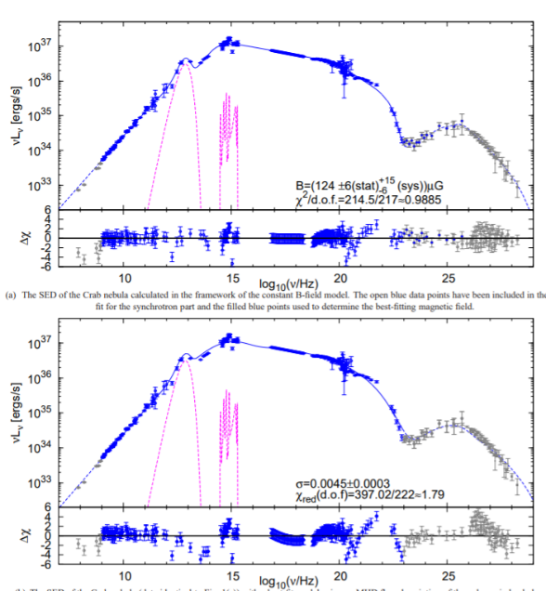
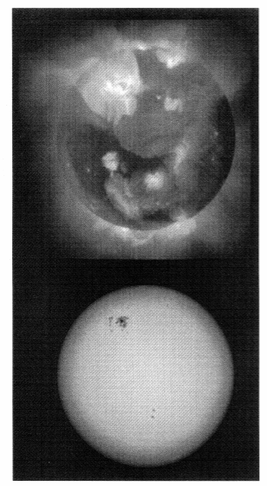
Within the natural sciences, it is often found that references support the finding within the paper being written. To support the hypothesis presented by the scientist, there are often references brought in to support past findings on the work being forwarded such as tables, graphs, mathematical work, pictures, and information to support the argument when necessary. As represented in both astrophysical articles (Haisch, 1996; Meyer, 2010) there are several references to outside articles and journals to support the information being founded. Within the paper on luminosity of the crab nebula (Meyer, 2010), there are several dozen references to outside experimentation in relation to the article such as general astrophysics, photo-optical instrumentation, and integration points. The sciences (including social sciences) use the APA citation format for their references.
Table 1 (Meyer, 2010)
Figure 2 (Haisch, 1996)
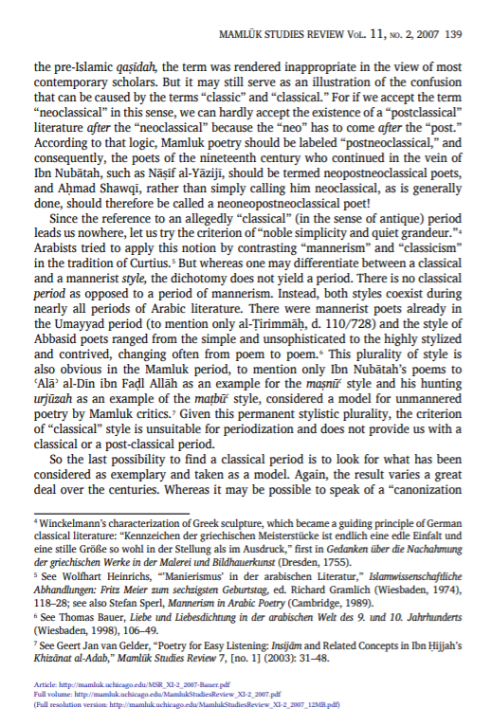
The social sciences relate highly to the natural sciences form of referencing as well as the humanities. The citation style is within the APA format, and the citations are to reference outside information on previous data collected as well as outside opinion on conceptual topics within the human world. With the paper on educational cognitive psychology (de Bruin, 2012), the author approaches the paper in a much more scientific realm with tables, graphs, and references to outside socially scientific sources as well as references to papers on society and relation to near humanities topics. Within the separate paper on The Psychology of Life Stories (McAdams, 2001), the referencing style pertains more toward the style of the humanities because the paper is directing in a format of thesis-based argument rather than methodology based on experimentation.

Figure 3 (Bauer,2007)
Within the humanities, there is much relation to the social sciences. The style of the paper is in argumentative format towards the conceptual thesis presented in the beginning of the paper. The references suggested throughout the paper are within the MLA format which approach the humanities and social world. These references are in suggestion towards outside opinion from other works. Within the paper In search of “Post-classical Literature”: a Review Article (Bauer, 2007), the approach to the citation are in-text references to the outside information such as an article which presents suggestions upon Arabian history by an outside author to support the argument.

Within each of the disciplines, there is a desire to seek out the correct levels of communication to form an argument, a thesis, a hypothesis, and information upon the level needed across the academic world. Within the natural sciences, such as physics, chemistry, or biology, there is much more direction towards a methodology upon the experimentation as well as past experimentation and facts presented by outside journals. The social sciences, such as psychology, anthropology, and economics, present themselves in a manner related to the natural sciences given that experimentation and methodology are considered as well as reference to past information and experimentation to support the hypothesis. Although it is related to the natural sciences, the social sciences seem to become a middle ground between the humanities and natural sciences being that it leans toward the concepts surrounding society and humanity. Within the humanities, there is a large desire to understand and spread the information that human create for themselves such as the arts, literature, and language. The humanities approach topic which may be approached in persuasive or argumentative form to develop concepts upon the information gained.

Discussion

There must be communication within the world to further the barriers of knowledge that has been set by the limits of humankind. Writing was once developed as a portion of such advancement and from this has come the expansion of the written and academic world. The movements of writing have taking place over millennia and continue to do so as long as humanity keeps itself curious. With the development of the educational writing curriculum came the process of writing in between each field. Because of its vast differences in discipline, communication comes across barriers depending on the information associated with the field. WAC (Writing Across the Curriculum) has been developed to overcome such boundaries.
From this experiment, I have learned that communicative barriers come in many forms, one of which being understanding. Further evidence, insight, and connection between the curriculum can be well identified in this study. With the disciplines of natural sciences, social sciences, and humanities at the forefront with astrophysics, psychology, and literature as the main point of view, the study delved into the analysis of such language. It was determined that each discipline has its similarities and differences, some more than others. With similarities, the disciplines can be found to embrace the understanding of language and communication in relation, specifically, to the directed audience. The differences and similarities between the knowledge in the academic world are astounding with much to be told. People section themselves off within the academic world to purpose themselves toward the understanding of a sole subject, yet, in a functioning society, knowledge must be learned and shared. Each of these disciplines share a similar goal within the academic world, to drive farther into the barrier of knowledge and learn more than what has been previously known before. In the future, much research can be done on the understanding of the concepts around WAC which can further push into embracing the academic world and putting a better future into the communication barriers that still stand.

References:

Anson, C. (2010). The Intradisciplinary Influence of Composition and WAC. NCU
Bartholomae, D. (1986). Inventing the University. Mayfield Publishing Company.
Bauer (2007) In search of “Post-Classical Literature”: A Review Article, Creative Commons Attribution
De Bruin, van Gog (2012) Improving Self-Monitoring and Self-Regulation: From Cognitive Psychology to The Classroom, Learning and Instruction
Haisch, Schmitt (1996) Advances in Solar-Stellar Astrophysics, Astronomical Society of the Pacific
Jauss, Bahti (1979) The Alterity of Modernity of Medieval Literature, New Literary History
McAdams (2001) The Psychology of Life Stories, Educational Publishing Foundation
Meyer, Horns, Zechlin (2010) The Crab Nebula as a Standard Candle in Very High-Energy Astrophysics, EDP sciences
Pemberton, M. (2019). Writing in and About the Performing and Visual Arts. WAC Clearinghouse
Stout, R. (2010). “Hello, I’m Carbon”: Writing about Elements and Compounds. American Chemical Society.
Walvoord, B. (1996). The Future of WAC. National Council of Teachers of English

