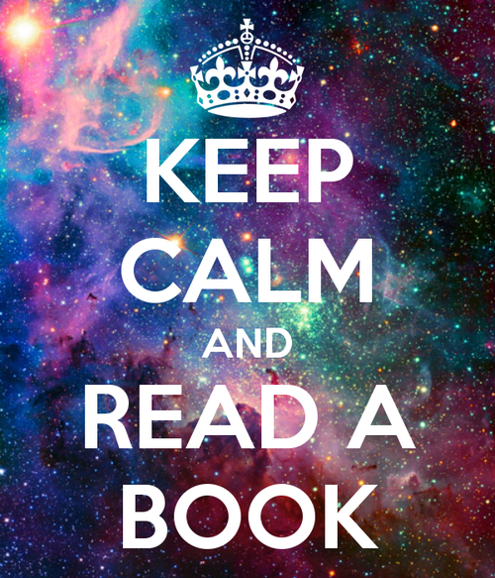  Take A Book  Read A Book*  * Please enjoy taking and reading these books. They are yours to keep or pass to the next reader.  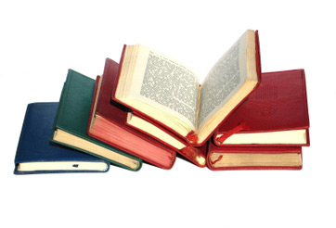 | To make donations call  Lit. Lovers  5404466710  ────  These books are free for you!  ────  Reading is a powerful tool.  ────  Keep calm and recycle on!  ────  Read with your children for free!  Longwood University Students  2300 Washington Ave  Fredericksburg VA 22401  May 5,2018  Michael Petruzzi, Theresa Chandler, Carol Korth, Shari Jones & Jane Yoder

