2014

Katrina Sexton

A1

12/2/2014

Don’t Blink

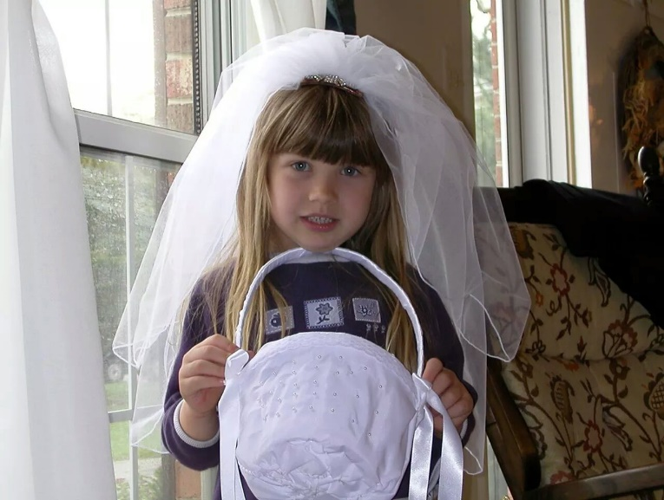

My Birth

I was born in the roots of Virginia were peanuts grow plentiful and people of all sorts of backgrounds live. On the first day of summer in 1997 with the air conditioning broken in the room and Winnie the Pooh on the television, I was born midday. Being the daughter of Shannon Sexton who was go to school full time while working nights, and Scott Sexton who working days, I spent a lot of one on one time with my parents. I spent most of my time as I grew up outside. Nothing could keep my indoors. When I was exactly four years and eleven months old, my brother was born and soon after my sister followed. My parents have raised me in a Christian household to believe in the American dream. I say “yes ma’am” and “no sir”, hold the door for people, and treat others with respect. I was spanked and taught how to treat people and make an impact on their life. My parents were young and wild before me, but when I came along, they led me down the path to change the world in a positive way.

Birth to 10

My first memories are hunting and fishing with my dad. These times were our special times. We bonded over the smell of stinky fish and gunpowder. It is here where I learned my dad was someone who loved me unconditionally and I could trust him with anything. I was daddy’s little girl and no matter what he did, I could forgive him because of those moments he gave.

School started for me at kindergaren. I did not go to preschool as most because my mom would spend the days with me, even though I did go to daycare when she had classes. School and daycare allowed me to strength indepedence and social skills. This ignited my love for learning which eventually lit my dislike for ignorance in my fellow classmates.

My siblings were born in 2002 annd 2004 and I soon became wrapped around their fingers. They became the center of my life and reason to live. I did everything with them and cared for them. I helped my dad take care of the munchkins when mom was not home and gave them someone they could always confideand I turn they gave me something worth fighting for. They made me want to be the best role model I could be.

Stages: trust vs. mistrust, Autonomy vs.shame/guilt, Initiative vs. guilt, and industry vs. inferiority

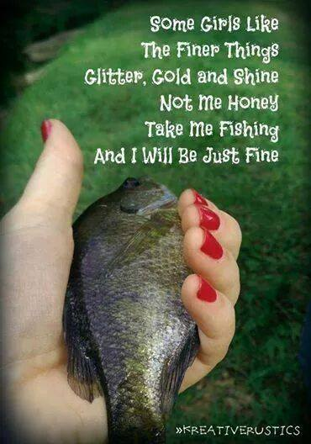

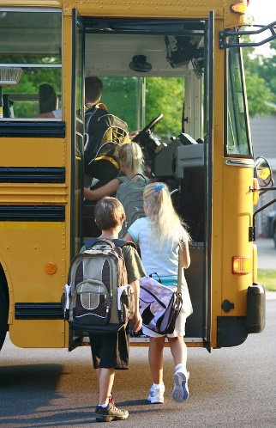

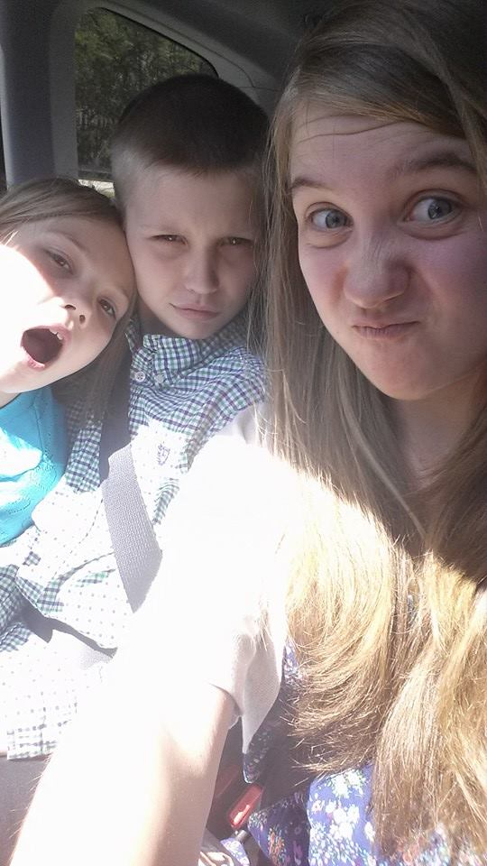

10-20

When I was 12, my parents filed for divorce. This has in turn caused my broken family to move multiple times and allowed for my stepmom to be part of my family. Through this tough time, I have been strong to show my siblings that everything is okay. These events took me away from my childhood home and caused much distress inmy life but overall made me a stronger person that is really close to her mother.

When I was 13 I started playing volleyball but little did I know that it would impact me so greatly. Not only did it allow me to meet amazing people and get in great shape, but it boasted my self conscious and boosted my mood when it seemed impossible. When I am down, I know I can rely on a good workout while playing volleyball to cheer me up, no matter what is going on. it has taught me leadership and the importance of each person on a team.

On my 18th birthday, I wil ride a mechanical bull. It has allows been my dream. I want to know how long I would last and beat my good friend’s time. Whenever the time arose in the past that one was avalible, volleyball tryouts or season would be right around the corner threatening me not to get hurt. The rush I will get has always been somehting ive dreamed of.

Stages: Industry vs. inferiority, Identity vs. role confusion

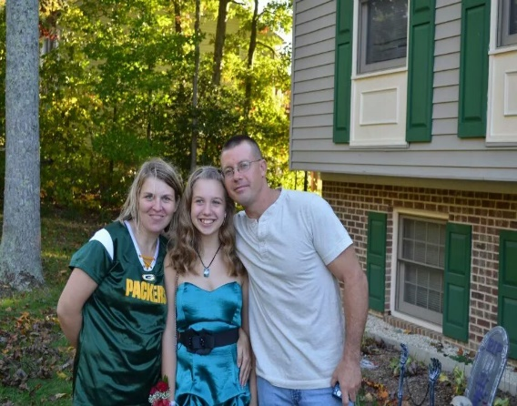

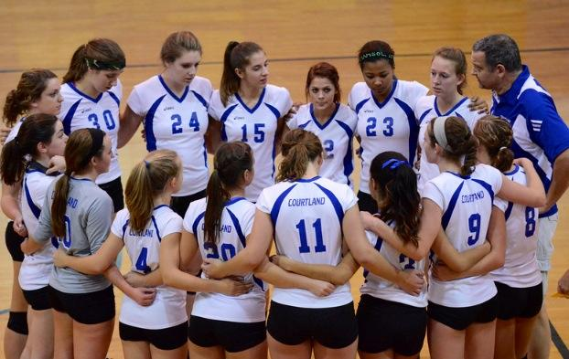

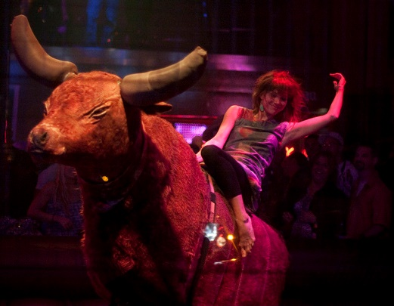

20-30

College will be a major portion of my early 20s. it will set me u for life. It will give me temptations and test me in unbelievable ways but will be a blast while doing it. While at college, I will study to be a nurse so I can save a life

The army will be with me from the day I leave hishschool. I will be in the reserves until colllege is done then shortly after I plan to enlist full time. This will be taxing both mentally and physically but it is my dream to save a soldier’s life and I plan to do just that. I need to make a positive impact on a soldier’s life and be the reason he can hug his daughter, wife, or mother again.

Even though college and the military will make my life hectic, I hope to build a relationship with someone and get married. Having someone by my side to support me through everything would help greatly. Someone to call my best friend and soulmate would be a deram come true.

Stages: Identity vs. role confusion, Intimacy vs. isolation



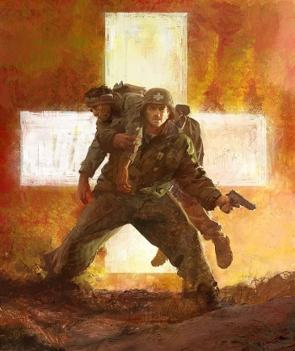



30-40

In my early 30’s I will have 3 kids, 2 boys and a girl. The first is going to be a boy named Brantley Ray. A little girl named Jessica Leigh will come next followed by a little boy named Landon Scott. They will take over my life and become the loves of my life. I will be there at every game, match, concert, and recital. I will try my hardest to always be there for them no matter what.

During this period, I will move to Georgia. The heat, beach, sweet tea, and atmosphere beckons me closer. I want my children to grow up on a large plot of land where they can fish, ride fourwheelers, or have as muh fun as they can. I want them otside in the country not inside in the city. No one knows how fun growin up outdoors is and how much it strengthens a perosn unless they do it themselves.

Stage: intimacy vs. isolation

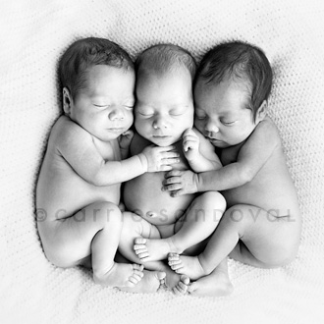



40-50

By early 40’s I will retire fom the army and get a real stable job at a hospital close to home, allowing me more freedom of time for my family. The extra income from my retirement will go to a college fund for each and save for a rainy day. Although the transition from military to civilian will be a difficult one, by this time, I will be mentally exhausted and will need to retire. This will help me kickstart my career in a hospital to prevent stagnation.

My childrens’ graduation from highschool and college will be bitter sweet. They will leave my care to find themselves and follow their dreams. As a parent, I will support them no matter what. I will help them follow their dreams, no matter the cost on me and will help them to be the best human beings they possibly can.

Stages: intimacy vs. isolation, generativity vs. stagnation





50-60

Grandchildren will enter my life and I will spoil them rotten. I will feed them cookies and take them to movies. I will love them unconditionally and treat them like they are the center of the universe. They will make me proud to call them my grandmother through individual achievements and acomplishments not matter how small. I will be the fun grandma that will let them out on the boat or fourwheelers whenever they want. They will keep me going until I cannot move anymore.

When im 55, I will go skydiving for my birhday. It is soething I have always wanted to do but I want to save it until later in life so I have something to look forward to. All my life I want to keep trying new things and keep as active a possible. I want to live life to the fullest. Skydiving will help me to do this.

Stages: generativity vs. stagnation





60-70

I will retire with my husband and we will have more time together. Our kids will be out of the house and happy with kids. My husband and I will be able to work on our relationship like never before. We will be financially set. The house will be paid off along with the cars and boat and other toys we decide to buy and we will be happy looking back on life.

Using money from multiple retirements, we will travel the world together. My husband and I will go to Greece, Rome, and Australia. We will have the freedom to pack u and go whenever we felt the need. Traveling will ease the stress of our lives and enable us to be happy and not regret anything in our lives.

Stages: integrity vs despair





Obituary

If you are reading this, that means I have passed to the next stage in my journey for eternity. Please do not cry fo me because I am no longer in any pain. To my dearest children, my belongings will go to for you are the center of my world. Thank you to my loving husband for being my rock all of these years, by my side til death. To Jordan, Taylor, Brandon, and Greg I love you all dearly! You guys are truly my best friends and I couldn’t have asked for anyone better to accompany me through this crazy journey. You have seen my at the highest of highs and lowest of lows and stuck by my side through it all. Without you guys I would not have lived life to the fullest like I did. My greatest pride was creating 3 beautiful children inside and out and my military service. There is no way I would ever take any of thaat back. As for regrets, I only have one, that I did not make a nationwide difference but I guess I did in a way through military service and saving the lives of so many people. I am so sorry to the family that were at my side the moment my soul was released but know that seeing your faces one last time meant everything. I am in a better place now. So in honor of my life, please laugh, fish, and lisen to Luke Bryan. Have fun but carry me in your heart so I can be right by your side like I never left. Always live life to he fullest and “don’t blink, life goes faaster than you think”. Take it from me. Well take care and I can not wait to see you all in the future! Love, Katrina Anne Sexton.