Cellular Respiration Lab

Taylor Pittman-Deering
Partners: Jennifer Oakes, Casey Davis, Katy Sexton
Miss Hunter
11/18/13

Introduction and Background­

Living systems require free energy and matter to maintain order, to grow, and to reproduce. Energy deficiencies are not only detrimental to individual organisms, but they cause disruptions at the population and ecosystem levels as well. Organisms employ various strategies that have been conserved through evolution to capture, use, and store free energy. Autotrophic organisms capture free energy from the environment through photosynthesis and chemosynthesis, whereas heterotrophic organisms harvest free energy from carbon compounds produced by other organisms. The process of cellular respiration harvests the energy in carbon compounds to produce ATP that powers most of the vital cellular processes. In eukaryotes, respiration occurs in the mitochondria within cells.

Cellular respiration can be measured using a respirometer, which measures relative volume as oxygen is consumed by something, for example, germinating plant seeds. As oxygen is consumed, the volume of gas decreases, which can be used to measure the rate of cellular respiration. Because respirometers are also sensitive to temperature and air pressure, a control respirometer is needed when using respirometers in an experiment.

Objective: The purpose of this lab is to view germinating pea seeds respiring.

Citations
"Cellular Respiration." AP Biology Laboratory Manual for Students. New York, NY: Advanced Placement Program, the College Board, 2001. N. pag. Print.
Reece, Jane B. "Ch 9: Cellular Respiration." Campbell Biology, AP Edition. Boston, M.A.: Pearson Education/Benjamin Cummings, 2011. N. pag. Print.

Material and Procedures

Materials

- 150 mL beaker (1)
- 200 mL graduated cylinder (1)
- Absorbent cotton (two small wads)
- Clock (1)
- Forceps (1)
- Germinating Peas (≈5.0 mL)
- Glass Balls (≈5.0 mL)
- Ice bath (1)
- Microrespirometer (1)
- Nonabsorbent cotton (two small wads)
- Potassium Hydroxide (KOH)
- Pipette (1)
- Thermometer (1)

Procedures

Step 1-A small wad of absorbent cotton was placed into the barrel of a microrespirometer.
Step 2- A pipette was used to place one drop of KOH on the absorbent cotton in the barrel.
Step 3- A small wad of nonabsorbent cotton was placed on top of the absorbent cotton in the barrel.
Step 4- A second microrespirometer was assembled using the same procedure as the first one.
Step 5- ≈5.0 mL of germinating peas were placed in one microrespirometer.
Step 6- ≈5.0 mL of glass beads were placed in the other microrespirometer.
Step 7- Both of the microrespirometers were submerged in an ice bath that was 7⁰.
Step 8- The microrespirometers were held in the water by a person's hand.
Step 9- Data was collected at 5 minute intervals for 20 minutes.

Data, Observation, & Analysis

A  Total Time (min) | B  Water Bath Temperature(Ice Water) | C  Total distance Fluid has moved (cm) | D  Change in fluid position during time interval (cm)
0 | 7⁰C | .1cm | -
5 | 6⁰C | .12cm | .02
10 | 5⁰C | .1cm | -.02
15 | 5.5⁰C | .105cm | .005
20 | 7⁰C | .12cm | .015

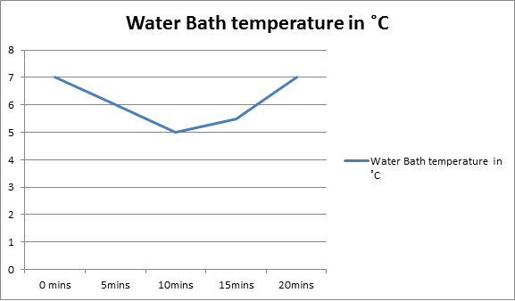
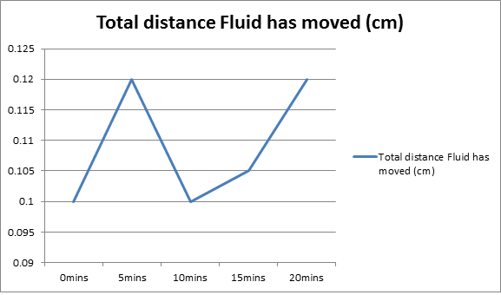

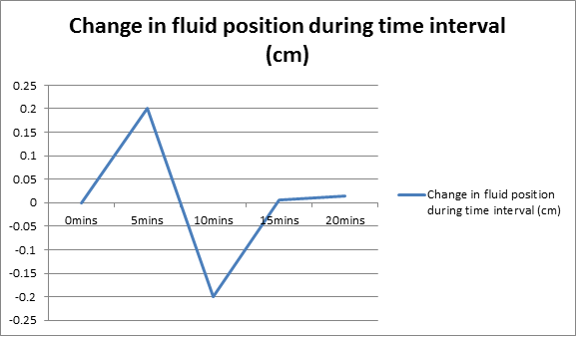

Qualitative Data:
The peas were small, green, and had short stems sticking out.

Conclusion

For this experiment, the peas used were already germinated and had a long stem protruding from the seed itself. these germinated seeds respired and pushed a small air bubble against the pressure from the water, showing its rate of respiration. Using a respirometer and thermometer, we were able to keep track of detailed notes regarding temperature and rate of respiration.
Due to the overwhelming chill of the ice water, cellular respiration did not occur as rapidly in the peas as we had hoped. At the lowest temperatures, the least amount of respiration is taking place. As the water warms, respiration quickens. Fluid position varied as the rate did. if the rate dropped, the position decreased. when the rate quickened, the position increased.
In the real world, cellular respiration effects metabolism and energy. If cellular respiration takes places slowly or inefficiently, energy levels decrease. all living things need energy to survive. energy is the only thing driving us forward and without it, cells would not function and we would die.
One possible error in the experiment was our choice to hold the respirometer in the ice cold water with hands. This caused the person to change hands which had an effect on water temperature. another human error was taking the respirometer out of the water after it had adjusted to the temperature of the water. a third human error was spilling water into the unsaturated cotton and possibly the water reaching down to to saturated cotton and the KOH- solution.

