Impacts of Field Maintenance on Diversity of Terrestrial Microfauna

Emily Douglass, Jonah Hottinger, Zach Sergi, and Maya Young
Longwood Department of Environmental Sciences
201 High Street
Farmville, VA 23909

Introduction
Terrestrial microfauna are small, microscopic organisms that play an important role in decomposition and nutrient flow in the soil. In turn, the plants use the nutrients that the microfauna cycle through the soil (Brown 1995). Without these microfauna, conservation of the ecosystem and the protection of wildlife would be more difficult ( Lees et al., 2016). Due to the importance of microfauna, we questioned how field maintenance such as mowing, herbicides, pesticides, fertilizers, etc impacted the microfauna of the area. We hypothesized that maintained areas (lawns) would have less biodiversity than unmaintained areas (fields).
Methods
Site description
This soil collection was done near the Environmental Education Center (EEC) at Longwood University in Farmville, Virginia once a week for three weeks, approximately 48 hours before observation. The sites used for this study were the maintained frisbee golf course (Lawn 1), unmaintained area beside the frisbee golf course (Field 1), maintained slope path (Lawn 2) and the unmaintained area beside the slope path (Field 2). Field 1 and Lawn 1 were within ten feet of each other in order to eliminate proximity as a factor. The same was done for Field 2 in relation to Lawn 2. This was done in late September, leading into early October. The weather for each collection was sunny for each day with no rainfall.
Sample Procedures
In each of the two field and two lawn sites, soil samples were collected to a depth of six inches using a bucket auger. Each sample had 300 grams of soil placed into a Berlese funnel. Each funnel was placed under a 60-watt heat lamp approximately 48 hours which caused the organisms to exit from the soil and fall into the collection vial that was attached at the base of the funnel. The collection vial contained 20 mL of deionized water. Remaining field and lawn soil samples that were not used for the Berlese funnel extractions were used to determine the soil pH, moisture, and nutrient content. Soil moisture was determined gravimetrically by oven drying 20 grams of each soil sample at 60 degrees C for two days.
Microfauna Identification
In order to examine as many organisms as possible, the researchers split into two groups and examined different samples. One group used a dissecting microscope to get a close-up view, focusing on Lawn 1 and Field 1. We used grid trays and a micropipette set to dispense 0.5 ml of the water at a time. We also used a pipette with the tip cut off in order to get bigger organisms that the micropipette could not collect. On the third collection day, we took a different approach in order to identify the specimens. After using the pipettes to collect the 0.5 mL of water and specimens, we poured the rest of the water into a grid tray to examine any microfauna not picked up by the pipettes. Most organisms were identified to the order level of classification. The other group used a compound light microscope and used pipettes to place the examined samples onto a slide. One hour was spent examining samples from Lawn 2 and then one hour was spent examining Field 2. Samples were collected by pipetting visible clumps of organisms floating on the water.
Data Analysis
In order to analyze the data, we used the program JMP Student Edition. We tested for statistically significant differences between slope position, location, and weeks with respect towards soil moisture, species richness, soil pH, and species diversity. For species diversity, we used the Shannon Wiener Species Diversity Index. We calculated the amount of Nitrogen, Phosphorous, and Potassium using the LaMotte Soil Kit. To find the pH of each sample, we took 50 grams of each sample and packed it into a beaker with 50 mL of Deionized water. After repeating this step for each soil sample, the Benchtop pH meter was used to find the pH value.
Result
The mean percent soil moisture of the lowland positions was determined to be greater than that of the upland positions, with a statistically significant p-value of 0.0117 (Fig. 1). The field locations had a larger mean species diversity than the lawn locations, with a statistically significant p-value of 0.0422 (Fig. 2a). The comparison of mean species richness for the field and lawn locations determined that there was no statistically significant difference between the two data groups (Fig. 2b). The pH level of week 1 and week 3 when compared had a p-value of 0 .011, so there was a statistically significant difference between the two time intervals (Fig. 3). The most abundant species found in the collected samples was the oribatid mite, which accounted for 43.93% of the total number of individual organisms recorded (Fig. 4).
Discussion
Our findings showed no significant difference between species richness with respect to fields and lawns. This suggests that the area around Lancer Park hosts the same organisms no matter the condition or location, meaning it does not matter if the area is maintained or not or if it is uphill or downhill. However, our findings do suggest that the maintenance of an area has a significant difference in species diversity. This suggests that the maintained lawns have worse living conditions for some microfauna than the fields. Overall, our findings support our hypothesis of lawns having less microfauna diversity than fields due to maintenance.
We were unable to test if the usage of herbicides, pesticides, or fertilizers were used and if it impacts the microfauna at our sampling sites. Due to lack of information, we were unable to confirm if these maintenance methods were applied. For a future study, we would like to test the impacts, if any, that herbicides, pesticides, and fertilizers have on microfauna. Previous studies have found that herbicides have a negative impact on these beneficial microorganisms (Druille et al., 2016). Another possible limitation from this study was that the samples were collected weekly. This allowed for possible changes in weather and other factors that impact the soil. With the probable future increase in urbanization and lawn maintenance practices. It is important that further studies are made to better understand the impact this will have on the soil community. Terrestrial microfauna has been found to be crucial in recycling and releasing nutrient flow (Kratina 2017). As humanity continues its efforts to conserve the Earth, we must not overlook the vital microfauna below us.

Literature Cited
Brown, G. G. 1995. How do earthworms affect microfloral and faunal
community diversity? Plant and Soil 170:209-231.
Kratina P., J. Pertermann, N. Marino, A. MacDonald and D. Srivastava. 2017.
Environmental control of the microfaunal community structure in tropical
bromeliads. Ecology & Evolution 7:1627-1634.
Lees K., A. McKenzie, J. Newell Price, C. Critchley, C. Rhymer, B. Chambers, and M. Whittingham. 2016. The effects of soil compaction mitigation on below- ground fauna: how earthworms respond to mechanical loosening and power harrow cultivation. Agriculture, Ecosystems, and Environment 232: 273-282.
Druille M., P. Garcia-Parisi, R. Golluscio, F. Cavagnaro, and M. Omacini. 2016.

Repeated annual glyphosate applications may impair beneficial soil

microorganisms in temperate grassland. Agriculture, Ecosystems, and

Environment 230: 184-190.

Figures
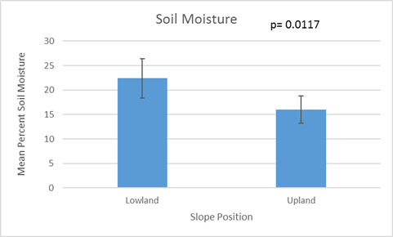
Fig1. Comparison of soil moisture by slope position. There was a statistically significant difference between the lowland and upland positions surrounding the Environmental Education Center (t-test: p= 0.0117). This averages came from 6 different replicates of both lower and upper positions. Error bars represent ±SE.
a 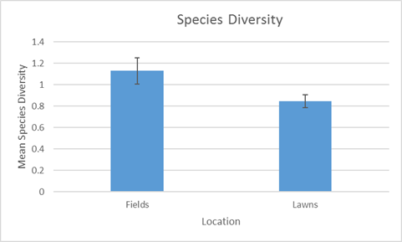
b 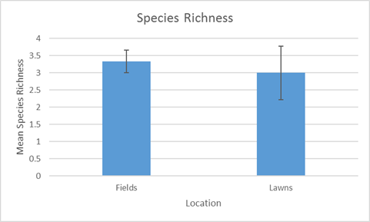
Fig2. Comparison of species diversity and richness of soil microfauna between fields and lawns. (a) There was a statistically significant difference between fields and lawns of species diversity (t-test: p= 0.0422). (b) There was no statistically significant difference between the species richness of lowland/upland fields and lawns. The Shannon Index was used to find the species diversity. A burlese funnel was used to extract the organisms from the soils obtained in fields and lawns. All means obtained from 6 replicates. Error bars represent ±SE.

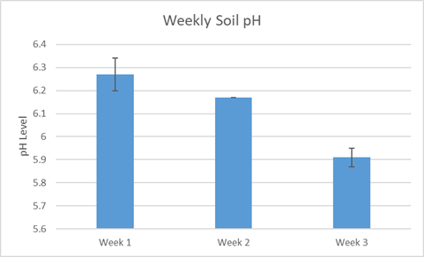
Fig3. Comparison of the weekly pH levels. There was a statistically significant difference between week 1 and week 3 (t-test: p= 0 .011). Week 2 did not have any replication for comparison. The soil was obtained from Longwood University’s Environmental Education Center (Farmville, Va). Error bars represent ±SE.
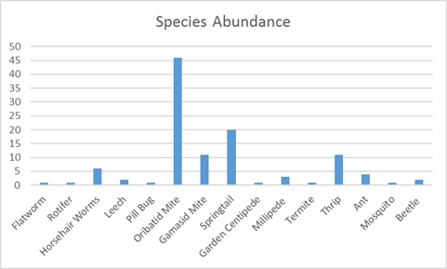
Fig4. The total abundance of organisms recorded for each species. These organisms were observed through microscopes in order to get the species count.

