Math 171 Project: THE AGE OF U.S. CURRENCY/COINS Fall 2017
Zach Sergi

The sample of 57 pennies were all collected either from my car, apartment, or random friends. The collection method used does show obvious signs of bias. This is because even though all coins were collected randomly, they were only from the local area or people who live in Virginia. These methods are a convenience sample and result in under coverage of the entire penny population. Placing the data collected into a histogram showed a distribution skewed right. I think the distribution is skewed right because pennies older than Q3 (29 years old) or the upper 25% of the penny population, have more than likely been taken out of circulation, making any older pennies less likely to appear. Also, two standard deviations to the left of the mean resulted in a negative age, a characteristic of a skewed right distribution. Using the outlier test, the upper outlier was determined to be at 68. Because the max of the sample was 56, there were no outliers present in the sample. The sample collected had a mean of 18.789 years old and standard deviation of 14.933 years old. The five number summary of the ages of the pennies came out to be: minimum = 1, Q1 = 3.00, median = 16.00, Q3 = 29, and the maximum = 56. The observation was made that the mean > the median, this is usually a result of the distribution being skewed to the right. This connects perfectly with histogram of the sample being skewed right. Using a T-confidence interval, the mean age of all pennies was determined to be between 14 (14.827) and 23 (22.751) years old at a 95% level of confidence. The margin of error for the estimate made was determined to be 3.962. To estimate the average age of pennies to within one year with 99% confidence, the sample size needed was calculated. First, the critical value was determined to be 2.3264, using invNorm. The standard deviation from the sample was used as the estimate for the true standard deviation of all pennies. Using all the necessary information collected, the sample size needed to estimate the average age of all pennies to within one year with 99% confidence was determined to be 4828 pennies. The age of pennies that would be considered “rare” (2% or less of the population) was calculated from InvNorm(.98,18.789,14.933). This calculation determined that 98% of pennies are younger than 50 year’s old, meaning that pennies 50 years or older are statistically considered “rare”.

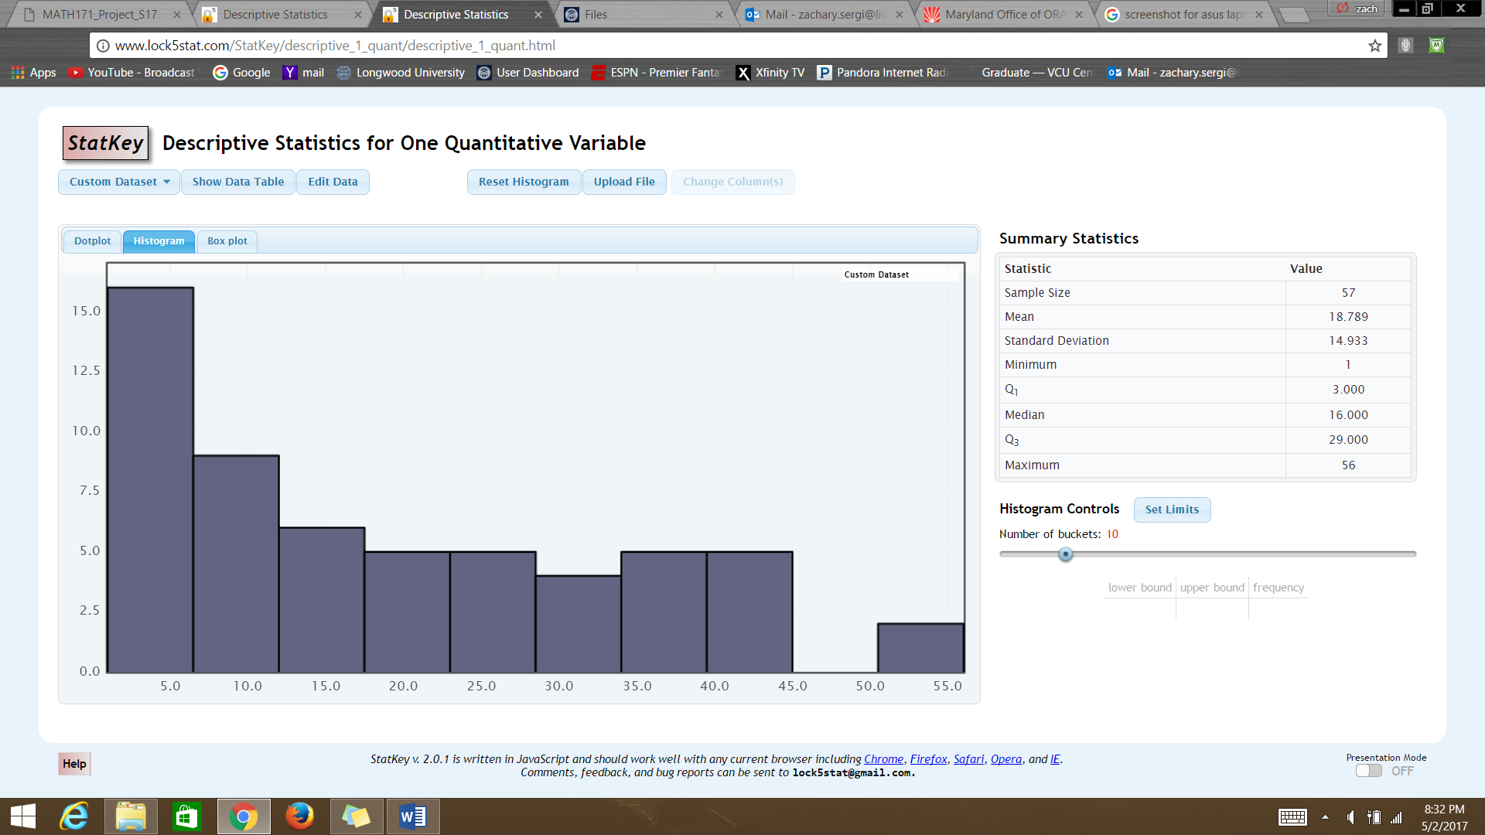
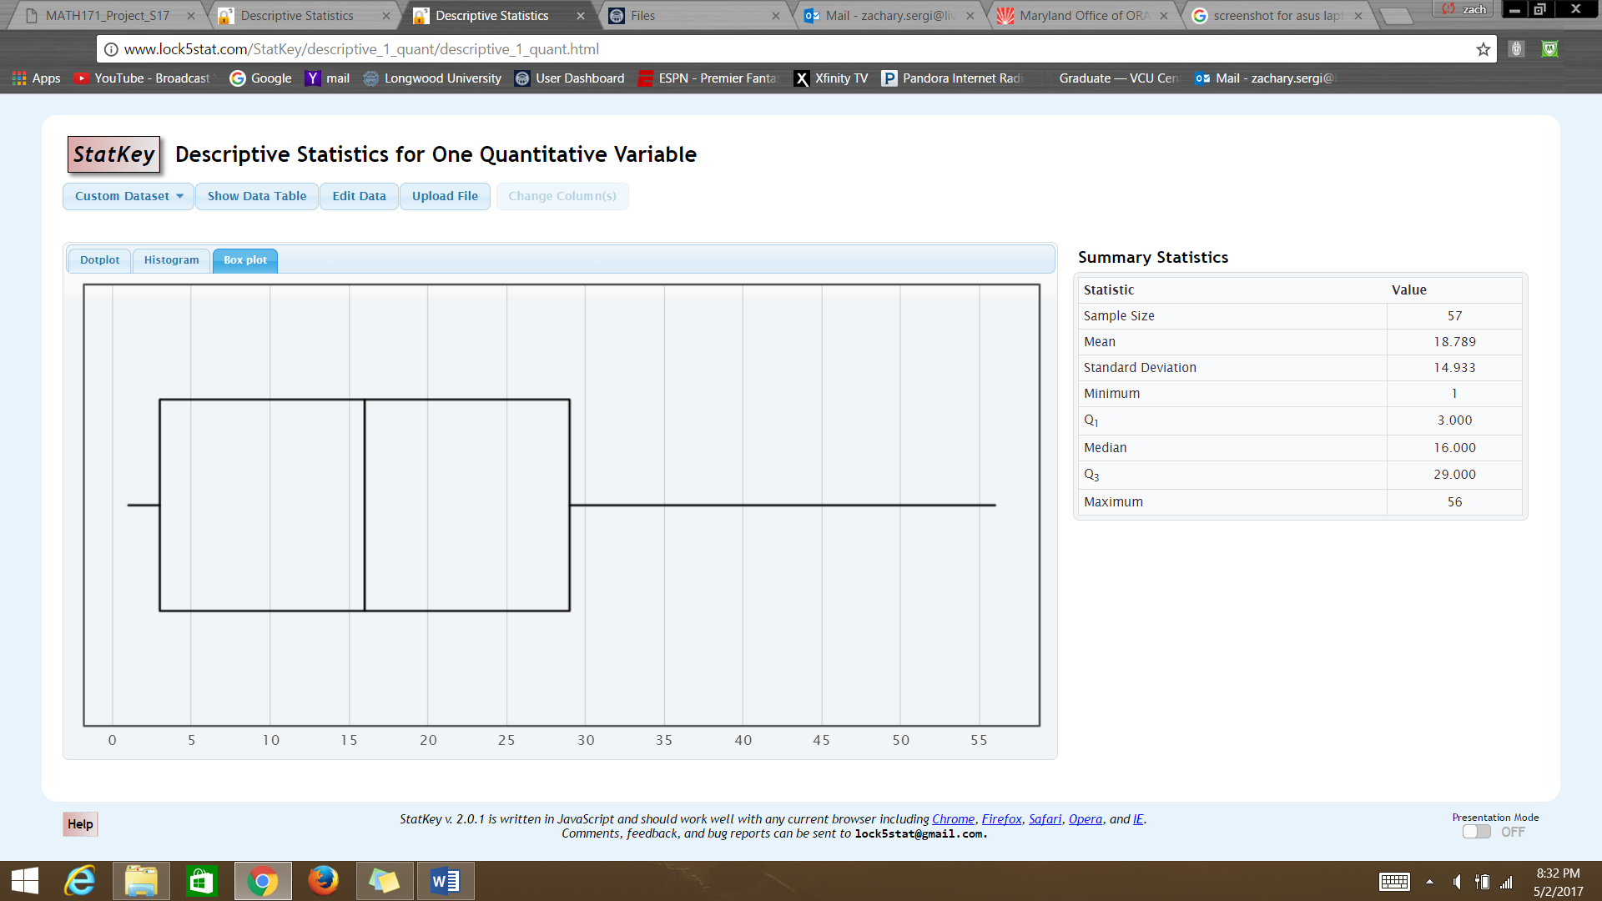

The sample of 55 dimes were all collected either from my car, apartment, or random friends. The collection method used does show obvious signs of bias. This is because even though all coins were collected randomly, they were only from the local area or people who live in Virginia. These methods are a convenience sample and result in under coverage of the entire dime population. Placing the data collected into a histogram showed a distribution skewed right. I think the distribution is skewed right because dimes older than Q3 (31 years old) or the upper 25% of the dime population, have more than likely been taken out of circulation, making any older dimes less likely to appear. Also, two standard deviations to the left of the mean resulted in a negative age, a characteristic of a skewed right distribution. Using the outlier test, the upper outlier was determined to be at 60 (59.5), and because the max of the sample was 51, there were no outliers present in the sample. The sample collected had a mean of 20.618 years old and standard deviation of 13.185 years old. The five number summary of ages of the sample of dimes came out to be: minimum = 1, Q1 = 12.00, median = 18.00, Q3 = 31.00, and the maximum = 51. The observation was made that the mean > the median, which is usually a result of the distribution being skewed to the right. This connects perfectly with histogram of the sample having distribution shaped skewed to the right. Using a T-confidence interval, the mean age of all dimes was determined to be between 16 (16.91) and 25 (24.326) years old at a 95% level of confidence. The margin of error for the estimate made was determined to be 3.708. To estimate the average age of dimes to within one year with 99% confidence, the sample size needed was calculated. First, the critical value was determined to be 2.3264, using invNorm. The standard deviation from the sample was used as the estimate for the true standard deviation of all dimes. Using all the necessary information collected, the sample size needed to estimate the average age of all dimes to within one year with 99% confidence was determined to be 3764 dimes. The age of dimes that would be considered “rare” (2% or less of the population) was calculated from InvNorm(.98,20.618,13.185). This calculation determined that 98% of dimes are younger than 48 year’s old, meaning that dimes 48 years or older are statistically considered “rare”.
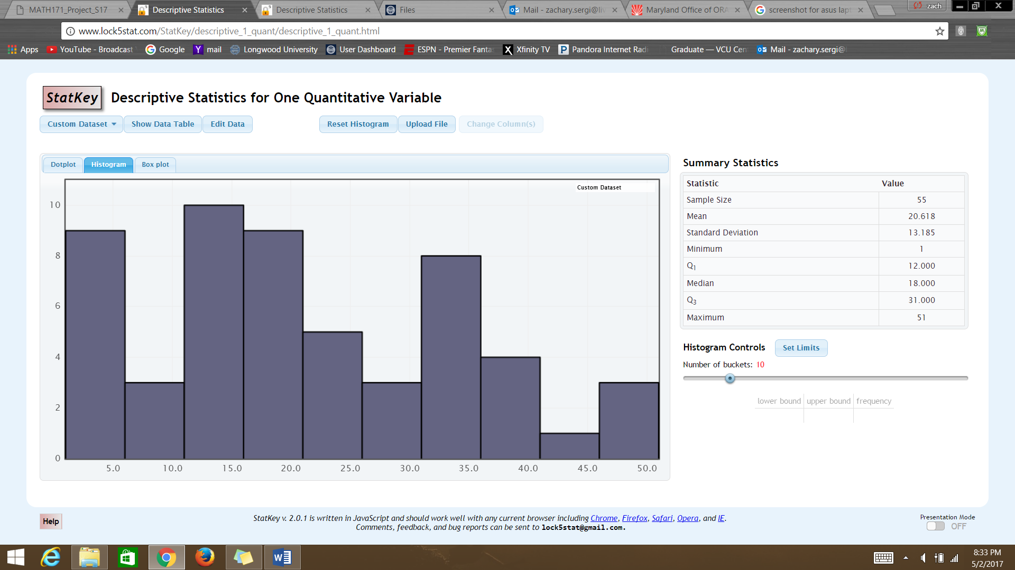
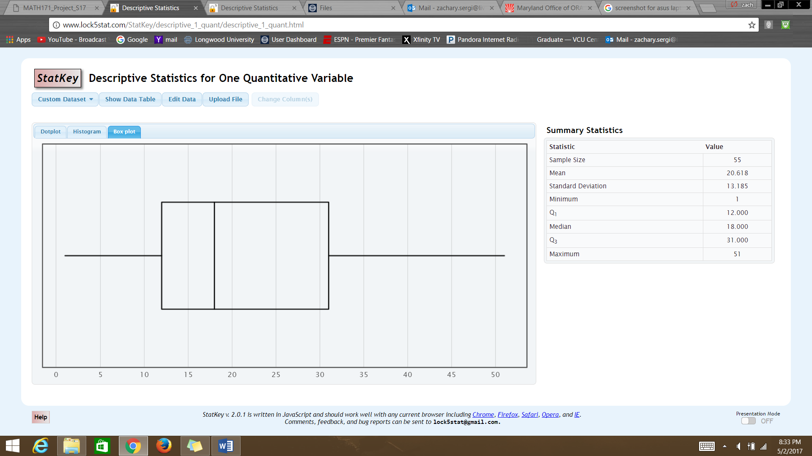

The question of interest for this project was whether the mean age of all dimes in circulation is the same as the mean age of all pennies in circulation? This question will be addressed by going through the P.H.A.N.T.O.M.S. method for this statistical hypothesis test. The two populations of interest are all dimes in circulation and all pennies in circulation. The null hypothesis assumed the mean age of all dimes in circulation equals the mean age of all pennies in circulation. The alternative hypothesis stated that the mean age of all dimes in circulation is not equal to the mean age of all pennies in circulation. The hypothesis test determined if there was any statistically significant evidence (.05 level of significance) that the null hypothesis should be rejected in favor of the alternative hypothesis. The two samples collected were not true SRSs because of reasons stated earlier, but were used anyway for the sake of the project. The two populations of question were both indeed from two distinct populations and the samples were also independent of one another. Finally, the sample size from each population were greater than 20, concluding that the two sample T test could be used even when both samples were skewed right. The necessary statistical values from each population was used for the two sample T test, resulting in a t-value of .6877 and a p-value of .4931. With a significance level of .05, there was no statistically significant evidence present. From this information, the statistical test failed to reject the null hypothesis in favor of the alternative hypothesis. In summary, I did not find statistically significant evidence at a .05 level of significance, that there is a difference between the mean ages of all dimes in circulation and all pennies in circulation. This answered the question first imposed that yes, there was statistical evidence that the mean age of all dimes in circulation is the same as the mean age of all pennies in circulation.

