Zach Sergi
Feb 12th-25th
Week 1- 92,925 steps
Highest date- 22nd 24,037 steps
Lowest date- 23rd 9,995
Week 2- 93,935 steps
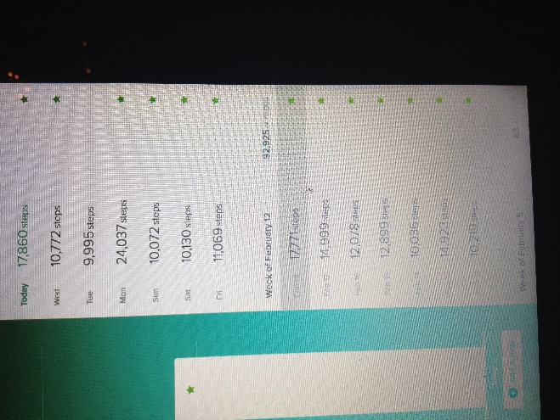
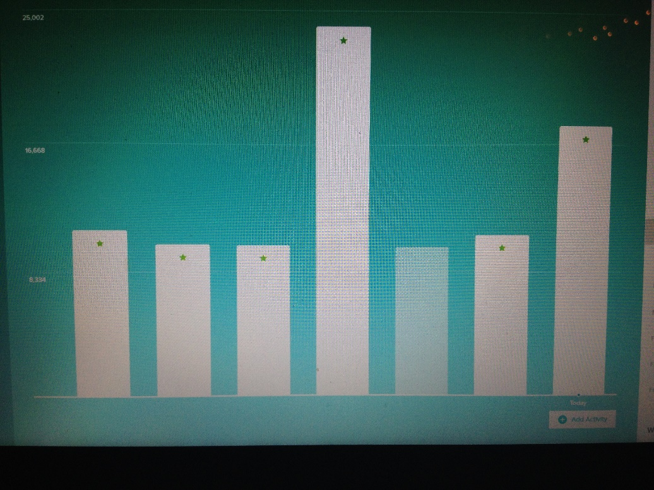
- Week 2
- Highest day was achieved because of a combination of lots to go do (walk to) and soccer practice later that night.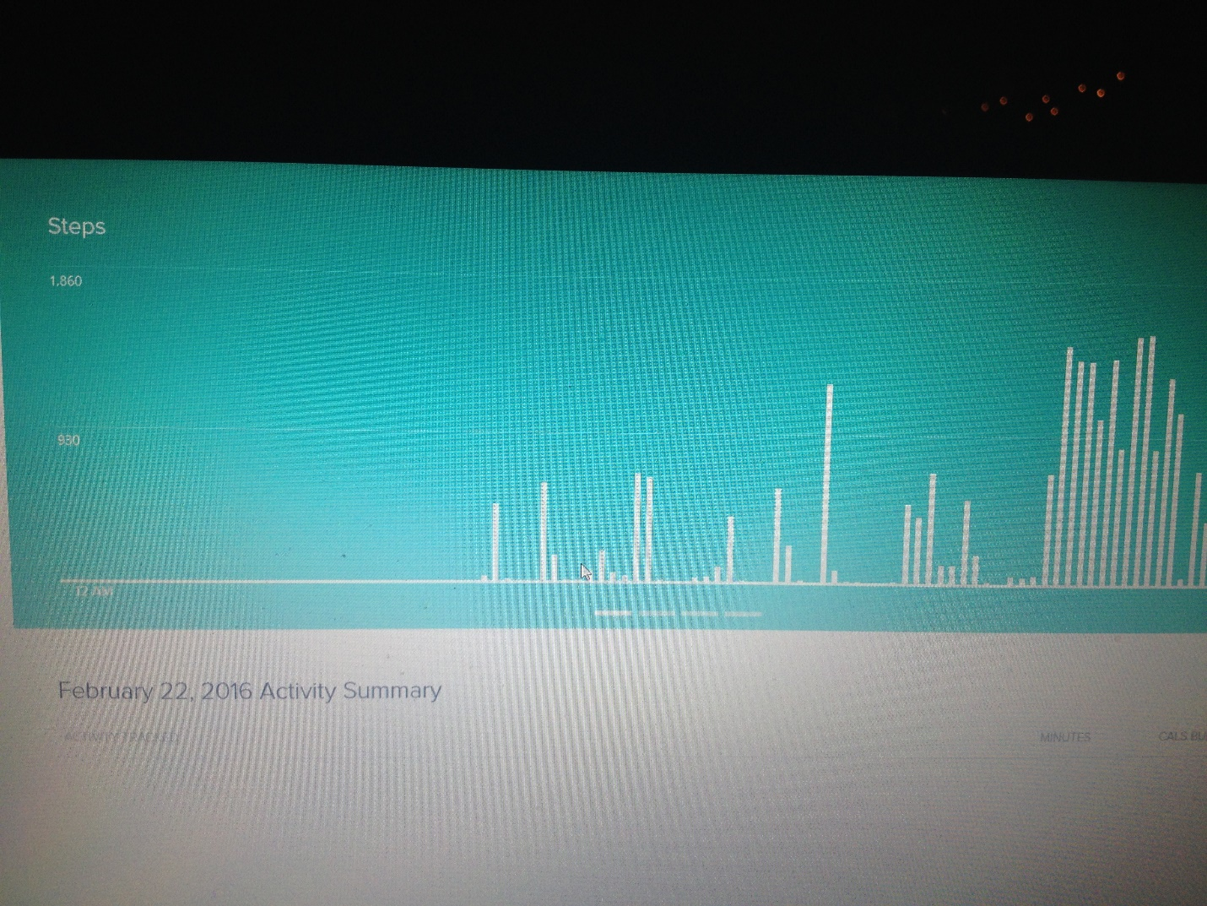

- Lowest day was achieved by lack of walking needed and failure to make up for it