Dylan Scordellis
LIFE STEM
September 10th, 2018
Summer Bridge Reflection
During my week at Hull Springs Farm, I made many new friends and learned new things. Some components of this Summer Bridge that interested me the most was Westmoreland State Park, sampling on a boat, and Tangier Island. All these places were very fun and also a great learning experience.
Westmoreland State park was my favorite because we got to fossil hunt in the water for shark teeth because the area used to be a mating ground for sharks and whales. Luckily, I found a shark tooth (even though it was small) and a fossil of a shell. After fossil hunting, we went inside to enjoy a presentation on an actual whale fossil that the company had recently excavated, and this was very interesting to me. The overall reason this whole trip was my favorite activity was because I always enjoy the outdoors and nature.
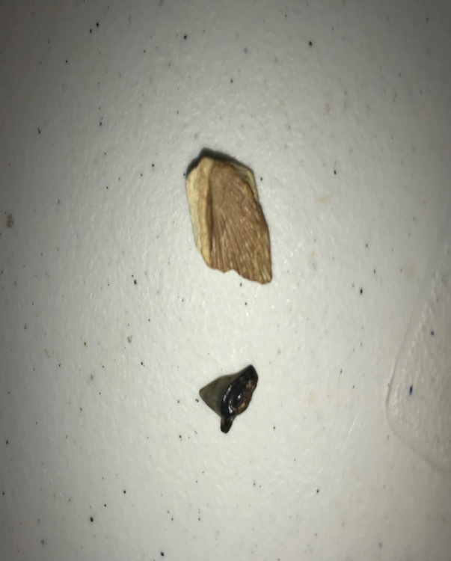
(This is the shark tooth and shell fossil that I had found)
During our day out in the water, my group got to collect samples of water from the Chesapeake Bay for future testing. We collected the water to discover chlorophyll levels within the samples. I really enjoying using the scientific equipment because I have never used it before and it was new to me. I am always fascinated from new things because I wonder how and why they work. Another reason this boat trip was fun is because it was a boat ride and I always enjoy days out on the lake.
One of the final destinations we went to was Tangier Island. The first thing we did was roughly a two-hour ferry boat ride to the island. Once we got there, the students including myself set out in groups to interview locals about the island’s issues. One thing I learned is that the island is sinking due to rising water levels which is very shocking. After some math and data collecting, the island is said to be underwater within about ninety years or so. One main answer I received from the interviews is that the island needs a sea wall to reduce rising water levels.
Overall, I had a great experience during this week at Hull Springs Farm and I will definitely go back next year. I truly enjoyed being outdoors and learning new things pertaining to science because that is my favorite subject and major (Environmental Sciences).

