Owl Pellet Data Sheet

1. Pellet length 3.9 cm Pellet width 2.4 cm

2. Number of skulls found in your pellet 1 skull was found

3. Identity of skulls found in your pellet: Vole

4. NOTES:

Voles (Microtus)
Average adult weight: 45 g
Habitat: open woodland
Activity: day or night
Food: main foods are roots and tubers; also eats leaves and stems of plants

I found a hip bone, two lower legs, ribs, a jaw, an upper leg, and a backbone.

Questions

1. Assuming that one owl produces one pellet per day, what is your estimate of the annual food consumption for your owl, based on your findings in the pellet you dissected? Express your answer as grams of food consumed in one year.
I estimate that each week the owl will eat two voles, one pocket mouse, two harvest mice, and one shrew. This will result in the owl consuming 7,644 grams each year.

2. How accurately do you think the content of owl pellets reflects the proportion and abundance of the small mammals in the area where the pellets were collected? What small mammals in the area may not be accounted for by sampling owl pellets?
Many of the masses seen on the prey list vary greatly. The vole we found in our pellet has a mass of 45 grams, which is much larger than many of the other organisms. This can cause speculation with our pellet. For this reason, I think the owl pellet reflects a very limited group and doesn’t reflect many organisms. The prey list is very limited but the owl can eat many organisms. Also, depending on what my classmates found in their pellet could also affect my answer on this question. If many of my classmates found voles as well, we can predict that voles had a high population rate in this area.
Some small mammals that may not be accounted for could be small squirrels or chipmunks. Also, the owl pellet provided was small, which did not allow for the bones of a larger mammal like the cotton rat or the pocket gopher to be seen, which leads me to believe the owl used for our lab may have been on the smaller size.
3.In addition to whatever prey you found in your pellet, suppose that your owl also was found to have eaten a shrew and a cotton rat through examination of the pellets from other days. Use this information to draw a diagram of a food web in which the owl is positioned at the highest trophic level. Then, add in the shrew, the cotton rat, and whatever prey you found in your pellet. Then, consider what food items all these animals eat (for various types of plant-derived foods, you can simply group it all together as “plants” to simplify your food web). Be sure to point the arrows in the correct direction in your food web. Note: you can either use the arrow drawing tool in Word (on the “Insert” tab, in the “shapes” pulldown menu) or you can draw the food web by hand on another piece of paper and then scan it and insert the picture into this Word file.

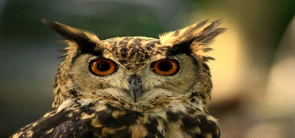
This Photo by Unknown Author is licensed under CC BY-SA

(Owl)

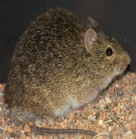
This Photo by Unknown Author is licensed under CC BY-NC-ND

(Cotton Rat)

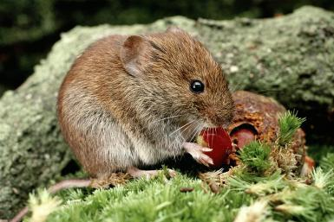
This Photo by Unknown Author is licensed under CC BY-SA-NC

(Vole)

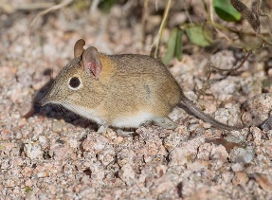
This Photo by Unknown Author is licensed under CC BY-SA

(Shrew)

4. Explain why raptors (such as owls), lions, and humans are often the most threatened organisms of a community that is exposed to toxins like DDT or mercury.

Raptors are the most threatened organism of a community that is exposed to toxins because they often are positioned at the highest trophic level. Humans feed on prey that often are exposed to these toxins which then second handily effects the raptors. For example, an owl may eat a mouse that ate berries that were infected with DDT which results in the owl being threatened.

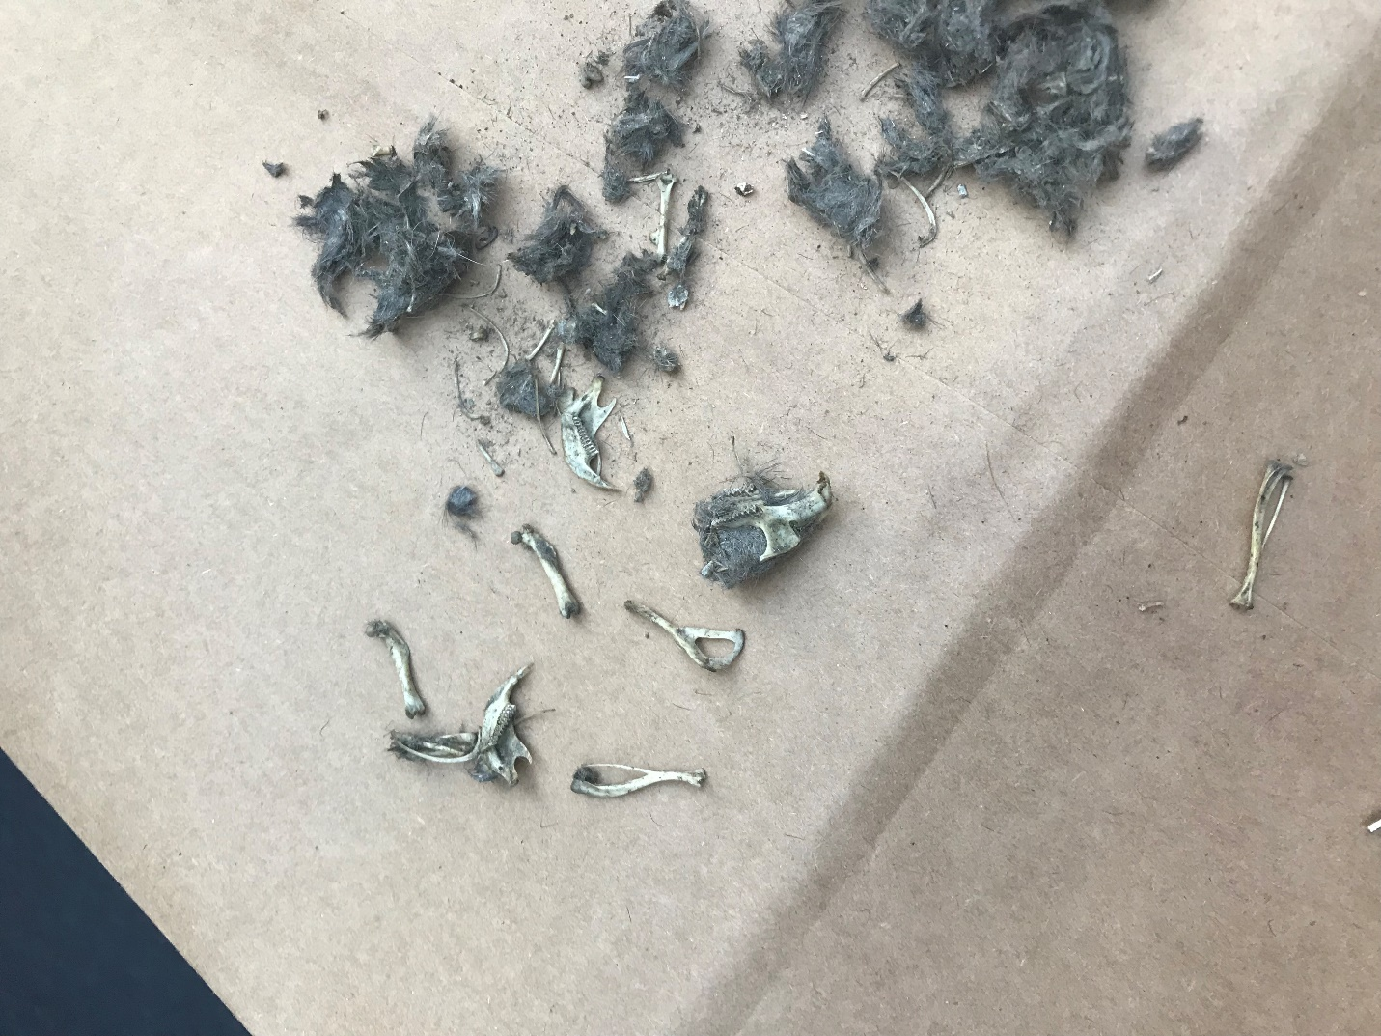
The picture I took of my lab!

