How Programs are being Assessed?  - Surveys created by Longwood University students  - Incentives such as receiving a $5 Walmart Gift Card for participating whether parents return survey or not  Children Served (Year 1)  - 35 Children in Farmville, VA  - Early Head start & Head start ages (6 weeks – 5 years old)  - Five programs designed  Children Served (Year 2)  Children Served (Year 2)  - 85 Children in Prince Edward County, Nottoway County & Cumberland County  - Age: 5 years Old  - Five programs designed |  | Goals for the Future  To expand and incorporate program designs into the public-school setting in order to reach more families and enhance parental involvement.

Feasibility Study
Kayla Barner & Haley Schultz

 |  | Background  Over the last two years students in Dr. Lee Bidwell & Dr. JoEllen Pederson have been actively collaborating with local community agencies in an effort to promote parental involvement in children’s education. Students have been designing interactive programs that targeted to enhance parental involvement outside of the classroom.  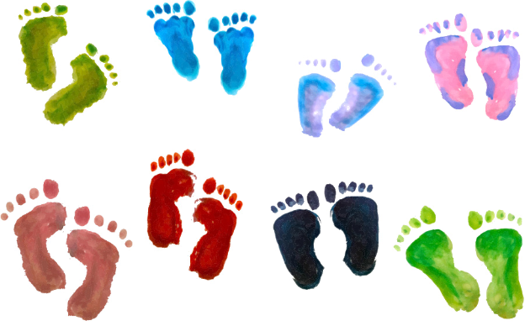 |  | “I can’t say there is any part of my life other than having to work that keeps me from being more involved in my kids life” (Respondent 13, 2018).
Needs Assessment  Before students designed programs, parents were given a needs assessment that would help determine how parents’ view their interactions with their children. As well as to help identify barriers and resources that affect the levels of parental involvement.  Findings from Needs Assessment  - Parents have various reasons for varying levels of parental involvement such as:  - Limited Resources  - Lack of time due to (work, education & other children)  - Limited access to available resources |  |  |  | Purpose of Programs  To address the concerns & barriers in which parents described in needs assessment and as a result increase levels of parental involvement.  Program Development  - Programs were designed based from the findings from the need’s assessment.  - Programs must be able to be completed in 30 minutes or less and also sensitive to child development.  - Programs must also be inexpensive so that families can imitate programs for future use.  - Programs must also be designed to include (S-Specific, M-Measurable, A-Attainable, R-Relevant & T- Time Based).

