Samantha Schlesser
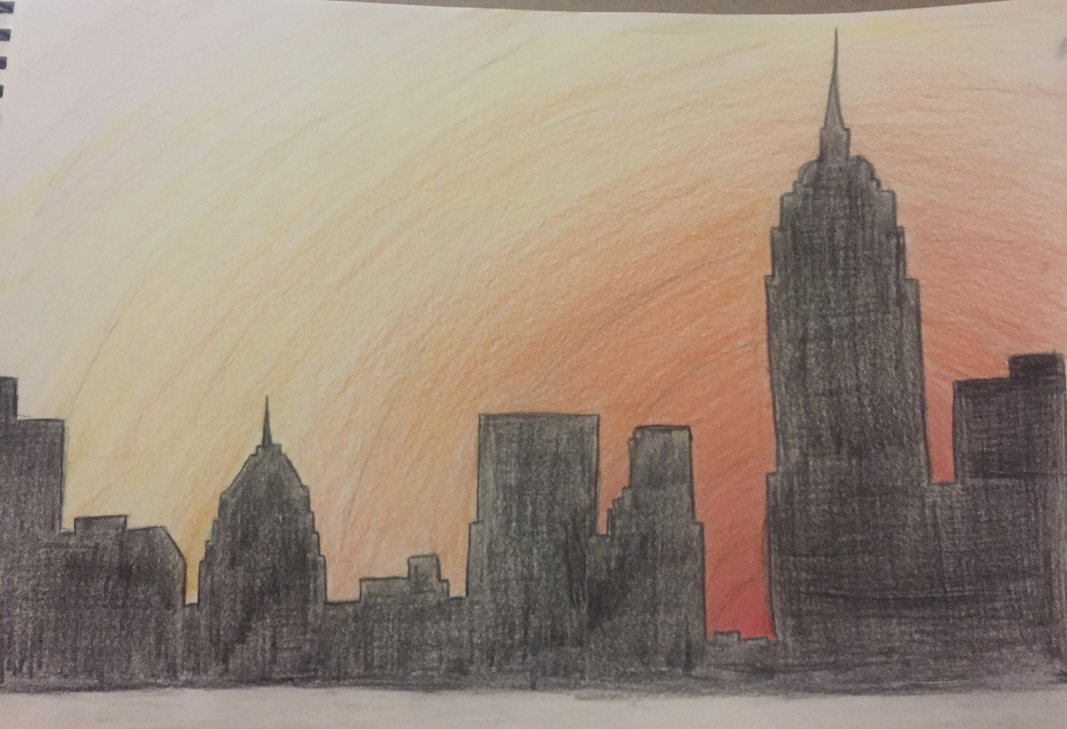
I drew a city landscape that includes the outlines of the buildings with directional lines to direct the viewer's eye along the city. The vertical lines show the height of the buildings while the horizon line at the bottom shows that the viewer is standing quite a distance away to view the entire city. The circular lines of the sunset are supposed to bring out the buildings even more. The sunset creates depth and a sense of perspective. It is supposed to create an image of a city that is calming down after a long busy day of commotion. It also shows the beauty of a sunset while also portraying that nature and things that are man-made can look beautiful together. I love cityscapes, and I was looking at the sunset outside my dorm window; my roommate has three Van Gogh paintings hanging up above her bed, one of which is Cafe Terrace at Night. I was also inspired by Monet and Van Gogh's use of perspective, colors, and architecture in their works. The boldness of the sunset helps to bring out the silhouettes of the buildings. The medium used is colored pencils on my sketchbook paper. I blended a mix of red, orange, and yellow to create the sunset, and black and brown for the silhouettes.
The painting below is what inspired me to draw the buildings, and the use of orange and yellow helped me to decide to draw a sunset.