Samantha Schlesser
Bi-Weekly Report Dates: January 28 - February 3 & February 4 - 10
Week 1 Total: 51,557 - High day: 12,387 steps, Low day: 3,227 steps
Week 2 Total: 54,743 - High day: 14,618 steps, Low day: 2,004 steps
Week 1 Reflection and Graphs
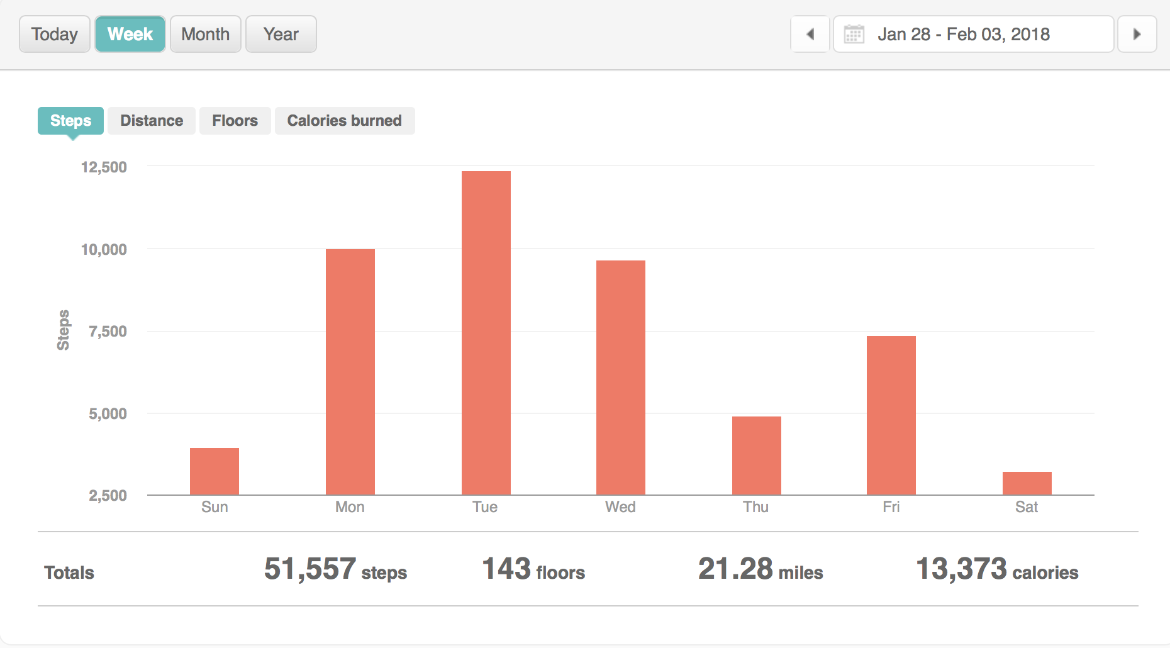
Reflection: During the week of Jan. 28 through Feb. 3, I made just over 50,000 steps which is not quite the recommended 70,000 steps per week; this was primarily because of how little activity I do on the weekend. On my high day, most of my activity was from 7 a.m. to around 10:30 a.m. This is the time I work in D-Hall, and on this day I was walking around cleaning tables and replacing napkins. Another high point of activity was from 2:30 p.m. until around 4:00 p.m. At this time, I went to Walmart with my friend and we spent quite a bit of time searching for bowls. After, at around 9 p.m., we went down to Chickfila to get milkshakes. On my low day, I did not make much of an effort to get out of bed. Around 1 a.m., I walked from my friend’s dorm to mine, and did not leave my dorm until 5 p.m. to get dinner and then walked down to my friend’s dorm again at 10:30 p.m. During these two weeks, I have only gone to the gym a couple times for Zumba. I have made an effort to stop eating at D-Hall and instead walk down to Moe’s and Chickfila, and to take the longer route to classes/events.

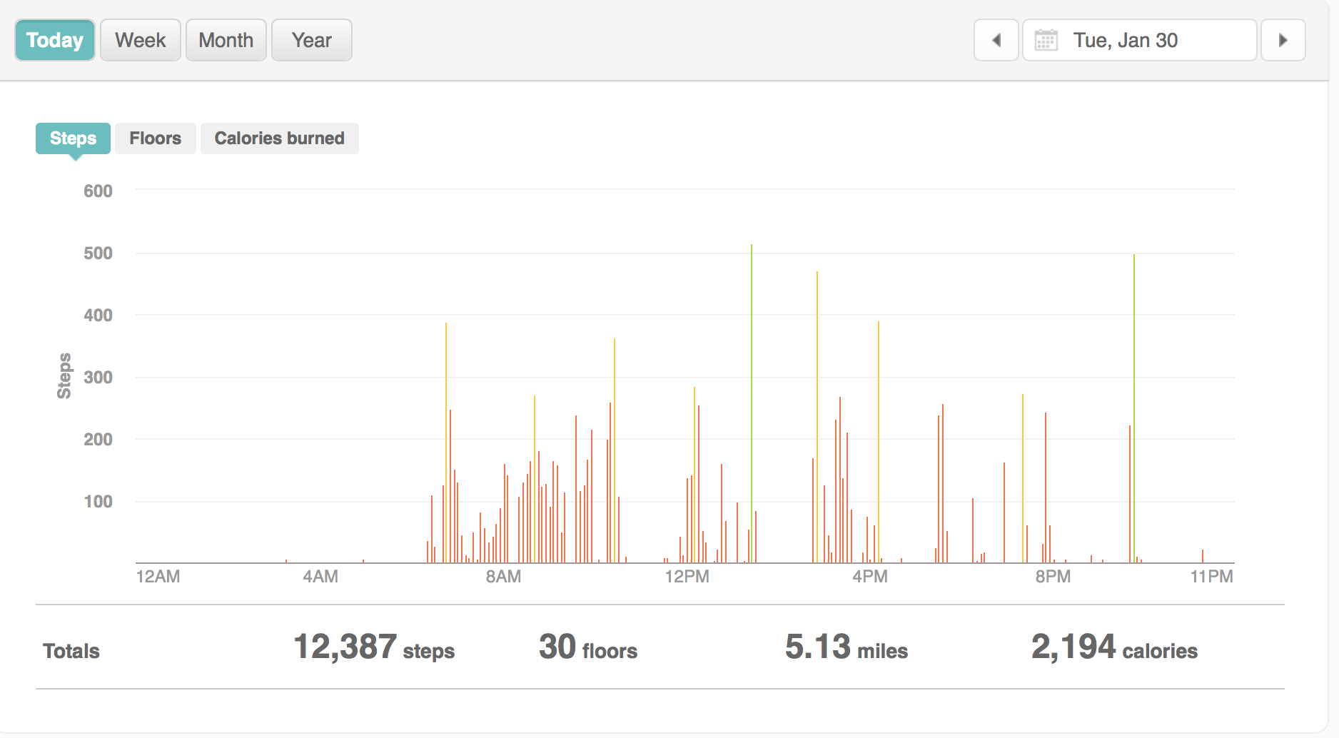

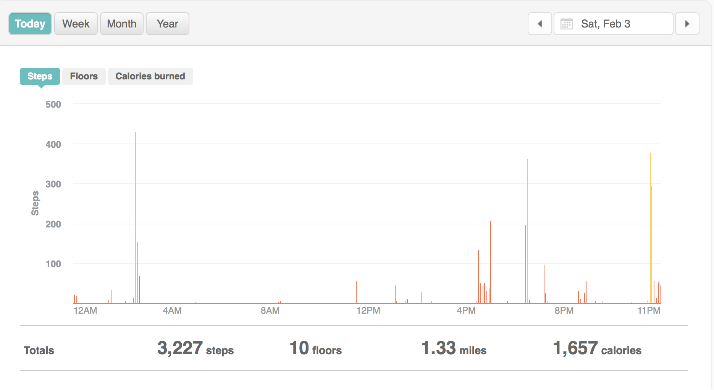

Week 2 Reflection and Graphs
Reflection: During the week of Feb. 4 through 10, I made over the previous week, but it was still not 70,000 steps. I made more of an effort to take more steps. On my high day, most of my activity was from 1:00 p.m. to 5:30 p.m., which also is when I work at D-Hall. I also had classes from 9:00 a.m. to 12 p.m. After work, I went to Zumba from 6:45 p.m. to 7:45 p.m. and worked out afterward. Seeing the graphs, I have made the conclusion that I need to go to the gym more days a week. On my low day, I did not feel well that morning or during the day, so I did not go outside my dorm all day. During the next two weeks, I will make more of an effort to go to the gym and take longer routes, as well, as making sure to actually remember to put my Fitbit on after taking a shower, which I have forgotten to do a couple times.
