Name: Hanna Schenkelberg
Bi-Weekly Report Dates: 10/7-10/13 & 10/14-10/20
Steps Week 5 Total: 76,756 High Day: Saturday 10/8 (12,134) Low Day: Friday 10/7 (9,754)
Steps Week 6 Total: 64,151 High Day: Friday 10/14 (11,974) Low Day: Saturday 10/15 (3,486)

Week 5 Graphs
Weekly Outlook

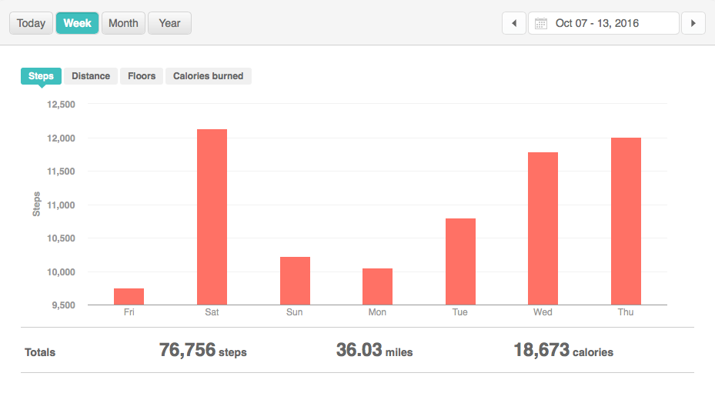

Low Day
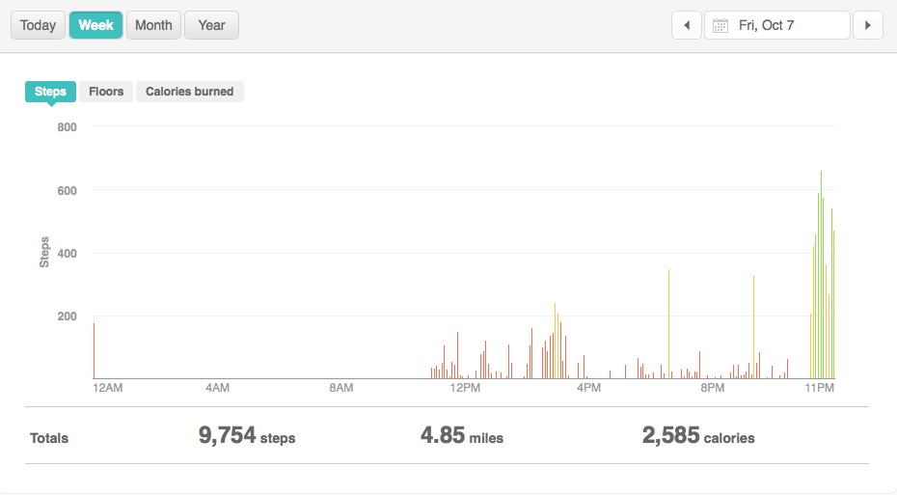
High Day
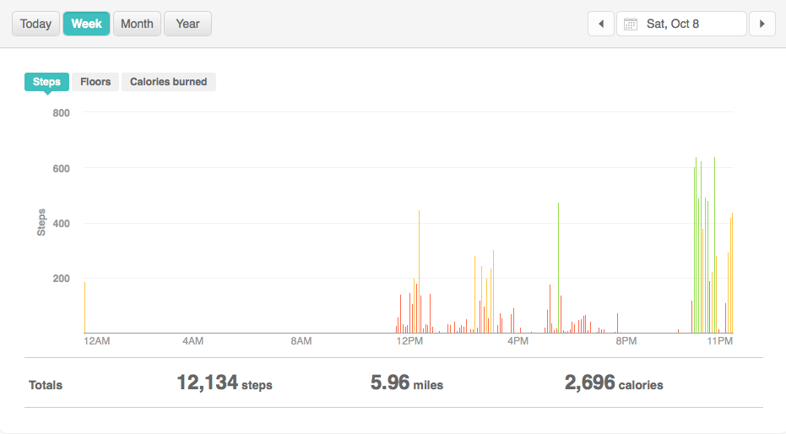

Reflection for Low Activity Day and High Activity Day (Week 5)
- Friday was my lowest day because I was not able to wear my Fitbit until later in the afternoon, and I did not have that much going on that day, causing low activity
- Saturday was my highest day because it was the last day of my fall break, which included playing in a volleyball game and walking around the mall with my friends, which lead to high steps
- I have found that in all of my reports, I tend to notice the trend of spread out activity, rather than gaining steps from a workout or walk

Week 6 Graphs
Weekly Outlook
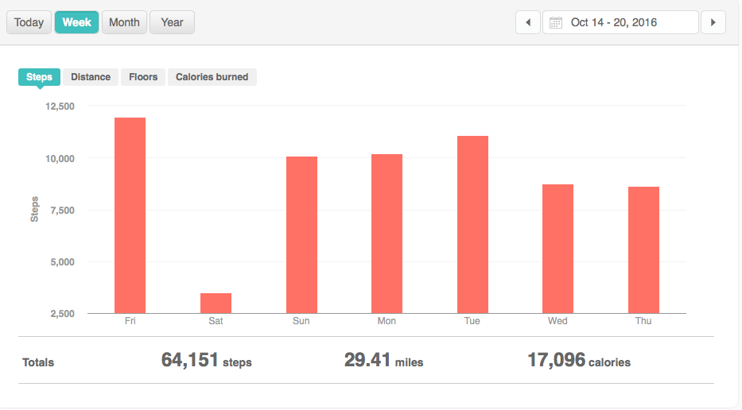

Low Day
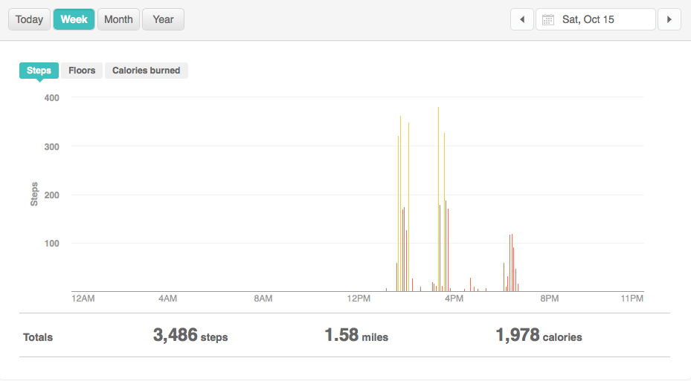
High Day
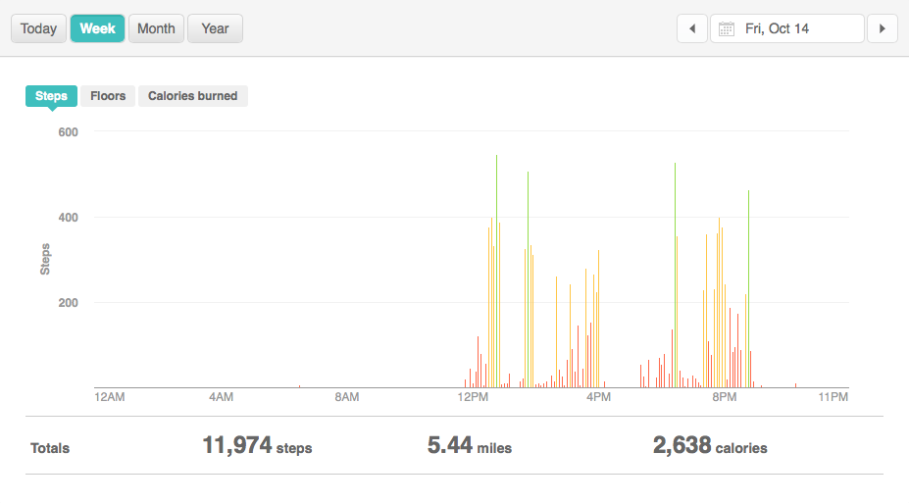

Reflection for Low Activity Day and High Activity Day (Week 6)
- Saturday was my low day because I was on a six-hour plane ride home from Seattle that day, which did not give me a chance to get barely any steps that day
- Friday steps were so high due to the fact that I was in Seattle walking around the city all day, which gave me very high steps. We walked all around, from one end of the city to the other, causing my activity to be constant

Environmental Barriers: Cones, Tires on sidewalk, trailers blocking paths, poles on the street, and cracked sidewalks

