Name: Karlie Schauer, Ashley Brown, Jeff Wagnon Date: 10/21/15 Ages/Grade Level: 8th/9th

Title of Lesson: NLCA Tennis Day One # of Students: 12 # Students needing adaptations: Not known
Motor, Cognitive, and Affective Behavioral Objectives (What will your students know and/or be able to do by the end of the lesson?)

- The students will be able to demonstrate a proper eastern forehand grip at least 75% of the time during the drills.
- The students will be able to use and demonstrate proper footwork in accordance to both fore hand and back hand swings 7 out of 10 times.
- The students will be able to make contact with the ball when it is even with their front hip 7 out of 10 times.
- The students will be able to show where the service line is and how it is used.
- The students will be able to explain to other students and teachers where the ball needs to land after a serve.
- The students will be able to explain what a let is and what follows a let (the server will be able to serve again).
- The students will be able to act in a cooperative manner when a component calls a ball out.
- The students will be supportive towards classmates in every drill for both good and not so good groundstrokes, volleys, and serves.
- The students will be able to demonstrate responsibility by helping with equipment both during and after drills.

Connections - Circle or highlight the numbers from each set of standards below that this lesson addresses:
National Content Standards (SHAPE, 2014)  Standard 1 - The physically literate individual demonstrates competency in a variety of motor skills and movement patterns.  Standard 2 - The physically literate individual applies knowledge of concepts, principles, strategies and tactics related to movement and performance.  Standard 3 - The physically literate individual demonstrates the knowledge and skills to achieve and maintain a health-enhancing level of physical activity and fitness.  Standard 4 - The physically literate individual exhibits responsible personal and social behavior that respects self and others.  Standard 5 - The physically literate individual recognizes the value of physical activity for health, enjoyment, challenge, self-expression and/or social interaction. | Virginia Standards of Learning (2015)  1. Demonstrate competence in motor skills and movement patterns needed to perform a variety of physical activities. (Motor Skill Development)  2. Apply knowledge of the structures and functions of the body and how they relate to and are affected by human movement to learning and developing motor skills and specialized movement forms. (Anatomical Basis of Movement)  3. Achieve and maintain a health-enhancing level of personal fitness. (Fitness Planning)  4. Demonstrate the aptitude, attitude, and skills to lead responsible, fulfilling, and respectful lives. (Social Development)  5. Explain the importance of energy balance and nutritional needs of the body to maintain optimal health and prevent chronic disease. (Energy Balance)  Fill in specific sub-standards: ________________________________
Assessment Plan (how will you assess student progress?):
We will assess the students’ process as well as their products through observation and asking questions throughout the drills.

Personal objective(s) for the teacher:
Karlie:
- Work on having a “teacher voice”
- Show proper demonstration
Ashley:
- Have clear and concise instructions with appropriate “talking speed”
- Know when and how to adapt drills to different skill levels
Jeff:
- Be able to be aware and use time wisely (Time management)
- Give clear instructions and demonstrations

Pre-requisite Skills (what do students need to know or have to be successful in this lesson?):
- The students should know how to toss, dribble, and bounce a ball.
- The students should know to move towards the ball when ball is hit towards them.
- The students should know to use communication when moving towards a ball.

Modifications / Adaptations:
- If the student can’t get the ball over the net, they can move towards the net.
- If the student is hitting the ball too far or too high, adjust their racket and show where it should be facing
Resources/equipment (with quantities):
- We need three nets
- At least 15 racquets
- As many balls that are available
- Tape to show service line and show boundaries
- 15 pedometers

Safety issues to consider:
- Balls flying everywhere
- Personal space with racquets
- Personal space with respect to other people

Time | Lesson Segment - include skill cues where appropriate | Activities/Task Applications - include extensions or simplifications if appropriate and instructions for drills, activity organization, LUG rules, etc. | DIAGRAMS
1:22-1:24  1:24-1:37  1:37-1:49 | Set induction  Jeff’s Drill  Ashley’s Drill  Karlie’s Drill  Jeff’s Drill: Part 2  Ashley’s Drill: Part 2  Karlie’s Drill: Part 2 | “Hello, my name is Ashley. Today we’re going to work on a few basic skills and drills in tennis. If time allows we will then move into a few games. I’m going to number you off 1-3 and you will move to your designated court after grabbing a racquet.”  The students will be informed how to properly demonstrate the eastern forehand grip. (1 minute) The students will then be aligned in their designated positions. One student on each side of the net with appropriate distance. Student A will toss the ball to student B who will volley the ball back to student A whom will catch the ball. The students will switch after two minutes.  The students will be informed how to properly demonstrate the eastern forehand grip. (1 minute) The students will then get in a designated line in front of teacher. The teacher will then throw 4 balls to each student and the student will hit 4 balls over the net while using proper form, retrieve them, and put them into the basket on the way back. They will then get back in line and rotate through.  The students will be informed how to properly demonstrate the eastern forehand grip. (1 minute). Students will stand on the service line across the net from the teacher. The teacher will bounce a ball to them, once the ball bounces the student will use a ground stroke to hit the ball back to the teacher. After three hits the hitting students will switch.  The teacher will briefly introduce what a backhand volley is and what it is used for. They will then volley the ball back and forth without bounce (both students using racquets).  After a brief recap of returns and a quick demonstration of a bounce serve, the teacher will have students get into a line in front of the teacher. The teacher will then have each student bounce serve two balls over the net while using proper form, retrieve them, and instead of putting them in the basket they will carry them back over to the side of the court and hit them once again.  The students will now stand across the net from a partner, both standing on the service line. This time students the groundstroke back and forth to each other. If necessary, the pair may take a step or two off the service line. | T  S S S S S S S S S S S S  S S  T  S S  T  S  S  S  T  S  S  S  S S  S S  T  Base Line  S S S  S S  S S
1:49-1:51  1:51-1:52 | Lead Up Game #1  [Karlie explains]  Lead Up Game #2  [If extra time available]  Closure | Using all 3 courts, two students will stand across net from each other, close to the service line. The rest of group will stand to the side of the court with teacher. The teacher will toss a ball in and the two students will play out the point. The player that wins the point will stay on the court, while the opponent chases the ball and moves a court to their left. The next student in line steps up and gets ready to play.  One player near net, one at baseline. Same game as last time, but with two players instead of one.  Ashley will signal for games to end and ask NLCA students to assist us in picking up equipment and taking nets down. When balls and racquets are gathered and nets are off poles, students will begin walking perimeter of the gym while the teachers (Jeff, Karlie, and Ashley) finish putting up nets. |   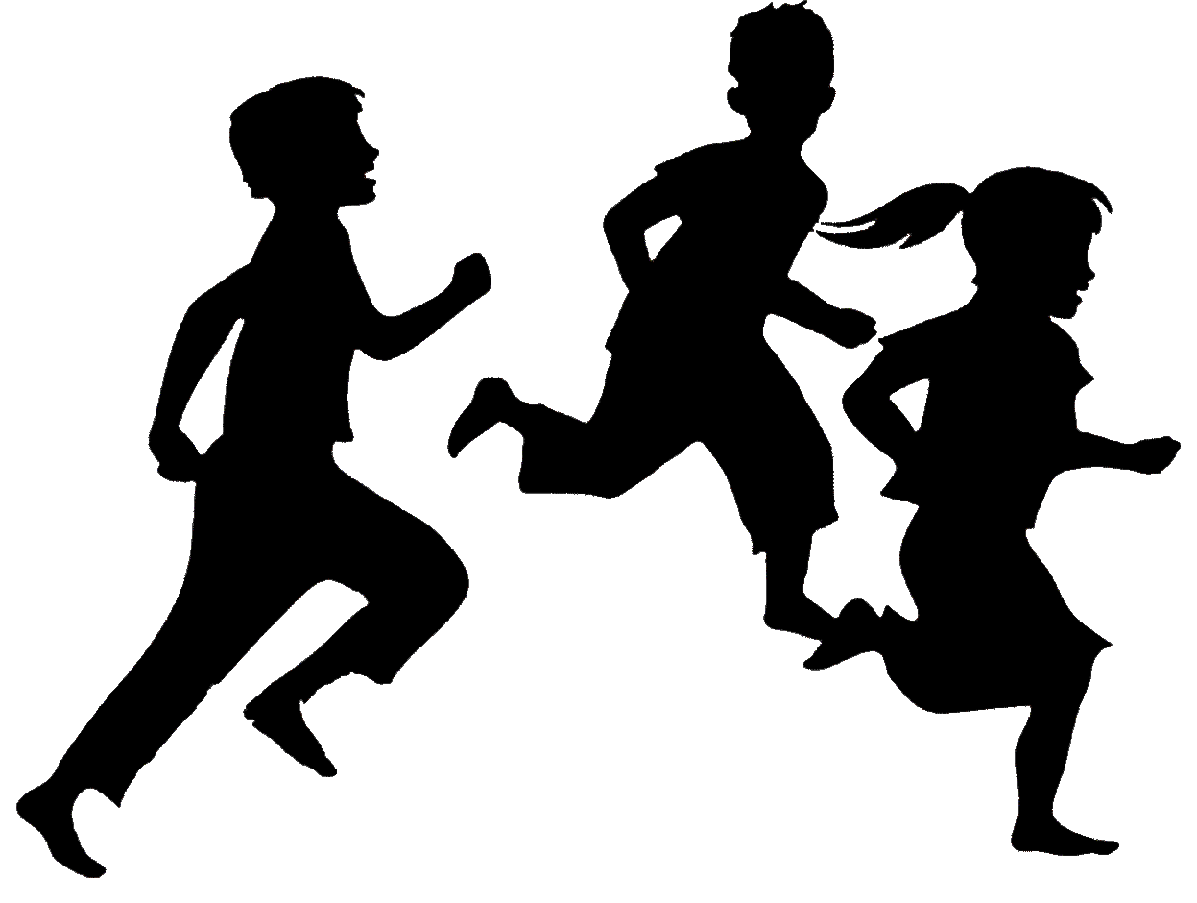    

Time | Lesson Segment - include skill cues where appropriate | Activities/Task Applications - include extensions or simplifications if appropriate and instructions for drills, activity organization, LUG rules, etc. | DIAGRAMS

