The Slide

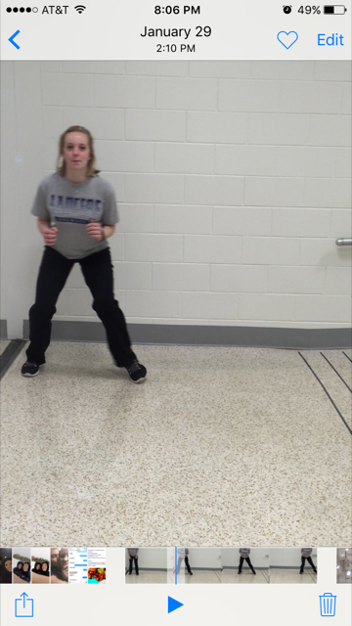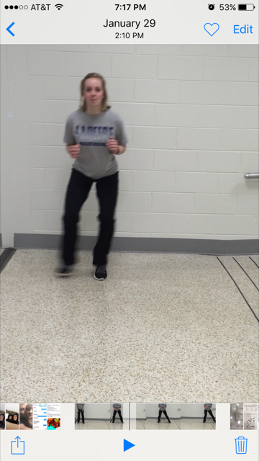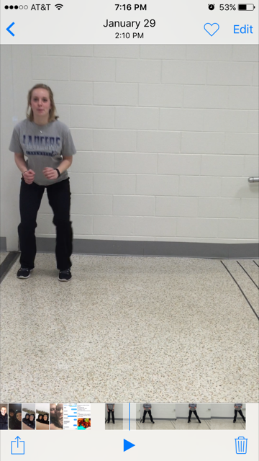

Stand with feet shoulder width apart and a slight bend in your knees. Keep your shoulders and hips square with eyes facing forward.

Begin by stepping out with the lead foot. Continue keeping your hips and shoulders square and eyes forward.

The follow foot with move in towards the lead foot, creating a slight flight phase. Directly following the flight phase, the lead foot will step out again.