Rolling a Ball with Hands

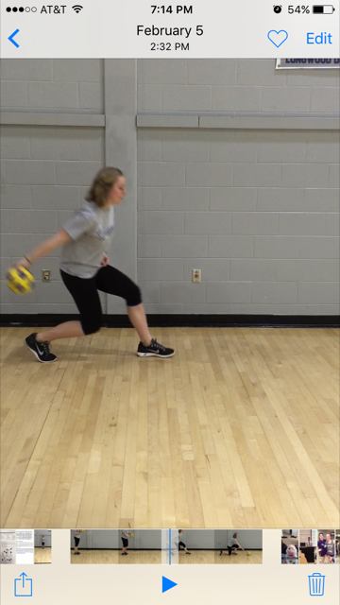

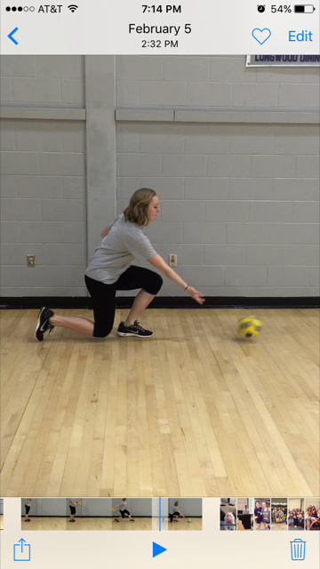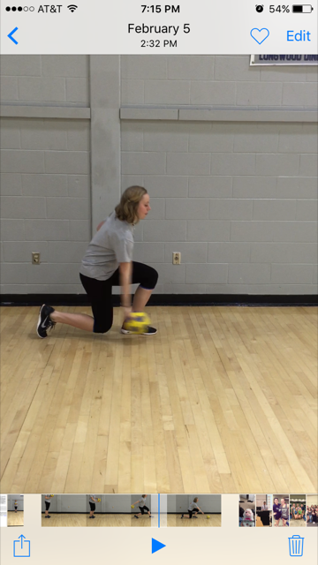

To begin the roller will have a slight runners stance with a forward lean. The bottom of the ball should be resting in the palm of the hand opposite the lead foot.

When getting ready to release the ball, the roller will get low enough that the ball is barely touching the ground and simply needs a push.

The arm should follow through completely behind the ball.