**Name _________________________**

**1) What is the area called that is 7 feet on both sides of the net?**

**A. Bounce zone**

**B. Non volley zone**

**C. Play zone**

**2) When serving, the ball should bounce directly in front of you over the next?**

**A) True B) False**

**3) Pickle ball is a low impact lifetime activity?**

**A) True B) False**

**4) You are serving from the star where should the ball land for a proper serve?**

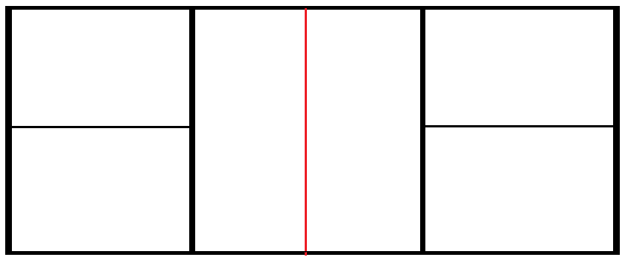

**5)  All serves must be below what body part ? _____________**

**6) Student A serves the ball, student B then does what?**

**A. Student B rushes to hit the ball**

**B. Student B allows the ball to bounce once before returning it**

**C. Student B does nothing**

**7) Pickleball is a combination of what 3 sports?**

1. **volleyball, basketball, and floor hockey**
2. **tennis, badminton and ping pong**
3. **flickerball, speedball and soccer**
4. **air hockey, darts and billiards**

**8) Circle the picture of the correct pickle ball grip**

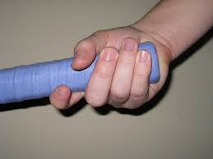 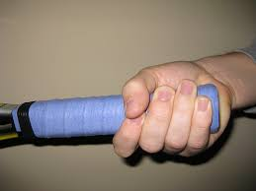

**9) On a scale of 1 to 10 rate yourself on your pickleball skills**

**1 none 2 3 4 5 6 7 8 9 10 Pro**

**10) What do you hope to learn in these next few week of pickleball?**