It is no secret that technology is actively evolving and changing the ways of communication for all generations. Generally, individuals who participate in texting do not text in complete sentence nor use proper grammar. There are many short cuts that exist in the world of texting that even I am guilty for using.
- WYD- What you doing
- HRU- How are you
- BRB- Be right back
- GTG- Got to go
- TTYL- Talk to you later
- LOL- Laugh out loud
- TY- Thank you
- SM- So much
- SMH- Shake my head
- JK- Just kidding
- HMU- Hit me up
These are just a few of the slang words that are used in texting, but do not shed light on cutting down on words as well. Today’s texters will spell things such as:
- U-You
- Txt- Text
- Addy- Address
- L8R- Later
- H8 U- Hate you
- Wut- What
- Rly- Really
- Bc- Because
- C- See
- Pls- Please
- B4- Before
- FB- Facebook
- IG- Instagram
- SC- Snapchat

In my personal opinion, it would not matter to me what my students do on their personal devices, but as texting and social media becomes more prevalent, students are bringing the improper habits of texting into their own formal writings in school. In The English Journal, an article written by Kristen Hawley Turner is published. The author conducted an informal experiment with her high school students. She started majority of her classes with an online discussion board in which her students participated. One day after the students had completed the discussion board, she brought attention to examples of students who chose to write in Standard English, and another student who chose to write in text speak. After the class as a whole conversed about the two forms of writing and what was more acceptable, a majority of students agreed that online writing should in fact follow the Standard English rules. The select few of students who were not convinced by their classmates’ arguments debated that rather it is school content or not, text speak is appropriate because of the nature of technology. On page 63 of The English Journal, Turner writes about the goals she has for her students and even states, “Issues of correctness cannot be ignored, and students must be expected to polish drafts of their writings using conventions of Standard English.” (Turner 2005 63).

As a future educator, it is truly concerning that some of Ms. Turner’s class truly believed that text speak is a suitable form of writing when using an online place to post school related writings. The article also discussed shorthand note taking; as it may seem harmless, it creates the bridge between text speak and Standard English. The author of this article also discussed ways to ensure her students would be writing in the Standard English form. Most of you are probably familiar with the traditional writing checklist which students use to edit their papers for errors in their Standard English. Well, Ms. Turner adapted this activity to help students stay accountable and ensure that they are not writing in text speak. Below is a picture of the chart that was placed in the article.
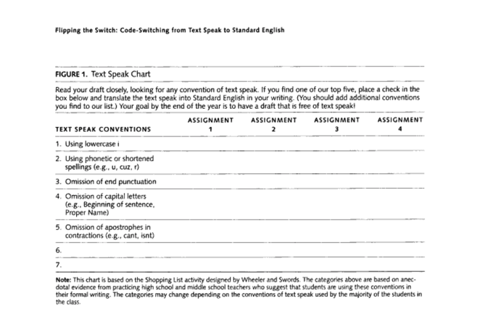

I believe it would have been very interesting to read how the students reacted to the chart and if it increased the reading fluency of their writings. I would predict that there would be the greatest change between pre and post-text speak chart for those students who believe that text speak is appropriate for school based writing. In an article posted by the George Lucas Educational Foundation, the author wrote, “In classrooms, code switching presents challenges in working with teens, who have a hard time moving out of established patterns of communication cemented at home and with peers outside of school.” (Levinson 2013). In my opinion, because I will be teaching special education, this is exceptionally true; not so much for the children who are in elementary school, but higher functioning high school students can definitely relate to this. Generally speaking, I can imagine that typical developing students will also struggle with changing patterns so often, therefore students keep their brain in

Advice to Parents

Encourage your child to text you and others using Standard English. Once the child has practiced this enough, it will turn into habit for them and their text speak will slowly begin to decrease and their use of Standard English will increase. For example, this is an example that I created of text speak vs Standard English in daily text messaging.

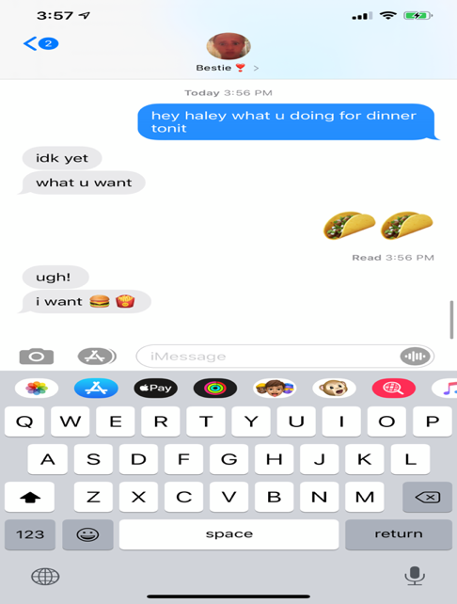.

Advice to Teachers

Start young when teaching students the importance of Standard English. Good ways to explain what code switching is to kids is pictured below. One way to have your kids practice the difference of text speak and Standard English would be to give them a few sentences and ask them to write it down as if they were to send it as a text to their best friend. After the students have completed that, ask them to write the same sentences, but as if they were writing it to be turned in for a grade. This will allow students to open their eyes on the difference of language and to be more aware of something they could subconsciously be doing.

Levinson, Matt. “The Digital Lives of Teens: Code Switching.” Edutopia, George Lucas Educational Foundation, 1 May 2013, https://www.edutopia.org/blog/digital-teens-code-switching-matt-levinson.
Turner, Kristen Hawley. “Flipping the Switch.” The English Journal, vol. 98, no. 5, May 2005, pp. 60–65., https://www.jstor.org/stable/40503300?seq=5#metadata_info_tab_contents.

