Name: Sarah Wright
Bi- Weekly Report Dates: September 15-21 & September 22-28
Steps Week 1 total: 72,223 steps High Day: Saturday 9/17 (13,373) Low Day: Wednesday 9/21 (6,806 steps)
Steps Week 2 total: 73,650 steps High Day: Saturday 9/24 (16,740 steps) Low Day: Monday 9/26 (6,099 steps)

Week 1 Graphs
Weekly Outlook
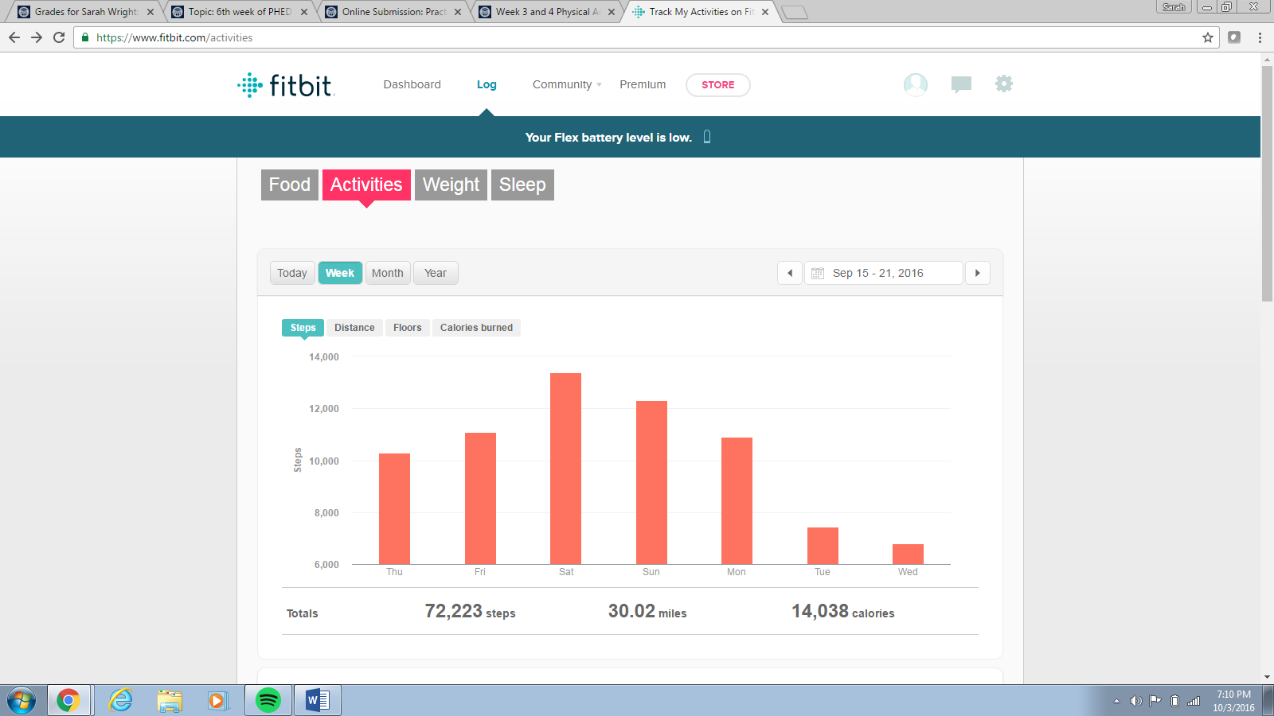
Low Day
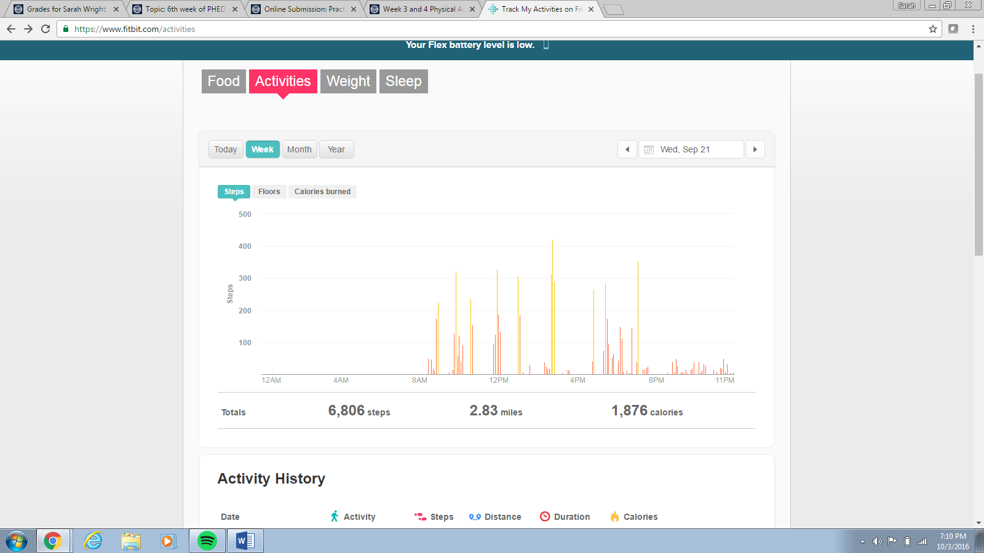

High Day
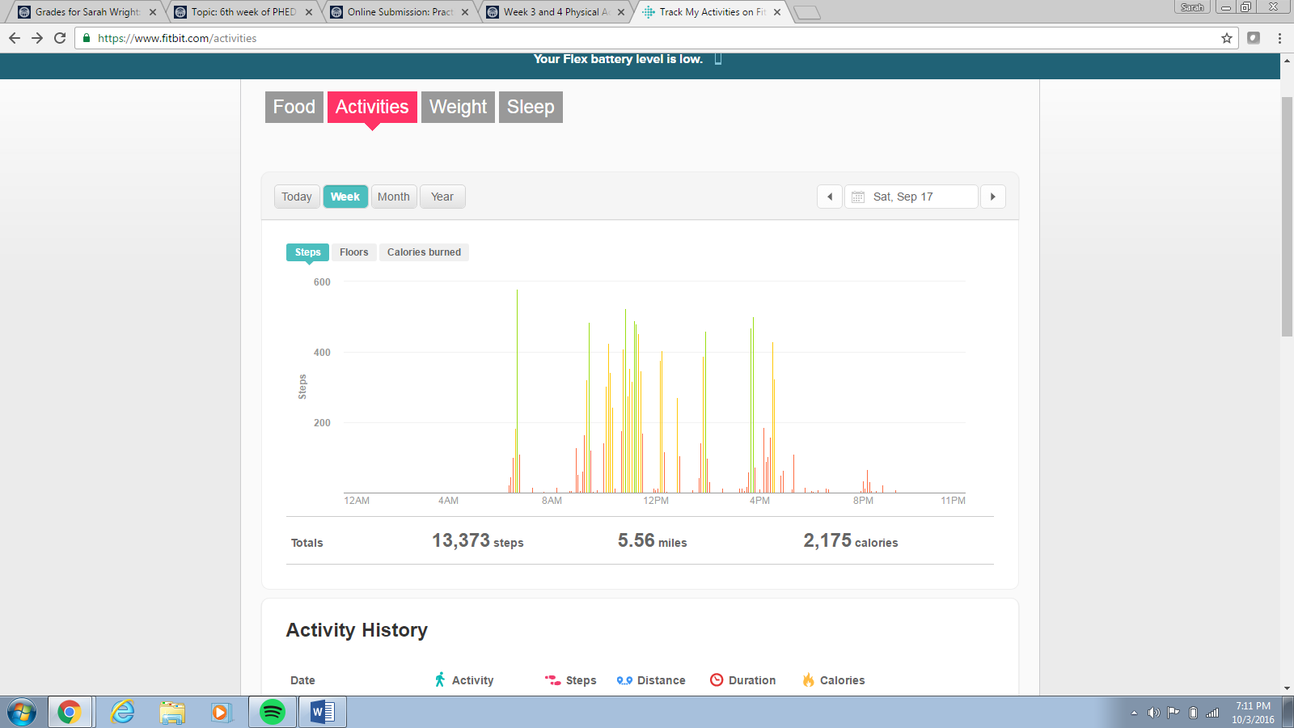

Reflection for Low Activity Day and High Activity Day (Week 3):
- Saturday I had large bouts of activity spread throughout the day
- I was at work Saturday and had to walk around a lot to take different items to different areas
- Wednesday I was not as active
- I had bouts of exercise, but none of them were noticeably large
- I had a lot of homework to do Wednesday, so I spent a lot of time in the library
- I could have increased by activity Wednesday by taking breaks from homework and walking around

Week 2 Graphs
Weekly Outlook
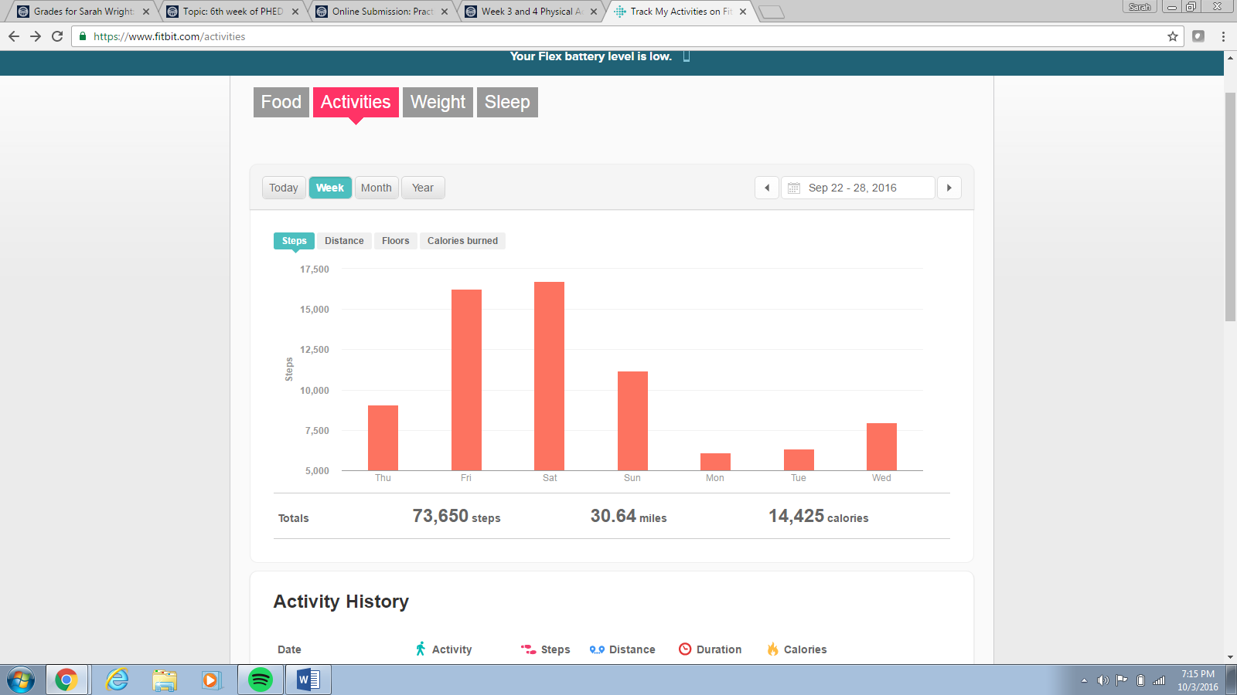

High Day
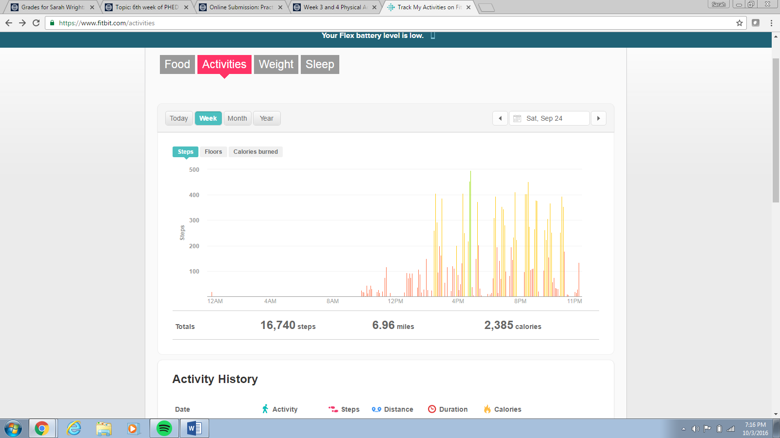

Low Day
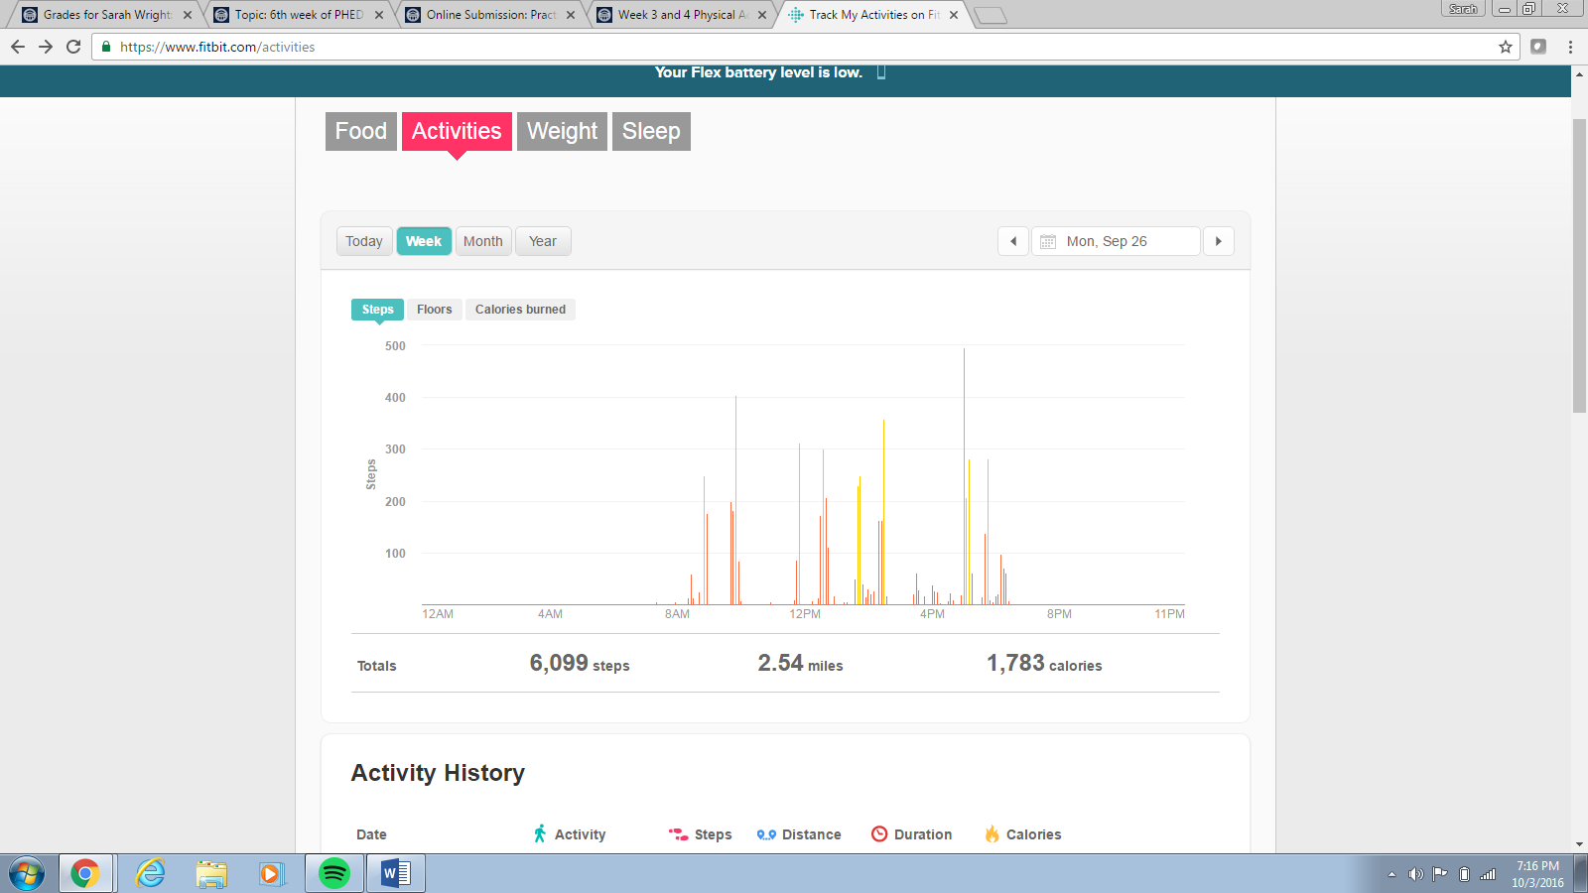

Reflection of Low Activity Day and High Activity Day (Week 4):
- Saturday I was at work and had to walk around to check on team members in different sections of Busch Gardens
- I had large bouts of activity pretty frequently
- On Monday I did not have much energy output
- I had lots of work to do in Hull, so I did not have a lot of activity
- My main activity was moving around campus to different classes
- It would be hard for me to increase my activity, because I was in so many meetings.
- I could have gotten up earlier on Monday and exercised

