Name: Sarah Myroup

Bi-Weekly Report Dates: Oct. 15-21 & Oct. 22-28

Week 1 Total: 81,807 steps
High Day: 16,362 steps Low Day: 4,937 steps

Week 2 Total: 84,525 steps
High Day: 16,393 steps Low Day: 5,723 steps

Week One Reflections and Graphs

I was home for fall break for part of this week, indicating the lower amount of steps on Sunday and Monday. However, upon arriving back to campus, I was back to being more active: doing things with friends, hitting the gym, and getting out of my dorm. I reached my highest number of steps- 16,362- on Saturday, October 21. I worked out early in the day, explored the town sporadically throughout, and went to a party that night. My lowest number of steps- a measly 4,937- was achieved on Monday the 16. The majority of my steps came from visiting the school I previously did an internship with. I also played with my dogs a lot later in the evening, resulting in a slight spike in steps. Other than that, I was fairly dormant that day, catching up on TV shows.

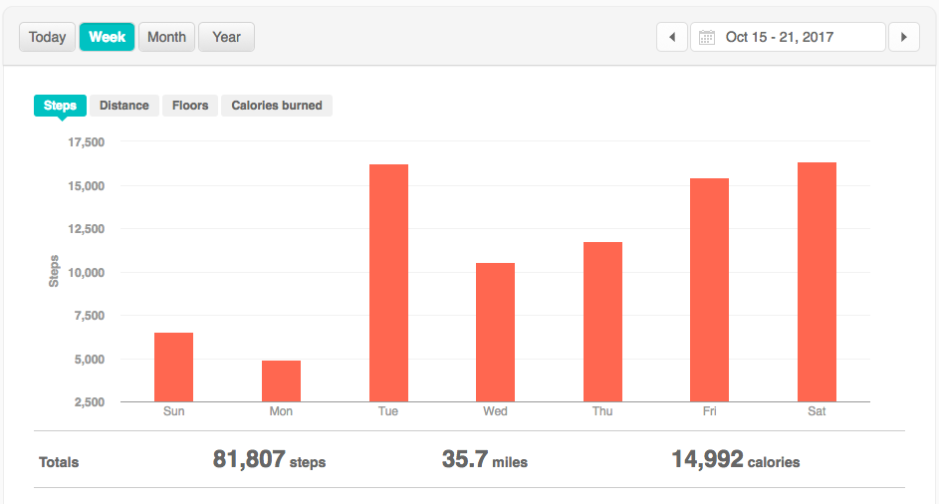

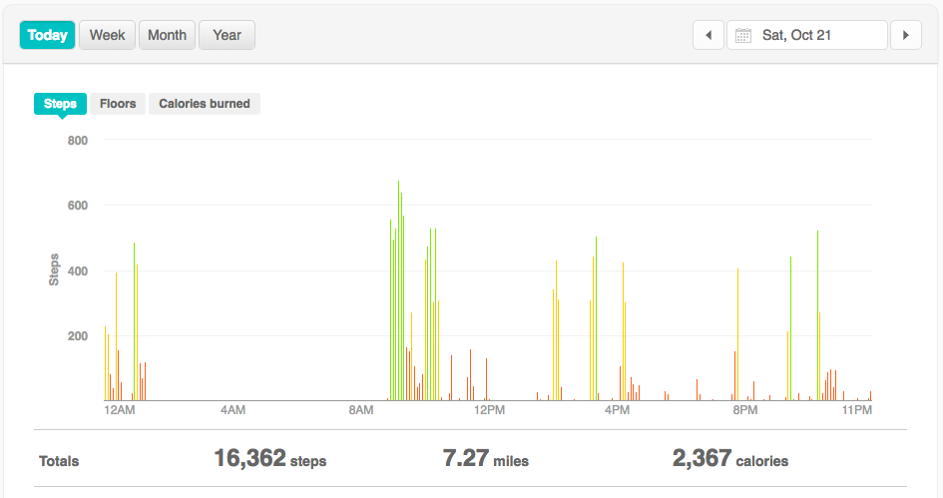

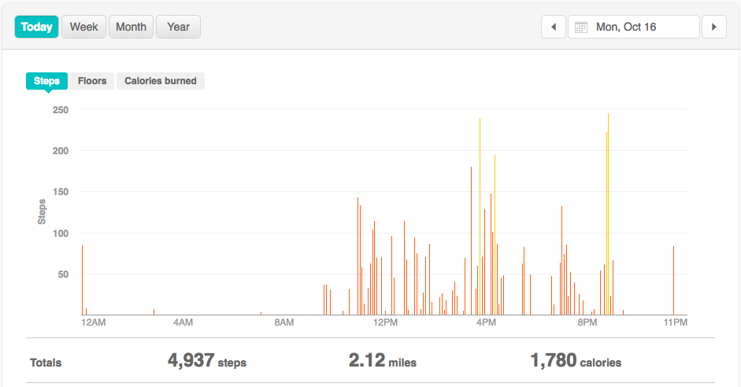

Week Two Reflections and Graphs

Here’s to another week of my average activity level. I continued going to the gym regularly and trying to stay active in other ways. My weekly high of 16,363 steps was reached on October 23. I went to the gym this day, and was later invited by friends to go walk down Main Street and stop in a few shops. My weekly low of 5,723 steps was reached on Friday, October 27. I made a quick trip home to see a show and support my old high school, so I spent over three hours in the car that day, sat for a show, then returned home to sleep. There was not much time for physical activity that day.

