Part 1: Connections to National and International Test Items

Part A: 4th Grade Mathematics Questions

2) Simon wants to watch a film that is between 1 ½ and 2 hours long. Which of the following films should he choose?
a) a 59-minute film
b) a 102-minute film
c) a 121-minute film
d) a 150-minute film

1 hour = 60 min  ½ hour = 90 min  2 hours = 120 min (60 x2) | The film must be between 90 – 120 minutes.  So, I cross out each one that is not between this time frame!  ANSWER: b) 102-minute film

8) A teacher asked 30 students in her class the flavor of their favorite ice cream. The table on the left shows how the teacher recorded the students' responses. In the bar graph on the right which ice cream flavor corresponds to the bar that is labeled X?
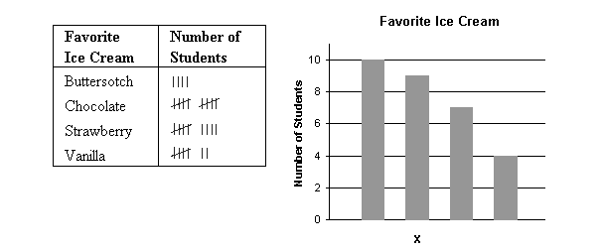
- butterscotch
- chocolate
- strawberry
- vanilla

Count tallies:  Butterscotch: 4  Chocolate: 10  Strawberry: 9  Vanilla: 7 | Bar x is the second most favored ice cream flavor. According to the tallies, the second most favored ice cream flavor is Strawberry, so that’s the answer!

Part B: Answering the questions

I got 100% of the questions correct!!! I did not find any to be particularly challenging, but I recognize that some of the mental reconfiguring required may be challenging for fourth graders.

Part C: Results Around the World

#2
- International Percentage: 30%
- United States Percentage: 33.8%
- Two different countries’ percentages: Italy- 25.7% & Singapore- 46.5%
- Versus US Students
  - Italy’s national average is just over 5% lower than that of the United States. While this gap is not huge, it could be attributed to different academic focal points in Italy. Perhaps language arts, English, and history are prioritized over mathematics, while the United States seems to invest a fair amount in its math lessons. The math content involved with this question could also be taught later than in America, so the students were not as familiar with the concept of time when facing this question.
  - Singapore’s national average is significantly higher than that of the United States. Singapore’s excellent mathematics curriculum is often brought up in discussions of education in other countries, so it should come as no surprise that they have the highest average percentage of the countries shown. Greater focus is placed on mathematics in this country, perhaps allowing students to learn the information earlier, or simply more time to work through problems. The Singapore Math books also illustrate that a variety of strategies for the same concepts are taught, enabling students to more thoroughly understand the problem rather than just the standard algorithm, which is commonplace in the States.

#8
- International Percentage: 47.3%
- United States Percentage: 69.4%
- Two different countries’ percentages: England- 74.7% & Japan- 89.4%
- Versus US Students
  - Perhaps the largest contributing factor to the higher rate of accuracy in England on this question could be attributed to the establishment of a national curriculum. All of England follows the same standards, while the United States only has statewide standards in place. These discrepancies could cause the United States rank below England’s average. If mathematics is stressed at the same level in all English schools, then students will most certainly have a more uniform understanding, leading to higher achievement across the board.
  - Like with Singapore in question 2, Japan answered correctly at significantly higher rates. Japan has a longer school year than the United States, and study sessions are often offered after the school day concludes. Preparatory schools are also popular in Japan, as students have the chance to further refine their knowledge. These modes of advancement, while present in the United States, does not seem as commonplace or vital, the public school system containing most students across the country.

Part D: Analyzing Student Thinking

2) Simon wants to watch a film that is between 1 ½ and 2 hours long. Which of the following films should he choose?
a) a 59-minute film
A student may select this response because they misread the text, seeing
the option of “between ½ hour and 2 hours long” rather than the 1 before the ½.
b) a 102-minute film
This is the correct answer. By determining that 1 ½ hours is equivalent to 90 minutes and 2 hours is equivalent to 2- 1 hour periods, or 120 minutes, they can search for the number of minutes that falls between 90 and 120.
c) a 121-minute film
This is just above the 2 hour mark, or 120 minutes, so reading the answers quickly could lead to mistakenly selecting this response.
- a 150-minute film
This answer would most likely be selected if the student miscalculates how many minutes are in one hour, therefore incorrectly determining the number of minutes in two hours.

8) A teacher asked 30 students in her class the flavor of their favorite ice cream. The table on the left shows how the teacher recorded the students' responses. In the bar graph on the right which ice cream flavor corresponds to the bar that is labeled X?
- butterscotch
The student more than likely did not understand where the x fell on the bar graph, or failed to read the information carefully. They could have also ranked the four flavors based on their personal taste, ranking butterscotch as their second favorite.
- chocolate
Chocolate was the most-favored flavor. Since the x is for the bar beside it, if a student did not look carefully, they could mistake the x for being under the tallest bar, representing chocolate. They could have also miscounted the number of tallies, perhaps forgetting to count the diagonal tallies.
- strawberry
This is the correct answer. The student either matched the number Bar x landed on to the flavor with the corresponding number of tallies, or recognized Bar x was the second most-liked flavor, counted the tallies, and found strawberry was the second most popular flavor.
- vanilla
Vanilla only has two less votes than strawberry, so if a student is not reading carefully, they may have decided vanilla had more votes, or mixed up the order of the flavors on the chart.

Part Two: Connections to National Standards and Virginia Mathematics Standards

Part A: NCTM Content Standards

Standards assessed in question #2
- Number and Operations

Standards assessed in question #8
- Data Analysis and Probability

Part B: VA Process Standards (Goals)

Standards assessed in question #2
- Problem Solving
- Reasoning and Proof
  - In order to solve this problem, students need to justify which answer is correct. However, this can only be done through converting the times mentioned in the question to minutes in order to match the potential answers. Then, once the numbers have been converted, the students must use problem solving and reasoning skills to determine which answer falls between 90 and 120 minutes. The converted minutes are their proof.

Standards assessed in question #8
- Connections
- Representation
  - Using these two process standards, students must first understand what number each tally represents, as well as what number each bar on the graph represents. Once realizing what each represents, students must then make the connection between the number represented in Bar x and the corresponding number represented through tallies.

Part C: VA Math Standards 2016

Standards of Learning addressed in question #2
K.9 The student will compare two objects or events, using direct comparisons, according to one or more of the following attributes: length (longer, shorter), height (taller, shorter), weight (heavier, lighter), temperature (hotter, colder), volume (more, less), and time (longer, shorter).
This standard is not featured in the attached curriculum framework. Henceforth, the 2009 Standard’s (K.9 The student will tell time to the hour, using analog and digital clocks) bullet points will be used.
- Many experiences in relating time on the hour to daily routines and school schedules (e.g., catching the bus, lunch time, recess time, and resource time) help students develop personal referents for time.
- Making sense of telling time to the nearest hour is reinforced when students recognize the positions of the hands on an analog clock and identify the corresponding time to the hour.

3.9 The student will
a) tell time to the nearest minute, using analog and digital clocks;
b) solve practical problems related to elapsed time in one-hour increments within a 12- hour period; and
c) identify equivalent periods of time and solve practical problems related to equivalent periods of time.
- The use of an analog clock facilitates the understanding of time relationships between minutes and hours and hours and days.
- Students need to understand that there are sixty minutes in an hour when using analog and digital clocks.

Standards of Learning addressed in question #8
2.15 The student will
a) collect, organize, and represent data in pictographs and bar graphs; and
b) read and interpret data represented in pictographs and bar graphs.
- The purpose of a graph is to represent data gathered to answer a question.
- A bar graph uses horizontal or vertical parallel bars to represent counts for several categories. One bar is used for each category, with the length of the bar representing the count for that category.

4.14 The student will *
a) collect, organize, and represent data in bar graphs and line graphs;
b) interpret data represented in bar graphs and line graphs; and
c) compare two different representations of the same data (e.g., a set of data displayed on a chart and a bar graph, a chart and a line graph, or a pictograph and a bar graph).
- Bar graphs display grouped data such as categories using rectangular bars whose length represents the quantity the bar represents. Bar graphs should be used to compare counts of different categories (categorical or qualitative data). Grid paper can assist students in creating graphs with greater accuracy.
- Comparing different types of representations (charts and graphs) provide students an opportunity to learn how different graphs can show different aspects of the same data. Following construction of graphs, students benefit from discussions around what information each graph provides.

*While the first two substandards are the same in 4.14 as 2.15, part c really illustrates the goal of question 8, showing how skills build over time

Part 3: Connections to Spring 2014 or 2012 Virginia Test Results and Practice Problems

Part A: Finding Released SOL Test Items

Found them!

Part B: The Released Items

Question #2

- Grade Level: 3 (Spring 2014)
This question requires an understanding of how many minutes are in 1 hour, just as with the question from Dare to Compare.

- Grade Level: 4 (Spring 2008)
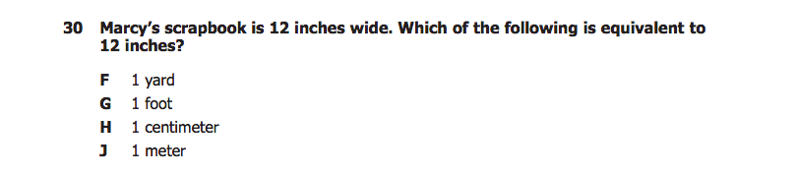
While not addressing time, this question still requires previous knowledge of key conversions in order to succeed. Just as question 2 asks students to recall that there are 60 minutes in 1 hour, this question requires students to know that there are 12 inches in 1 foot.

Question #8

- Grade Level: 3 (Spring 2014)

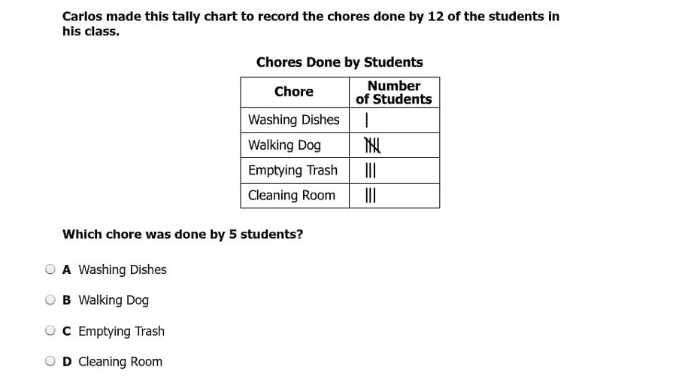
Both call for an understanding of what tallies represent.

- Grade Level: 4 (Spring 2014)
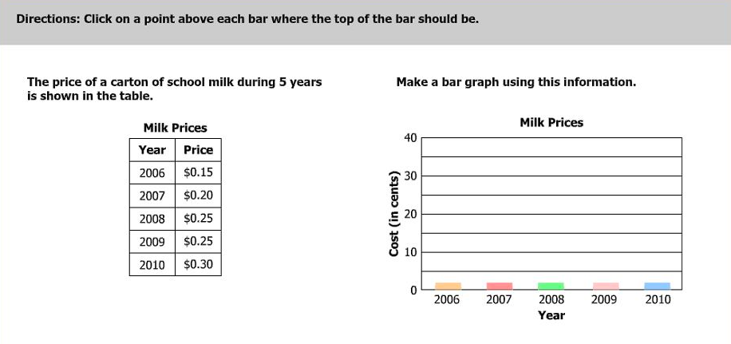
This question requires the students to put the information in the table into a bar graph, requiring them to understand how a bar graph should be arranged according to the given data, which is also required in question 8.

Part C: Degree of difficulty of each problem

Question #2
- Grade Level: 3 (Spring 2014)
This question, while covering the same ideas as the Dare to Compare (DTC) problem, proves less difficult. The DTC problem requires a few different steps: one must first convert 1 ½ and 2 hours into minutes, and then place each of the potential answers in relation to the allotted time of 90 -120 minutes until one falls between the two times. While the SOL question requires students to know how many minutes are in an hour, they then only need to multiply 60 minutes by 5 to find the answer. 60 x 5 is a relatively simple equation to solve, students only then needing to find the matching answer choice.

- Grade Level: 4 (Spring 2008)
This SOL question is much simpler than the DTC problem. While the DTC problem requires applying conversions in order to create a timeframe and find the answer that works, this SOL question only asks students to know a conversion. With this problem, it could very much be an “if you know it, you know it; if you don’t, you won’t” scenario, where the question cannot be confidently answered if the student does not know one conversion. However, knowledge of 1 ft = 12 in is all that is needed to reach the correct answer here.

Question #8
- Grade Level: 3 (Spring 2014)
This SOL question is less difficult than the DTC problem. The DTC problem asks students to understand what the tallies represent and how they translate into the provided bar diagram. This question, however, only asks that students know how to count tallies and translate them to numerical representations. It requires less steps and no translation between graphs or tables.

- Grade Level: 4 (Spring 2014)
The SOL question is more difficult than the DTC problem. The DTC problem provides both the tallies and the bar diagram, only requiring students to interpret in information. In this SOL question, however, students must understand how to make a bar diagram, arranging by year and understanding how high each bar should go and why. Numbers are provided, but the bar diagram is left for students to create.

The End! (:

