Longwood University has existed since March of 1839, and the town of Farmville even longer. Since its establishment, students have been attending, graduating, and leaving their mark on the small town they call home for nine months of the year. Years passed, students proceeded through to graduation on Wheeler Lawn, people came and left the town, and more students continued pouring in. For today’s classes, there seems to be a common complaint: there’s nothing to do in Farmville. That could certainly set a negative precedent for an incoming freshman such as myself, but I refuse to believe it until I experience it. I am determined to make the most out of my home away from home.

Saturday, October 6, 2017
That quest to “make the most” takes us to this day, which was the kickoff to the Longwood University tradition of Oktoberfest! It appears to be an event anticipated by all, and a fantastic kick off to the semester (even if we already started classes back in August). This was my first Oktoberfest, so I took a deep look to figure out the bands that were playing and events available to me. Somehow, this weekend unexpectedly turned into more than a campus event that allowed for new experiences both at and away from Longwood.

4 PM: Color Wars
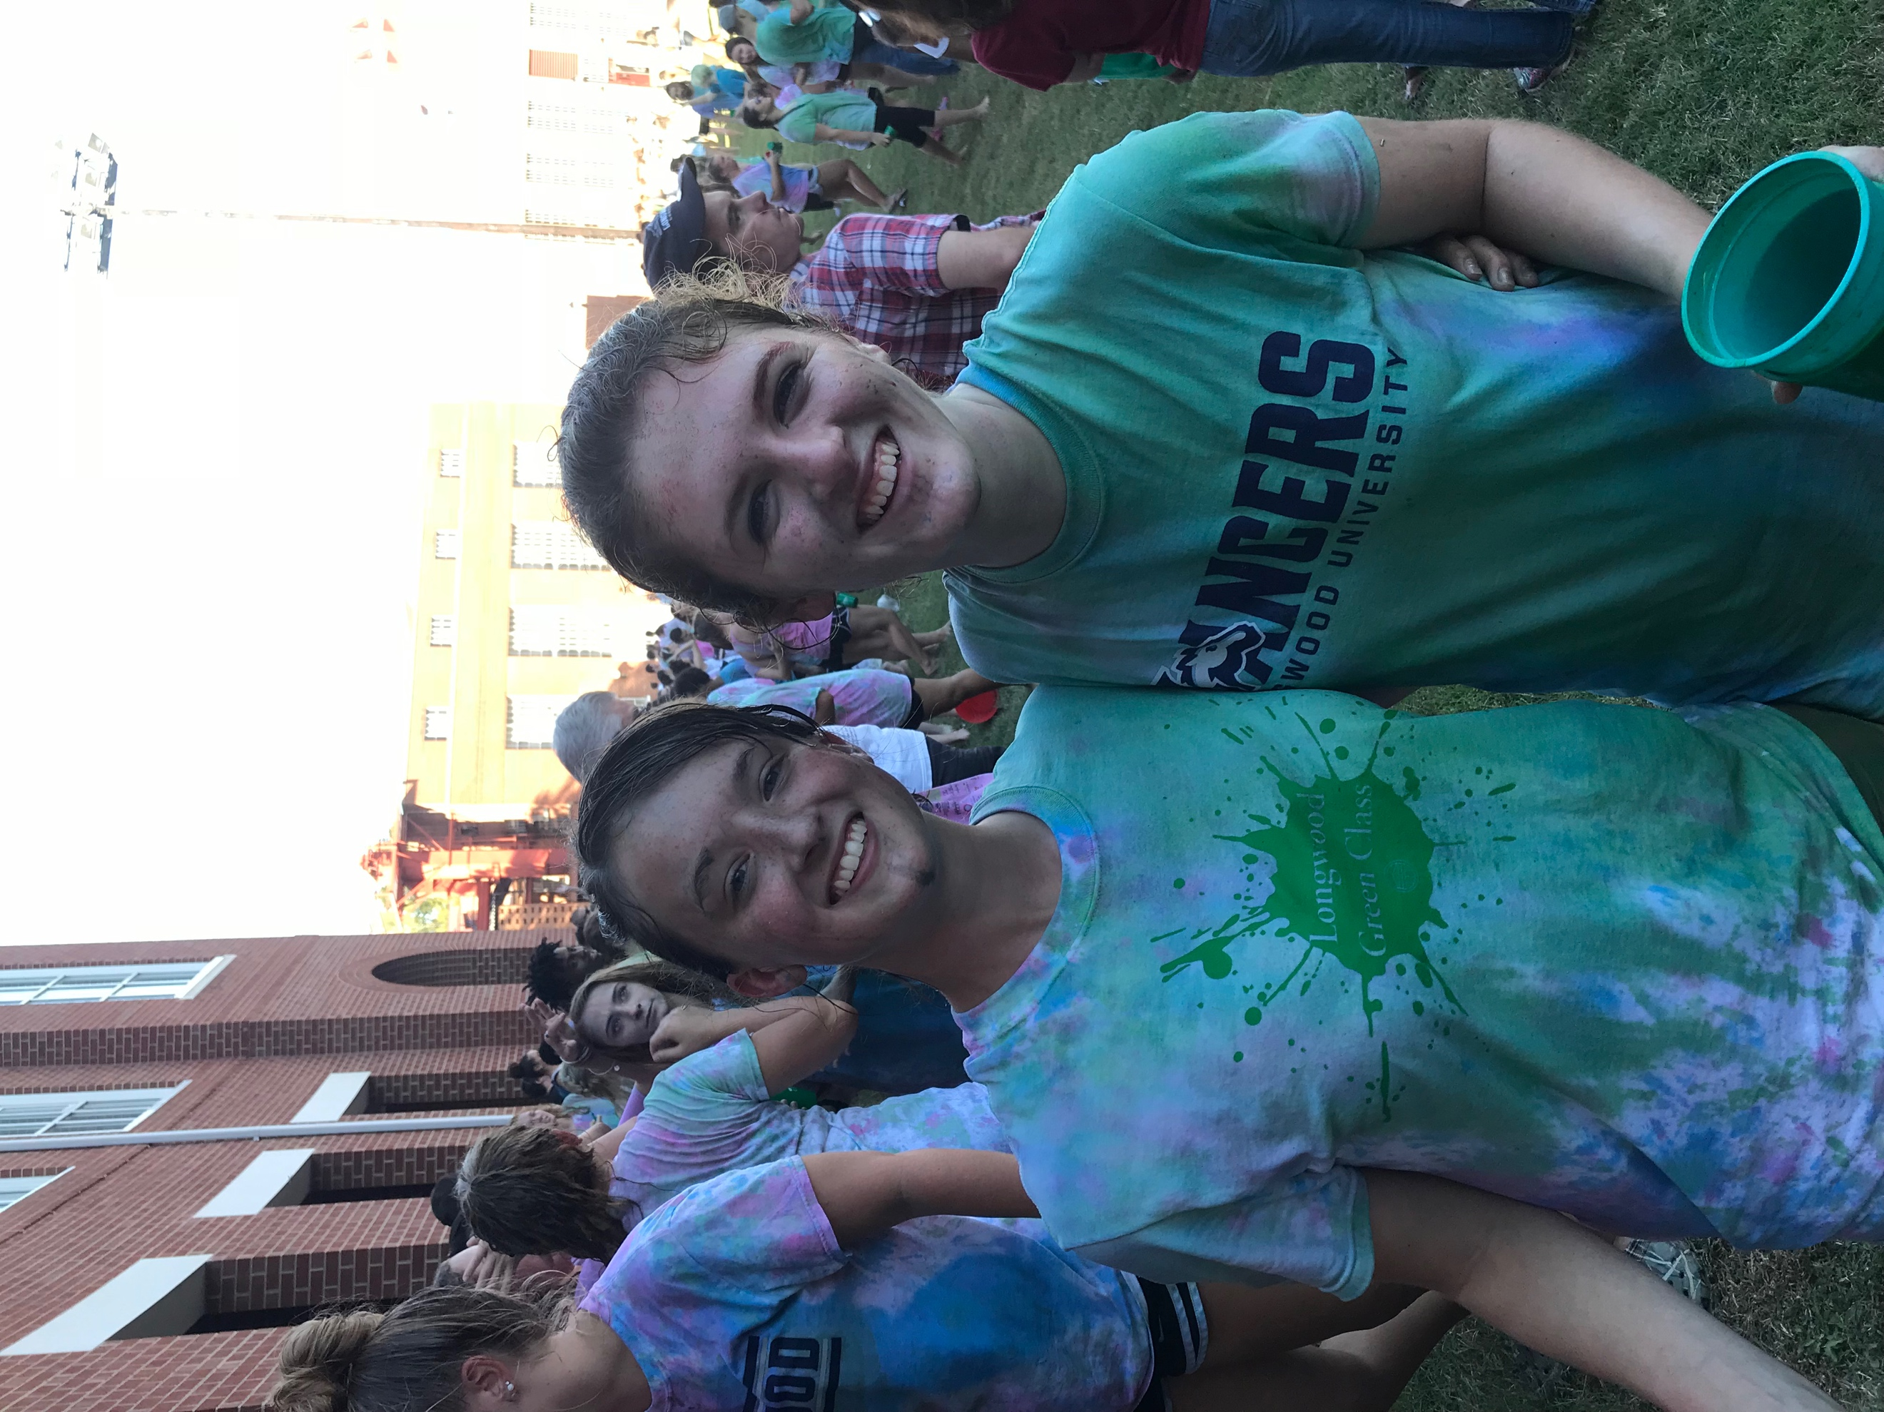
The infamous kick-off to a fantastic weekend could no better be described than an extreme tie-dying battle. Arriving prepared in a white shirt and pants I did not mind seeing ruined, I was met with trash cans full of red, green, and blue paint, and a huge crowd of excited students. People of all years came out to witness and participate in the paint war. Although cups were provided, many chose to bring their own containers, often in the form of large jugs to could gather more paint to splash others with. The group I came with quickly assembled around a trashcan and filled out cups. A few of us chose to be adorned with a handprint from one another to begin the coloration on our shirts. After a few games and rules (“Don’t pick up the trashcans!!!”), the colorful war was mere seconds away. My friend Hannah and I proceeded to the front of the green class, prepared to get drenched. The red class stood on one side of Iler Field, the green class on the other, cups dripping with paint. Then, the countdown began. Three. Two. One. The next thing I knew, I was charging forward, paint hitting me from all sides. I thrust my cup into the air, watching as the paint rained down on those in front of me. Once our cups were empty, Hannah and I bounced through the crowd to return to our trash cans and refill, only to continue splattering and being splattered. This thrilling battle lasted a little less than ten minutes. By the end of it, I was left with a shirt dyed all colors, hair crusting up from paint, and a memory to last a lifetime. However, I would rather forget the process of scrubbing the paint off in cold shower water.

6 PM: Dinner
After managing to scrub most of the unwanted remnants of Color Wars away, Hannah and I planned on grabbing dinner at D Hall. It was not anything special, but it was paid for. However, I received an unexpected text from a friend, Chris, explaining that he and quite a few others were cooking dinner down in Wheeler Lobby tonight, and we were invited! As could be expected, dinner plans changed, and Hannah and I headed downstairs to find a few different things. First: other than Chris, we knew absolutely no one we would be eating with. Second: dinner was not yet prepared, so we had the opportunity to help bake and cook, which is a hobby of mine. Third: the planned meal was not simply Kraft Mac and Cheese. We’re talking homemade baked chicken, alfredo, roasted and spiced potato slices, and caramel apples and chocolate mousse pie for dessert. Yeah, I would definitely call that better than D Hall. While helping caramelize apples in Wheeler’s kitchen and stirring spices in potatoes, conversation struck up among us, and I learned more about the group of strangers, quickly growing an appreciation for them. Soon enough, around fifteen of us squeezed around two joined tables in the lobby to eat a beautifully prepared meal on paper plates and drink sparkling grape juice out of dollar store glasses (with the price tags still on). Within just a few hours, a group of strangers became a group I would call my friends. College is cool.

9 PM: Walk Around Town
At dinner, Hannah and I especially clicked with a select few people: Chris, Kenny, Madi, and Corbin. We were not ready to be done hanging out by the time dinner finished, so we went off on our own. Kenny is a sophomore at Longwood, and he wanted to “show us the sights.” I already explored around campus quite a bit with friends beforehand, so I knew most of the places he took us, but it was nevertheless a fun experience to see it all once more with a group of people I genuinely enjoyed being around. We walked down Main Street, finding the majority of stores to be closed (unsurprisingly), walked through the loud music and crowds of people on both sides of Buffalo Street, and walked up and down the many hills of Farmville. Where we went did not concern me, as I was enjoying my company and whatever came next.

11 PM: Driving Around
This is what came next, then. There are very few things I enjoy more than long, late drives with friends. After walking around for some time, our group piled into Kenny’s car and decided to head beyond where our feet would take us. We drove the dark and empty streets of town, observing very little night life other than those partying or at Walmart. On the drive, we were able to enjoy the peacefulness of the quiet small town and the ability to get to know one another a little more. Eventually, Kenny brought up a supposedly haunted house nearby. He was not talking about some Halloween attraction, but rather, a house abandoned after a family was murdered inside. We drove close enough to see the creepy looking farmhouse, but not too close in case someone was there. Whether the stories swirling around that house are history or folklore, I was able to learn a bit more about Farmville, just in time for the spookiness of October.

October 7, 2017

1 PM: Oktoberfest
The big day of the weekend arrived! Bands, carnival games, and food were in store, but the booths were the first thing to experience. I reunited with Hannah, Madi, Chris, Kenny, Corbin, and another person from the dinner named Sherina. As we began to walk through the rows and rows of booths, it appeared as if every club had a spot, and I would surely be broke if I bought each of the things I wanted from them. Of course, that rings true for most things in life, so I needed to pick and choose which clubs to buy from. As a member of the Honors Student Association, I bought a cake pop to support. Other than that, I donated to the Hispanic/ Latino Association’s support fund for Puerto Rico, and paid for matching henna tattoos with Hannah at the Belly Dancing booth. A few of the others went to the Longwood Players booth for face painting, and we later reconvened. We then stumbled upon the free carnival games, which included basketball and the mallet game where one tries to hit a platform hard enough to ring a bell. As hard as I tried, that mallet game was a lot more difficult than expected. I still had a blast trying, though. Oktoberfest was busier than I expected, but I certainly enjoyed being able to walk around and check out fun activities and events while learning some more about the various organizations on campus.

3:30 PM: She’s a Legend
This was the Oktoberfest band I really wanted to see. I checked out each performer prior to the event, and the music of She’s a Legend was my favorite by far. Hannah and I broke off from the group to catch their performance, laying down a blanket fairly close to the stage. Our friend Kenzie joined us. The group was just as talented as they sounded in their recordings, and held an excellent stage presence. The singer shared funny stories, explained the few covers and tributes they did, joked about how none of us really knew who they were, and even joked about how he had food poisoning just the night before. The guitarist and bassist both hopped around stage, long hair being trashed in every direction. The drummer even stepped up for a vocal solo at one point! Hannah, Kenzie, and I were able to sit back and enjoy their music, perhaps getting a little too into it, such as when we started singing along to songs we did not even know the lyrics to- but the lead vocalist told us to make up words, anyway. Following the concert, the three of us swung around to the side of the stage and spoke to the singer, complimenting his performance and hearing a little more about his encounter with food poisoning. She’s a Legend was my favorite concert I’d been to in about a year, and I am incredibly grateful that Oktoberfest introduced me to a fantastic group to listen to.

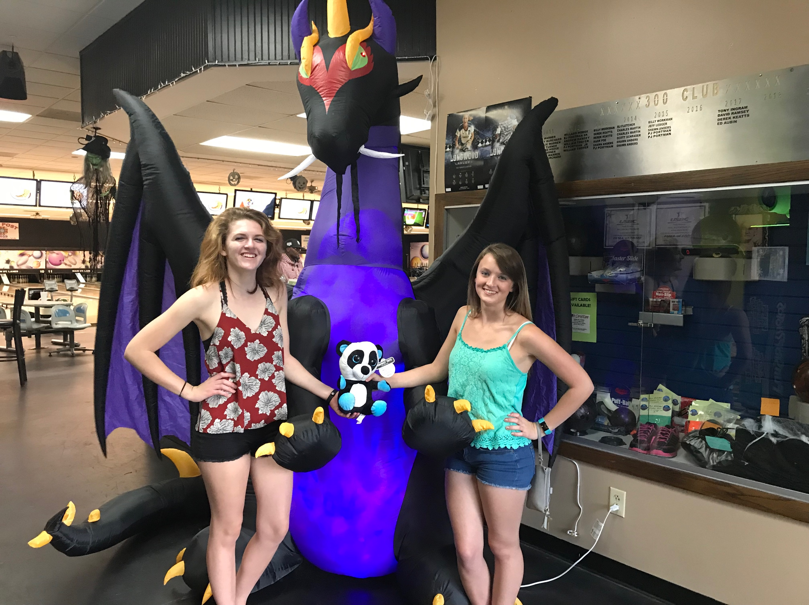
6 PM: Bowling
Most of our dinner group met up once more for bowling at Main Street Lanes! Kenny took a few trips in his car since there were so many of us. I was in the second car trip, so as we waited for more people to arrive, those of as at the bowling alley had some fun with the claw machine and air hockey. It seems like leaving a bunch of college students in an arcade may be a bad idea for our wallets. By the time the final car of people arrived, though, we had each won a stuffed animal and I successfully lost a game of air hockey. Then it was time for the main event: bowling! Within the first few frames, we learned very quickly that we all suck. The first few frames were almost completely gutter balls. Luckily, failing is half the fun of bowling. I managed to reach the highest score of everyone playing: 118! So, maybe I suck just a little less than everyone else.

That was a little more than 24 hours in Farmville, but every second was a blast! Although it may not always be as eventful as Oktoberfest weekend, I still rarely find myself bored here. Contrary to popular belief, I have thus far found Farmville to be full of adventure, so long as one has the right attitude and buds by their side. In fact, I found that as long as I have the right people at my side, we can make fun out of anything.

