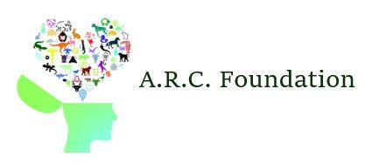
April 2, 2018 - FOR IMMEDIATE RELEASE
Animal communication is commercialized

PHOENIX, AZ ––A scientific way to communicate with your pets was announced yesterday by pet neurology company the A.R.C. Foundation.

“Many of us have thought about the potential of a conversation with our dog or cat,” said the company’s CEO Pamela R. Stapleton, during the announcement. “With our breakthroughs in neurological technology, any pet lover can see what their pet thinks about them.”

This new form of communication comes after years of expensive research, funding, and court battles. The process works by inserting a tiny microchip into a pet’s brain and allows for patients to exchange thoughts with their beloved cat, dog, horse, bird, etc.

During testing, the A.R.C Foundation learned that other companies in China, and Russia were also on the brink of a breakthrough with animal based neurological technology. The foundation hired an entire nightshift of innovative scientists and veterinarians to potentially beat these foreign companies, and successfully did so.

Services are available upon consultation, with the option of monthly, weekly, or one time appointments. Each session costs exactly $250 and at least four are recommended for the best most enriching experience. The company guarantees customer satisfaction and a clear, professional means of communication with your pet.

“Thanks to the A.R.C. Foundation, we were able to schedule weekly appointments to talk with Lipton and work through his issues. After only a few short weeks of sessions, Lipton was happier than ever,” added Mark and Natalie Price, a young couple who were among the first to use the new service.

The A.R.C Foundation is offering a 15% discount to all pets over 10 years of age until the end of the month at the A.R.C. Foundation Neurology Center, located at 6055 Clawson Circle.

-30-

Schedule a consultation today by calling 555-543-5432 or by visiting our website at www.arcneurology.com.

