Website Analysis for
James River Water Sports Inc.

Submitted to:

James River Water Sports Inc.
Marketing Department
201 High Street
Richmond VA, 23226

Prepared by:
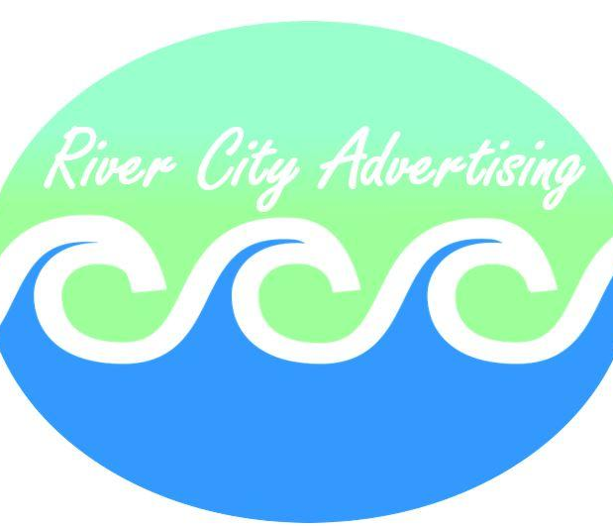

6800 Franklin Court
Glen Allen VA, 23058

November 22, 2018

Table of Contents

Letter of Authorization . . . . . . . . . . . . . . . . . . . . . . . . . . . . . . . . . . . . . . . . . . . . . . . . . . . . . . . . . . . . . . . . . . .2
Letter of Transmittal . . . . . . . . . . . . . . . . . . . . . . . . . . . . . . . . . . . . . . . . . . . . . . . . . . . . . . . . . . . . . . . . . . . . . 3
List of Figures . . . . . . . . . . . . . . . . . . . . . . . . . . . . . . . . . . . . . . . . . . . . . . . . . . . . . . . . . . . . . . . . . . . . . . . . . . . .4
List of Tables . . . . . . . . . . . . . . . . . . . . . . . . . . . . . . . . . . . . . . . . . . . . . . . . . . . . . . . . . . . . . . . . . . . . . . . . . . . . .4
Executive Summary. . . . . . . . . . . . . . . . . . . . . . . . . . . . . . . . . . . . . . . . . . . . . . . . . . . . . . . . . . . . . . . . . . . . . . . 5
Introduction . . . . . . . . . . . . . . . . . . . . . . . . . . . . . . . . . . . . . . . . . . . . . . . . . . . . . . . . . . . . . . . . . . . . . . . . . . . . .. 6
Methodology . . . . . . . . . . . . . . . . . . . . . . . . . . . . . . . . . . . . . . . . . . . . . . . . . . . . . . . . . . . . . . . . . . . . . . . . . . . . 7
Analysis of “Hala Gear” . . . . . . . . . . . . . . . . . . . . . . . . . . . . . . . . . . . . . . . . . . . . . . . . . . . . . . . . . . . . . . . . . . 8
Visual Design. . . . . . . . . . . . . . . . . . . . . . . . . . . . . . . . . . . . . . . . . . . . . . . . . . . . . . . . . . . . . . . . . . . . . 8
Ease of Access. . . . . . . . . . . . . . . . . . . . . . . . . . . . . . . . . . . . . . . . . . . . . . . . . . . . . . . . . . . . . . . . . . . . 9
Presentation of Information. . . . . . . . . . . . . . . . . . . . . . . . . . . . . . . . . . . . . . . . . . . . . . . . . . . . . . .9
Analysis of “Naish”. . . . . . . . . . . . . . . . . . . . . . . . . . . . . . . . . . . . . . . . . . . . . . . . . . . . . . . . . . . . . . . . . . . . . .11
Visual Design. . . . . . . . . . . . . . . . . . . . . . . . . . . . . . . . . . . . . . . . . . . . . . . . . . . . . . . . . . . . . . . . . . . . 11
Ease of Access. . . . . . . . . . . . . . . . . . . . . . . . . . . . . . . . . . . . . . . . . . . . . . . . . . . . . . . . . . . . . . . . . . . 12
Presentation of Information. . . . . . . . . . . . . . . . . . . . . . . . . . . . . . . . . . . . . . . . . . . . . . . . . . . . . .12
Analysis of “Sic Maui”. . . . . . . . . . . . . . . . . . . . . . . . . . . . . . . . . . . . . . . . . . . . . . . . . . . . . . . . . . . . . . . . . . . 13
Visual Design. . . . . . . . . . . . . . . . . . . . . . . . . . . . . . . . . . . . . . . . . . . . . . . . . . . . . . . . . . . . . . . . . . . . 13
Ease of Access. . . . . . . . . . . . . . . . . . . . . . . . . . . . . . . . . . . . . . . . . . . . . . . . . . . . . . . . . . . . . . . . . . . 14
Presentation of Information. . . . . . . . . . . . . . . . . . . . . . . . . . . . . . . . . . . . . . . . . . . . . . . . . . . . . 14
Conclusions . . . . . . . . . . . . . . . . . . . . . . . . . . . . . . . . . . . . . . . . . . . . . . . . . . . . . . . . . . . . . . . . . . . . . . . . .. ... 16
Recommendations . . . . . . . . . . . . . . . . . . . . . . . . . . . . . . . . . . . . . . . . . . . . . . . . . . . . . . . . . . . . . . . . . . . . . 17
Appendix A: Survey Questions & Results. . . . . . . . . . . . . . . . . . . . . . . . . . . . . . . . . . . . . . . . . . . . . . . 18
Survey. . . . . . . . . . . . . . . . . . . . . . . . . . . . . . . . . . . . . . . . . . . . . . . . . . . . . .. . . . .. . . . . . . . . . . . . . . . 19
Results. . . . . . . . . . . . . . . . . . . . . . . . . . . . . . . . . . . . . . . . . . . . . . . . . . . . . . . . . . . . . . . . . . . . . . . . . . 21
Appendix B: Minutes . . . . . . . . . . . . . . . . . . . . . . . . . . . . . . . . . . . . . . . . . . . . . . . . . . . . . . . . . . . . . . . . . . 22
Minutes Log. . . . . . . . . . . . . . . . . . . . . . . . . . . . . . . . . . . . . . . . . . . . . . . . . . . . . . . . . . . . . . . . . . . . 23

James River Water Sports Inc.
Human Resources Department
4678 Riverside Drive
Richmond, VA 23226
August 3, 2018

Carol Simmons
Marketing Supervisor
River City Advertising
1200 Main Street
Franklin, VA 23177

Dear Mr. Green:

Subject: Overview of Water Sports websites

In the past 2 years, 56 new water sports websites have been created. Online and digital marketing has created a cutthroat and competitive market. Due to the increase in these sites, research was done to evaluate the existing water sports websites, in order to better market watersports in general and the companies that promote watersports.

As previously mentioned on January 9, 2017, we would like your team to further research existing sites to evaluate their content, marketing capability and overall public appeal. This research could greatly benefit companies to come and your cooperation would be greatly appreciated.

We look forward to receiving your report. If you require any further help or information, please feel free to contact Dave Fary at 666-666-5765. Ext 236.

Yours Sincerely,

Matthew Perry
Director
Department of Marketing

1200 Main Street
Franklin, VA 23177

September 12, 2018

Matthew Perry
Director of Marketing
James River Water Sports Inc.
4678 Riverside Drive
Richmond, VA 23226

Dear Mr. Perry:

Subject: Water Sport Website Analysis and Suggestions Completed

We are excited to present the website analysis report that you requested in your letter of August 3, 2018. Our report analyzes the following three websites.

- Sic Maui
- Hala Gear
- Naish

As is evident, all three websites provide basis for comparison and analysis for James River Watersports Inc.

We would like to thank Bethany Gordon for her help in preparing this report. If you have any questions or comments about the report , we would be happy to meet with you or with a member of your staff. I can be reached at (999)-999-5645, ext. 3.

Yours sincerely,

Angela Nottoway

Angela Nottoway
Chief Consultant

List of Figures

Figure 1: Hala Website Logo
Figure 2: Naish Surfing Website Logo
Figure 3: Sic Maui Website Logo
Figure 4: Hala Website Homepage Banner
Figure 5: Hala Website Social Media/Search Bar
Figure 6: Hala Website Shop Link
Figure 7: Hala Website Board Overview
Figure 8: About Hala Gear
Figure 9: Hala Carbon Nass - T 14’
Figure 10: Naish Website Homepage Banner
Figure 11: Naish Website 2018 Products
Figure 12: Naish Website Product Videos
Figure 13: Naish Website Homepage Drop Down Menus
Figure 14: Sic Maui Website Homepage Banner
Figure 15: Sic Maui Instagram Gallery
Figure 16: Sic Maui Board Model Selection
Figure 17: Sic Maui Homepage Photo Scheme

List of Tables

Table 1: Visual Design Survey Results
Table 2: Ease of Access Survey Results
Table 3: Presentation of Information Survey Results

Executive Summary

A transition from global retail sales to online shopping sales has increased the demand for a professionally presented, appealing website. The internet is full of water sports websites - geared towards either experienced waterman or beginners trying to get their feet wet. However, there are very few websites that focus well on both audiences.

James River Water Sports Incorporated has asked River City Advertising to recommend three websites that present products, information, and media professionally. These three websites will serve as the points of analysis for the new website James River Water Sports is creating. They each feature good and bad qualities that will help James River Water Sports develop a competitive and user-friendly website that will boost online sales and overall public awareness and image.

River City Advertising’s task was to choose three websites, analyze each, and draw conclusions about the qualities they believed James River Water Sports should implement moving forward.

Each website was analyzed and rated using the following criteria:

- Visual Design: Website layout, visual appeal, colors, graphics;
- Ease of Access: How easy the website is to navigate, interface, menus; and
- Presentation of Information: Overall organization, quality of information.

The results of our analysis, which were supported by a survey completed by the public, led us to recommend features from the following three websites for James River Water Sports’ online presence.

- Hala Gear
- Sic Maui
- Naish

The overall goal of this report is to provide James River Water sports with the tools and knowledge necessary to create a great website. We are confident that our analysis of these websites and our recommendations will prove useful in the construction of the new website

Introduction

Recently, water sports have become more popular amongst the public as a whole. They are no longer associated with solely surfing at the the beach but with leisure paddle boarding, adventurous white water rafting and thrill seeking water skiing. According to a survey performed in February of 2017, 43% of Americans currently and actively participate in water sports, and 58% said they will likely participate in water sports in the near future.

River City Advertising works as an advertising and consulting agency that works closely with clients to achieve desired website designs, create lasting campaigns and provide professional suggestions. River City Advertising was commissioned by James River Water Sports to analyze three existing water sport retail websites in order to create a new and innovative site to celebrate their 20th year of business. The company will officially present their new website in April of 2019 which not only marks James River Water sports 20th anniversary as a business but serves as the launch of their new paddle board line. With this special milestone and reveal quickly approaching, River City Advertising is prepared to work tirelessly with James River Water Sports to bring their vision to life. James River Water sports will have the very best qualities of a water sport website with the additional flare of a customer friendly design and an easy to navigate layout.

As retail sale models continue to decline, online stores such as Amazon, Ebay, ect. continue to to rise. It is more important than ever to have a strong, professional appearance on the internet. Our goal with this report is to provide online design tools, creative suggestions, and relevant advice to James River Water Sports.

River City Advertising was asked to analyze three websites and make recommendations based off of relevant attributes and features. Our analysis focuses on three websites - two are leaders in the water sports industry and the other is a smaller start-up, closer in size to James River Water Sports.

River City Advertising, based in Richmond, Virginia has been in the water sports marketing industry for fifteen years and has done research and analysis for hundreds of other sports companies. As the focus of our analysis, we chose the Hala Gear, Sic Maui, and Naish websites. Each website was analyzed and rated based on the following criteria:

- Visual Design: Website layout, visual appeal, colors, graphics;
- Ease of Access: How easy the website is to navigate, interface, menus; and
- Presentation of Information: Overall organization, quality of information.

In addition, a survey asking specific questions about the three websites was sent out to 200 potential customers. The answers of the survey were confirmed in our results.

Method

A survey was made available to 200 individuals using the simple random sample method. Out of these 200 participants, a total of 143 individuals responded to questions regarding the design principles, functionality and the presentation of information on three existing paddle boarding websites.

The following paddle boarding sites were analyzed in order to make suggestions and generate ideas as to how the new paddle board line will be visually revealed:

Figure 1: Hala Website Logo Figure 2: Naish Surfing Website Logo Figure 3: Sic Maui Website Logo
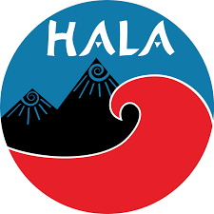

Website #1 Analysis: Hala Gear: https://halagear.com/

Visual Design
- The Home page appeared to have quality graphics and an appealing layout of information.
Figure 4: Hala Website Homepage Banner
  - 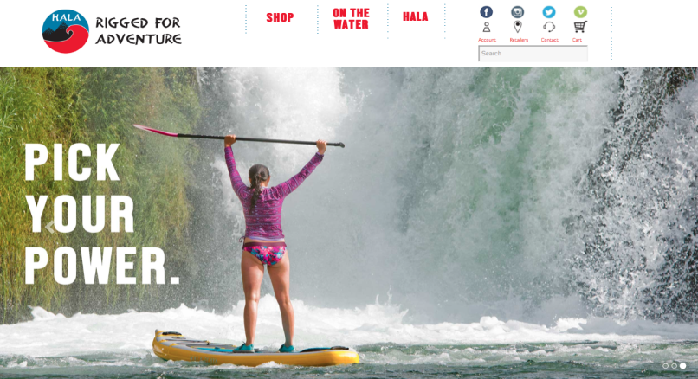
- Hala Gear was visually the most outdated. While the social media bar below is a helpful and almost necessary tool for companies seeking to promote themselves in current society, Hala Gear’s social media bar presented as too simplistic and overall displeasing to the eye.
Figure 5: Hala Website Social Media/Search Bar
  - 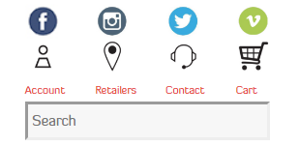
- The products listed on Hala Gear’s website were visually boring and presented as easy to dismiss. The page titled “Shop” takes you to a total of 44 products that are arranged periodically, without any particular product them or labeled groups.
Figure 6: Hala Website Shop Link
  - 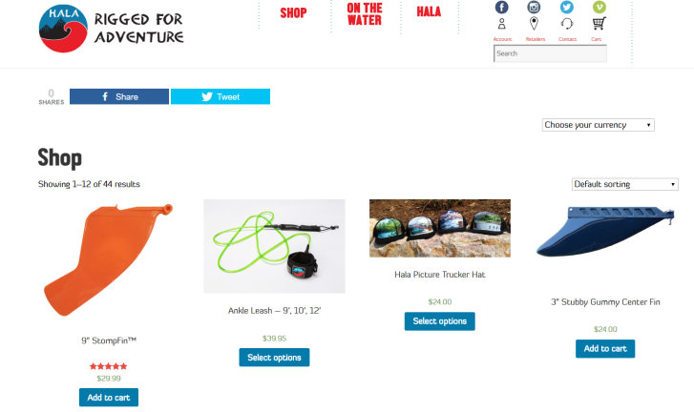
Ease of Access
- This page bellow was featured within the Hala Gear website. It features all of the company’s available boards side by side so that the customer can both view the title and overall design of the boards before seeking further information.
Figure 7: Hala Website Board Overview
  - 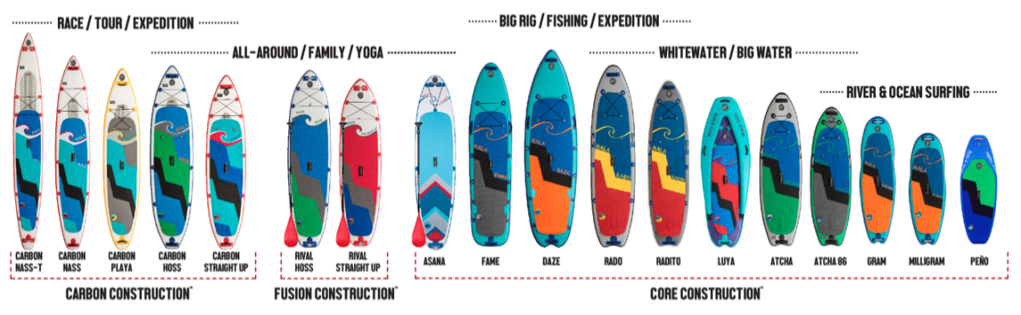
Presentation of Information
- Hala Gear uses a combination of non-professional font choices, even with their “About Us” section. The information about their company and mission/goal is not listed within these statements.
Figure 8: About Hala Gear
  - 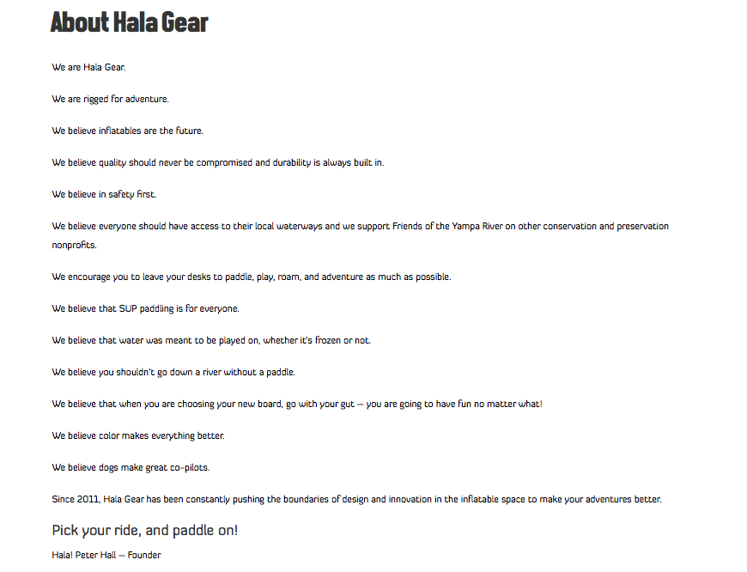
- The product information was listed clearly and thoroughly.
Figure 9: Hala Carbon Nass - T 14’
  - 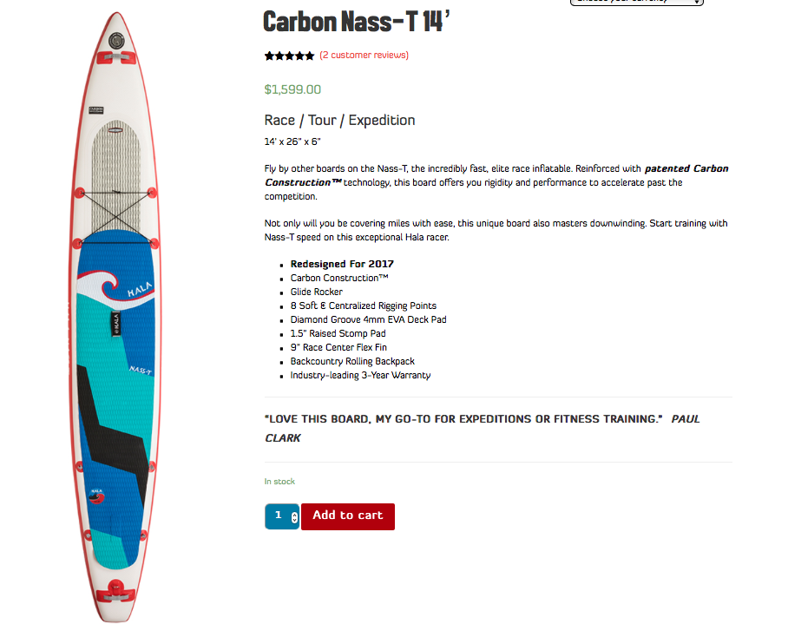

Website #2 Analysis: Naish Surfing: https://www.naishsurfing.com/

Visual Design
- Naish Surfing accomplished something not yet viewed in the analysis of these three websites. They featured a video slideshow on their homepage.
Figure 10: Naish Website Homepage Banner
  - 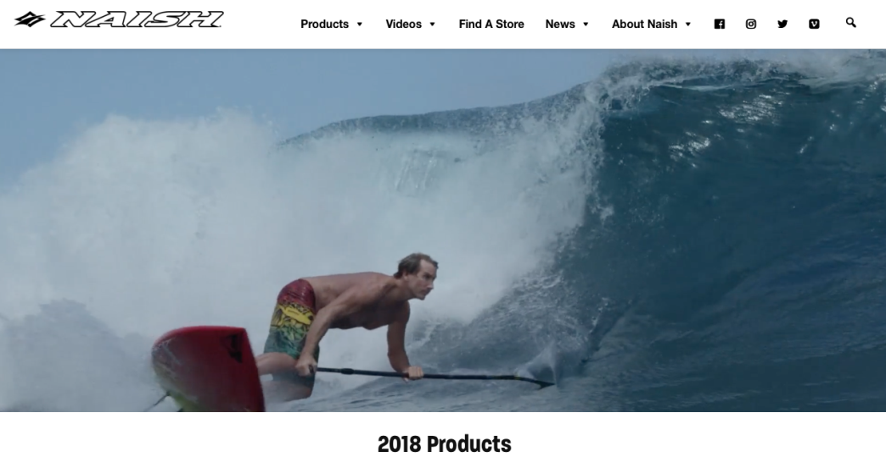
    - This photo generates interest and a positive attitude amongst customers.
  - These photos on the homepage, along with their external links, are organized in a visually pleasing and symmetrical fashion.

Figure 11: Naish Website 2018 Products Figure 12: Naish Website Product Videos
    - 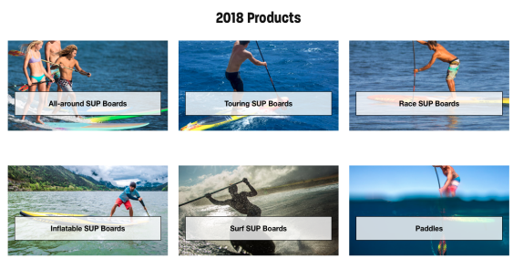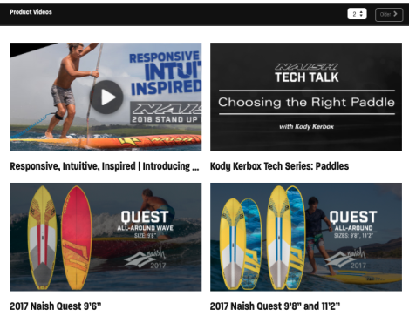

Ease of Access
- Naish was found to be the easiest website to navigate
- Aside from the 5 page titles and social media icons/search bar, Naish presents a simple layout that highlights two main sections being: 2018 Products & Latest News as seen in figures: 11 & 12.

Presentation of Information
- This website utilized product videos as well as instructional product videos.
- The pages and external links were clearly labeled on the website’s page/drop down columns.
Figure 13: Naish Website Homepage Drop Down Menus
- Font was clear and professionally spaced.

Website #3 Analysis: Sic Maui: https://sicmaui.com/

Visual Design
- Overall, Sic Maui was the most visually appealing website. They utilized professional photography for their products, homepage graphics and site links.
Figure 14: Sic Maui Website Homepage Banner
  - 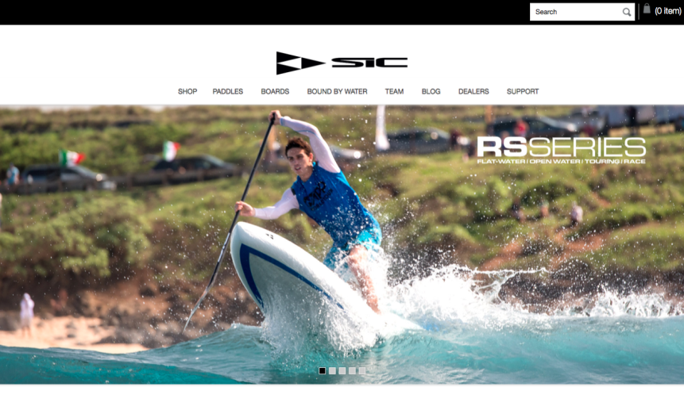

- They also incorporated an Instagram gallery within their website. This is a great way to both generate and and visually display positive customer service. Links to available products are also included within the Instagram gallery so that the customer can quickly locate the the product that they are viewing.

Figure 15: Sic Maui Instagram Gallery
  - 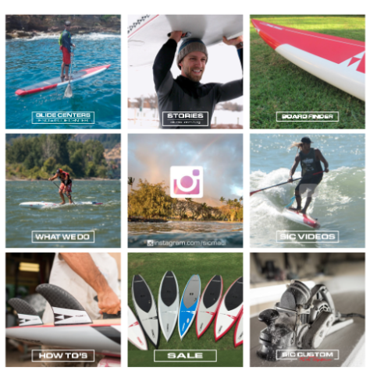

Ease of Access
- Sic Maui was by far the most difficult website to navigate.
- The products featured on the website were difficult to locate due to jargon and the abundance of different board/paddle product titles.

Figure 16: Sic Maui Board Model Selection
  - 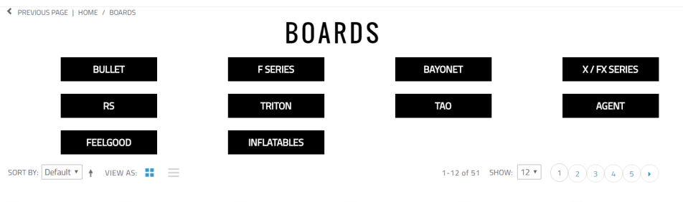

Presentation of Information
- The information presented on this website was found to be cluttered and easily overlooked due to intense graphic usage.
- The use of photo page breaks made the information difficult to locate.

Figure 17: Sic Maui Homepage Photo Scheme
  - 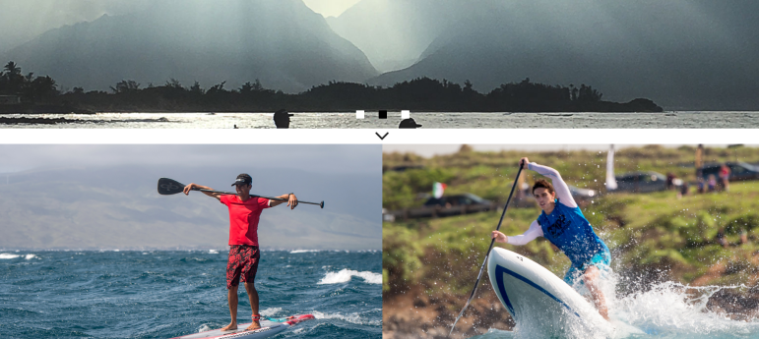

Conclusion

Overall, through the analysis of the three water sport websites Hala Gear, Naish Surfing and Sic Maui, River City Advertising can safely identify what will and what will not be included within James River Water Sports website. According to the survey responses of 143 individuals, it was determined that while Sic Maui presented very cinematic design elements, it distracted from the overall presentation of information. In regards to means of accessibility and user friendly features, Naish Surfing and Hala Gear were found to be the most easy to navigate.

Professional Recommendations

River City Advertising would suggest the following for James River Water Sports considering their upcoming 20th business anniversary, website redesign, and paddle board line launch:

- Use a video slideshow header on the main website page to generate interest in both the product and sport itself
- Utilize empty/white space on drop down menus and pages
- James River Water Sports should temporarily incorporate a home page centered around their 20th anniversary and launch of their new paddle board line along with links to new product details and reviews
- Provide an Instagram gallery that connects customers with certain products from individual photos/posts

Appendix A: Survey Questions
& Results

Survey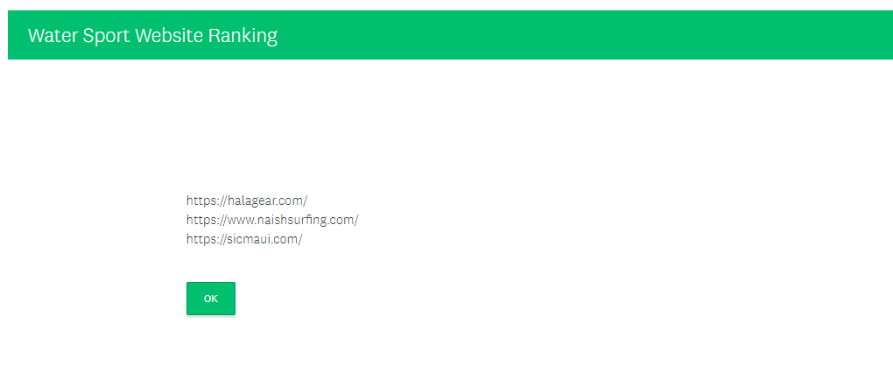
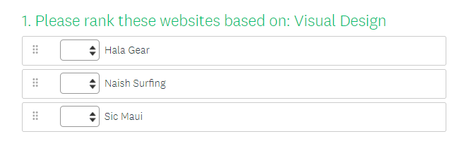
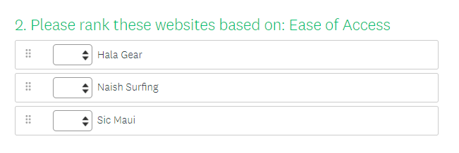
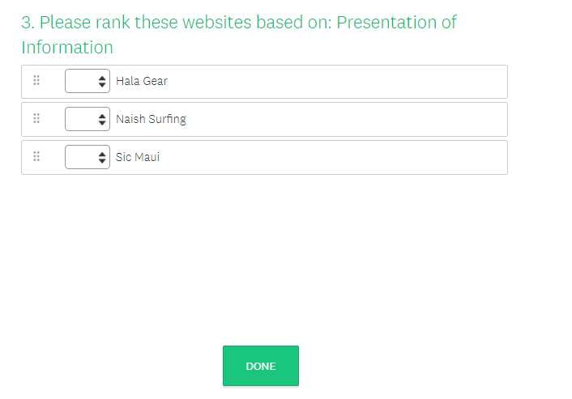

Results
Table 1: Visual Design Survey Results Table 3: Presentation of Information Survey Results
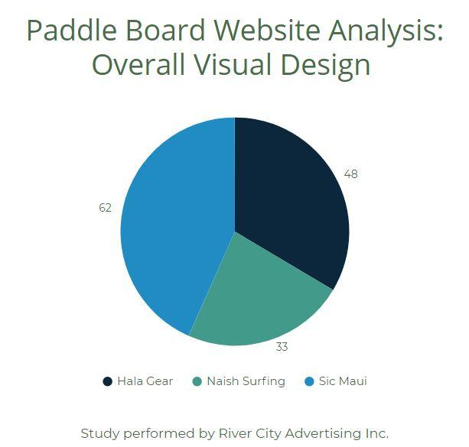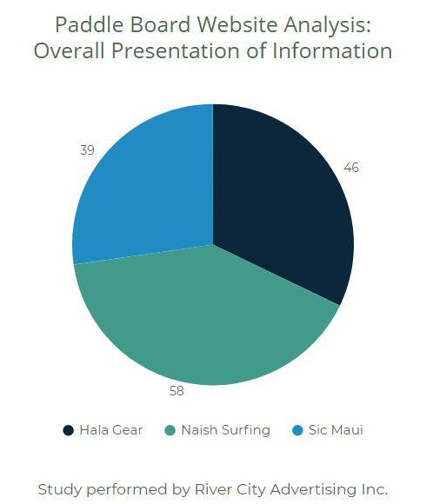

Table 2: Ease of Access Survey Results
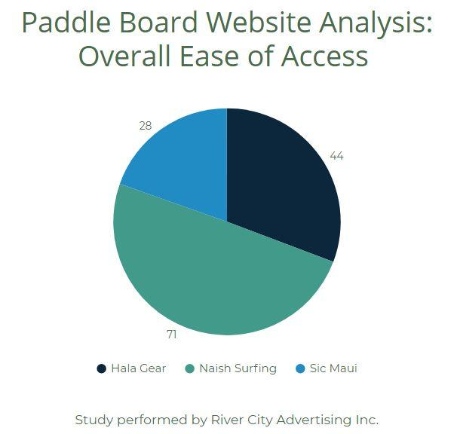

Appendix B: Minutes

Minutes Log

April 16, 2018
Team Meeting - 12:00 PM - 2:50 PM
Shelby + Parker
April 18, 2018
Team Meeting - 12:00 PM - 1:00 PM
Shelby + Parker
April 23, 2018
Team Meeting - 12:00 PM - 1:00 PM
Shelby + Parker
April 25, 2018
Team Meeting - 12:00 PM - 1:00 PM
Shelby + Parker
April 30, 2018
Team Meeting - 11:00 PM - 4:00 PM
Shelby + Parker
May 1, 2018
Team Meeting - 3:00 - 6:00 PM
Shelby + Parker

