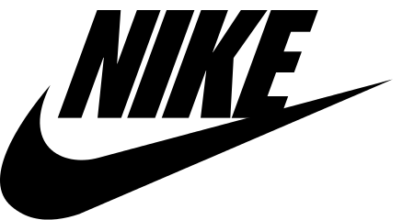
Press Contact:
Riley Bedford
NIKE Corporation
(503) 671-6453
nikefoundation@nike.com

For Immediate Release

Nike plans to reveal their Spring 2018 collection to the public at special event near its headquarters in Beaverton, OR

Beaverton, OR November 9, 2017- NIKE will reveal their new spring collection on January 27 by holding an event at the North Star Ballroom in Beaverton, Oregon. With each new product the President of Product and Merchandising, Michael Spillane, will explain how the footwear or apparel is made.
Nike will show its publics how trustworthy its products are. Nike wants the public to know that when they are working out, the apparel and footwear will be durable enough to get them through the toughest training. Nike will explain what the price of the product is and why it is that price. Nike hopes to up its sales this upcoming new year and these products will be different from any other Nike product you have ever seen.
“It is our goal for us to put out something that will last a long time and will still look new months after buying it. Along with that we tried to find ways to make the product stylish and up to date in todays fashion trends.” said President of Product and Merchandising, Michael Spillane.
Nike continues to keep up with everyday changing trends seen in the media. Nike also strives to be on top of today’s technology and incorporates that into their apparel. The public will see this in the spring 2018 reveal, as Nike hopes to increase their sale revenue.
Past Nike products have included the NikeConnect NBA jersey, which gives fans the opportunity to use their cell phone app to connect with their favorite players. This new collection will have even more technology involved in the apparel and footwear. Nike hopes that incorporating new technology will help the company connect with their publics more.
About Nike: Nike is located in Beaverton, OR and sells active wear. Their mission is to make sure everyone feels like they can be an athlete. Find out more about Nike by visiting there website: www.Nike.com.

###

