Final Blog Marketing Report
Marketing Summary

- Goals for your promotional efforts?
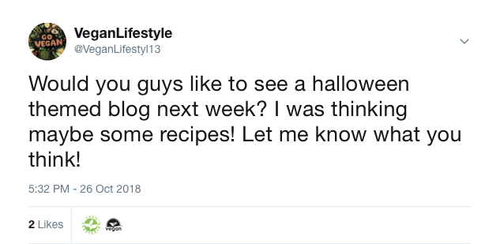
--I would ask my followers a lot of questions so that they had the option to replay and to let me know what they wanted me to see.
--I didn’t always add a link to my blog because I wanted to have some engagement without making them trying to click on the link.
-- 2 likes, 1 profile click
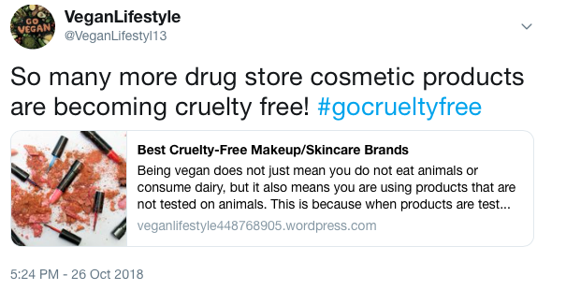
--When it seemed fitting I would use a hashtag to go along with my tweets in order to try to get new engagement.
--When adding a hashtag I wanted to be original, but also find a hashtag that would be clicked on.
--67 impressions

2.) Best individual tweets
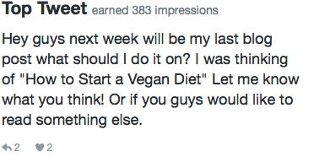

--This tweet got 2 likes, 2 replies and was seen 390 times

--This was my most seen tweet and I got the most engagement off it. It got 46 likes, 37 replies, 2 retweets, 18 profile clicks and was seen 3,212 times.

3.) Best hashtags
When I first started off I made sure to include a hashtag every week, but as time went on I stopped using hashtags because my tweets with hashtags did not get very much attention. One hashtag I used was #gocrueltyfree and that tweet only ended up getting 67 impressions, which is one of my lowest. The hashtag that I used when I first started the blog was #veganlifestyle and that got me 125 impressions which was about average for my twitter. Another time when I used this hashtag I got 133 impressions.

4.) Best messages not from Twitter
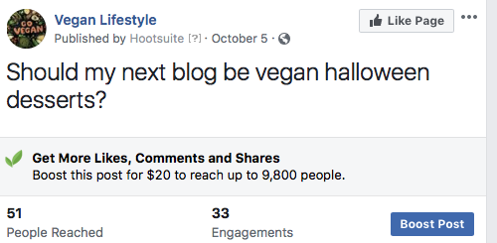
--This Facebook post reached 51 people and had 33 engagements. This post got 5 comments, 1 like and was clicked on 22 times.

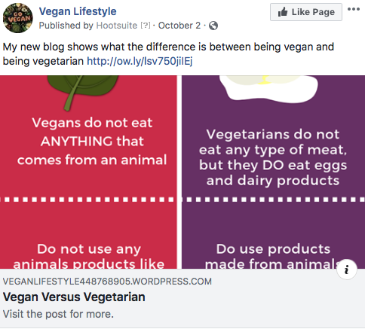

--This post was my next highest reached post. This one only reached 8 people though, it also got 2 likes and 1 click on it.

5.) Most clicked link from all social media messages
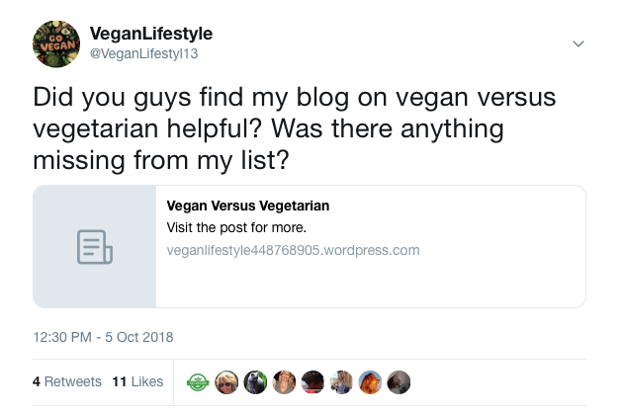
--This tweet was my most clicked on linked. The linked was clicked 29 times. It also got 4 retweets and 11 likes. Even though this link was the one clicked on the most, the post itself had a typo that was not corrected until after this tweet went out.

6.) Most read post (from site statistics)

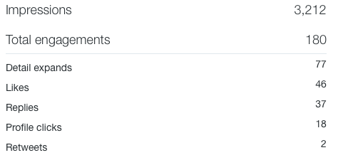
My most read post was from Twitter and it was, “Have any of you guys gone from vegetarian to vegan? If so why did you?” To the side I have the statistics on the tweet. It was significantly higher in impressions than all my other tweets.

7.) At least 1 statistic not include from those above
Number of Retweets: The most retweets I got in my blog were four. This was for the tweet two questions above where I asked if they found my blog on vegan versus vegetarian helpful and if they would add anything. The second most retweets I got in my blog were only two and I got that on two different post. My first one was “How are you guys liking my blog post so far? Is there anything in particular you guys want me to post about?” and the other one that also got two retweets was “Have any of you guys gone from vegetarian to vegan? If so why did you?” I found these interesting to be the most retweeted since they were both just questions.
Marketing Analysis
1.) How did you try and differentiate yourself from others?
I made my blog different from other by adding in a mixture of blogs on vegan recipes and how to live a vegan lifestyle. Many of the blogs I found related to being vegan were either all about recipes or living a vegan lifestyle, not many of them combined the two. I wanted there to be a blog about being vegan were people can learn a little bit about what foods to eat, but also what kind of makeup to buy or how to remain vegan in college.
2.) What worked about your content marketing campaign?
I think what really worked for me was asking my audience questions. Of course sometimes I would not get any replies, but all of my best tweets were when I asked questions about what my followers wanted to see or just questions about their experience being vegan. I think also not adding a link everytime I tweeted helped me because most the times the links I used were not clicked very often, except on tweets where I asked a question first.
3.) What did not?
What did not work for my marketing strategies was using hashtags. I should have done more research into what were the most popular hashtags being used that involved the word vegan, that way more people might of clicked on my profile to view it. I came up with my own hashtags and only checked if one of them was already a hashtag, “gocrueltyfree”It was already a hashtag, though not very popular I am guessing because when I used this hashtag I got the least amount of impressions.
4.) What was your best idea on Twitter?
My best idea on Twitter was asking my followers personal questions about their own experiences. They seemed to like that because whenever I did that I always got responses for them. When I asked about my own blog I did not get very many replies.
5.) What are you most proud of on your second social media platform?
On my Facebook page I am most proud of my post where I directly talked about a follower because it was a lot harder on Facebook to be personal with the people who liked my page. At least when I let them know that I appreciated them liking my post, they felt good about it. It was also a good way I was able to get them more involved.
6.) What would you do differently in the future?
In the future I would add more entertainment to my blogs. Going through my post most of them were “facts” and questions I asked. Next time I would add memes and video clips and maybe ask them if they tried my recipe to send me pictures. I would do that so that my Facebook and Twitter looked more appealing than what it is now which is just questions and links.
7.) What platform was more successful? Why do you think this was the case?
Twitter was definitely more successful for me. I think that is because I had a really hard time trying to get people to like my Facebook page so not many people were viewing my Facebook page. My Twitter on the other hand I had more interaction with my followers and my tweets were being viewed more and I was getting replies. Another reason was because a majority of my followers on Twitter were actually vegan and no one that liked my Facebook page was vegan, so they did not care as much.

