**Personality Disorder Short Case Studies**

1. 

1a. For case study #1, I think that the individual discussed has Antisocial personality disorder. This is evidenced by his lack of guilt, disregard for social rules and obligations, and his impulsive acts.

2. 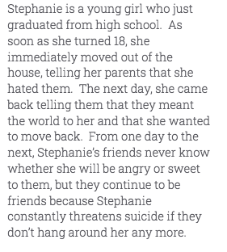

2a. For case study #2, I think that the individual discussed has Borderline personality disorder. This is evidenced by her constant threats of suicide, emotional instability, and fear of abandonment.

3. 

3a. For case study #3, I think that the individual discussed has Paranoid personality disorder. This is evidenced by her distrust of others and her guarded and suspicious behavior.

4. 

4a. For case study #4, I think that the individual discussed has Histronic personality disorder. This is evidenced by her dramatic behavior, attempts to receive the attention of others, and her inappropriately seductive manner.

5. 

5a. For case study #5, I think that the individual discussed has Avoidant personality disorder. This is evidenced by his avoidance of people to avoid criticism and his avoidance of people in general.

6. 

6a. For case study #6, I think that the individual discussed has Schizotypal personality disorder. This is evidenced by her disheveled appearance, magical thinking, and her odd beliefs.

7. 

7a. For case study #7, I think that the individual discussed has Narcissistic personality disorder. This is evidenced by her expectations to be admired, willingness to lie and exploit others to achieve her goals, and self-absorbed nature.

8.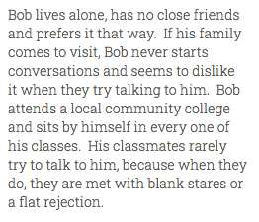

8a. For case study #8, I think that the individual discussed has Schizoid personality disorder. This is evidenced by his lack of desire for relationships, his detached and aloof nature, and his lack of emotional response.

9. 

9a. For case study #9, I think that the individual discussed has Obsessive Compulsive personality disorder. This is evidenced by his preoccupation to details and devotion to productivity.

10. 

10a. For case study #10, I think that the individual discussed has Dependent personality disorder. This is evidenced by her apparent fear of abandonment and lack of self confidence.