Name: Kacie Reusser | Date: October 7, 2019 |  | Date: __October 7, 2014____
Lesson Focus: Plotting points and understanding coordinate planes |  |  | Grade Level: __Fifth
Curriculum Standards (SOL):  Computation and Estimation  6. 8: The student will a) identify the components of the coordinate plane and b) identify the coordinates of a point and graph ordered pairs in a coordinate plane  NCTM Content Standards:  Measurement and Geometry  NCTM Process Standards: Communication, Connections, Representation, Reasoning and Proof, Problem Solving  Materials/Resources:  - Battle ship board  - Scavenger hunt sheet  - Smartboard  - Under Construction activity sheet  - Word problem sheet  - Coordinate plane paper  - Expo markers  - Powerpoint  - Pencil  - VDOE website  - NCTM Content Standards |  | Time
Lesson Objectives: A statement or statements of what the students will be able to do as a result of the lesson. Need to be observable and measurable.(ABCD format)

- The student will be able to understand points along the x and y axis by plotting given coordinates in the treasure hunt activity and the under construction activity with fewer than 3 errors.
- The student will be able to apply their understanding of coordinate planes and plotting points through the game of human battleship with 100% accuracy.
- The student will be able to display their knowledge of how to read coordinate planes and plot points on coordinate planes through the human battleship game, the treasure hunt activity, and the under construction activity with fewer than 5 errors altogether.
Introduction: Set behavior expectations. Ask students to think about careers that would use coordinate planes, especially for those who could see it in their dream profession. Have them share out about how that field uses coordinate planes. **Some examples include: Farming, electricians, engineers, cartographers (map-makers). Also, relate it back to their life by asking them if they have heard of or played the game battleship. Tell that the game of battleship IS a coordinate plane! |  | 10 min
BEFORE:  - Review what a coordinate plane is and how to read it and how to plot points from different coordinates  -Have to go along the x axis first! Think about video games and real life, you have to travel to where you want to go before you jump up, at least in most cases. I know that sometimes in Fortnite, you can just jump up to get whatever you want, but usually you have to run to where you want to be before you jump. Think about track. In track, you have to run to the hurdles before you jump them! (This is about why x goes first!)  - Introduce stations, provide an example of each, and check for understanding of activity and go over behavior before continuing. I will also go over that each station is 13 minutes and a timer will be up on the smartboard so when it goes off, we will quickly and quietly transition to the next station. I will explain that I know that the battleship game looks like much more fun than the other activities, but ensure that everyone will have a turn at the game and that the other activities are fun too! |  | 15 min
Activity:  Station 1  - Battleship! There will 4 teams of 2 (students will get to pick their partner within the group) at each station playing against each other with manilla file folder boards.  - Students will work together to figure out the coordinates to try and win.  - Explain to them the rules-no peeking, if someone says your plot, you are honest. Remind them that this is just a fun game and not a real competition and it’s nothing to get upset over when they get “sunk.”  Station 2  - Treasure Hunt! Given a coordinate plane, students will follow instructions to try and find where “x” marks the spot.  - Along the way, it will tie back to adding and subtracting positive and negative integers because they will have to find the points and stops along the way.  - Before releasing them into the stations, show them an example so that they understand how to move along a coordinate plane.  - At the end of the activity, they will find the last point on the sheet in their classroom (that will be turned into a coordinate plane) and they will find the hidden treasure of a chocolate coin.  Station 3  - Under Construction! Students will have a coordinate plane and they can build a house! They will have an example of what the house should look like, but where they plot the points is up to them!  - If they finish early, they may add some extra features to their house.  - They can color these rooms if they are feeling extra creative.  OR  - Word problems! Students will solve various word problems that will test their ability to plot and read coordinate planes.  - Students should already know what to do with this station as they have a word problem station whenever they have stations in class.  - Word problems will include questions where they have to plot and pick points off of the plane and turn them into coordinates.  - This activity is for students who are not feeling creative or for those who just want some extra practice with the word problems. |  | 39 min  (13  mins  at  each  station)
AFTER/Closure:  - Review the activities – Were there any questions that were more challenging or trickier during any of the activities? Did you find it easy or difficult plotting the points, rather than just writing them? How was it working in teams for battle ship?  - Review coordinate planes. What does the x axis mean? The y? How does it look in ()?  - Wrap it up – Can anyone tell me a time that they have had to use a coordinate plane? What about when they’re playing a sport? Soccer for example, you would have to run up the field, and then over to block the ball. Did we think of any other careers than this morning?  - Check for understanding – Give me a thumbs up if you are clear or a sideways thumb if we’re still a little confused.  - Exit ticket: Give them a piece of graph paper where they would have to graph 2-3 points and then write the coordinates for another 2-3 points already on the paper. |  | 5-10 min
Inclusion:
This is an inclusion class, so there is a variety of different learners in there. In order to help students achieve their full potential in this lesson, I would
- Pair them with stronger math students that can help them
- Monitor them closely during all of the stations
- Go more into depth on how coordinate planes work by providing more examples and by giving a demonstration
- Provide more examples on how to operate and plot on the coordinate plane by giving a demonstration

Assessment:
Through self-assessment, my observations, and the exit ticket, I will determine how the class is feeling about the topic. By doing so, I will see if the class will need another review about the topic and we will review one more time as a whole class before we continue on. Also, if it seems like there are struggling at one of the stations, I will pause the lesson to explain it so that there is no confusion on the rotations. I will walk around, monitor, and assist at all stations. If by the end, I determine that students still need some review, I will talk with my CT to determine how to move forward. If it is just a handful of students still struggling, I will see if I can work with them during their power up time.

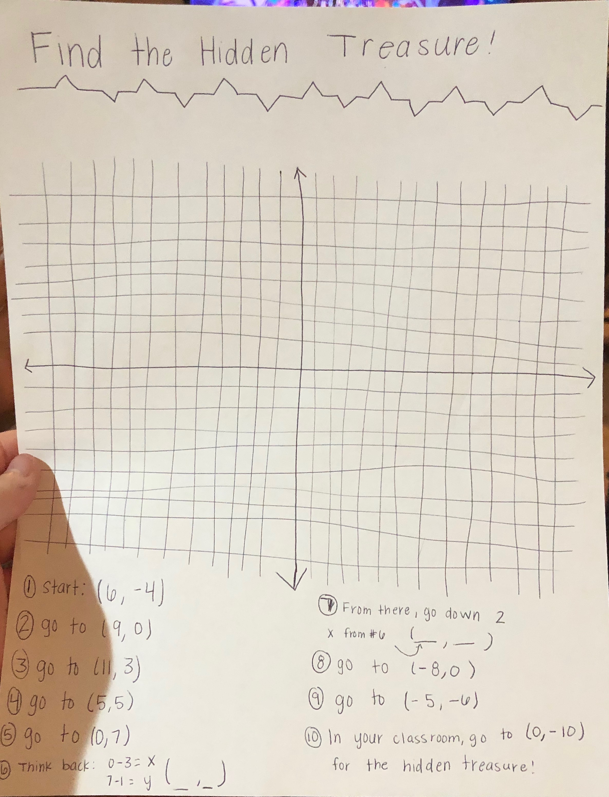
**I will have a different version of this where #6 and #7 will already be plotted and they would have to write the coordinates in the event that it is too difficult for some because of the fact that this is an inclusion class. Also, the graph will be neater (possibly copied from the internet).
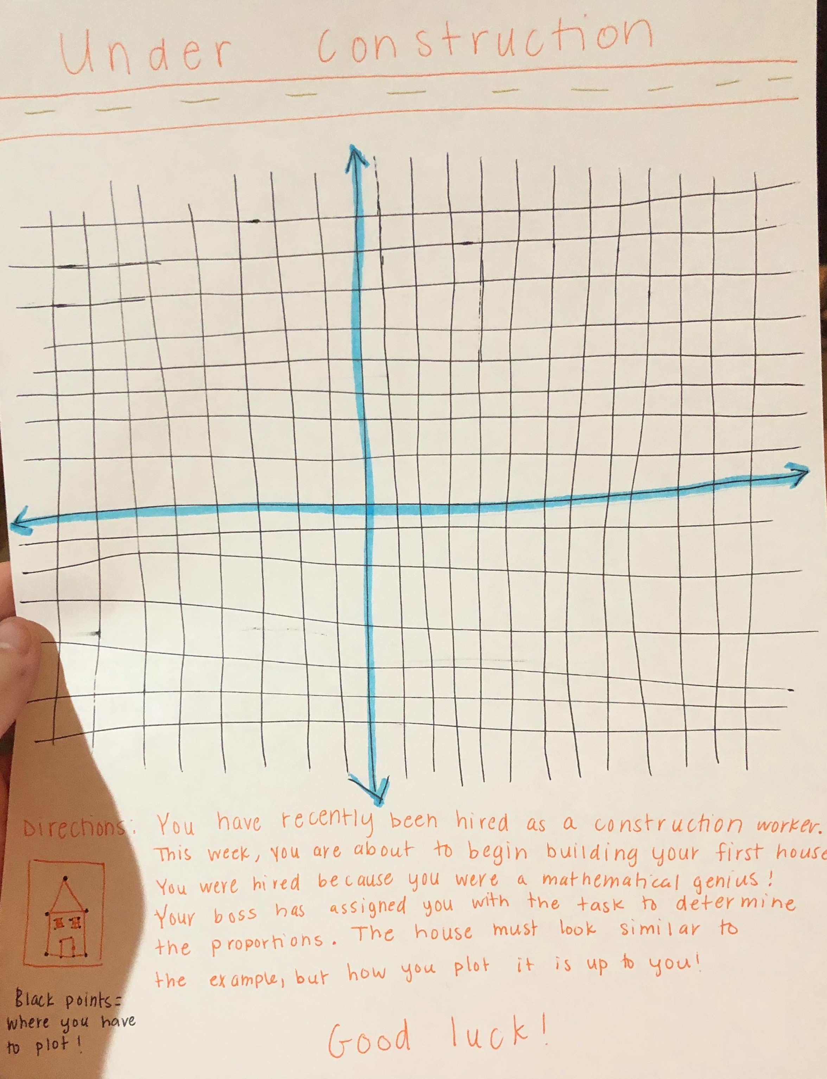
**They will have spaces where they can write their coordinates and the plot points will be labeled so that I can make sure that they understand. Also, the graph will be neater (possibly copied from the internet).
Let’s Practice!

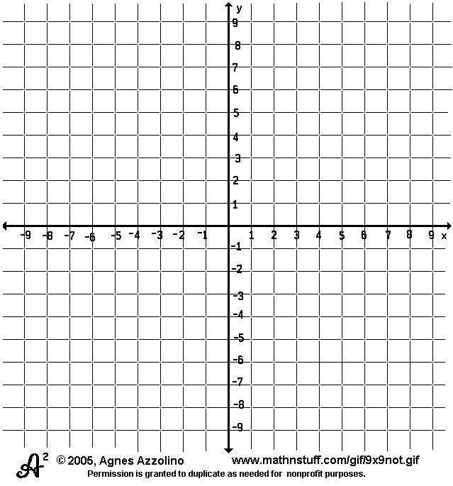

- Alpine Ace is at (0,0), but he needs to travel to (-4,7) in order to get to the next level. First, he needs to see what it looks like so he can plan his next move. With a blue crayon or marker, can you mark where he started and where he needs to end up.
- Ariana Grande is running away from the paparazzi! She started by just getting some coffee with her friends at (-3,-6), but then she was spotted by the paparazzi! She had to go up the street to her house to get away! Her house is at (__, ___). Mark her points with a pink crayon or marker!
- It’s Super Bowl time! Tom Brady is at (6, 0), but in order to get a touchdown, he needs to run down the field to (___, _____). Show how he travelled with a red marker or colored pencil.
- You want to climb Mt. Everest (wow!). Since you are starting at a really low elevation, say about (0, -5), somehow you have to make it to the top (10,10). Show how you did it with a green crayon or marker!

