Detecting GMOs in Foods
Rebecca Sydnor
BIO 101-05
19 November 2018

- Introduction
Most people are unaware of what foods are genetically modified. Genetically modification is when gene technology alters the genetic make-up of a living organism, whether that be an animal, plant or microorganism. The process that combines genes from different organisms is known as recombinant DNA technology, and the resulting organism is classified as “genetically modified” (Anilakumar& Bawa, 2012). This allows a plant to express a gene that is not native to it or to modify other genes (Key Ma & Drake, 2008). It is important to know whether a food is genetically modified or not and whether labels should be enforced. It has been skeptical if genetically modified foods actually affect the environment and the consumer negatively or not The Institute for Responsible Technology performed an experiment involving rats on a GMO diet and concluded that after just ten days of feeding, the GMO potato used affected every organ negatively (Norris, 2015). Although, many scientists had a hard time believing this and sought out their own experiment. The National Institute of Toxicological Research in Korea performed an experiment with rats. They altered male and female rat’s diets, feeding them either GMO potatoes or non-GMO potato. After an examination of the reproductive organs, liver, kidney and other areas, there showed no differences between the rats who on a GMO diet and non-GMO diet.
To test if we can detect genetically modified organism in food a variety of foods were tested in an experiment. This experiment is important because most individuals are unaware of what foods have been genetically modified and don’t realize how much genetically modified food they have consumed (Ackerman, 2016). The food samples included organic corn, frozen corn, corn puffs, cornmeal, tortilla chips, and a meatball. Since corn is a vegetable, it was presumed all of the food samples had to include plant mix. Also, assumed that every single one of them was genetically modified, except the organic corn. This is because genetically modifying organic products is not prohibited by the USDA (McEvoy, 2013). The experiment process included extraction of the DNA of each food sample and PCR reaction before testing the sample in the gel electrophoresis.
- Methods
The first part of this experiment was the DNA extraction from every food sample. Every group of experimenters was assigned one of the food samples. A prediction was then made if the food sample contacted genetically modified organisms or not. The experimenter weighed out 1 gram of the assigned food sample. Took the weighed out sample and crushed the food with a pestle and mortar. For every gram of food, 5 ml of water was added to the mortar. The food and water was grinded with the pestle until the substance became slurry. Then a pipette was used to draw 50 microliters of the food slurry from the dish into a PCR tube and capped off. The PCR slurry filled tube was then spun at a quick rate to dissolve the slurry completely into a watery substance.
The second part of the experiment started with the PCR reaction. PCR reaction when performed analyzes the presence of GMO DNA sequences. PCR is DNA replication in a test tube and allows the experimenter to amplify specific sections of DNA and make millions of copies (Mardigian & Wiseman, n.d.). To measure the plant master mix (green) and the master mix (red) within all the samples, 6 PCR tubes were labeled with group numbers followed by a G or a P. Then 20 mL was delivered to the tube of each DNA sample with a gun to get the accurate 0.02 ml amount of mix into the food sample. Following each mix with this process, using a fresh tip, the tube was placed on ice. After completion with both mixes, the PCR tubes were then placed in the thermal cycler. A thermal cycler is a laboratory apparatus that amplifies segments of DNA via the polymerase chain reaction. This will allow the experimenter to know if the food contains plant mix and/or master mix.
- Results & Discussion
As for the results, they almost aligned perfectly with the hypothesis. The organic corn was not genetically modified like hypothesized, although it was not the only one. The cornmeal was also found not genetically modified. In figure 2, both food sample 2 (cornmeal) and 5 (organic corn) were not shown to be genetically modified. As shown in figure 1, like theorized, all of the 6 food samples included plant mix. For the most part, the results supported the hypothesis. Cornmeal was an assumed genetically modified food because most products that contain corn have been unless they have been organically certified. These results show that just because a food product may contain corn, does not always mean the product has been genetically modified. A consumer should not assume because a certain product is an ingredient in another, it has been modified or not.
Modifying foods allows them to taste better, grow larger and have a longer shelf-life and as of now, biotech foods are safe for humans. Dr. Dean DellaPenna, a professor at Michigan State University, stated that risks exist everywhere in our food supply and there is minimized risks by doing rigorous testing with genetically engineered foods (Ackerman, 2016). An agriculture scientist at the Center for Plant Biotechnology Research at Tuskegee University argued the importance of biotech foods and the fact that over eight hundred million people are malnourished on this earth and the number is only growing (Ackerman, 2016). The risks on a human’s life outweighs the small impacts genetic geoengineering can play on the environment. If research continues with the new technology, the risks and benefits can be weighed with their risks and allow scientists to understand them more.

- References
Ackerman, J. (2016, September 28). Food: How Altered? https://www.nationalgeographic.com/environment/global-warming/food-how-altered/
AnilaKumar R. K., Bawa S. A. (2012) Genetically modified foods: safety, risks and public concerns – a review. US National Library of Medicine National Institutes of Health https://www.ncbi.nlm.nih.gov/pmc/articles/PMC3791249/
McEvoy, M. (2013, May 17). Organic 101: Can GMOs Be Used in Organic Products? from https://www.usda.gov/media/blog/2013/05/17/organic-101-can-gmos-be-used-organic- products
Norris, M. L. (2017, January 19). Retrieved November 3, 2018, Will GMOs Hurt My Body? The Public's Concerns and How Scientists Have Addressed Them. http://sitn.hms.harvard.edu/flash/2015/will-gmos-hurt-my-body/
Key, S., Ma, J. K., & Drake, P. M. (2008). Genetically modified plants and human health. Journal of the Royal Society of Medicine, 101(6), 290-8.
Wiseman, B., Dr., & Mardigian, R. (n.d.). Biotechnology Explorer™ GMO Investigator™ Kit. https://www.cpet.ufl.edu/wp-content/uploads/2012/10/GMO-Investigator-Kit- manual.pdf

- Figures & Tables
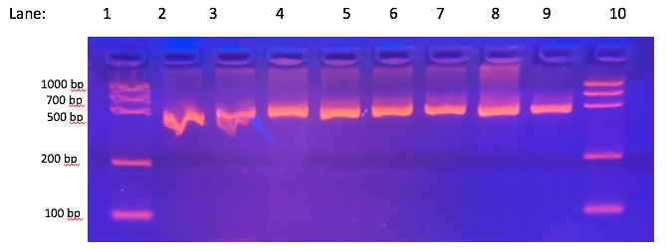
Figure 1. Gel electrophoresis results for plant gene PCR reaction (green reaction)
Figure 1. Gel electrophoresis results for plant gene PCR reaction (green reaction)

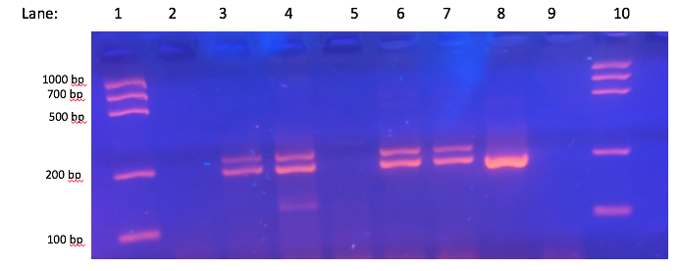
Figure 2. Gel electrophoresis results for GMO gene PCR reaction (red reaction)

